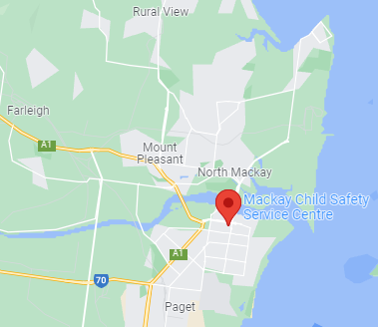
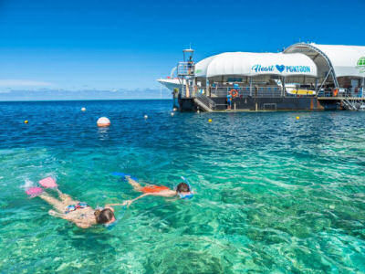
Find out more
Contact Recruitment to discuss this opportunity or speak to the Mackay Child Safety Service Centre team.

About Mackay

Refer to the Mackay Regional Council page for local town information, facilities, or recreation ideas.

Community Living

Mackay has a population of 133,931 and the town is serviced with shopping centres, hospitals, childcare, state, and private schools. Childcare vacancies are shown here: CareforKids.com.au
Mackay is a city in the Mackay Region on the tropical coast of Queensland, Australia. It is located 970 kilometres (603 miles) north of Brisbane and is close to Airlie Beach and the Whitsunday Islands. Mackay is nicknamed the sugar capital of Australia because its region produces more than a third of Australia's sugar. The area which is now Mackay City was originally inhabited by the local Yuibera people.
Incentives

- $1,500 relocation incentive

- $2,500 remote allowance incentive scheme

- $29.00 fortnight locality allowance

- Department staff have access to entitlements (up to 5 weeks annual leave per year)

Mackay

Child

Safety

Service Centre

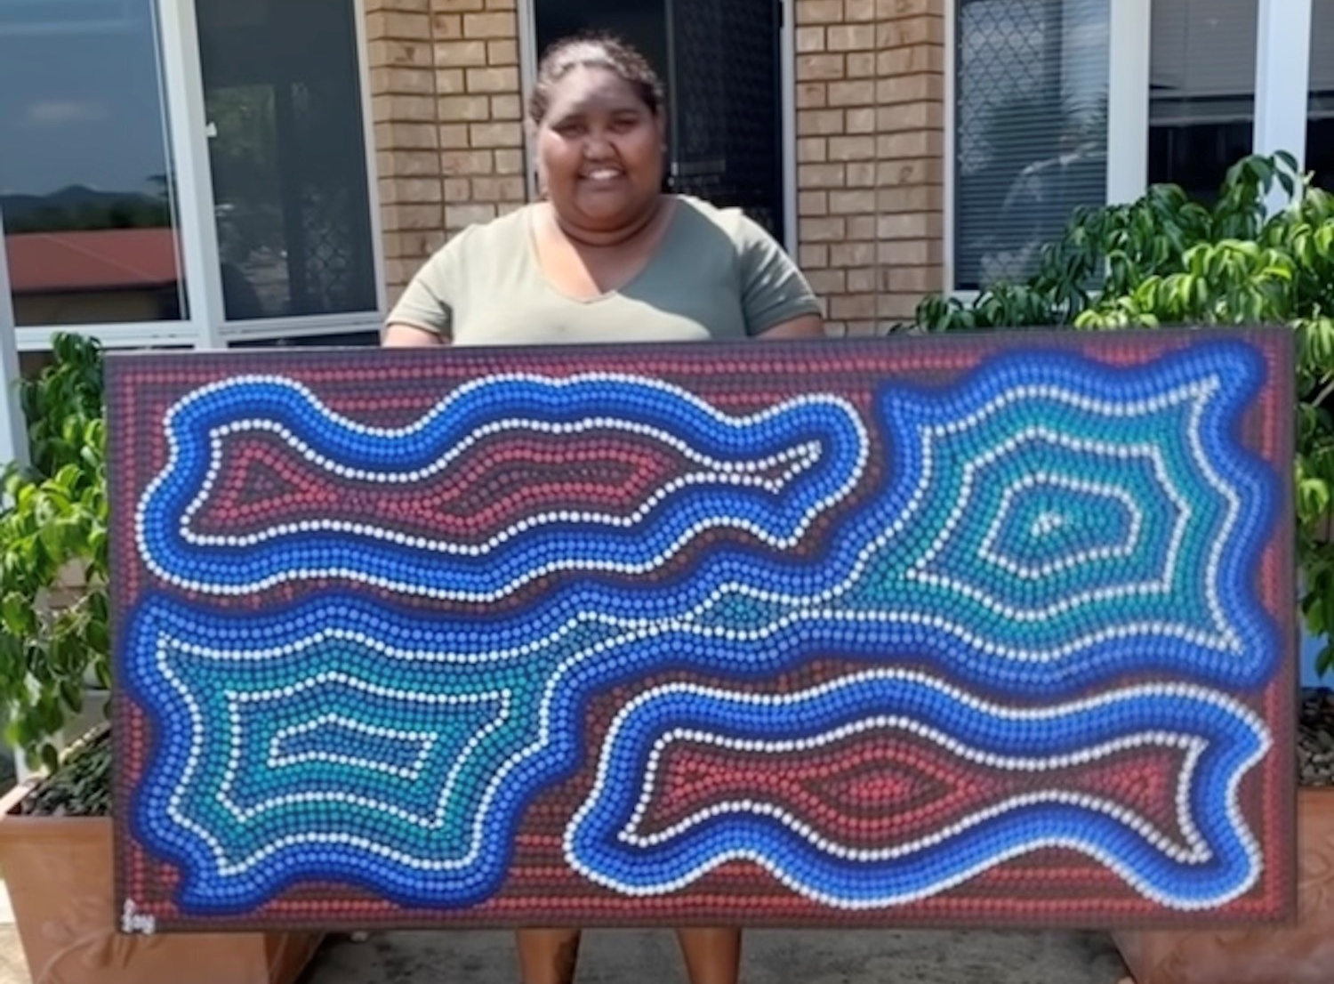
Mackay Administration Officer Fay Weeks expresses her culture into her artwork in her spare time

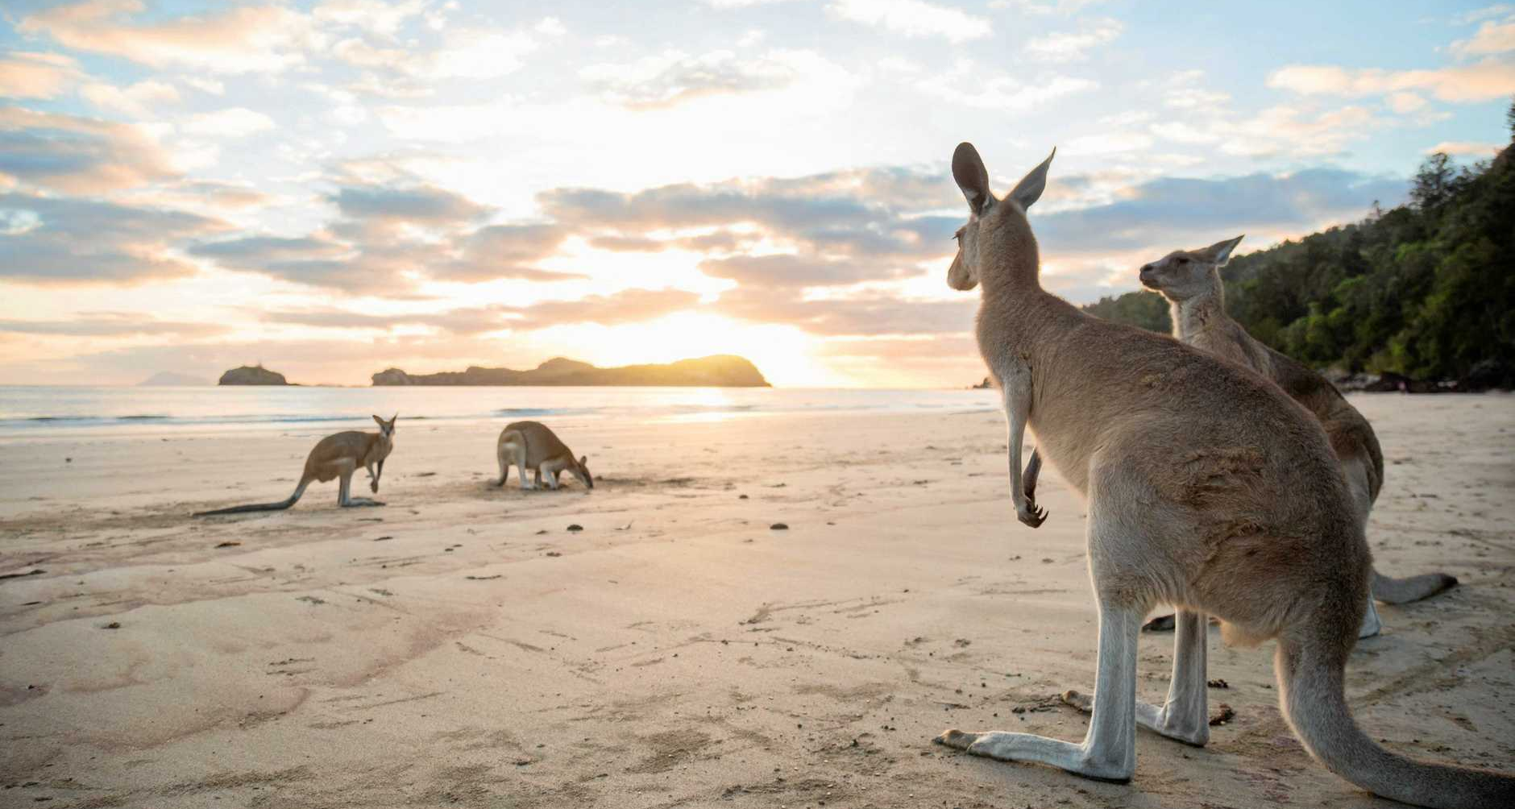
Kangaroos at Cape Hillsborough, one of the many beautiful beaches in Mackay, Whitsunday’s region

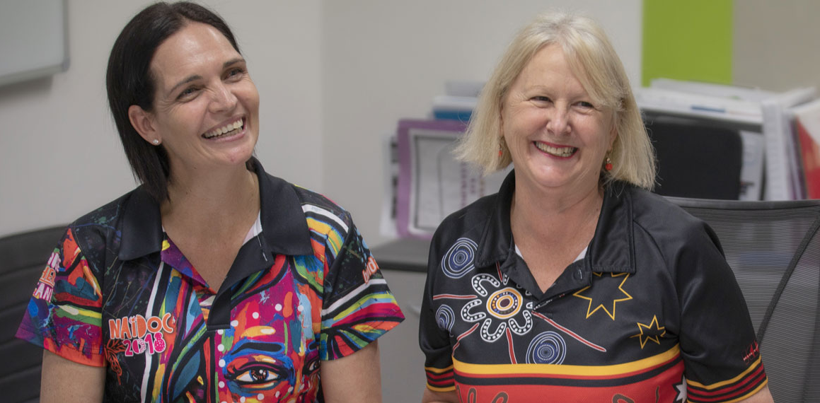
Welcome to Mackay! Captured above are two Mackay staff members Kerry & Carrie

Liveability in Mackay

Mackay is situated between Townsville and Rockhampton. Approximately 3hr 49mins (336.0 km) drive from Rockhampton and approximately 4hr 39mins (386.1 km) drive from Townsville.
Mackay has a humid subtropical climate. Average maximum temperatures range from 30 °C (86 °F) in summer to 23 °C (73 °F) in winter, while minimums range from 11 to 23 °C (52 to 73 °F).
Mackay has a range of housing options available with full air conditioning. There are a number of state and private schools, TAFE, and Universities in the area.
A trip to Mackay promises natural encounters that feel like you’re chartering your own adventure, whether it be exploring secluded beaches, casting a line, discovering tropical islands just offshore or hiking its famous hinterland.
Mackay has an excellent portfolio of restaurants, offering a range of cuisines for group or individual dining. There are a number of award-winning restaurants within the Mackay City Centre.
Caneland Central is conveniently located in the Mackay City Centre. It offers the widest variety of stores and services with over 200 stores together with Myer, Target, Big W, Woolworths, Coles, JB Hi Fi and Best & Less.
Mackay Base Hospital provides general health services. The hospital undertook redevelopment adding more operating theatres, a dedicated coronary care unit, a larger intensive care unit, new emergency and outpatients' departments, renal support services, day oncology and a dental services unit.
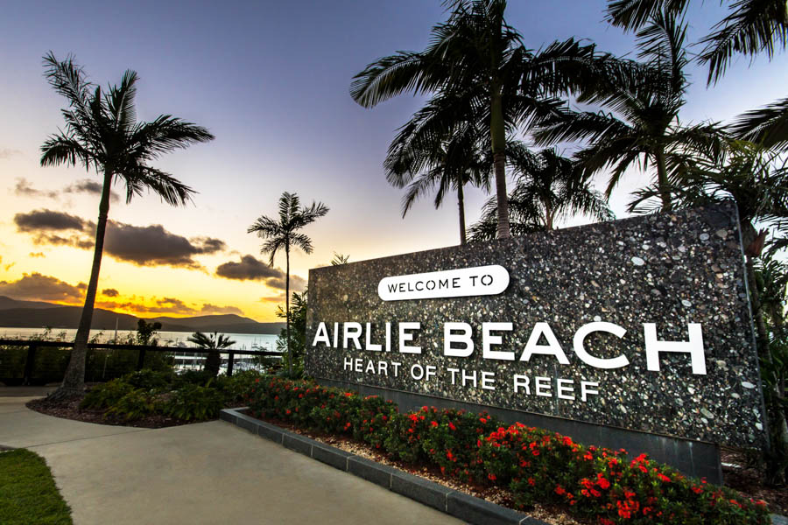
Top reasons to consider Mackay:
- Mackay has the fastest growing economy in regional Queensland today
- Explore the natural attractions
- Lower house prices offer affordability
- Be part of the Mackay community
- Develop your career with experienced child protection practitioners and colleagues.
- Work across the whole child protection continuum

Pioneer Valley & Eungella National Park
The park’s ancient rainforest is one of the best places in the world to see the remarkable platypus in the wild. It is just one hour’s drive from Mackay and offers a range of activity and dining options.
Sarina Sugar Shed
Australia’s only miniature sugar mill and distillery located 30 mins south of Mackay. Specialising in rum and liqueurs. Enjoy a close-up, interactive and highly engaging guided tour, and get to taste some yummy goodies as well!

The Bluewater Trail
The trail meandering along the river and the city’s green spaces, leading to the Mackay Regional Botanic Gardens. The trail is ideal for escorted walks or bike rides, fitness activities such as yoga sessions and boot camps.
Mackay Beaches
The Mackay area features 31 amazing white-sand beaches that run all along the region’s coast. You can enjoy swimming, fishing, boating, and whale-watching at these beaches. Adjacent parks provide free picnic and barbecue facilities.
On the Weekend
A wonderful landscape of waterfalls, flora and volcanic boulder formations make Finch Hatton Gorge a must-see attraction. There are many walking tracks which weave through the sub-tropical rainforest and swimming waterholes.
Things to do
‘Make a difference’

