Proposed funding declaration under section 12, Community Services Act 2017

Department of Children, Youth Justice and Multicultural Affairs Funding Declaration 2021
Community Services Act 2007, section 12

Short Title

This declaration may be cited as the Department of Children, Youth Justice and Multicultural Affairs Funding Declaration 2021.

Commencement

This declaration commences on 19 October 2021.

Funding

This declaration relates to the following funding provided, or available to be provided, under a program of funding administered by the Department of Children, Youth Justice and Multicultural Affairs (the funding) -

Funding provided under the following Investment Specifications published by the department from time to time:
  - Youth Justice.

Pending updates to the Youth Justice Investment Specifications this will also include:

    - Drug and alcohol residential treatment program; and

    - Intensive support for families.

Declaration

The funding is declared to be funding to which the Community Services Act 2007

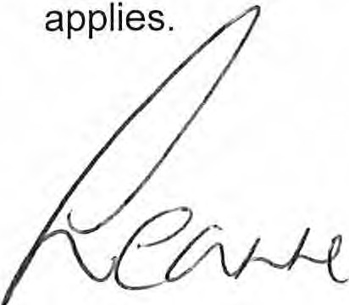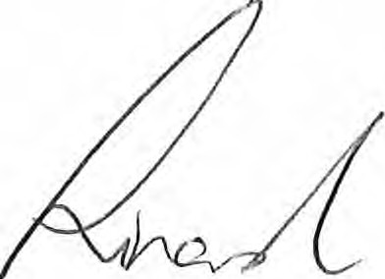

Leanne Linard MP
Minister for Children and Youth Justice and Minister for Multicultural Affairs

22 / 11 / 2021

