Youth Justice Investment Specifications

July 2021
Reviewed annually
Next review date: July 2022

- Investment intent
Community safety is promoted when children and young people have positive connections to self, family & friends, community & culture and education, training & employment.
Addressing youth crime remains a key priority for our community. The Queensland Government is committed to investing in programs and services that promote community safety, based on evidence of what works to reduce the impacts and incidences of youth crime.
While the vast majority of young people who have contact with the youth justice system will cease offending on their own and transition to adulthood with little incident, a small, high risk group of repeat, recidivist or early onset offenders do require extensive support to stop offending and exit the criminal justice system.
The Department of Children, Youth Justice and Multicultural Affairs provides discrete funding to support young people in contact with the youth justice system with the right mix of services at the right time to build thriving and connected communities with reduced crime.
Our investment in outsourced services is evidence based in relation to what works in reducing youth crime and tailored to the needs of young people in contact with the youth justice system. The evidence shows:
- young people with a low risk of reoffending should be provided with minimal, “light touch” services because intervening can have counterproductive outcomes through exposing young people to a greater range of risk factors and increases the potential for future offending; and
- high risk, recidivist young people should be provided with intensive ongoing support to stop offending and reconnect with positive, prosocial activities including education, training, and employment.
Partnering with the non-government sector allows us to support increased community safety by targeting services across a continuum of service delivery, including prevention, early intervention and high intensity rehabilitation, responding to the individual risk and needs of young people in the youth justice system.
The non-government sector is uniquely placed to partner with us to provide sustainable services to young people, in the youth justice system, and their families.
Our outsourced service investment focuses on initiatives to help prevent youth crime and improve outcomes and reduce demands in the Youth Justice system. It is aligned with the four pillars of the Youth Justice Strategy and structured to provide services that are evidence based, place based and focused on keeping the community safe:
- intervene early (investment priority 1 - keeping young people connected);
- keep children out of court (investment priority 2 - strengthening young people’s connections);
- keep children out of custody (investment priority 3 - reconnecting young people); and
- reduce reoffending (investment priority 4 - healing young people’s connections).
The aim is to enable young people to break the cycle of offending and live well.

- Investment context
Between 2017 and 2020, the government invested an extra $550 million dollars into the youth justice system, underpinned by the Working Together Changing the Story Youth Justice Strategy 2019-23. This included a significant increase in the funding provided to our
non-government sector.
The Strategy is a strong statement confirming public safety is paramount. It puts us on a path to build the community’s confidence that we are responding to their concerns and experiences in relation to youth crime.
Queensland has high rates of young people remanded in custody which puts increased pressure on courts, police and youth detention centres, with little impact on stopping offending behaviour. Our investment allows us to focus expenditure earlier in the youth justice continuum to intervene early, divert young people from court and custody and reduce reoffending.
Queensland is large and our population is spread over cities, rural towns and remote communities. Our state is diverse and a one size fits all approach does not work. Our service provision needs to be flexible and adaptable to provide place-based approaches, based on local community need and strengths.
Aboriginal and Torres Strait Islander children and young people are over-represented in the youth justice system and are affected by the impacts of intergenerational trauma on families resulting from experiences of colonisation, the Stolen Generations and other discriminatory laws, policies and practices of our society, systems and institutions. This is of critical concern, as is the limited available evidence on what is most effective in reducing over-representation in a Queensland context.
Young people are at the centre of our program design, which aims to deliver a balance of evidence and community level data and advice. Particularly, we rely on input from Aboriginal and Torres Strait Islander community members to help shape our responses for Aboriginal and Torres Strait Islander children and young people.
Investing in Aboriginal and Torres Strait Islander community designed and led programs allows us to contribute to the evidence base of what works to support our Aboriginal and Torres Strait Islander young people to stop offending.
Our investment is complemented by continuous improvement processes, reliant on accurate data collection, quality in service provision and supporting agile responses that enable ongoing learning and quality service improvement through communities of practice and evaluations.
Our young people require our services to be agile, consistent, persistent and proactive in their approach. They need boundaries, but they also need empathy and coordinated support to be reconnected to their communities.
Collaboration and integration leveraged through local investment partnerships promote a holistic approach to young people to connect them to health and mental health services, education, training and employment, reducing key risk factors for future offending.
The youth justice service sector offers a unique perspective, working alongside Courts, Police and other service providers often at a time of heightened stress and vulnerability for young people and their families. Operationalising service responses in business and after hours to meet the ongoing needs of young people can be challenging, with the added complexity of high community expectations while placing the child or young person at the centre of
decision-making.

- Investment recipients (target cohort)
Our children and young people:
- are aged 10-17;
- are at moderate to high risk of offending and/or recidivism; and
- have moderate, high, and complex needs.
The reasons young people end up in the youth justice system are complex. Young people, particularly Aboriginal and Torres Islander young people:
- are faced with intergenerational trauma and disadvantage, and the range of impacts this has on social and emotional wellbeing;
- often have a history of child protection involvement;
- are disengaged from mainstream schooling and literacy levels are well below average Queensland children;
- have under-detected and under-reported health and mental health needs; and
- often experience a range of negative impacts to their social and emotional wellbeing.
Young people and their families who enter and remain in the youth justice system generally present with complex and extreme needs and challenging behaviour. Therefore, they are often required to engage with multiple organisations. This can lead to intervention fatigue for young people, families and our service providers.
Children and young people may enter the youth justice system continuum at any point spanning across prevention, early intervention, and high intensity rehabilitation services.
There is a growing number of girls and young women in the youth justice system and they often have very complex needs. The problem behaviours of girls and young women are more closely linked to interpersonal relationships, trauma and abuse, mental health issues and developmental transitions.
Between 10-17 years of age, children and young people experience major physical, emotional, social and cognitive development influenced by a wide range of factors.
Children and young people who have experienced trauma and maltreatment often experience developmental issues, reduced resilience, immaturity and impulsivity.
Children and young people who have experienced trauma, maltreatment and/or a history of child protection involvement may be more likely to fear and mistrust authority including the police, the justice system, and government agencies.

4. Investment priorities
The youth justice service sector offers a unique perspective, working alongside Courts, Police and other service providers often at a time of heightened stress and vulnerability for young people and their families amid high community expectations. We engage and collaborate with these partners to identify service delivery gaps and prioritise strategic partnerships to address them.
Our investment aims to ensure that young people receive integrated and coordinated supports and services across agencies through collaborative and active efforts that match young people’s individual needs, including sharing information and practice insights.
Responding to the individual risks and needs of young people in the youth justice system, we invest across the continuum of youth justice service delivery (including prevention, early intervention and high intensity rehabilitation) aligned with the four pillars of the Youth Justice Strategy:
- intervene early (keeping young people connected);
- keep children out of court (strengthening young people’s connections);
- keep children out of custody (reconnecting young people); and
- reduce reoffending (healing young people’s connections).
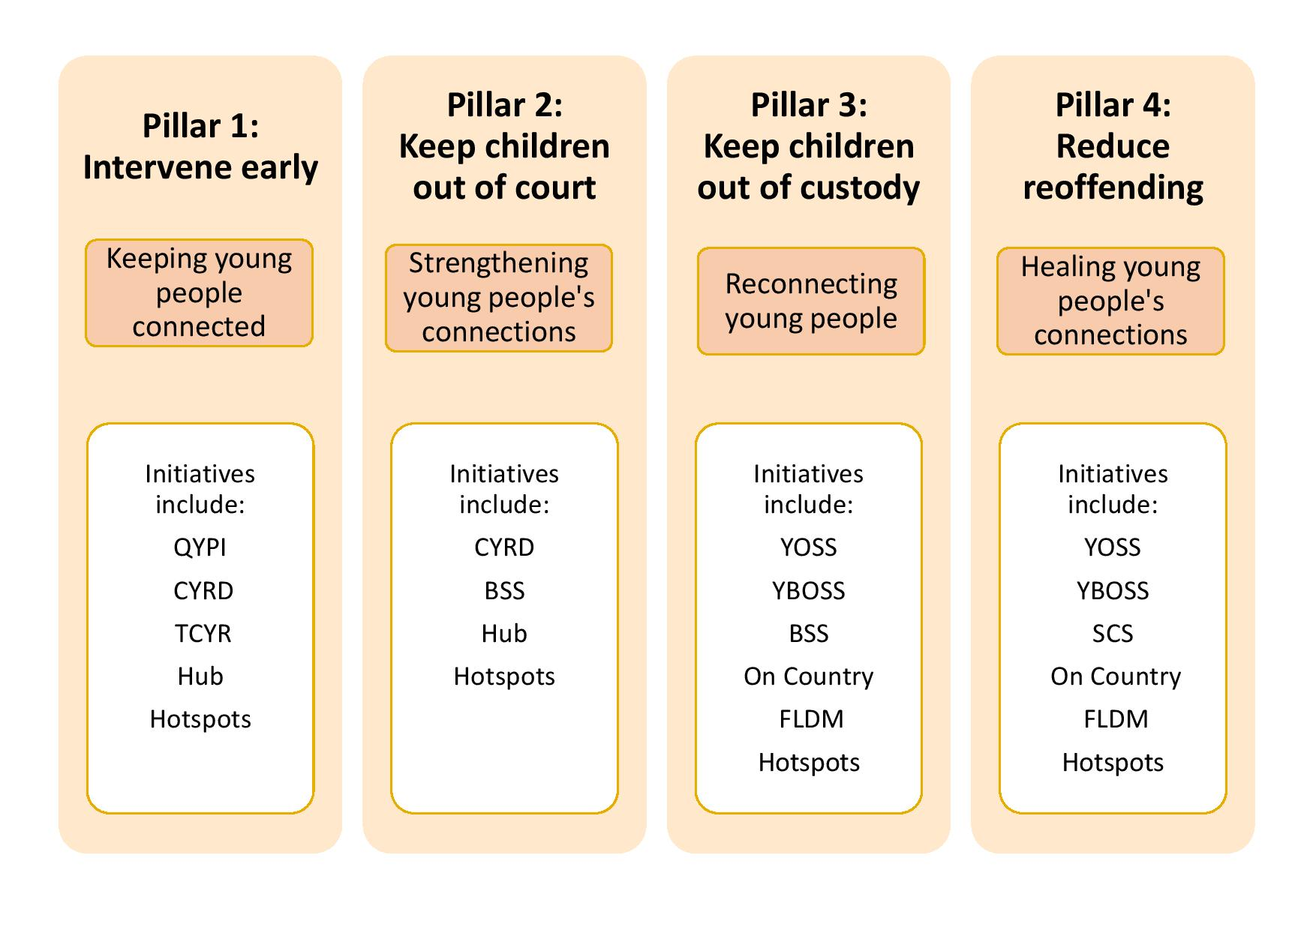
Public safety is paramount and community confidence is essential. We know that when young people have strong, positive connections to family, friends and community and positive engagement with education, training and prosocial activities they are less likely to offend – leading to increased community safety and confidence. We invest in a range of integrated, flexible and adaptable services to support connections and engagement, using place-based approaches informed by local community needs and strengths.
With a focus on quality and integrity, we are committed to continuous improvement and will regularly review our investment priorities. We value feedback from our partners, our Youth Justice colleagues, young people, families and communities which informs decision-making about investment, program design and service delivery.
4.1 Requirements of all services
Tailored services reflect the diverse gender, developmental age, health and mental health, educational, social, emotional, safety, wellbeing and other needs of children and young people, their families and the community.
There must be a range of appropriately qualified and experienced staff, including strategies to engage Aboriginal and Torres Strait Islander staff.
The department is committed to place-based approaches to creating systemic change by collaborating across the community to work towards shared outcomes - harnessing the vision, resources and opportunities of community. Service providers form collaborative community partnerships, including with specialised service providers, other youth focused agencies, Youth Justice Service Centres, local community groups and relevant local, state and federal government agencies to ensure the best outcome for the young person.
When working with Aboriginal and Torres Strait Islander young people, their families and communities, Service Providers must be familiar with the five elements of the Aboriginal and Torres Strait Islander Child Placement Principle and how they can be applied to supporting young people experiencing vulnerability.
Due to the nature of the services and the vulnerability of the Service User group, each Supplier is expected to comply with the Working with Children (Risk Management Screening) Act 2000.
Service Providers ensure the accurate collection of required data via the use of the provided SRS client information system and the P2i reporting system.
Youth crime, and its impacts on the community, are very topical issues and naturally attract media attention. Suppliers must develop and maintain policies and procedures to address media enquiries and attention which comply with applicable legislation for information sharing (including the Youth Justice Act 1992) and meet departmental requirements. Suppliers must liaise with the department in the preparation and approval of any media statements and other publications.
All agencies working with young people because of their involvement with the youth justice system and/or child safety system need to comply with the confidentiality obligations of the Youth Justice Act 1992 and Child Protection Act 1999. Information exchange about young people should occur in a manner that protects the young person’s right to confidentiality.
4.2 Critical success factors / principles for service delivery
Active efforts and persistent engagement: A range of evidence-based engagement approaches and repeated efforts engage young people in activities and services throughout service provision.
Service capability: Service staff have the skills and experience to engage the most complex and difficult to engage young people and families.
Young people participate in decisions and planning: Young people are enabled to participate in decision-making so services are relevant to their needs. Participation enables young people to develop valuable skills in identifying their needs and what services or activities could help them into the future.
Services and activities are responsive to the needs of a young person: Young people have different levels of need and differing circumstances. Service responses are tailored to the individual needs and strengths of young people.
Evidence based services: Services are based on theory and contemporary evidence about what works to reduce offending behaviour in young people and build on young people’s inherent strengths and where relevant, contribute to achieving targeted behaviour change.
Services connect young people with their family, school, training, culture and community: Young people are assisted to engage in a positive and sustainable way with their families, peers, schools and community networks.

Activities are culturally appropriate and safe: Activities that have a cultural focus are delivered in order of preference by: individuals or organisations from the young person’s community or language group; another Aboriginal person or Torres Strait Islander who is compatible with the young person’s community or language group; another Aboriginal person or Torres Strait Islander who or a non-Indigenous person who is assessed as appropriate, in consultation with key Aboriginal or Torres Strait Islander persons and/or organisations. This principle is also applied when delivering interventions to young people and their families and communities from other culturally and linguistically diverse backgrounds.
Quality, child safe services: Service providers recruit, supervise and support suitably qualified staff with the skills required in a Youth Justice context and Child Safe practices are implemented throughout the organisation.
Service delivery is monitored and evaluated: Services and activities are delivered for the purpose of achieving the desired goals of the young person and the initiative. Service delivery and activities are monitored and data collection reporting on outcome measures is a priority.
Service delivery is flexible and responsive to local needs and emerging issues: Service delivery and activities need to be adapted to suit the needs local communities, while the integrity of the service is maintained. Service providers are integrated and connected to their local community and understand the service mix available to young people and families, including delivering the right services at the right times. This includes after hours responses where needed.

- Service requirements
5.1 Service type: Keeping young people connected
Focus: Intervening early
We will connect children, young people and families to services and supports so they can address their health, wellbeing, safety and education needs. Preventing crime begins with making sure children are born healthy and are brought up safe and well. Prevention and early intervention are the responsibilities of the whole community as well as government. Actions focus on ensuring that when children and families start experiencing problems, they receive help as early as possible.
Young people with a low risk of reoffending should be provided with minimal, “light touch” services because intervening can have counter-productive outcomes through exposing young people to a greater range of risk factors and increasing the potential for future offending. These services are largely focused on diversion.
Diversion services work with police to provide a culturally appropriate, alternative intervention to police charging and/or remanding young people in custody. The priority for diversion services is to be responsive during high risk periods, particularly after hours (including via outreach), in response to requests from police to assist with the de-escalation of a potential arrest and/or to prevent remand.
Target group: Young people coming to the attention of police engaging in high risk behaviours that may result in an arrest.
Features of these services include:
Capacity to immediately respond and engage the target group at known locations or as identified by police or others.
Ability to work collaboratively (e.g. police and other suppliers - where required) to assess situations, the needs of young people and respond appropriately.
Highly skilled staff with the ability to identify and de-escalate high risk behaviours that may be influenced by several factors (e.g., trauma, substance use etc.).
Transport young people to an assessed/identified place of safety.
Engage and collaborate with families and other people of significance to the young person to enable young people’s immediate safety and to focus on reducing at risk behaviour.
Provide updates to Youth Justice, police and other relevant stakeholders on trends and outcomes of the young people’s needs, the support provided to the young person and the follow up required.
Actively collaborate to integrate with existing services and networks to ensure young people are linked to any required ongoing support services to respond to identified need.
Prosocial activities may be incorporated to support the primary focus of the diversion response required by police.
5.2 Service type: Strengthening young people’s connections
Focus: Keeping young people out of court
Where possible, we will divert children from court, ensuring children and young people with early or low-level offending have positive family and community influences, are engaged in education, training and activities, and get support to address their behaviours. There is consistent evidence that many children who offend for the first time will not reoffend and that providing support and diverting them away from court is the most effective and efficient response. These actions provide options for diversion with interventions suitable for children who are at higher risk of offending, including for Aboriginal and Torres Strait Islander children.
When young people have strong, positive connections to family, friends and community and positive engagement with education, training and prosocial activities they are less likely to offend. A range of integrated, flexible and adaptable services support connections and engagement, using place-based approaches informed by local community needs and strengths.
Target group: Young people aged 10 to 17 years at high risk of offending or reoffending (and their families) with a focus on those that are disproportionately represented in the Youth Justice system, particularly Aboriginal and Torres Strait Islander young people.
Features of these services include:
Provide initial and ongoing assessment of young people’s individual needs (e.g. responsive to age, gender, culture etc.) including risk assessment and safety planning as needed.
Assist young people to achieve their goals by providing individual, practical and well-planned assistance focused on the factors that are contributing most to offending behaviour including facilitating positive connections to family, friends and community and their engagement with education, employment and prosocial activities.
Provide practical support including convening case panels with relevant stakeholders to plan, monitor and review case plans at required periodic intervals.
Collaborate with other service providers to support young people to address the identified need and achieve positive outcomes.
Needs based and developmentally appropriate cultural mentoring programs and activities that involve family and kin in forming relationships and have strong links with Aboriginal and Torres Strait Islander Elders, communities and services.
Support young people to meet their bail and order requirements through assertive outreach and service delivery including warm referrals to health and mental health services and facilitated referrals to counselling.
Additional services include working with the young person's carer (parents/kin/other) to include them in the care planning and ensuring they know which appointments the young person is required to attend; practical support to attend appointments including court appearances etc; intensive support, using a trauma informed approach; assistance in locating young people to reduce risk of failure to attend court or other appointments; working with families, significant others and key stakeholders in an appropriate cultural context; supporting young people and families to connect/reconnect to their culture; engaging with a young person’s legal representative.
5.3 Service type: Reconnecting young people
Focus: Keeping young people out of custody
Children and young people who have offended need to have a safe place to live, be supervised and supported to repair harms, address behaviours and reconnect with families and communities. Evidence shows that, for most offenders, detention is not the best way to stop offending behaviour. Where custody is required, the best outcomes are achieved when
pre and post-release therapy are applied to reduce recidivism. Children and young people who have been through detention are at more risk of committing offences when they return to the community.
Target group: Young people who: have had involvement in the youth justice system; have committed or are alleged to have committed an offence; are remanded/at risk of being remanded in custody; are exiting detention and are at risk of reoffending and returning to detention; or are early in their offending career/a sibling of a known offender and are exhibiting offending behaviour and are at high or very high risk of reoffending.
Features of these services include:
A range of strengths-based processes that adhere to a common set of principles and bring children, young people, family, community supports and professionals together to discuss wellbeing concerns, problem solve and plan for future action.
Bail and order support services including support to meet court-based requirements (such as appearances) and support to comply with bail and order conditions (including case management).
A visiting and on-demand service response for Aboriginal and Torres Strait Islander children and young people detained in watchhouses, to promote and prioritise their social, psychological, physical and cultural support needs, personal wellbeing and gender considerations including connections to family and community.
Intensive bail support and community-based co-responder services deliver enhanced access to highly coordinated and intensive active efforts to help young people comply with bail conditions, particularly for high risk and recidivist offenders. This service response is delivered through intervention, diversion, crisis support and immersive case work.
An Aboriginal and Torres Strait Islander community led cultural support response to address young people’s connection to Aboriginal and Torres Strait Islander culture, positive
self-identity, and better living through participating in a program on country (including individualised cultural support and case plans, active efforts to connect young people with education, employment and training supports and integrated partnerships in the young person’s community of origin.
Intensive early intervention programs designed to provide culturally safe intensive family support and case management to young people and their families, to help young people to build their individual capacity and take ownership of their actions.
Link young people to existing education programs in the community and support them to remain engaged by providing behavioural and practical supports. Where there are no appropriate alternative education programs in the community: provide a service to address the young person’s numeracy and literacy development needs and support their engagement to education, or broker the delivery of this element from an education provider, or provide a proposal to the department for consideration that will address the young person’s educational needs.
5.4 Service type: Healing young people’s connections
Focus: Reduce reoffending
To make our communities safer, children and young people who are repeat offenders must receive rehabilitation and support that stops reoffending and enables their successful reintegration with families, culture and communities. The best way to reduce reoffending is by delivering evidence-based interventions that address the risks and needs of each child and are delivered with the right intensity and frequency. These actions ensure that young people access programs to address their offending and personal circumstances, and they are supported to transition back into the community as law-abiding citizens.
Target group: Young people aged 10 to 17 who are repeat offenders and those with high and complex needs; young people who have been cautioned by police/have committed or are alleged to have committed an offence; young people with previous involvement in the youth justice system; young people early in their offending behaviour/a sibling of a known offender and exhibiting offending behaviour; are exiting detention and are at risk of reoffending and returning to detention; young people on a youth justice Alternative Diversion Program and/or Intensive Supervision Order; young people remanded in custody/at risk of being remanded in custody due in part to a lack of positive support in their community and require support to prepare them for release into community; young people granted bail who require support to meet bail conditions and without support are at risk of entering detention.
Features of these services include:
Integrated, needs based, developmentally appropriate and multi-systemic wrap around services for children and young people most likely to reoffend. This includes practical and behavioural support which is personalised and focused.
Assist children and young people with disability, challenging and harmful behaviours, and/or mental health and substance misuse issues, including referral for eligible young people to access National Disability Insurance Scheme (NDIS) packages.
Specialist intervention (therapeutic and rehabilitative) services for adolescent sex offenders who are involved in the youth justice system.
Holistic, intensive and multi-disciplinary alcohol and drug use interventions by staff trained in working through trauma, challenging behaviours and complex needs.
Immersive on country experiences and intensive case work support for Aboriginal and Torres Strait Islander young people.
Intensive family partnerships involve work with young people, families and within community to promote the family and young person’s capacity and motivation to practically meet conditions set by the court, police or youth justice.

- Reporting requirements (data design)
Demographics
Gender, age, ethnicity/cultural identity, geographic area, educational attainment etc.

Diversion services
Number of group activities, services provided to participants and/or instances of support, services provided and activities.

Referral/connection data.

Number of distinct young people receiving a service in the reporting period.

Number of distinct Aboriginal and Torres Strait Islander young people receiving a service in the reporting period.

Case management services
Number of distinct young people receiving a service in the reporting period.

Number of distinct Aboriginal and Torres Strait Islander young people receiving a service in the reporting period.

Number of referrals in:
  - # Accepted;
  - # Not accepted;
      - # No capacity
      - # No consent
      - # Not within scope of contract.

Number of closure assessments showing improvements in support domains:
  - Initial/current situation assessment;
  - Closure assessment; and
  - Needs met.

Number of cases with a positive change in:
  - # Family connections;
  - # Education/training connections;
  - # Employment connections;
  - # Cultural connections;
  - # Health/mental health connections;
  - # Prosocial connections; and
  - # Accommodation support and connections.

Transition/closure plan:
  - Needs met – no further support required; and
  - Transition to other supports/who (referrals out).

Referral/connection data.

Case studies.

Cohort | Inputs | Activities | Throughputs/Outputs/Measures | Outcomes (short and medium term) | Outcomes (longer term)
Our children and young people:  - are aged 10-17  - are at moderate to high risk of offending and/or recidivism  - have moderate, high, and complex needs | $  Core programs - approx. $5m recurrent  Youth Offender Support Services (IP 3 & 4)  Youth Bail and Offender Support Service (IP 3 & 4)  Specialist Counselling Services (IP 4)  Time Limited Initiatives - approx. $24.6m  Queensland Youth Partnership Initiative (IP 1)  Community Youth Response and Diversion (IP 1 & 2)  Townsville Community Youth Response (IP 1 & 2)  Bail Support Services (IP 2 & 3)  On Country (IP 3 & 4)  Family Led Decision Making (IP 3 & 4)  Transitional Hub (IP 1 & 2)  Cultural Support in Watchhouses (IP 3)  Hot spots – responding to emerging community need (across all IPs)  Resources  Relationships  Families, carers, support people  Elders and community members  Non-government sector  QPS and courts  Other government agencies | Keeping young people connected (IP1)  Pillar 1 - Intervene early  Strengthening young people’s connections (IP2)  Pillar 2 - Keeping young people out of court  Reconnecting young people (IP3)  Pillar 3 - Keeping young people out of custody  Healing young people’s connections (IP4)  Pillar 4 - Reduce reoffending  Measurements include:  - Activities delivered  - Intensity and dosage of activity  - Time spent  - Number of times provided  - Brokerage spend and on what | Diversion services  Number of group activities/services provided to participants and/or instances of support, services provided and activities  Referral/connection data  Number of distinct young people receiving a service in the reporting period  Number of distinct Aboriginal and Torres Strait Islander young people receiving a service in the reporting period  Case management services  Number of distinct young people receiving a service in the reporting period  Number of distinct Aboriginal and Torres Strait Islander young people receiving a service in the reporting period  Number of referrals in  - # Accepted  - # Not accepted  - # No capacity  - # No consent  - # Not within scope of contract  Number of closure assessments showing improvements in support domains  - Initial/current situation assessment  - Closure assessment  - Needs met  Number of cases with a positive change in:  - Family connections  - Education/training connections  - Employment connections  - Cultural connections  - Health/mental health connections  - Prosocial connections  - Accommodation support and connections  Transition/closure plan  - Needs met – no further support required  - Transition to other supports/who (referrals out)  Referral/connection data  Case studies | Children and young people feel safe and have their primary needs met through responding to:  - Attitudes/orientation  - Personality/behaviour  - Leisure/recreation  - Substance abuse  - Peer relations  - Family/parenting  - Education/training  - Employment  - Disability, focus and attention needs  - Mental health/trauma  - DFV  - Culture  - Gender identity  - Housing  - General health/wellbeing | A decrease in:  - youth offending  - youth reoffending  - young people in court  - young people in custody (frequency and duration).
 |  |  |  | Children and young people exhibit:  - an increase in prosocial behaviour and attitudes  - improved compliance with / successful completion of orders  - improved positive cultural connections  - improved relationships with family, kin and community | Increased community confidence in the youth justice system
 |  |  |  | Children, young people and their families are connected to and engaged with other appropriate services (e.g., health, housing, education, learning/training, employment) | A decrease in reported concerns about community safety and the impacts of youth crime
 |  |  |  | Aboriginal and Torres Strait Islander children and young people have strengthened connections to family, community and country | Programs contribute to reduced disproportionate representation of Aboriginal and Torres Strait Islander children and young people in the youth justice system
IP = Investment Priority
- Expected outcomes from our investment
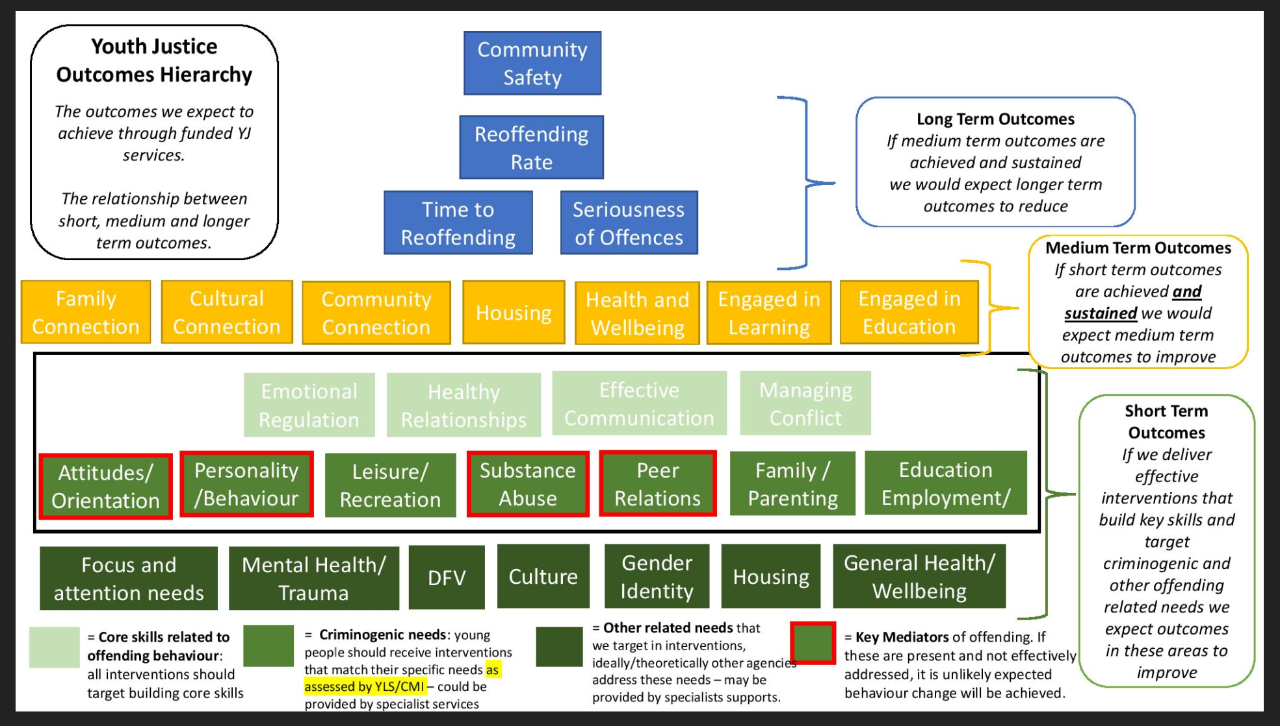

Date of approval: xx July 2021
Date to be reviewed: xx July 2022

Office: YJ Commissioning & Investment
Help Contact: yjcommissioning@youthjustice.qld.gov.au

Links:
Youth Justice Strategy
Our Way Strategy and Action Plan
Queensland Procurement Policy
Queensland Indigenous Procurement Policy

Source: https://www.cyjma.qld.gov.au/resources/dcsyw/youth-justice/resources/yj-pocket-stats-2019-20.pdf

