Child and Family Services
Our objective
- Enable the safety and wellbeing of children and young people, especially those in or leaving care.

Our strategy
We will work with parents, families and communities to support loving homes and enable children, especially children in care, to be safe, loved and thriving.

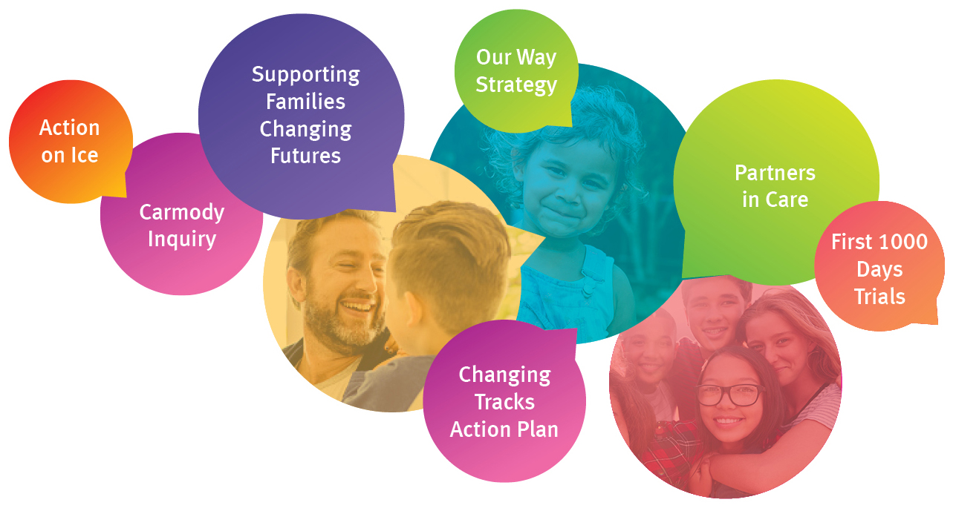
Our performance indicators
- Reduce child abuse and neglect.
- Improve outcomes for, and wellbeing of children in, or at risk of entering the child protection system.
- Reduce the disproportionate representation of Aboriginal and Torres Strait Islander children in the child protection system.

Our achievements
- Facilitated the continued implementation of the Supporting Families Changing Futures reform program in collaboration with other agencies.
- Continued to embed the strengths based, safety oriented child protection practice framework.
- Delivered high-quality statutory child protection services.
- Progressed the Our Way strategy and Changing Tracks action plan to reduce the disproportionate representation of Aboriginal and Torres Strait children and families in the child protection system and improve life outcomes for Aboriginal and Torres Strait Islander children and families.
- Funded and supported family based and non-family based care and transition services.
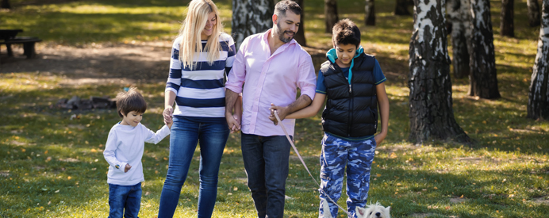
Child Safety reforms
The Queensland Child Protection Commission of Inquiry (Carmody Inquiry) and subsequent Government responses set out an ambitious 10 year roadmap for reform of the state’s child protection system.
Substantial progress has been made in the first five years of reform which have focused on building a system to support families earlier and to restore and improve the child protection system.
Building a strong continuum of care, from early intervention to tertiary support has been a priority. Frontline services have been restored and boosted through additional funding and positions and related strategies to address the ongoing demand for services.
More services including Family and Child Connect Services, Intensive Family Support Services, Aboriginal and Torres Strait Islander Family Wellbeing Services and Assessment and Service Connect, have been established to support families earlier when experiencing risk and vulnerability.
The release of Supporting Families Changing Futures 2019-23 in July 2019 marked the halfway point in the ten year reform plan arising from the Carmody report in 2013. The strategy builds on what has been achieved to date and outlines the key priorities and actions over the next five years.
Transition to adulthood and extending foster carer allowance
All young people need support, especially when moving out of home – even more so for young people exiting care.
Education, training, employment and housing are key areas young people have to navigate and prove even more difficult for young people with a care experience who may not have the support of a significant person in their life.
The department is committed to doing more to support these young people in their transition to adulthood and funds Transition to Adulthood initiatives including Next Step After Care to support young people transitioning or who have transitioned from care.
The Specialist Services Team provides direct ‘hands on’ support for young people transitioning from care who have complex and extreme behavioural, psychological, emotional, disability and mental health needs and who are most at risk of homelessness.
When there are outstanding case plan goals that have not been met when a young person reaches 18 years of age, and they wish to receive ongoing casework support from the department, support can be provided through a support service case. A support plan is developed in consultation with the young person and reflects remaining goals needing to be completed from the young person’s transition to adulthood plan.
In 2018-19, the department announced extending the foster and kinship allowance to support the change in eligibility as a result of the introduction of Prep into Queensland, ensuring young people can remain with their carers regardless of their education status, until they turn 19 years of age.
More support for Indigenous families is paying off
The Our Way strategy is a 20 year commitment to close the gap in life outcomes for Aboriginal and Torres Strait Islander children and families and eliminate the disproportionate representation of Aboriginal and Torres Strait Islander children and families in the child protection system by 2037. The Changing Tracks Action Plan 2017-18, developed in partnership with First Nations peoples sets the foundation for change to ensure all Aboriginal and Torres Strait Islander children in Queensland grow up safe and cared for in family, country and culture, is the first phase of the strategy and is showing early positive results.
The proportion of Aboriginal and Torres Strait Islander children in care has stabilised after fourteen consecutive years of increases in Aboriginal and Torres Strait Islander over-representation in the child protection system. A total of $34.4 million per year has been invested to roll out 33 Aboriginal and Torres Strait Islander Family Wellbeing Services across the state, making it easier for families to access the support they need, when they need it.
More than 5,200 Aboriginal and Torres Strait Islander families have been referred to Family Wellbeing Services, which in turn means these families are receiving more support to help make sure they can safely care for their children at home.
Improving experiences for children in care and leaving care
Support for foster and kinship carers has been transitioned to non-government agencies to help ensure carers receive the support they need in their caring role.
A new digital health pathway for children in care has commenced where children have an initial health check within 30 days of entering care and a comprehensive health and development assessment within 90 days.
In addition a trauma based therapeutic framework, Hope and Healing, has been implemented to improve the quality of care provided to children and young people in residential care.
The Next Step After Care service was established to provide services and support for young people as they transition from care to live as independent adults. More than 2,000 young people have accessed Next Step After Care.

Performance scorecard
Service standards and other measures | Notes | 2017-18  Target/Est | 2017-18  Actual | 2018-19  Target/Est | 2018-19  Actual
Child and Family Services¹
Rate of substantiated harm per 1000 children (0-17 years of age) | 2,3,4 | 4.9 | 5.1 | 5.1 | Not available
Rate of children subject to protective orders per 1000 children (0-17 years of age):
- All children | 2,3,4,5 | 8.7 | 8.6 | 8.5 | Not available
- Aboriginal and Torres Strait Islander children |  | 47.6 | 46.6 | 46.0 | Not available
- Non-Indigenous children |  | 5.4 | 5.4 | 5.3 | Not available
Rate of children entering out-of-home care per 1000 children (0-17 years of age):
- All children | 2,3,6 | 2.0 | 2.1 | 2.1 | Not available
- Aboriginal and Torres Strait Islander children |  | 10.3 | 10.5 | 11.1 | Not available
- Non-Indigenous children |  | 1.3 | 1.4 | 1.3 | Not available
Percentage of Aboriginal and Torres Strait Islander children placed with kin, other Indigenous carers or Indigenous residential care services | 7 | 59% | 56% | 59% | Not available
Proportion of children on a care and protection order exiting care after 12 months or more who had 1 or 2 placements | 8 | 38% | 39% | 38% | Not available
Out-of-home expenditure per placement night | 9 | $157 | $184 | $176 | Not available
Notes:
- 2018-19 actual end of year performance results for Child and Family service standards are not available for inclusion in the annual report. This data is expected to be published on the department’s website by October 2019.
- Using a 'rate per 1000’ as the unit of measure allows for changes in population to be taken into account from year to year.
- The Department of Child Safety, Youth and Women is the lead agency for child protection and is responsible for coordinating actions to reduce the rate of children in the tertiary child protection system. Action by other government agencies and non-government agencies to support vulnerable families earlier will contribute to reducing these rates over time.
- This service standard is a partial indicator of effectiveness in protecting children and assisting families to protect and care for their children outside of the statutory system.
- Historical data shows an upward trend in the rate per 1000 children subject to protective orders, in particular court assessment orders which are used to provide the authority for a number of actions that allow for the completion of an investigation. It is anticipated that the rate will increase slightly in 2019-20, stabilise thereafter and then decrease in the long term through the implementation of the series of initiatives as part of the child and family reforms and the Our Way strategy and its Changing Tracks Action Plan.
- To date, the child and family reform program has been successful in moderating demand growth on the child protection system, including the number of children entering care, despite the increasing complexity of families coming to Child Safety's attention. Achieving a reduction in the rate of children entering out-of-home care is expected to occur over several years.
- The service standard reports the placement outcomes of Aboriginal and Torres Strait Islander children. When an Aboriginal and/or Torres Strait Islander child needs to be placed in care, the department seeks to maintain a placement with kin, Indigenous carers or Indigenous residential care services.
- The department seeks to provide stable environments for all children in care. Placement stability is influenced by the child or young person’s needs and capacity of the carers. Long term historical data shows a downward trend in the proportion of children on a care and protection order exiting care after 12 months or more who had one or two placements. This reflects, in part, longer periods for which children are in care and the corresponding increased likelihood of multiple placements. This trend is expected to stabilise as child and family reforms take effect.
- A key reason for the increase in out-of-home care expenditure per placement night is the increase in children in care with complex needs and challenging behaviours. The department has also increased expenditure to better support young people transitioning from care to adulthood.

