Women, Violence Prevention and Youth Services
Our objectives
- End domestic, family and sexual violence and abuse.
- Enable young people to have a voice and provide opportunities to lead and contribute.
Promote gender equality and provide opportunities for women to lead and contribute.
Our strategies
- We will work with communities and our partners to enable people to recognise, prevent and respond effectively to domestic, family and sexual violence, and ensure the way we work supports people who have experienced violence and holds those responsible to account.
- We will work with communities and our partners to enable young people to have a voice in developing relevant government policies, programs and services and enable young people to have a voice and contribute to the future of their community.
- We will promote gender equality for women and girls, and lead and facilitate projects to support, promote and protect women’s rights, interests, leadership and wellbeing.
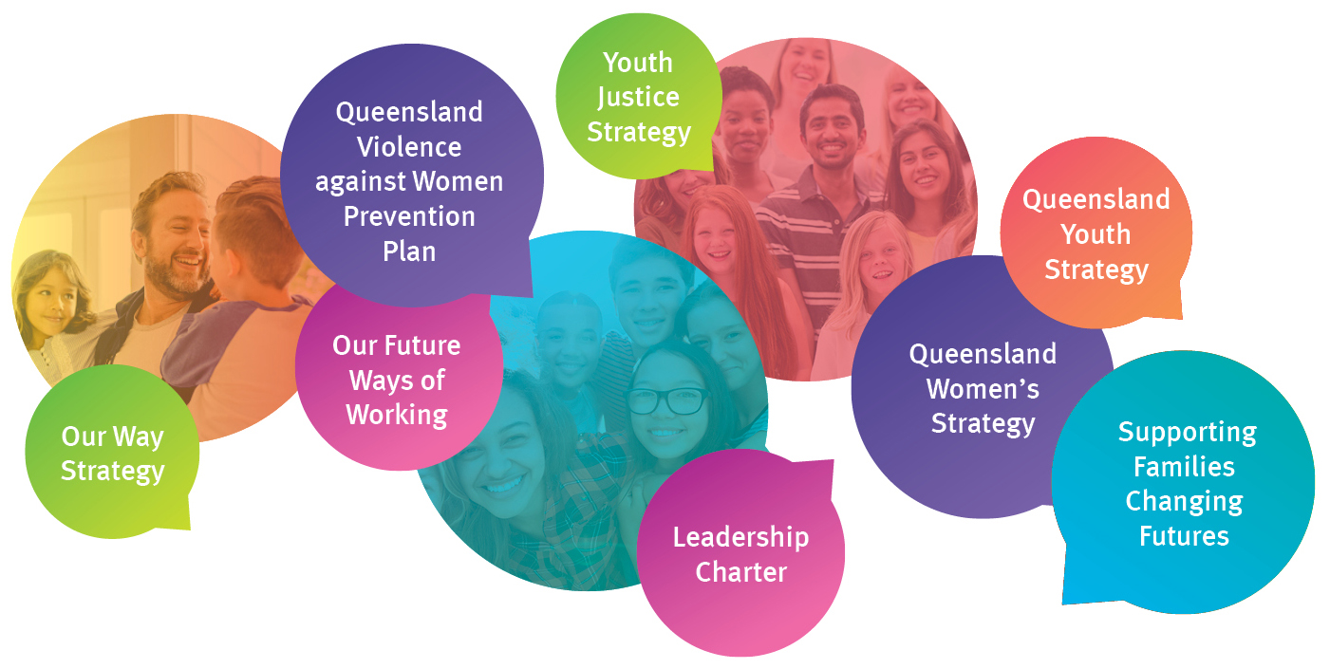
Our performance indicators
- Improve gender equality for women and girls.
- Improve the social, economic and civic participation of young people.
- Reduce the rate of domestic, family and sexual violence.

Our achievements
- Continued to implement relevant actions under the Queensland Domestic and Family Violence Prevention Strategy and the Queensland Violence against Women Prevention Plan.
- Launched Queensland’s Framework for Action – Reshaping our approach to Aboriginal and Torres Strait Islander domestic and family violence and Queensland’s plan to respond to domestic and family violence against people with disability.
- Commissioned additional domestic and family violence and sexual assault services.
- Implemented community inclusion, participation and resilience strategies to benefit women and children.
- Continued to implement the Queensland Youth Strategy across government to support young people to achieve their full potential.
- Continued to implement the Queensland Women’s Strategy across government and community to achieve gender equality in Queensland.

Preventing domestic and family violence
The department focused on contributing to preventing and responding to domestic and family violence, including implementing actions in the Queensland Domestic and Family Violence Prevention Strategy and commissioning of additional domestic and family violence services.The department is committed to investing in contemporary service delivery models that are responsive to the needs of victims of domestic and family violence, including mobile support services that provide specialist case management support to address immediate safety needs.
The department continued to respond to a number of the recommendations of the Not Now, Not Ever report and implemented the Queensland Domestic and Family Violence Prevention Strategy. DFV Implementation Council data indicates that systems are now stronger, services are more responsive and community attitudes towards domestic and family violence are changing.
The department recognises the need to place a greater focus on meeting the needs of Queenslanders disproportionately more likely to experience domestic and family violence or who face additional barriers when accessing support. This will be achieved through the implementation of initiatives such as Queensland’s Framework for Action – Reshaping our approach to Aboriginal and Torres Strait Islander domestic and family violence, and Queensland’s plan to respond to domestic and family violence against people with disability.
The department will continue to contribute to the implementation of the Queensland Domestic and Family Violence Prevention strategy, Queensland’s Framework for Action – Reshaping our approach to Aboriginal and Torres Strait Islander domestic and family violence, and the Action Plan for Queenslanders with disability who experience domestic and family violence.
Fighting sexual violence in Queensland
Enhanced services, as a result of recommendations from the Queensland Violence against Women Prevention Plan and the Youth Sexual Violence and Abuse (YSVA) Steering committee Final Report are tackling the complex and entrenched issues of sexual violence in Queensland’s communities. A holistic approach to combating sexual violence is being undertaken by the department with significantly increased funding for sexual assault services that target young people experiencing sexual harm and supporting early intervention responses to support young people exhibiting reactive or problematic sexual behaviours.
Since the release of the Final Report the department has completed and advanced a number of recommendations including the commissioning of additional youth sexual violence services; extending Respectful Relationships education in schools and tackling cyberbullying.
Sexual abuse counselling services to provide counselling and support to children and young people in the child protection system is also being provided.

Providing Support for Young Queenslanders
The department is committed to assisting young people at risk and experiencing challenges who need support. Youth support and case management services provide one-on-one support and assistance, including referrals for young people who need additional or specialised help. Enhancements to the youth support model during 2018-19 included extending the date range to include eight to 21 year olds and streamlining processes.
The department is the lead agency in the continued implementation of, and engagement of stakeholders for, the Queensland Youth Strategy, which sets the government’s vision for young people to be active participants in Queensland’s economic, civic and cultural life.
Promoting gender equality and women’s wellbeing
The department has continued to deliver the Women on Boards initiative aimed at increasing the number of women on boards in the public, private and not-for-profit sectors. Research has shown that diversity of gender on boards provides financial, performance and social benefits. As an illustration of the initiative’s success the number of women members of Queensland Government bodies increased to 49 per cent as at 30 June 2019 compared to 31 per cent in July 2015. This result is well on track to meet the objective of parity by 2020. The department has 79 per cent women on its government bodies and its Executive Board comprises 50 per cent women.
The department has continued to engage Queenslanders in achieving gender equality and respect for women and girls in 2018-19. It will enable women’s leadership and participation, and engage with agencies and the community to continue implementation of the Queensland Women’s Strategy across its priority areas; leadership and participation; economic security; safety; and health and wellbeing.
Royal Commission into Institutional Response to Child Sexual Abuse
The department has lead responsibility for 59 of the 189 recommendations that build on 220 earlier recommendations from the Royal Commission into Institutional Response to Child Sexual Abuse final report. Three have been completed and others are underway with the reform agenda to be progressed over five years.
The Queensland Government provisioned approximately $500 million for participation in the National Redress Scheme for Survivors of Institutional Child Sexual Abuse (National Redress Scheme). The National Redress Scheme provides eligible applicants support through a monetary payment, access to counselling and psychological care, and the option to receive a direct personal response from the institution responsible for providing the redress from the State.
In November 2018, we commenced participation in the National Redress Scheme and as at 30 June 2019, 507 requests for information on the scheme had been received. The department has also established and provides secretariat support for the Truth, Healing and Reconciliation Taskforce. The Taskforce enables the voices of people who experienced institutional child sexual abuse, and their supporters to remain central to our implementation of the Royal Commission’s proposed reforms.

Performance scorecard
Service standards and other measures | Notes | 2017-18  Target/Est | 2017-18  Actual | 2018-19  Target/Est | 2018-19  Actual
Women, Violence Prevention and Youth Services¹
Percentage of women appointed to Queensland Government Boards | 1 | 50% | 47.5% | 50% | 52%
Number of domestic and family violence counselling service users with cases closed/finalised as a result of the majority of identified needs being met | 2 | - | 28,040 | 26,000 | 21,915
Percentage of youth receiving Youth Support services whose majority of needs have been met | 3 | - | 57% | 57% | 58%
Average cost per hour of counselling services for people affected by domestic and family violence | 4 | - | - | $120 | $117.82
Average cost per hour of Youth Support service delivery | 5 | $145 | $122 | $122 | $122
Notes:
- This is a whole-of-government measure monitoring progress for achieving gender equity targets for boards of management approved by the Queensland Government. Gender diversity is recognised as a key determinant in productivity and the provision of better services.
The measure refers to all significant appointments made in the financial year on all Queensland Government bodies on the Queensland Register of Appointees other than those ‘out of scope’ government bodies and positions. The following are considered ‘out of scope’ (i) Bodies established to meet inter-jurisdictional agreements (ii) Full-time or part-time statutory office holders (iii) Courts and tribunals, and (iv) Government and non-government ex-officio positions.
- The Domestic and Family Violence service users who have their case plans closed/finalised at a time in which it is assessed that the majority of identified needs have been met. Needs are considered met when the client has achieved the goals that have been identified in their case plan. These needs may include (i) increased understanding of the impact of domestic and family violence (ii) understanding where the responsibility for violent behaviour sits (iii) how to use the safety plan to reduce risk (iv) being aware of available resources and how to access help/support (v) a professional assessment of reduced risk of domestic and family violence occurring.
Based upon the individual’s needs a service user can have a case closed more than once over the reference period. The count of cases does not therefore equal the number of unique individuals to receive services. All data is reported to the department by service providers as part of their service agreement requirements.
In 2018-19, this was a new measure. During the year, a small number of large high-volume providers have implemented new client management systems that more accurately capture the work undertaken with clients and their situation at case closure. This has a seen a reduction in the number of case plans closed/finalised with the majority of identified needs met. As a result, targets for 2019-20 for this measure have been reduced to 20,000. Data quality will improve as providers implement similar initiatives.

- This measures the percentage of Youth Support program, Support and Case Management service users who had their case plans closed/finalised as a result of majority of needs being met. Cases remain open during the period of time clients are receiving services until the majority of needs are deemed to have been met. Needs are considered met when the young person has self-assessed they have achieved the goals that they have identified in their case plan. These needs may include stable housing/accommodation, employment, engagement with education, re-connection with family, drug and alcohol support, mental health support and domestic and family violence support.
- This measure is calculated by dividing the total amount of funding provided by the department to service providers by the total amount of counselling hours reported by funded organisations. The average cost of services is determined by factors such as the volume and mix of service types, the location of services being delivered (e.g. urban, regional, remote) and geographical coverage (e.g. place-based or multiple locations). The average cost per hour has been calculated on established funding arrangements..
- This measure is calculated by dividing the total amount of funding provided by the department to funded service providers by the total amount of service delivery hours reported across funded service types. Service types are (i) Information Advice and Referral (ii) Support and Case Management. The average cost of services is determined by factors such as the volume and mix of service types, the location of services being delivered (e.g. urban, regional, remote) and geographical coverage (e.g. place-based or multiple locations). The average cost per hour has been calculated on established funding arrangements.

