Queensland Government third annual progress report Royal Commission into Institutional Responses to Child Sexual Abuse
December 2020

Copyright
This publication is protected by the Copyright Act 1968.
© State of Queensland 2021.
Licence
This work is licensed by the Department of the Premier and Cabinet under a Creative Commons Attribution (CC BY)
4.0 International licence. To view a copy of this licence, visit: https://creativecommons.org/licenses/by/4.0/
You are free to copy, communicate and adapt this publication, as long as you attribute appropriately, including:
- The name of the publication “Queensland Government third annual progress report Royal Commission into Institutional Responses to Child Sexual Abuse”
- A link to the work if you have sourced it online
- The copyright licence statement above
- Indicate if you have made changes to the work.

Contents
Message from the Minister 2
Overview 4
Our approach to implementation 5
Snapshot of 2020 progress 7
2020 Update from the Truth, Healing and Reconciliation Taskforce 9
Theme 1: Prevention and growing safer organisations 11
2020 Highlights 12
Looking forward 16
Theme 2: Protecting children and young people 17
2020 Highlights 18
Looking forward 22
Theme 3: Healing and support 23
2020 Highlights 24
Looking forward 27
Information about support services 28

Message from the Minister
The Royal Commission into Institutional Responses to Child Sexual Abuse (Royal Commission) was one of the most significant inquiries Australia has ever seen.
It is my privilege to join this journey of reform, alongside the thousands of people with lived experience who continue to courageously speak out about institutional child sexual abuse and push for change.
Child sexual abuse is one of the most confronting issues we can face; as individuals, families, organisations and communities. Child sexual abuse in the institutions in which we entrust the care of our children shakes us to our core.
The COVID-19 pandemic has challenged us in ways we could never have imagined. However, the Queensland Government continued to progress Royal Commission reforms to address the mistakes of the past and make Queensland as safe as possible so our children can thrive. This report outlines our many achievements through 2020.
Creating child safe organisations is one of the most important outcomes from the work of the Royal Commission. Queensland Government agencies are working to incorporate the principles of child safe organisations into their work with children. In 2020, we commenced a major project to further grow child safe organisations by exploring options for oversight and regulation of the Child Safe Standards and a Queensland Reportable Conduct Scheme. We will commence targeted engagement with stakeholders to inform possible options in early 2021.
We have made changes to our laws to better protect children and young people including introducing new criminal offences for failing to report child sexual abuse and failing to protect a child from institutional child sexual abuse. We have also changed our laws to better recognise the nature of child sexual abuse such as extending grooming offences to a child’s family or carer and addressing sentencing issues.
The Royal Commission noted that Aboriginal and Torres Strait Islander children and young people are safest when connected to their families, communities and culture. In May, we released Changing Tracks 2020-2022 which continues our commitment to eliminate the disproportionate representation of Aboriginal and Torres Strait Islander children and young people in the child protection system by 2037.
We have more to do to support people with lived experience heal from institutional child sexual abuse. We made a $1.5 million investment in trauma-informed training for police and commenced work on a pilot intermediary scheme to help vulnerable witnesses provide evidence in court.

We remain committed to encouraging all relevant Queensland non-government institutions to join the National Redress Scheme to ensure as many eligible Queenslanders as possible can access the recognition they deserve. During 2020, we continued to engage with
the Federal Government to promote operational improvements to the Scheme. We have boosted funding for specialist support services and non-government and government agencies alike are embracing principles of trauma-informed care.
Queensland’s Truth, Healing and Reconciliation Taskforce, chaired by Mr Robert (Bob) Atkinson AO APM, continues to provide invaluable advice to the Queensland Government as we implement the Royal Commission’s recommendations. Their commitment is unwavering, and I thank each Taskforce member for their service in 2020.
It has been an extraordinary year. We have made significant progress and I look forward to building on our momentum and continuing to work towards the Royal Commission’s vision in 2021.
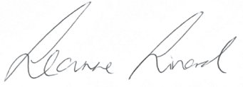

The Honourable Leanne Linard MP
Minister for Children and Youth Justice and Minister for Multicultural Affairs

Overview
Over its five-year inquiry, the Royal Commission into Institutional Responses to Child Sexual Abuse (Royal Commission) heard of the many and systemic failings of institutions to prevent, detect and appropriately respond to child sexual abuse. The Royal Commission made a total of 409 recommendations which weave together a far-reaching and ambitious reform agenda to fundamentally change how we see and respond to institutional child sexual abuse in Australia.
The Royal Commission’s 409 recommendations are contained in four reports:

1. Final Report
December 2017
2. Criminal Justice Report
August 2017
189
recommendations over 17 volumes
85
recommendations
3. Redress and Civil
Litigation Report
September 2015
4. Working With
Children Checks Report
July 2015
99
recommendations
36
recommendations

The Royal Commission’s recommendations are complex, inter-related and encompass all institutions engaging with children and young people. The recommendations call for action from federal, state and territory governments, non government institutions as
well as the broader community. Many recommendations require long-term and sustained work to embed new practices, develop new laws and build new systems of regulation and oversight. Some recommendations aim for national approaches to prevent child sexual abuse and support the healing of people with lived experience.

Our approach to implementation
Of the 409 recommendations made by the Royal Commission, 317 applied to the Queensland Government.
We are now three years into implementing these recommendations and during this time we have developed a deeper understanding of how the Royal Commission’s
recommendations come together into a cohesive reform agenda. While our annual reports will continue to provide the same information of previous years, we are now organising our implementation across three key themes:

Theme 1:
Prevention and growing safer organisations

Theme 2:
Protecting children and young people

Theme 3:
Healing and support

Prevention and growing safer organisations is about doing our best to make sure the mistakes of the past are not repeated by ensuring organisations and the community are better equipped to keep children and young people safe. This includes our work on the National Strategy to Prevent Child Sexual Abuse as well as our focus on growing child safe organisations.
Protecting children and young people includes prevention as well as better detecting and responding to child sexual abuse when it occurs in institutions now. This includes improving reporting and information sharing as well as making our responses to children and young people sensitive to the trauma they have experienced. It also covers enhancements to the criminal justice system recommended by the Royal Commission to better protect children and young people.
Healing and support recognises the profound and ongoing impact of institutional child sexual abuse on people with lived experience. This is about taking responsibility for the mistakes of the past by our participation in the National Redress Scheme and reforms to civil litigation as well as improving how support services and the criminal justice system respond to people with lived experience. Under this theme of healing and support,
we are also tackling the complexities of responding to children who engage in harmful sexual behaviours.

The diagram below further explains how our themes align with the 317 Royal Commission recommendations directed at the Queensland Government.

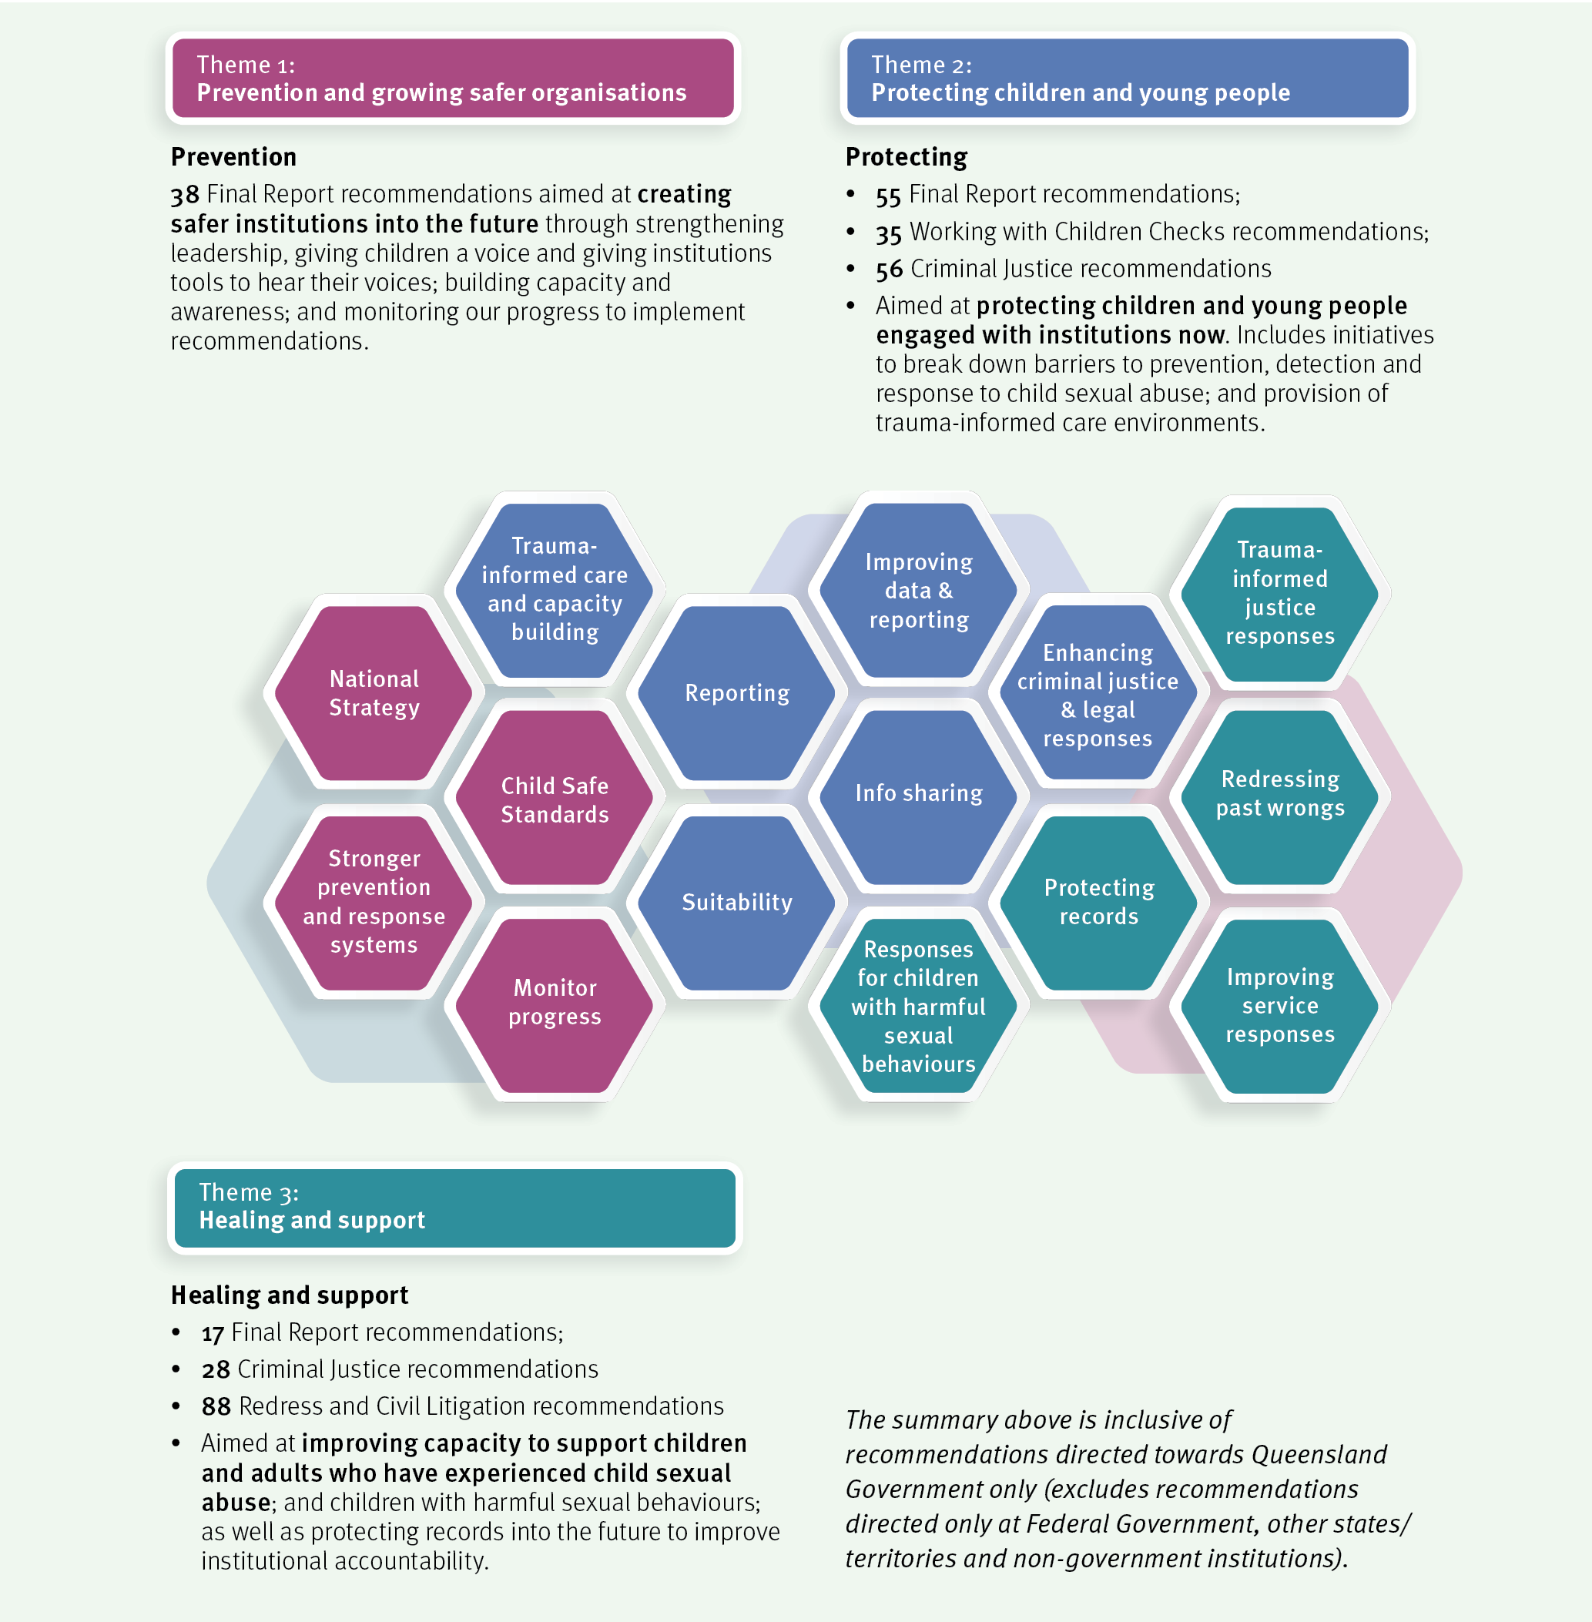

Snapshot of 2020 progress
The Queensland Government has now completed 162 of the 317 recommendations directed to state and territory governments by the Royal Commission. These recommendations are summarised below.

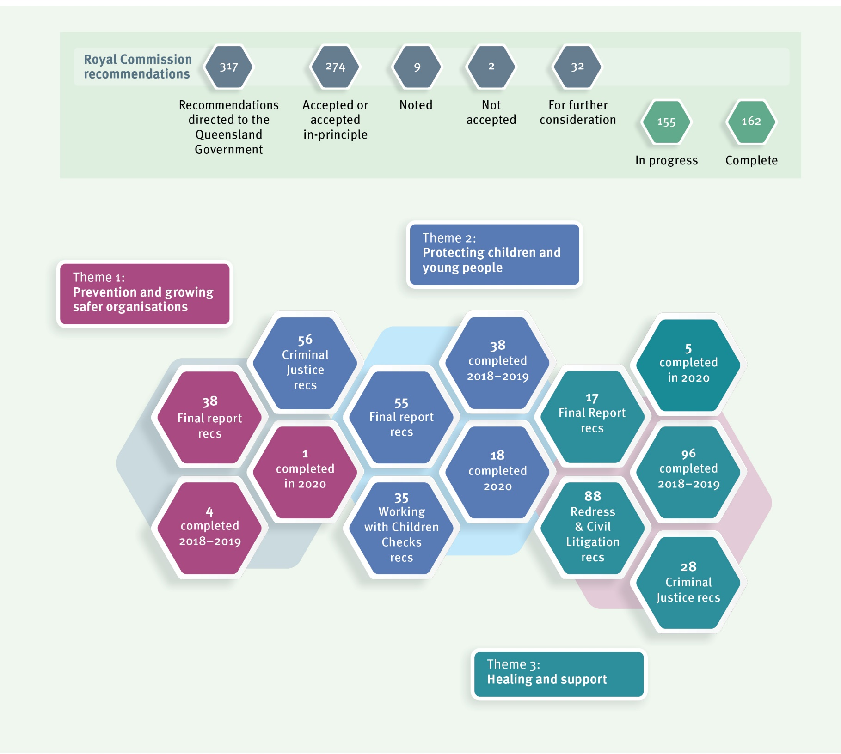155

This report outlines the Queensland Government’s actions over 2020 to contribute to the path set out by the Royal Commission. It builds on the work we progressed over 2018–2019 which is outlined in our previous annual reports. For more information, these reports can be found here: https://www.premiers.qld.gov.au/publications/categories/reports/gov- response-royal-com-child-abuse.aspx
It reflects work from a range of Queensland Government agencies, including the Department of the Premier and Cabinet; Queensland Treasury; the Department of Justice and Attorney-General; Department of Education; Queensland Health; the Queensland Police Service; the Department of Children, Youth Justice and Multicultural Affairs; the Department of Seniors, Disability Services and Aboriginal and Torres Strait Islander Partnerships; and the Department of Communities, Housing and Digital Economy. Some of these departments have recently undergone machinery of-government changes arising
from the 31 October 2020 election, and in this report we will generally refer to them by their current names as at end 2020.
This report also describes our collaborative work with federal and state and territory governments. This includes work through the Community Services Ministers’ meeting, the Education Ministers’ meeting and the Ministers’ Redress Scheme Governance Board. For more information, reports by the Australian Government on national work can be found here: https://www.childabuseroyalcommissionresponse.gov.au/.

The Queensland context
Best practice tells us that we need to continually improve our services and responses to children and young people. In addition to working our way through the Royal Commission’s recommendations, the Queensland Government remains committed to progressing reforms and initiatives that have come from reviews and inquiries that have been conducted here in Queensland.
Many of these Queensland initiatives focus on some of our most vulnerable children and young people — children and young people who are in contact with the child protection and youth justice systems. These reforms include Supporting Families, Changing Futures (flowing from recommendations of the Queensland Child Protection Commission of Inquiry); the Queensland Family and Child Commission (QFCC) reviews of the blue card and foster care systems and the Independent Review of Youth Detention.
Broadly, all these reforms, including the Royal Commission’s recommendations, are aligned towards a shared purpose. Together, they aim to keep Queensland children and young people safe and supported to reach their full potential.
We know that we need to apply the lessons learned from all these reviews and inquiries. To ensure comprehensive and cohesive responses, we have been working to deliver on recommendations in a way that builds on and progresses the shared aims and intent of each review and inquiry.

2020 Update from the Truth, Healing and Reconciliation Taskforce
A key feature of our implementation of the Royal Commission reforms in Queensland is being able to draw on the expertise and lived experience of our Truth, Healing and Reconciliation Taskforce (the Taskforce). The Taskforce, chaired by former Police
Commissioner and Royal Commissioner, Mr Bob Atkinson, AO APM, includes membership of four people with lived experience of institutional child abuse, two representatives of services that support people with lived experience, one representative of out-of-home care providers and one representative of religious institutions. By providing advice to the
Queensland Government on key issues relating to the implementation of Royal Commission reforms, the Taskforce helps to ensure our work is informed by people with lived experience of institutional child abuse here in Queensland.
Key areas of focus for the Taskforce this year have been:

- the National Redress Scheme, including advice to the Department of Children, Youth Justice and Multicultural Affairs on the delivery of direct personal responses and counselling and psychological care
- providing advice on the Queensland Government’s consideration of the Royal Commission’s criminal justice recommendations
- the National Centre for the Prevention of Child Sexual Abuse
- consultation on the next stage of reform to the Child Protection Act 1999 and
- commencing a Listening Tour across Queensland to provide information on the Royal Commission and National Redress Scheme and offer an opportunity for input into the Taskforce’s advice to the Queensland Government.

The Taskforce held seven formal meetings in 2020 as well as its first community forum in Toowoomba, as part of its Listening Tour. It is important to the Taskforce to hear from people with lived experience of institutional child abuse and their supporters as well as organisations delivering services to children, young people and people with lived experience. Although community forums were delayed due to COVID-19, the Taskforce plans to continue the community forums in 2021.

Throughout 2020, the Taskforce continued stakeholder engagement with support services, government agencies and meeting with people with lived experience of institutional child abuse. The Taskforce also presented at several forums and events held by non-government organisations across Queensland to continue its work in raising awareness of the Royal Commission and the impact of institutional child abuse.
In July 2020, the Taskforce progressed a submission to the Royal Commission into Aged Care Quality and Safety. In the submission, the Taskforce explored how the impact of institutional child abuse affects how people experience aged care services and supports.
Looking forward to 2021, the Taskforce remains committed to:

- hosting forums across Queensland
- continuing to provide advice to the Truth, Healing and Reconciliation Grants Program
- connecting with people with lived experience of institutional child abuse
- providing advice to the Queensland Government on the implementation of the Royal Commission recommendations.

Theme 1: Prevention and growing safer organisations

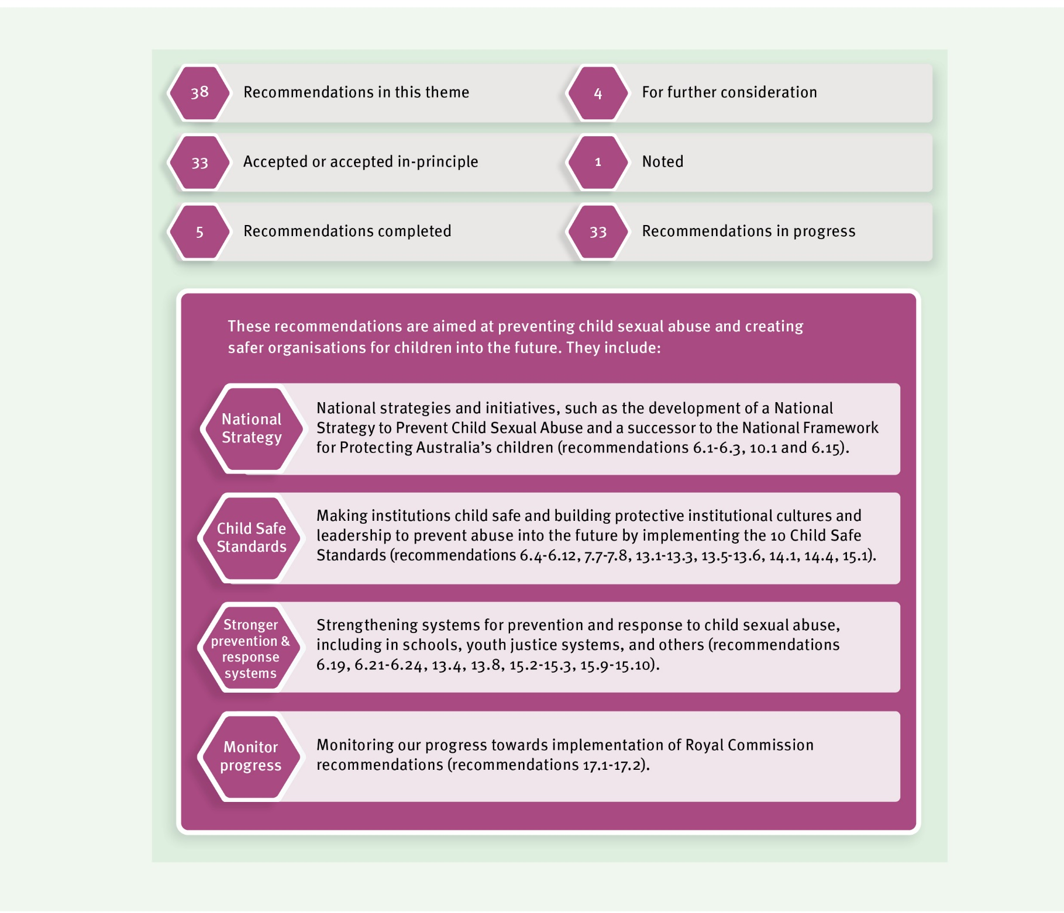

2020 Highlights

Implementing child safe standards
When we talk about ‘child safe standards’ in this report, we are broadly referring to the range of recommendations made by the Royal Commission about child safe standards across Volume 6 and others; alongside the National Principles for Child Safe Organisations (National Principles), which incorporate the 10 standards recommended by the Royal Commission, and were endorsed by the former Council of Australian Governments in 2019.

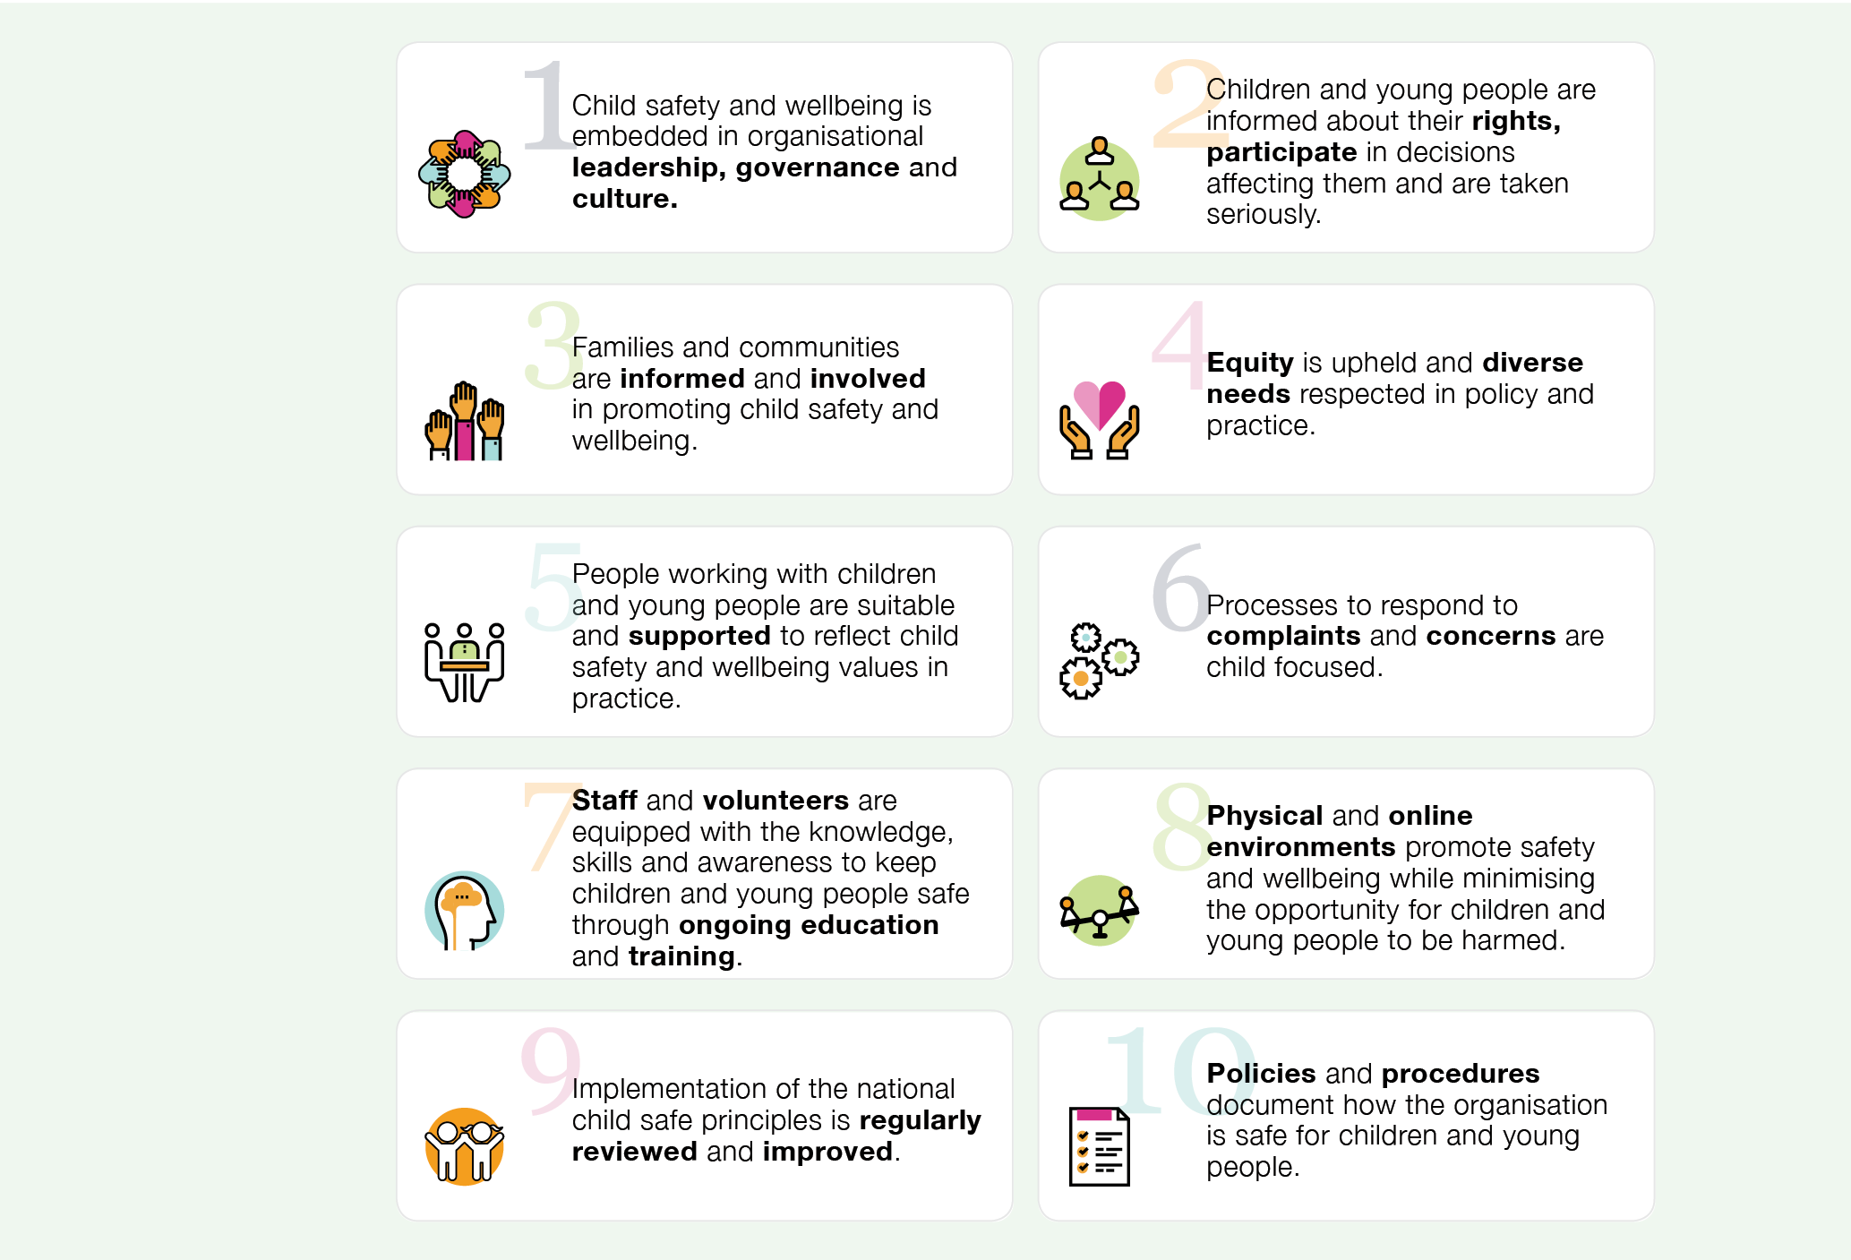

Figure: National Principles for Child Safe Organisations (source: National Office for Child Safety https://childsafety.pmc.gov.au/resources/national-principles-child-safe-organisations-poster)

In our first annual progress report, the Queensland Government accepted the child safe standards as informing best practice for departments that provide services to children. In 2020, departments continued the work of incorporating child safe standards into relevant policies, procedures, practices and cultures and, importantly, identified areas of strength, gaps and key priorities.

Child safe practices in youth detention
Some great progress is being made to promote safety in Queensland Government organisations. The Department of Children, Youth Justice and Multicultural Affairs has completed a full-scale review of youth justice operational policies in line with the Human Rights Act 2019 and the National Principles. This has resulted in a stronger alignment with the National Principles and the establishment of a new quality assurance process Explore, Experiment, Enhance to review and continuously improve the delivery of child safe services and operations.

Promoting the safety of children and young people in our schools and online
In 2020, the Department of Education developed and released the Aware. Protective. Safe. Strategy to strengthen its approach to keeping all children and young people safe from sexual abuse in Queensland schools and early childhood services.
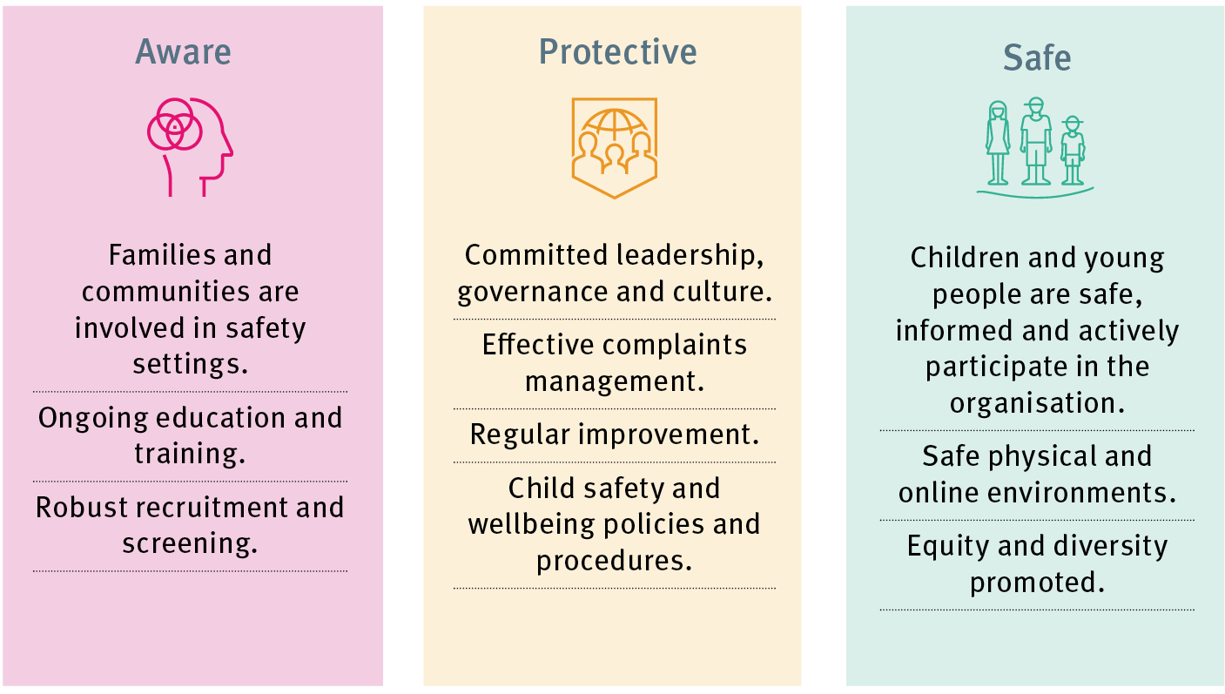

The Aware. Protective. Safe. Strategy reinforces the Department of Education’s commitment to the safety and wellbeing of children and young people. It also identifies how it is building on existing child safe environments by implementing the National Principles. This ensures the Department of Education is best placed to build a long-term and nationally consistent approach to strengthening a culture of awareness, protection and safety for all Queensland children and young people.

The Queensland Government is also committed to ensuring that schools are equipped with the resources they need to appropriately prevent and respond to incidents of online abuse and promote the safety and wellbeing of children in online environments.
Over 2020, the Department of Education has:
  - developed and promoted Online Safety in State Schools that summarises the role of the Department of Education’s Cyber Safety and Reputation Management unit and more broadly, the department’s strategies for keeping students safe online
  - promoted a wide range of resources by the eSafety Commissioner and developed additional learning resources to support student cyber safety including a statewide professional development program for school principals and leadership teams, and an online course for Years 11 and 12 students called ‘Cybersafety — Making positive online choices’
  - provided education sessions for students, staff and parents regarding safe, positive and respectful online behaviours
  - participated in national discussions, including providing input into the review of the Australian Curriculum in the context of online safety education
  - promoted the critical importance of pre-service professional education regarding online safety. In Queensland, nine out of ten universities have confirmed that online safety and anti-bullying prevention education has been included in their pre-service teacher education programs. In collaboration with the Department of Education, the Queensland College of Teachers has now introduced eSafety requirements for program accreditation

Improving regulation and oversight
In late 2020, the Queensland Government commenced two projects to further progress implementation of child safe organisations. The Department of Children, Youth Justice and Multicultural Affairs is considering and developing options for implementation and oversight of child safe standards in Queensland, with the Department of Justice and Attorney-General working on options for a Queensland Reportable Conduct Scheme.
In 2021, both departments will continue to work closely together to ensure coordinated thinking about the possibilities for regulation and oversight in Queensland, and engage with key stakeholders about this work.

National collaboration towards the prevention of child sexual abuse
The Department of Children, Youth Justice and Multicultural Affairs has continued to work with the Federal Government (through the National Office for Child Safety) and state and territory governments on the development of a National Strategy to Prevent Child Sexual Abuse. Noting the Community Services Ministers (CSM) meeting is now time-limited, Ministers will prioritise the development of this strategy over the next
12 months. Implementation of the strategy will be monitored by the Children and Families Secretaries group.

Work has also progressed on ways to promote nationally consistent approaches to the safety of children in organisations through the National Principles, information sharing and incident reporting.
The Queensland Government has participated in a national working group which is supporting progress on the Royal Commission’s recommendations relating to therapeutic responses to children with harmful sexual behaviours. This group’s work includes developing priorities for inclusion in the National Strategy to Prevent Child Sexual Abuse.
While national collaboration was significantly impacted by COVID-19 with members focusing on efforts to respond to emerging issues caused by the pandemic, this work re-commenced in late 2020.

Effective use of technology in youth detention centres and safe physical environments
The Department of Children, Youth Justice and Multicultural Affairs completed the full roll-out of body-worn cameras across Queensland youth detention centres in 2020. This
included staff training, monitoring and commencement of formal review processes. These cameras help ensure that interactions between young people and staff can be better captured, while maintaining privacy and safeguards.
As part of ongoing improvement for the safety of young people within youth detention centres, existing CCTV technology was reviewed and adapted as part of the work to build additional accommodation at the Brisbane Youth Detention Centre. This work is also on track for the new West Moreton Youth Detention Centre.
This is an important element of the Queensland Government’s commitment to continually review, develop and improve the safety of young people within youth detention centres through a range of procedural and physical security measures.

Looking forward
In 2021, the Queensland Government will continue our range of work both nationally and here in Queensland aimed at preventing child sexual abuse and growing child safe organisations. This includes:

  - continuing national work to promote child safe organisations. In addition, our Queensland projects looking at possible options for oversight and regulation of child safe standards and a Queensland Reportable Conduct Scheme will be our key focus over the coming year, including engagement with key stakeholders during the first half of 2021

  - as part of the Department of Education’s ongoing work to deliver the Aware. Protective. Safe. Strategy, we will continue to monitor implementation activities, assess the effectiveness of our actions, and identify further strategies to continually strengthen our approaches

  - finalising reviews of the use of body worn cameras in youth detention centres to inform continued accountability and transparency in the operation of detention centres and

  - continuing our participation in national efforts to prevent child sexual abuse including the development of the National Strategy to Prevent Child Sexual Abuse.

Theme 2: Protecting children and young people

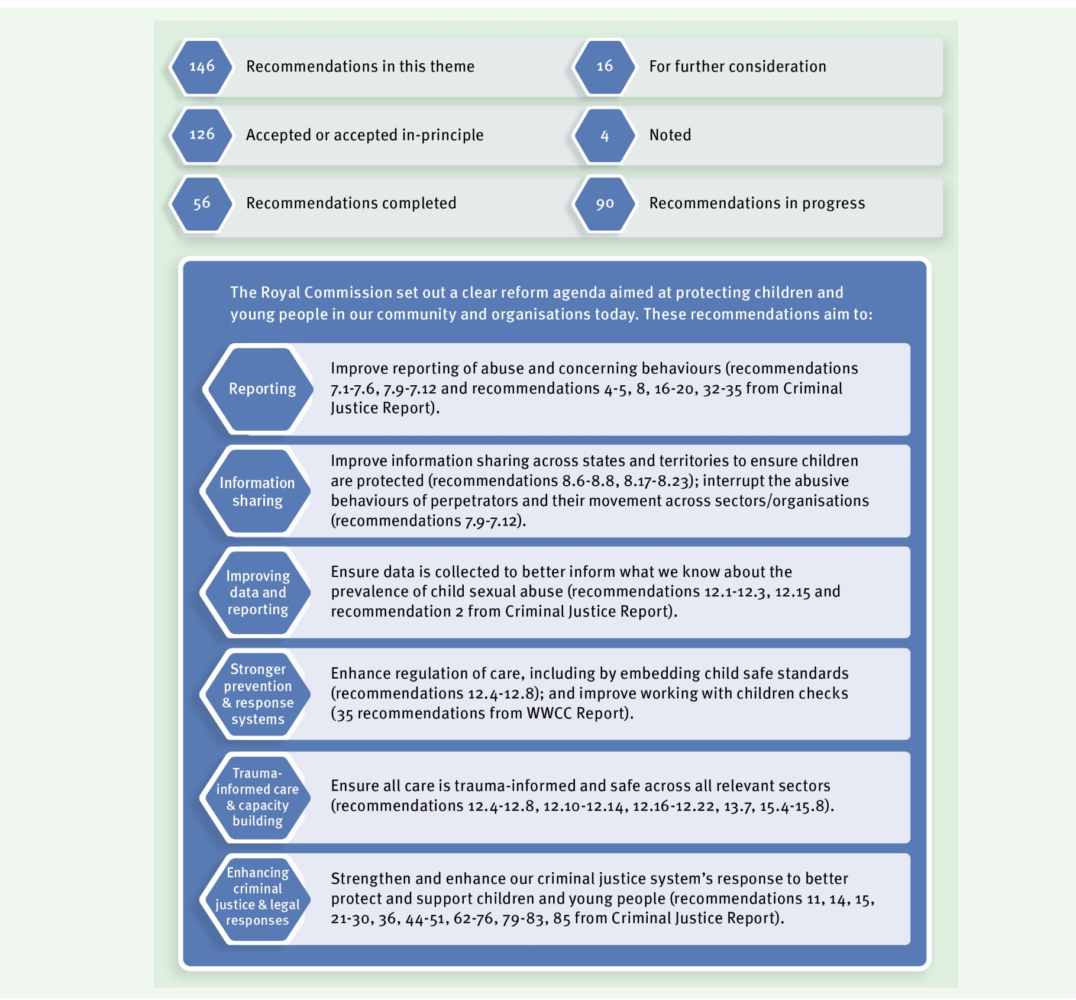

146

2020 Highlights

The Criminal Code (Child Sexual Offences Reform) and Other Legislation Amendment Act 2020
The Queensland Government continues to reform the criminal justice system’s response to child sexual abuse as well as better support people with lived experience. A number of
recommendations from the Criminal Justice Report were implemented by the Criminal Code (Child Sexual Offences Reform) and Other Legislation Amendment Act 2020 (Amendment Act), which was passed by the Queensland Parliament on 8 September 2020.

Failure to report and protect offences
Significantly, in recognition of past failings of individuals and institutions, the Amendment Act creates a new criminal offence relating to a failure to report belief of a child sexual offence. This new offence requires all adults in the community to report child sexual abuse to the police, unless they have a reasonable excuse.
The Amendment Act also creates another offence of failure to protect a child from a child sexual offence. This offence applies in an institutional setting.
The Amendment Act makes it clear that these new offences apply to information or knowledge gained during, or in connection with, a religious confession.
The new offences have not yet commenced and work is ongoing to support effective implementation through a comprehensive communication strategy.

Other changes to enhance criminal justice responses
The Amendment Act also addressed a number of other recommendations in the Royal Commission’s Criminal Justice Report. Queensland laws now:
- provide for retrospective application of the offence of maintaining a sexual relationship with a child under 16 years
- extend application of the offence of grooming a child under 16 years to grooming behaviour directed towards a person who has care of a child
- ensure that an offender’s ‘good character’ cannot be relied upon as a mitigating factor at sentence where that good character has assisted the offender to commit child sexual abuse
- ensure that perpetrators of historical child sexual abuse are sentenced in accordance with today’s sentencing standards rather than those that applied at the time the offence was committed
- modify common law judicial directions and warnings to a jury in relation to delay and forensic disadvantage and
- provide for retrospective application of the removal of limitation periods and immunities on prosecutions for certain child sexual offences.
These amendments commenced on 15 September 2020.

The Amendment Act also includes the legislative framework to support introduction of a pilot intermediary scheme in Queensland to improve special measures for vulnerable witnesses in child sexual offence proceedings.

Commencement of ‘No Card, No Start’ and improvements to the blue card system
Building on reforms that commenced in 2019, which included expanding the list of disqualifying offences under the Working with Children (Risk Management and Screening) Act 2000, the remaining provisions of the Working with Children (Risk Management and Screening) and Other Legislation Amendment Act 2019, including the ‘No Card, No Start’ requirement, commenced on 31 August 2020.
‘No Card, No Start’ means that people now need a blue card before they can start working with children. The changes associated with ‘No Card, No Start’ are designed to strengthen protections for children, streamline blue card processing and empower job seekers. To ensure people are job ready and can commence work as soon as possible, these legislative amendments now allow a person to apply for a blue card prior to starting work and without an existing agreement to work.
To further complement the new ‘No Card, No Start’ laws, the paper-based blue card system has been modernised so that applicants now have the option to apply and pay for their card online. As at 31 December 2020, over 60,000 blue card applications had been
processed online. Additionally, applicants using the online application who did not return any assessable information received their blue card, on average, in less than three business days.

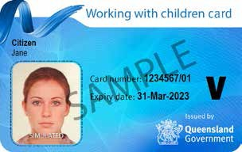

To support the new online system, additional safeguards have been introduced. These include new identity check processes and a redesigned physical card which will, for the first time, contain a photograph of the card holder.
An online portal has also been developed to enable organisations to manage their blue card obligations more effectively. Organisations can now view their linked cardholders and applicants, see a real time status of their application and card status, link new people to their organisation and de-link people who have left. Feedback from organisations using the portal has been extremely positive.

Delivering trauma-informed care
In 2020, the Department of Children, Youth Justice and Multicultural Affairs completed work to implement several recommendations focused on providing trauma-informed care.
The Royal Commission highlighted the importance of supports, training and tools for people who care for children in out-of-home care, particularly to ensure that children and young people can communicate their views and be heard; and that their needs are met in a trauma-informed way. This includes prevention of and appropriate responses to harmful sexual behaviours by children and young people; and disruption of sexual exploitation.
It also includes implementing strategies to increase the likelihood of stable placements.
Residential care services are subject to Minimum Qualification Standards, which include a requirement for employees working with young people to have undertaken e-learning modules under Hope and Healing: Queensland framework for working with children and
young people living in residential care (Hope and Healing). During 2020, practice guidelines complementing Hope and Healing were produced to support residential care workers to respond to situations where police call-out may be necessary, including where
a child or young person has experienced sexual abuse. Hope and Healing also supports safe and stable placements in residential care.
The Department of Children, Youth Justice and Multicultural Affairs has partnered with PeakCare Queensland to adapt Hope and Healing for foster and kinship care services.
Safe and stable placements are also supported by the continued implementation of the placement matching policy and foster carer matching tool, and resources in the Child Safety Practice Manual.
To provide strategic oversight of the significant ongoing practice reform in the Department of Children, Youth Justice and Multicultural Affairs, a new senior executive position, the Chief Practitioner, was established in late 2020.
Trauma-informed care continues to be a priority for youth justice service delivery with ongoing staff training. Restorative practices have been embedded in youth detention policy and procedures, which are supported by ongoing training and Restorative Practice Coordinators in youth detention centres. Speech pathologists work with young people in detention and educate staff regarding cognitive and developmental disability needs.

Supporting Aboriginal and Torres Strait Islander peoples
The Royal Commission heard that Aboriginal and Torres Strait Islander children and young people are safest when they are connected to their families, communities and culture.
In May 2020, the Queensland Government and Family Matters Queensland released Changing Tracks 2020-2022. Changing Tracks reasserts the partnership reflected in the Our Way Strategy between Family Matters Queensland and the Queensland Government. Our target is to close the gap in life outcomes for Aboriginal and Torres Strait Islander children and families and eliminate the disproportionate representation of Aboriginal and Torres Strait Islander children in the child protection system by 2037.

A key action in Changing Tracks 2020-22 is to co-design and implement an Aboriginal and Torres Strait Islander healing strategy to address the impact of intergenerational trauma, grief, loss, violence and abuse.
The Department of Children, Youth Justice and Multicultural Affairs will work with key partners across government and the community to maximise opportunities for implementation of the healing strategy.
Over 2020, the Department of Children, Youth Justice and Multicultural Affairs continued to support the full implementation of the Aboriginal and Torres Strait Islander Child Placement Principle. This includes working with other jurisdictions towards improving national data collection so we can improve our understanding of the application of the principle as well as its outcomes for safely reunifying children and young people in care with their families.

Continued national collaboration to enable better informed child protection practice
Queensland continues to contribute to national data collection to improve what we know about the prevalence and characteristics of child sexual abuse, particularly abuse experienced in out-of-home care. In 2020, the Department of Children, Youth Justice and
Multicultural Affairs provided new data to the Australian Institute of Health and Welfare as part of its 2019-20 Child Protection National Minimum Data Set. This work contributed to efforts to establish national reporting about abuse in out-of-home care as recommended by the Royal Commission.

Improving Working with Children Checks nationally
The Queensland Government continued to participate in a national working group, chaired by the federal Department of Home Affairs, to discuss and progress recommendations from the Working with Children Checks Report. This included work with federal, state
and territory governments on integration with the Working with Children Checks National Reference System. This system will help improve the effective sharing of information across Australia about people who have been prohibited from working with children.

National collaboration against child exploitation
In 2020, the Australian Federal Police and Queensland Police Service together established the Cairns Joint Anti Child Exploitation Team. This team will coordinate investigations and responses to protect against the sexual exploitation of children in Queensland.
Queensland also currently chairs the National Child Protection Working Group (Operation Griffin), which continued work to improve national responses to child sexual abuse.
Operation Griffin is made up of representatives from all state and territory police and the Australian Federal Police.

Expanded ways to report sexual assault
In line with recommendations aimed at encouraging the reporting of child sexual abuse, the Queensland Police Service has developed and launched an online sexual assault reporting form which provides an additional channel for people who have experienced sexual assault to report to police. The online form went live on 25 August 2020 and removes the need to phone police or attend a police station to file a report about sexual assault, should a person not wish to do so. It complements existing reporting processes and has been developed to balance recording requirements with the need to ensure the online reporting option is simple and user-friendly for all. Safeguards have also been established to identify matters that may be urgent and require an immediate response.

Looking forward
In 2021, the Queensland Government will continue our broad work to improve the protection of children and young people including:

- undertaking activities to support implementation of the new offences of failure to report and failure to protect

- building the capacity of staff and partner organisations to respond to child sexual abuse in out-of-home care, led by the Chief Practitioner in the Department of Children, Youth Justice and Multicultural Affairs

- analysing the findings of a youth justice internal review of the speech pathology program to inform future service delivery and maintain a focus on trauma-informed care and related training for staff

- continuing work to improve data collection and reporting to ensure we have a strong evidence base. This includes contributing to the development of the Australian Institute of Health and Welfare’s national reporting about abuse in out-of-home care and continuing to improve the Child Protection National Minimum Data Set into the future by implementing the Department of Children, Youth Justice and Multicultural Affairs’ new information system, Unify

- considering further reforms to the criminal justice system to better protect and support children and young people

- continuing national discussions and progress on implementing recommendations from the Working with Children Checks Report

- following a consultation process in 2019, considering the next stage of reforms to the Child Protection Act 1999 to ensure it provides a contemporary legislative framework for Queensland’s child protection and family support system and

- considering further reforms and improvements to the blue card system.

Theme 3: Healing and support

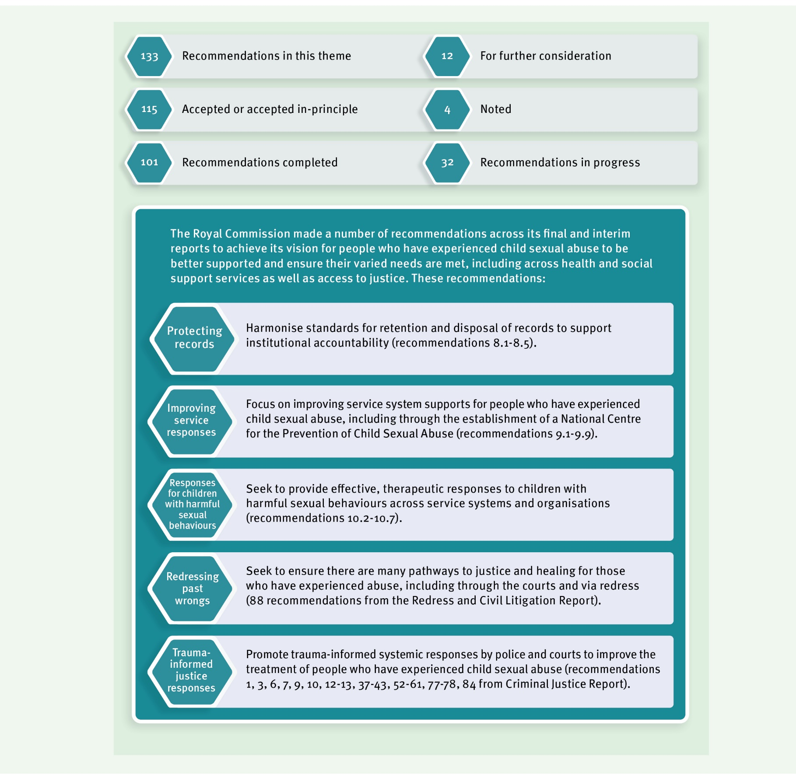

2020 Highlights

Guidelines for creating and keeping records
The Royal Commission found that poor record keeping contributed to the failures of many institutions to identify and respond to child sexual abuse and has exacerbated distress and trauma for many people with lived experience.
In March 2020, the Queensland State Archives published the Guideline on creating and keeping records for the proactive protection of vulnerable persons (the guidelines) and accompanying authorisations for disposal of these records.
The guidelines include a foreword by former Commissioner of the Royal Commission, Mr Robert (Bob) Atkinson AO APM, and deliver on recommendations related to ensuring that appropriate information and guidance is provided about records retention.
The guidelines provide advice for public authorities in making decisions about public records related to interactions with vulnerable persons, including which records to make and keep. The disposal authorisations set the minimum retention period those public records need to be kept. The Queensland State Archives has also led an information webinar and published a suite of accompanying advice to support the guidelines and disposal authorisations, including summary videos and Frequently asked Questions.

Ensuring trauma-informed responses in the criminal justice system
The Royal Commission made a number of recommendations aimed at ensuring that police responses to people with lived experience of child sexual abuse are trauma informed.

Trauma-informed training for police
The Queensland Government has allocated $1.5 million to the Queensland Police Service to develop and roll-out a trauma-informed training package to better focus the police response on the person with lived experience of sexual assault. The University of
Queensland (UQ) is developing this program and with consultation now completed, UQ has progressed work on a comprehensive and integrated police training package.
A team has been established at the Queensland Police Service Academy to support the delivery of this initiative. The project extends over several years and is expected to be completed in 2023.

Better support for witnesses in child sexual abuse criminal cases
As previously mentioned in this report, the legislative framework to support the establishment of a pilot intermediary scheme in courts to improve special measures for vulnerable witnesses was established by the Criminal Code (Child Sexual Offences Reform) and Other Legislation Amendment Act 2020.
Intermediaries are typically speech pathologists, occupational therapists, psychologists and social workers who assist police and the courts to obtain the best evidence

from witnesses with communication difficulties. Intermediaries assess the witness’ communication needs and provide practical advice on the best way to communicate with the witness.
The aim of the pilot intermediary scheme is to ensure better quality evidence for police and courts and to reduce the difficulties and stress experienced by witnesses, including people with lived experience, during the court process.

Participation in the National Redress Scheme
As part of our commitment to ensuring people with lived experience of institutional child sexual abuse have access to justice and healing, the Queensland Government has been participating in the National Redress Scheme for people who have experienced institutional child sexual abuse (National Redress Scheme) since November 2018.
As at 31 December 2020, 1,758 applications had been received which identify a Queensland Government institution as potentially responsible for the abuse. Nationally, over 9,100 applications had been received as at 31 December 2020, with 4,530 payments made, totalling $376.9 million.
During 2020, the Queensland Government worked with the federal government and state and territory governments on ways to improve the operation of the National Redress Scheme, including increasing the participation of non-government institutions. Queensland Government Ministers and agencies conducted engagement activities with funded non-government service providers to encourage them to take responsibility for past wrongs and demonstrate their commitment to the safety of children today by joining the National Redress Scheme.
As a participating institution, the Queensland Government provides the opportunity for direct personal responses to be delivered to redress applicants. During 2020, the training of senior Queensland Government executives to deliver trauma-informed and sensitive direct personal responses has continued.

Sexual violence prevention and support for people with lived experience
In 2019, the Queensland Government released Prevent. Support. Believe. Queensland’s Framework to address Sexual Violence and we have continued our investment in sexual abuse support and prevention services over 2020. As part of our $12 million funding package for priority actions to respond to youth sexual violence and abuse, we have funded three community-led, place-based trials to develop local responses to youth sexual violence and abuse.
These trials began in December 2019 and involve working with young people and communities to co-design and implement projects based on local priorities and needs. The trials focus on prevention, awareness raising, sector capacity building and improving local referral pathways. While COVID-19 impacted some aspects of this work in 2020, community consultation and co-design work has now re-commenced. The trials are being conducted in Toowoomba, Fraser Coast and Yarrabah.

In addition to these three community trials, the $12 million funding package is providing service enhancements to specialist youth, sexual violence and counselling services in five high-need locations across Queensland (Gladstone, Rockhampton, South Burnett, Caboolture and Toowoomba). These services provide trauma-informed counselling for young people who have experienced sexual violence or child sexual abuse and early intervention responses for young people engaging in harmful sexual behaviours. The funding is also supporting training, mentoring, research and evaluation activities to develop a stronger knowledge base around youth sexual violence.
Under the National Partnership Agreement on COVID-19 Domestic and Family Violence Responses, Queensland received a total share of nearly $25.64 million to increase services available for women and families impacted by domestic and family violence. Alongside a range of other initiatives, this funding included $2.7 million for sexual assault services to help services employ additional staff to meet increased demand.
These types of local responses complement our national work to help ensure that services are responsive to the needs of people with lived experience of child sexual abuse. This includes participating in national discussions led by the federal Department of Social Services regarding the design and establishment of a National Centre to raise awareness of the impacts of child sexual abuse, support help-seeking and guide best practice advocacy and support and therapeutic treatment. We are also collaborating with the National Office for Child Safety and state and territory governments on workforce development and
other initiatives to enhance therapeutic responses to children engaging in harmful sexual behaviours. This is occurring via a national working group that is responding to some of the Royal Commission’s recommendations regarding children with harmful sexual behaviours.

Trauma-informed service delivery
The Royal Commission found that recognising people with lived experience and the impacts of child sexual abuse in all relevant human services policy frameworks would better integrate a trauma-informed approach in service delivery. This in turn would help ensure improved service delivery to meet the often complex and multiple needs of people with lived experience.
Relevant human services identified by the Royal Commission in this way include mental health, drug and alcohol, child protection, homelessness, family services, aged care and disability. Overall, programs, strategies, resources and projects that support the
Queensland Government’s delivery of these types of services are aligned with, or already incorporate, principles of trauma-informed care. Some examples include:
- the Department of Communities, Housing and Digital Economy commenced the roll-out the ‘Trauma Informed Care — Delivery Model’ from June 2020 to implement evidence- based, sustainable changes to embed trauma-informed practice within housing service delivery. This forms part of the Queensland Housing Strategy Action Plan 2017–2020
— Service Delivery Transformation

- Hope and Healing: Queensland framework for working with children and young people living in residential care (now being adapted for foster and kinship care)
- a number of Queensland Health service delivery initiatives are informed by principles of trauma-informed care including Queensland Health’s Aboriginal and Torres Strait Islander Mental Health Strategy 2016–21, which supports a range of culturally safe, trauma-informed mental health, alcohol and other drug services for Aboriginal and Torres Strait Islander people and
- the Human Services Quality Framework which suggests trauma-informed practice as a way organisations can meet their obligations to deliver services that respect and value the individual.
The Queensland Government is committed to ongoing consideration of the benefits of trauma-informed approaches for relevant frameworks, policies and programs, as
recommended by the Royal Commission. We will also pursue trauma-informed approaches in relevant policy frameworks and human service delivery nationally, as appropriate.

Looking forward
In 2021, we will continue to build on our progress towards fully realising the Royal Commission’s vision for people with lived experience to be better supported and ensure their varied needs are met including health and social support services as well as access to justice.

- We will commence a pilot witness intermediary program in relation to child sexual offence prosecutions to assist people with communication difficulties to give their best evidence.

- We will continue to ensure continuous improvement of, and access to, specialist sexual abuse counselling services and youth sexual violence and abuse services, including through community-led action plans to address youth sexual violence in
three communities.

- We are working on a comprehensive action plan to support the implementation of
Prevent. Support. Believe. Queensland’s Framework to Address Sexual Violence.

- The Queensland State Archives will continue to look for opportunities to promote across Queensland the Guideline on creating and keeping records for the proactive protection of vulnerable persons as well as disposal authorisations. National work with the National Archives of Australia and Council of Australasian Archives and Records Authorities will continue to ensure a consistent approach to keeping records and to provide guidance.

- We will continue to encourage and support the participation of non-government institutions in the National Redress Scheme to improve and maximise access to redress.

- We will continue our participation in national work to improve the operation of the National Redress Scheme.

Information about support services
We know it can be difficult to read about institutional child sexual abuse. There are support services available to those who need assistance. If immediate assistance is required, 24-hour support is available through:
- Lifeline: 13 11 14
• 1800 Respect: 1800 737 732
- MensLine Australia: 1300 789 978

Lotus Place is a dedicated support service and resource centre for Forgotten Australians and can be contacted via phone on 3347 8500. For more information, please visit the Lotus Place website ( http://www.lotusplace.org.au/).
Free legal advice and information about the justice or redress pathways available to survivors of institutional child sexual abuse can be accessed through knowmore, on 1800 605 762. For more information, please visit the knowmore website (http://knowmore.org.au/).
Further advice and resources for support regarding child sexual abuse can be found online by visiting https://www.qld.gov.au/community/getting-support- health-social-issue/support-victims-abuse/child-abuse/child-sexual-abuse/child- sexual-abuse-help.

