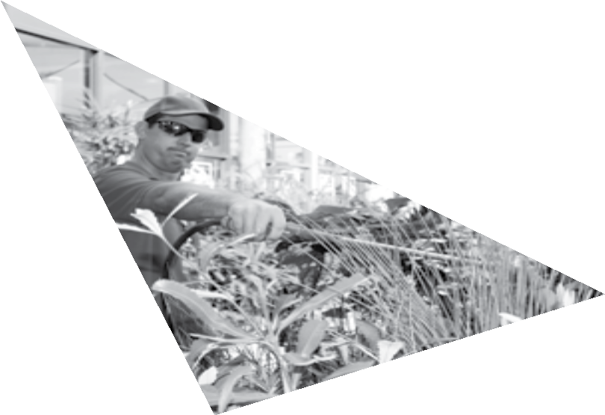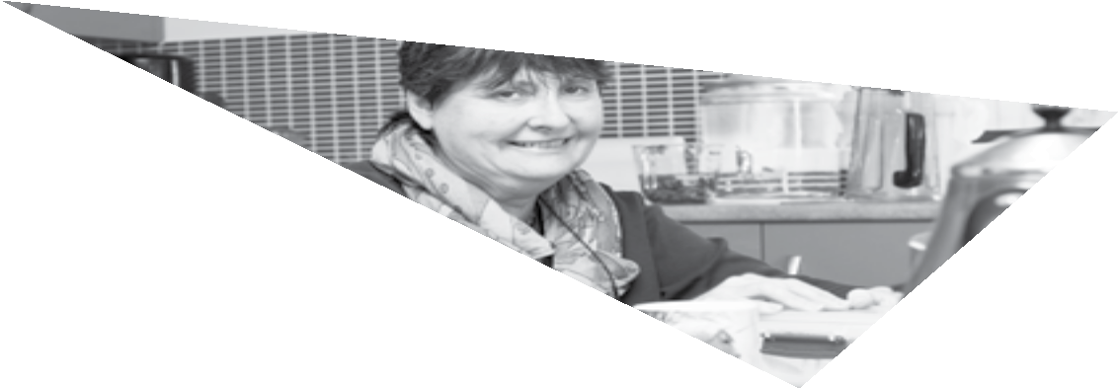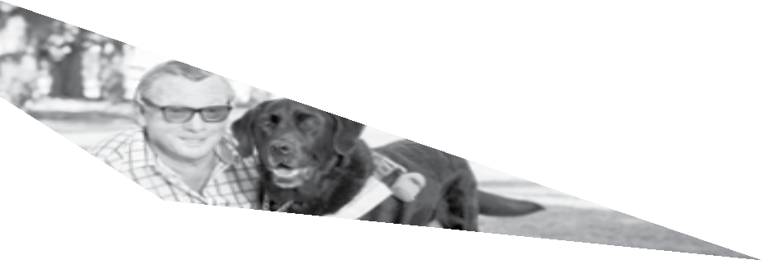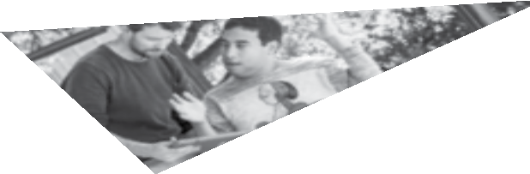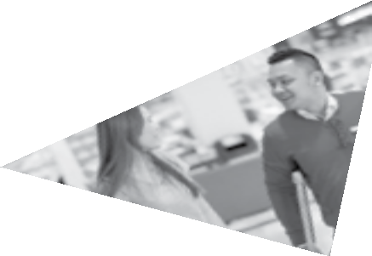

ALL ABILITIES QUEENSLAND: OPPORTUNITIES FOR ALL State disability plan 2017–2020 a

ALL ABILITIES QUEENSLAND: OPPORTUNITIES FOR ALL

State disability plan 2017–2020

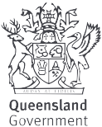

CONTENTS

MINISTER’S MESSAGE 1
INTRODUCTION 2
COMMUNITIES FOR ALL 5
LIFELONG LEARNING 7
EMPLOYMENT 8
EVERYDAY SERVICES 9
LEADERSHIP AND PARTICIPATION 10
INTERNATIONAL, NATIONAL AND STATE CONTEXT FOR
ALL ABILITIES QUEENSLAND: OPPORTUNITIES FOR ALL 11
IMPLEMENTATION AND MONITORING 12

MINISTER’S MESSAGE

All Abilities Queensland: opportunities for all, our new state disability plan, will have far-reaching and positive outcomes both for people with disability across the state —and the whole Queensland community. I am proud to be involved with a plan for a more inclusive Queensland.

This plan will guide actions by the Queensland Government, working in partnership with the Commonwealth Government, local governments, businesses, non -government and community organisations, communities and individuals. Together, we will create a future that enables Queenslanders with disability to have the same access to opportunities as every other Queenslander.

We all have a part to play, and the five priorities of the plan guide us on the kinds of changes that we can make to grow a Queensland in which everybody can thrive and reach their full potential.

I encourage each of us to make the kinds of changes — small and large — that can help build an all abilities Queensland and open up opportunities for all.

I’m pleased that every Queensland Government department has signed up for this quest. By aligning their Disability Service Plans to the priority areas, their actions over the next three years will go a long way to breaking down barriers for people with disability and further improving their access to services.

Also important is that the timeframe for the plan aligns with the transition to the National Disability Insurance Scheme in Queensland as well as the final three years of the National Disability Strategy 2010–2020.

I look forward to working with you in building a more inclusive Queensland — absolutely everybody has a role to play.

Coralee O’Rourke MP
Minister for Disability Services, Minister for Seniors and Minister Assisting the Premier on North Queensland

INTRODUCTION

Queensland is a state full of opportunities. The Queensland Government wants to help build an inclusive Queensland where all Queenslanders, including the one in five Queenslanders who have a disability, can thrive and reach their full potential as equal citizens. A Queensland where people with disability are respected for their abilities and have equal access to opportunities, to contribute and participate in all that Queensland has to offer.

This plan builds on the progress already made in creating more inclusive communities and guides how Queenslanders can work in partnership with the Commonwealth and local governments, the corporate sector, non-government and community organisations, communities, and individuals, to build a more inclusive Queensland.

A plan developed by Queenslanders for Queenslanders

Between August 2016 and April 2017, over 1,000 Queenslanders had their say in shaping this new state disability plan. Over 380 responses were received from delegates at the August 2016 Queensland Disability Conference. More than 540 individuals and organisations made submissions in response to the Towards an all abilities Queensland consultation paper and around 250 people participated in discussions. The plan has been guided by this extensive consultation and we will work together, across the community, to bring it to life throughout Queensland.

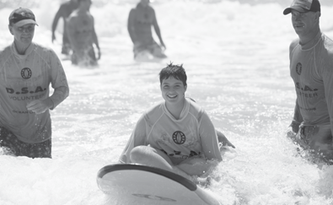

Vision

The plan’s vision is “opportunities for all Queenslanders”. This statement links strongly to consultation feedback and also to the intent of the National Disability Strategy 2010–2020 to create an inclusive society that enables people with disability to fulfil their potential as equal citizens.

In this plan, we commit to building a fairer, more inclusive Queensland where people with disability, their families and carers, are able to access opportunities on the same basis as everyone else. The plan recognises that Queenslanders with disability reflect the diverse community we live in and are individuals with different backgrounds, values, beliefs, experiences, interests, skills and abilities, who live in all parts of our state and are of all ages. The plan will be implemented to achieve outcomes for all Queenslanders with disability, including Aboriginal and Torres Strait Islander peoples and people from culturally and linguistically diverse backgrounds.

Structure of the plan

The plan has five priorities for action to support the achievement of the vision of “opportunities for all Queenslanders”:

- Communities for all

- Lifelong learning

- Employment

- Everyday services

- Leadership and participation.

Through the actions the Queensland Government will take to implement this plan and the collective contributions and activities of our partners, the vision will be brought to life. The plan will also be updated to reflect progress, and new actions added as they are developed.

Timeframe

This plan covers the three-year period from July 2017 to June 2020 and will be implemented through each Queensland Government departments’ disability service plans for the same period. This plan also reflects Queensland’s commitment to implement the National Disability Strategy 2010–2020 and complements the implementation of the National Disability Insurance Scheme (NDIS) in Queensland by breaking down barriers to the participation of people with disability in community life and improving access to the services that everyone needs.

A plan for all Queenslanders

This is a plan for all Queenslanders. Everyone benefits when communities are more inclusive and accessible. All levels of government, private industry and non-government organisations, community groups and individuals have an important part to play in making Queensland a state where everyone has opportunities to fulfil their potential.

What you, our partners, can do

Everyone in our community can take steps to ensure that our businesses, services, communities and neighbourhoods are accessible and responsive to Queenslanders with disability. We have created a new website that includes stories, practical resources, and information which all Queenslanders can draw on to ‘do their bit’ to create equal opportunities for all.

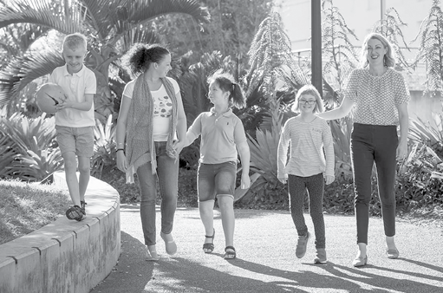

COMMUNITIES FOR ALL

Our goal

People with disability are welcomed, valued and respected members of their communities, and community activities, sports, arts, tourism and recreation are accessible and inclusive of all Queenslanders with disability.

What we will do

The Queensland Government will support communities to be welcoming and inclusive, and enable Queenslanders with disability to participate in the political, economic and social aspects of community life. We will take action to recognise diversity, including Aboriginal and Torres Strait Islander peoples and people from culturally and linguistically diverse backgrounds; promote and uphold rights; and invest in enabling arts, sport and recreation and tourism activities to be more accessible and inclusive.

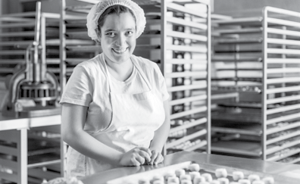

We will work to ensure positive attitudes towards people with disability to open doors to more opportunities by developing and sharing resources to dispel myths and misconceptions, and drive change by enabling business and community groups to create more inclusive cultures. We will promote examples of inclusion and enable people with disability to share their personal experiences to help raise awareness and change community attitudes.

We will also work with partners to improve accessibility of places and spaces and ensure information is accessible and available in multiple formats and languages.

How we will know we are making a difference

We will know we are making a difference as positive attitudes and greater awareness become more widespread in our communities and the rights of people with disability are upheld and promoted. Queenslanders with disability will also be respected for their diversity, individual abilities and contributions, with people experiencing respectful personal and community relationships.

We will also see more places and spaces in our communities that are accessible to all Queenslanders and information will be more widely available in a variety of formats. More welcoming and inclusive communities will also mean more Queenslanders with disability will be able to participate in the cultural, artistic, sports, travel and recreational activities and opportunities they enjoy.

6

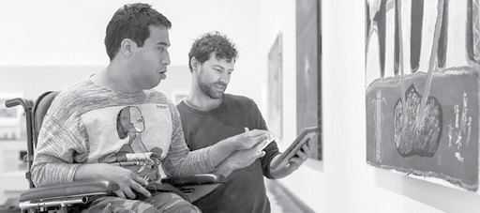

LIFELONG LEARNING

Our goal

Queenslanders with disability have the same opportunities as everyone else to access education and learning across all stages of life.

What we will do

The Queensland Government recognises that inclusive learning opportunities are fundamental to improved opportunities for social and economic participation. We will take action to support students, educators, parents and carers to enable lifelong, inclusive learning opportunities for Queenslanders with disability.

How we will know we are making a difference

We will know we are making a difference when all Queenslanders with disability, regardless of their age, are achieving in the variety of learning opportunities Queensland has on offer as educational services are accessible and responsive to Queenslanders with disability.

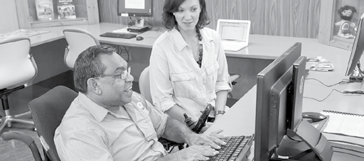

EMPLOYMENT

Our goal

Queenslanders with disability have increased access to employment opportunities.

What we will do

The Queensland Government recognises work is an important contributor to economic security, wellbeing and a way of building social networks. We will take action and work with partners to increase participation in the workforce for people with disability across our state, including increasing the number of people with disability employed in the Queensland public sector.

How we will know we are making a difference

We will know we are making a difference as the proportion of Queenslanders with disability participating in employment increases both within the public and private sectors across Queensland.

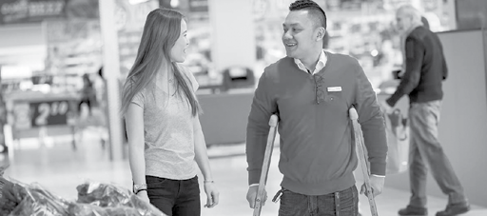

EVERYDAY SERVICES

Our goal

Queenslanders with disability have the same opportunities as everyone else in the community to access services, such as housing, health, transport, disability and community services, and justice and community safety are accessible and responsive to their needs.

What we will do

The Queensland Government recognises the importance of ensuring the services we deliver are accessible and responsive to the needs of all Queenslanders, including Queenslanders with disability. We will work across Queensland Government service agencies to improve accessibility for people with disability to ensure universal services complement the supports eligible people will access through the NDIS.

In implementing the actions, we will work to improve the experience of Aboriginal and Torres Strait Islander peoples with disability, and people with disability from culturally and linguistically diverse backgrounds to access culturally capable supports.

How we will know we are making a difference

We will know we are making a difference when services such as housing, health, transport, disability and community supports, and justice and community safety are accessible and responsive to Queenslanders with disability. This will result in better outcomes for Queenslanders with disability.

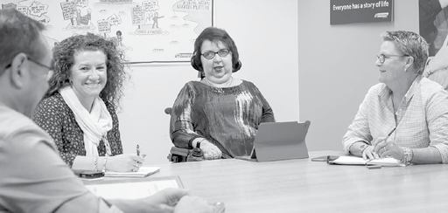

LEADERSHIP AND PARTICIPATION

Our goal

Queenslanders with disability have the same opportunities as everyone else to participate in Queensland’s society and democracy, influence decisions that affect them and take up key roles in public and private organisations.

What we will do

The Queensland Government is committed to ensuring that Queensland does not miss out on the wealth of experience, knowledge and innovative ideas that people with disability can contribute across the broad range of leadership and civic participation opportunities.

We will take the lead in improving consultation and engagement with people with disability and their families and carers in developing Queensland policy and programs. We will also work to promote diversity in leadership and develop and support current leaders and leaders of the future.

How we will know we are making a difference

We will know we are making a difference when more Queenslanders with disability feel able to have their say on important community issues and participate in decision-making processes. We will also see more Queenslanders with disability in leadership and governance positions within our organisations, businesses and communities.

INTERNATIONAL, NATIONAL AND STATE CONTEXT FOR ALL ABILITIES QUEENSLAND:
OPPORTUNITIES FOR ALL

United Nations Convention on the Rights of Persons with Disabilities
NATIONAL
INTERNATIONAL

National Disability Strategy 2010–2020 (NDS)
National Disability Insurance Scheme (NDIS)

1 |  | 2 |  | 3 |  | 4 |  | 5 |  | 6
Inclusive |  | Rights |  | Economic |  | Personal |  | Learning |  | Health and
and |  | protection, |  | security |  | and |  | and skills |  | wellbeing
accessible |  | justice and |  |  |  | community
communities |  | legislation |  |  |  | support

Second Implementation Plan (NDSIP)
Driving Action 2015–2018

Third Implementation Plan Measuring Program 2019–2020 (to be developed)

Objective 1: Supporting the independence and social and economic participation
of people with disability

1
Continued transition of the NDIS

2
Improving employment outcomes for people with disability

3
Improving outcomes for Aboriginal and Torres Strait Islander people with disability

4
Communications activities to promote the intent of the NDS across the community and all sectors

Disability Service Plans 2017–2020 (each Queensland Government agency)
All Abilities Queensland: opportunities for all
(State disability plan 2017–2020)
STATE

NDS: National Disability Strategy
NDSIP: National Disability Strategy Implementation Plan NDIS: National Disability Insurance Scheme
1
Communities for all
(NDS 1,2)
2
Lifelong learning (NDS 3,5)
3
Employment (NDS 3;
NDSIP 2)
4
Everyday services (NDS 1,2,4,6;
NDSIP 1)
5
Leadership and participation (NDS 2,5)

IMPLEMENTATION AND MONITORING

Real progress will be made through collective actions of partners working together. We will continue to work in partnership with Queenslanders with disability, families and carers and our government, business, industry and community partners.

Each priority has been deliberately chosen to contribute to achieving the overarching vision. Each Queensland Government action will be monitored and measured to ensure the plan is on track to reaching its goals and achieving its vision.

An annual progress report on the implementation of the plan and Queensland Government actions will be published and will identify any updates to actions over the life of the plan.

The views of Queenslanders with disability on the progress under the plan will also be sought through engagement with the Queensland and Regional Disability Advisory Councils.

The annual progress reports will also inform Queensland’s contribution to national reporting on the implementation of the National Disability Strategy 2010–2020 in 2018 and 2020.

© The State of Queensland (Department of Communities, Child Safety and Disability Services) 2017

Copyright protects this publication. Excerpts may be reproduced with acknowledgment of the State of Queensland (Department of Communities, Child Safety and Disability Services).

Department of Communities, Child Safety and Disability Services GPO Box 806, Brisbane QLD 4001

www.communities.qld.gov.au

Photos: Peter Waddington except; top left front cover Guide Dogs Queensland; page 3 Andrew Hobbs; page 6 iStock. Artwork: Page 7, Installation view at QAG, 2017. Ginger Riley Munduwalawala / Mara people / Australia NT
1937–2002 / Garimala (The Two Snakes) 1988 / Synthetic polymer paint on canvas / Purchased 1990 with funds from ARCO Coal Australia Inc. through the Queensland Art Gallery Foundation

