Time | Content | Slide
 | Acknowledgement of Country or Welcome to Country
10 mins | Slide 1: Title slide  Facilitator will welcome participants and distribute name tags.  Introduction of Aboriginal or Torres Strait Islander facilitator  Provide information about yourself.  Introduction of participants  Provide a getting-to-know ice breaker activity to enhance participants comfort with the group. A quick ‘introduction only’ option is to ask participants to take turns to provide the following information:  - Their name and the length of time as an approved carer.  - The number of Aboriginal and/or Torres Strait Islander children they are caring for.  - The child or children’s cultural group - Aboriginal, Torres Strait Islander, or both.  - Housekeeping details  - Let participants know the location of toilets; the arrangements for breaks and catering; the arrangements for smokers and phone messages; the evacuation and emergency exits and meeting points as well as any other Workplace Health & Safety requirements.  - Group rules  Facilitator will lead a dialogue with participants regarding what is needed in the workshop environment for them to feel comfortable. From this discussion, list the group rules on a flip chart or butchers paper which can then be displayed in the room for the duration of the session. At a minimum the group rules should include confidentiality; respecting different opinions; punctuality when returning from activities or breaks. | 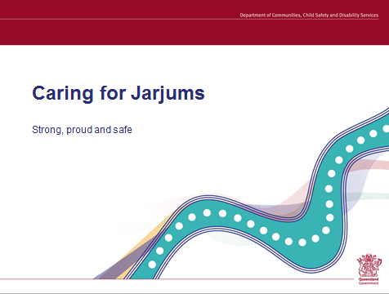
3 mins | Slide 2: Learning outcomes  Explain the purpose of the session is to consider culturally sensitive legislative principles and responsibilities when providing out-of-home care for Aboriginal and Torres Islander children.  Acknowledge that participants will have brought with them different levels of knowledge about, and experience with, Aboriginal and/or Torres Strait people and communities. For some participants, they may have been caring for an Aboriginal or Torres Strait Islander for many years, while others present may be attending the workshop because of a future possibility of providing a placement to an Aboriginal or Torres Strait Islander child.  Read aloud the four learning outcomes from the slide. | 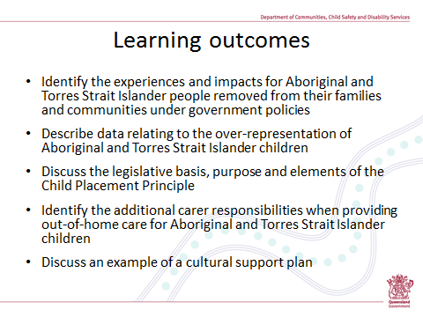
2a  2 mins | Slide 3: Content of session | 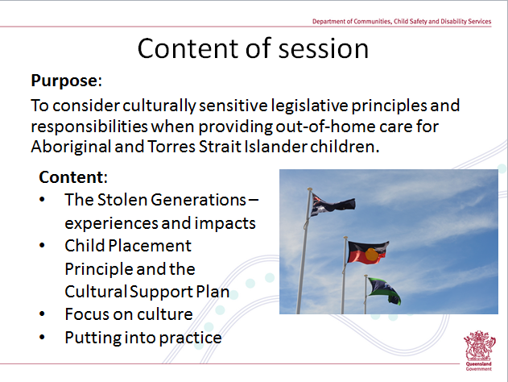
 | Section 1: The stolen generations
10 mins | Slide 4: Stolen Generations – reflection discussion  Provide butchers paper and marker pens to each table.  Ask participants to work in their table groups and discuss the three questions. Remind people there are no right or wrong answers to these questions. Emphasise that this isn’t a test of knowledge but a reflection exercise – allowing you to bring to the front of your mind the information that you have heard or read about over many years.  There won’t be any feedback process to the whole group.  Remind participants to be mindful during this discussion that this could be a sensitive topic for Aboriginal or Torres Strait Islander participants, who may have been or may have a parent or grandparent who is a member of the Stolen Generations.  Invite the large group to share any comments about the reflection activity – for example, ask them how they found the reflection activity. What was useful about going through the activity?  Alternative process  As facilitator you can instead lead this as one large group exercise. | 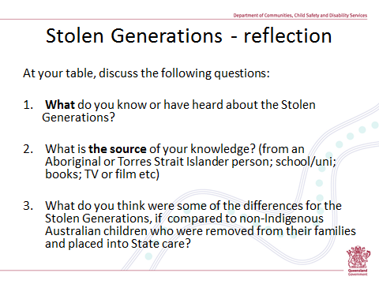
30 mins | Slide 5: Lessons from the past – handout  This segment uses handout 1, which contains the transcript of Donna Meehan’s testimony from ‘The Stolen Generations Testimonies’ website.  The purpose of this segment is to provide information to participants about the Stolen Generations:  - to broaden their understanding/awareness about the experiences of children and young people who were subject to removal from their families and communities under the government policies at that time, and  - to increase their awareness of the continuing impacts of these experiences.  The transcript outlines Donna’s story. Donna Meehan, who was born in north west NSW in 1954 was removed from her mother and community when she was 5 years old, along with her six siblings. Donna’s transcript was selected because of the recency of her removal and the fact that she was placed with foster carers.  It is critical that participants be provided with sufficient time to debrief and reflect on the transcript content. Thirty minutes are set aside for this session (20 minutes for the screening and 10 minutes for debriefing and discussion).  For There are a number of different ways to facilitate this session – please refer to ‘Additional Facilitator Notes: Lessons from the Past’.  Advise participants that there are 30 other testimonies from Aboriginal and Torres Strait Islander people who were subject to the removal policies of past governments. These can be accessed online at: http://stolengenerationstestimonies.com/index.php/testimonies/974.html  Please note: There are difficulties associated with viewing the video content associated with the testimonials on the Stolen Generations’ Testimonials site; however transcripts continue to be accessible from the website. | 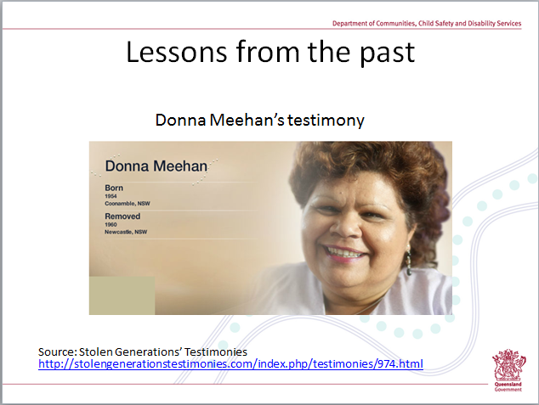

5 mins | Slide 6: Over-representation  Despite the cessation of the government policies that gave rise to the Stolen Generations (which occurred up to the 1970s), there is a growing and alarming trend across all Australian states and territories, that Aboriginal and Torres Strait Islander children are entering and remaining in the out-of-home care system at a rate that is both out of proportion to non-Indigenous children, and out of proportion to the size of the population of Aboriginal and Torres Strait Islander children – as this graph so clearly demonstrates.  The graph shows the over-representation of Indigenous children across the child protections system compared with non-Indigenous children.  In 2013-14, Indigenous children were seven times more likely than non-Indigenous children to receive child protection services in general or to be the subject of substantiated abuse or neglect, and about nine time as likely to be on a care and protective order in out-of-home-care.  Ask participant group:  What do you think could possibly explain the differences in these numbers? Or, why do they think this has been happening?  Responses could be written on a whiteboard, or alternatively, you may prefer to draw out a discussion with the group, and as necessary generate new questions to promote participants deeper thinking and group discussion.  To assist in facilitating this discussion, refer to the “Additional Facilitators Notes: Over-representation”. | 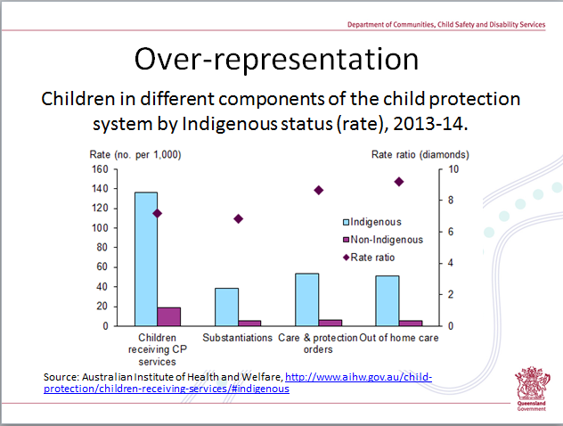

5 mins | Slide 7: Mind your language  Suggested information:  - Language is not a neutral vehicle. It can impart so much more than what may be intended – such as judgment, insults, racial slurs and reminders of past government practices.  - It’s important to be aware of the words and phrases that should not be used when communicating with or about Aboriginal and Torres Strait Islander peoples; and why these words should not be used.  - ‘Aboriginal’ and ‘Torres Strait Islander’ are not the names that were used by the first peoples when referring to themselves – these terms are a legacy of colonisation.  The words and terms not to use:  - For the first 200 years of colonisation there was a raft of laws enacted specific to Aboriginal and Torres Strait Islanders, which included definitions and classification terminology – the various Acts are explained in the handout distributed during Module One of the Pre-Service Training.  - Explain that the “Historical Overview of Legislation and Past Practices Impacting On Aboriginal and Torres Strait Islander children” was distributed in Pre-Service Training and can be available for participants as part of this module, if desired.  - The word ‘Aborigine’ is a prime example of wording that has negative associations with past government practices and is no longer used for that very reason.  - The use of ‘ATSI’, either in spoken or written form, is another example. The use of this acronym to refer to cultural groups or to refer to the culture of an individual person is considered very disrespectful and should not be used.  - Perhaps the most significant feature of past Government polices was the practice of defining Aboriginality by proportions of blood. Phrases such as ‘part Aboriginal’, ‘half caste’, ‘quarter caste’ or ‘octoroon’ (1/8), all reflect the time of the governments assimilationist policies and have especially negative and emotive connotations - these terms, as well as any blood quantification of Aboriginality, continue to be highly offensive to Aboriginal peoples.  - The attitude behind this thinking still lingers in the minds of some people – that is, the belief that a person might be less aboriginal because they have a lighter skin tone.  - Like any other cultural groups, Aboriginal and Torres Strait Islander peoples from different areas retain varying degrees of their culture, language, customs, laws and traditions. Many Aboriginal people have both Aboriginal and non-Aboriginal ancestry but this does not make them any less Aboriginal.  - Similar to this is a sometimes held view that ‘remote’ Aboriginal people are “more aboriginal” and those living in urban locations, who are seen to be “less Aboriginal”.  - The diverse elements of Aboriginal and Torres Strait Islander peoples cultures vary according to where people are raised, their closeness to traditional ways, and the influence of other cultures through marriage etc. Provide examples and/or explanations from your own experience or knowledge.  Preferred language usage  - The regional terms (listed at the bottom of the slide) are commonly used by Aboriginal people to describe themselves. For instance, a Queensland Aboriginal person may refer to himself as a ‘Murri’. The listing here is not complete – ‘Yuin’ is used on the south coast of NSW; Yolngu in the Arnhem Land region and so on.  - The terms that non-Indigenous people would likely use would be more general terms – such as ‘Aboriginal peoples’ (with a capital A) or Torres Strait Islander peoples (always with capitals). If you want to refer to both cultural groups, you would either say ‘Aboriginal and Torres Strait Islanders’ or alternatively you would use the word ‘Indigenous’ or ‘Indigenous Australians’, always with capitals. | 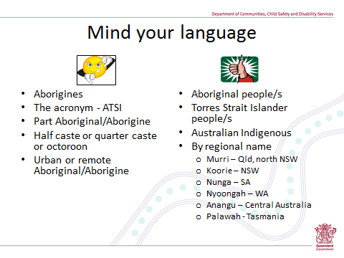

 | Section 2: Child Placement Principle
5 mins | Ask participant group:  - Who has heard of the Child Placement Principle?  - What do you know about the Child Placement Principle?  Receive the comments participants provide, without too much comment or correction.  Acknowledge that some information about the Child Placement Principle was provided to foster carer applicants during their Quality Care: Pre-service Training modules. However some participants may not have had the opportunity to attend this training, or they may have attended a long time ago.  Slide 8: Child Placement Principle  Read the quote aloud to participants  Provide the following basic factual information:  - The Child Placement Principle is part of Queensland’s Child Protection Act 1999.  - It applies only to children who are Aboriginal and Torres Strait Islander.  - All the States and Territories across Australia have incorporated a ‘Child Placement Principle’ into their legislation – though it is not exactly the same in each State.  - It has been part of Queensland’s child protection practice for 30 years – being introduced into policies in 1984, before being incorporated into the 1999 legislation.  - A number of years ago (in 2006), the Child Placement Principle was expanded, with the addition of two new sections – these new sections strengthen the requirements if a child is in a placement with non-Indigenous carers.  - Despite the fact that it has been around for so long, the Child Placement Principle is sometimes misunderstood – as indicated by this quote, with some people generalising that it is simply about the hierarchy of preferred placements for Aboriginal and Torres Strait Islander children.  - As we will see, it is considerably more than that.  Discussion activity  Provide Handout Two: Child Placement Principle.  Allow time for participants to read and discuss the information in their table groups – about 5 minutes.  Distribute:  - Handout 3: Carer Fact Sheet 6: Understanding the Child Placement Principle  - Handout 4: Carer Fact Sheet 7: The Role of the Recognised Entity  - Handout 5: Carer Fact Sheet 11: Maintaining family contact  - Handout 6: Carer Fact Sheet 13: Keeping a life diary | 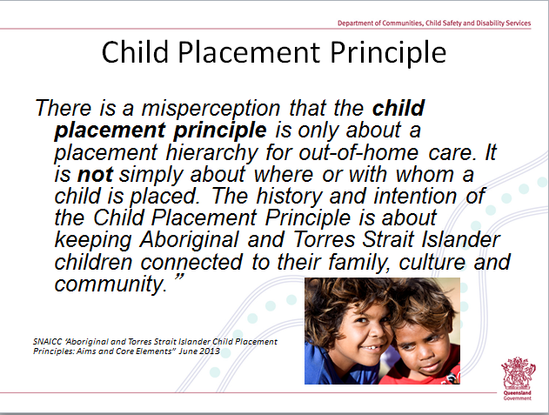

5 mins | Slide 9: Elements of the Child Placement Principle  In summary, the Child Placement Principle has at least 4 separate elements.  Read out the content of the slide. Make the following points:  - Two of these elements are more specific to the actions and decision making of the department, these being the 2nd and 3rd points:  - partnering with the Recognised Entity and  - placement prioritisation  - The remaining two points have direct relevance to both carers and the department - about protecting the cultural rights of Aboriginal and Torres Strait Islander children in out-of-home care, and  - preserving their connections with family, community and culture.  - These four elements are not isolated to Child Placement Principle, but are repeated frequently throughout other parts of the Child Protection Act 1999 – particularly the need for the child’s connections and cultural identity.  Put the question to participant group: What/where else is there reference to the cultural needs of an Aboriginal or Torres Strait Islander child? Refer to Additional Facilitator Notes: Child Placement Principle.  The Child Placement Principle also recognises that it is not always possible to place a child according to the ‘hierarchy’ of preferred placements, and the legislation allows for the placement of Aboriginal and Torres Strait Islander children with non-Indigenous carers. It doing this though, it sets down a number of other considerations:  - For the placement to be ‘near to’ the child’s family or near to their community and language group – ‘near’ means either geographically close or in terms of family and cultural connection.  - For the non-Indigenous carer to be committed to facilitating the child’s contact with their family members (not just their parents), their community or language group and their culture; and that the placement will enhance the child’s sense of their Aboriginal or Torres Strait Islander identity. This reference can be found in sections 83(5)(b) and all of (7).  The overarching intention of the Child Placement Principle is about keeping Aboriginal and Torres Strait Islander children connected to their families, their community or language group, and their culture. | 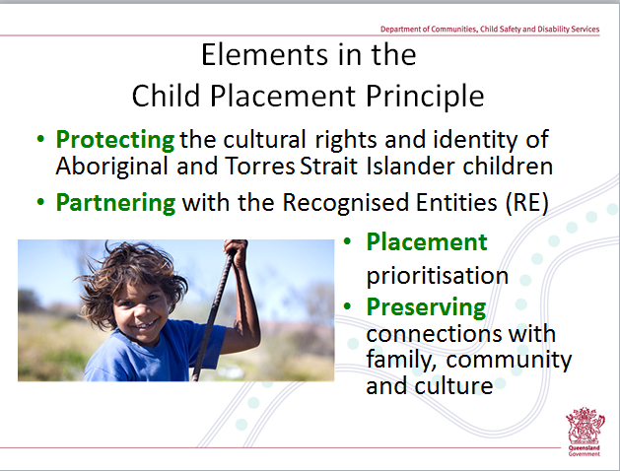
5 mins | Put the question to participant group: What do you think the Child Placement Principle mean for you as carers? Record responses on the whiteboard or a flipchart.  Slide 10: What does this mean for me?  The legislation makes it very clear that carers for Aboriginal and Torres Strait Islander children have additional responsibilities – these are quite significant and are specific to the development of the child’s cultural identity and to the need for the child to attain and/or retain connections to their family and community.  Read the points on the slide and provide the additional information:  - The legislation specifies that the things that help Aboriginal and Torres Strait Islander children to acquire or maintain a strong sense of who they are, where they belong include:  - Having contact with their Indigenous parents, extended family, and community group;  - Empowering them to have an understanding about, and connection with, their culture;  - Overall – working with them in a way that preserves their cultural identity.  - A child’s contact with their Aboriginal and Torres Strait Islander family is the most important way of the child maintaining their cultural connections.  - If the child is placed with non-Indigenous family, then there is an obligation to ensure that efforts are made so that the child can have contact with family members who are Aboriginal or Torres Strait Islander – of course, taking into account the child’s safety.  - The department has the main responsibility for assessing and making decisions about with whom and how the child will have contact. They will consult with the Recognised Entity who have the cultural knowledge and the community knowledge.  - The department will usually record who is in a child’s family using a 3 generation genogram (or similar information) which will display family members on their mother’s side and their father’s side, and the names of family members. (Sometimes this is at front of the child’s case plan).  - The department will also record how a child’s cultural needs are to be met in their case plan – in a specific section of the case plan referred to as the Cultural Support Plan (There will be more information on the Cultural Support Plan shortly).  Put the question to the participant group: Ask for a show of hands - For those currently providing care for an Aboriginal or Torres Strait child, who has a copy of the child’s genogram, or has written information about the names/relationships of extended family members – specifically the family members who are Aboriginal and Torres Strait Island?.  For carers indicating they don’t have a copy of the family genogram, suggest that they make a note now, to ask their CSO for a copy of the genogram or its equivalent. Explain this information is invaluable for carers to have. It is also vital that children and young people in care have a copy of this information, which can be included in their Life Diary or Life Story Booklet. | 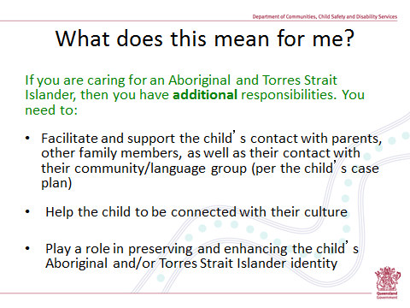
15 mins | Slide 11: Activity  Distribute ‘Activity One: What do you think?’ as well as butchers paper and felt tip pens to each table.  Explain the activity  Ask participants to discuss each statement at the table, and document the views on the butchers paper provided. Affirm there will likely be a mixture of points recorded on the side of ‘agreeing with’ and on the side of ‘disagreeing with’. Write down all key points your table group raised. Explain that feedback to the large group will be required. Provide 10 minutes.  Facilitate feedback  Allocate 5 minutes for this process.  Additional facilitator notes outline further information on the 4 statements, to stimulate reflection and discussion. | 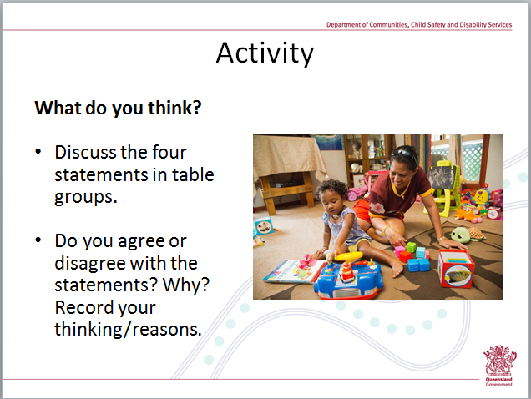
15  15 mins | Slide 12: The child’s Cultural Support Plan  Additional facilitator notes outline further information on the Aboriginal Self (Pattel, 2007) to stimulate discussion on the Cultural Support Plan – this information is included at the end of this guide. The Aboriginal Self information can be used as an additional resource when discussing the child’s Cultural Support Plan.  - The purpose of the Cultural Support Plan is to document the child’s individual cultural needs, specifying (refer to the Aboriginal Self to prompt discussion – self, family and culture, community and western society):  - what is needed to ensure the development of the child’s cultural identity  - what cultural connections and contacts are important for the child  - who will play a role in this – what and when.  - Every Aboriginal and Torres Strait Islander child in out-of-home care should have a cultural support plan, (as should children from other cultural groups). It’s not a separate document but is incorporated into the child’s Case Plan. Like the Case Plan, the child’s CSO will review it every 6 months, at which point a new/revised Cultural Support Plan is developed. The constant 6 month cycle of review means the plan can be responsive to the child’s developing cultural needs at different points in time in the child’s life.  - While the department will write up and distribute the child’s case plan, they don’t develop the Cultural Support Plan in isolation from others. It is developed in a collaborative way with the contribution from family members; the Recognised Entity; and possibly an Indigenous departmental Child Safety Support Officer, and/or the Indigenous Foster and Kinship Care Service, and/or the child’s carer.  Distribute Handout 7: An example of a Cultural Support Plan for Julie Smith.  Provide participants with 5 minutes to peruse and discuss the document. Draw their attention to the shaded areas – which provide the key questions that the Cultural Support Plan has to answer.  Take participants through each shaded area, allowing them the opportunity to ask questions or seek clarification. Refer to Additional Facilitators Notes for an explanation of each section of the Cultural Support Plan.  The carer is just one person who plays a role in the support and development of the child’s cultural needs – carers don’t carry this responsibility alone. However because of a carers day to day interactions with the child, you are in a vital position to actively support and contribute to the child’s cultural development:  - at the most simple level this can be demonstrated by how you express yourself to the child, and the attitudes you convey about Aboriginal and Torres Strait Islander people. This includes being aware of the attitudes you or others convey to the child; drawing the child’s attention to positive Indigenous role models – in the local community, on the sports field, in the media, on TV or radio.  - by the choices you make for the child – for example, checking to see if there is an Indigenous child care centre near to you and making the choice to enrol the child there – so that they have increased opportunities for exposure to cultural activities and other Aboriginal or Torres Strait Islander people; attending to the child’s health needs via the Aboriginal Health Service instead of your local GP; by enrolling the child at or being a spectator at Indigenous sporting clubs; or by choosing week-end activities for the whole family which can provide everyone with an increased exposure to and appreciation an aspect of Aboriginal or Torres Strait Islander culture.  - by showing an interest in and facilitating the contact the child is having with their extended family members and their community. | 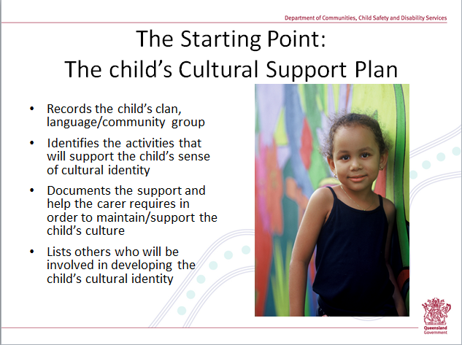
BREAK – 15 mins

 | SECTION 3: FOCUS ON CULTURE
3 mins | Put the question to participant group: Why do you think there is an emphasis on the cultural connections and cultural identity for Aboriginal and Torres Strait Islander children?  Slide 13: Why is culture important?  Read quote.  - There is an increased understanding (from governments and those in child welfare fields, as well as academics and researchers) of the centrality of family, land and culture to Aboriginal people and that healthy identity development is inextricably linked with cultural identity.  - Amongst Aboriginal and Torres Strait Islander peoples, culture is regarded as a powerful force that helps to ‘grow up’ a child.  - Cultural identity is known to be a protective factor and strength for Aboriginal people. Without it, the child is without that source of strength.  - Culture plays a key role in the child’s development, identity and self-esteem and contributes to their overall well-being  - Culture builds resilience and is in accord with the UN Convention on the Rights of the Child.  - Cultural connections reduces the child’s feelings of isolation | 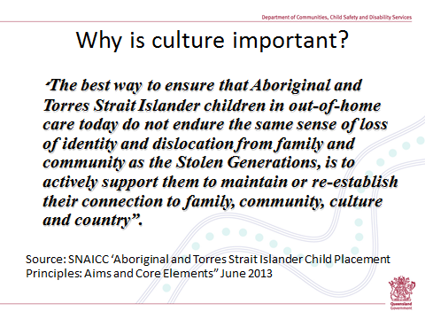
2 mins | Slide 14: Identity  Read aloud the quotes and elaborate on their inherent message. For instance:  - That Aboriginal identity is more than ‘colour’ or physical features – how you look or your parentage. Aboriginal identity is linked with language, land and clan relationships.  - The second quote, from a contemporary man from the Torres Strait Islands who has been living in NSW as well as studying at Harvard University, identity is linked with place and spirituality.  - It’s all about shared cultural values and belief structures; and spirituality such as The Dreaming (part of the shared oral history about creation) or for Torres Strait Islanders, from the stories of the Tagai. | 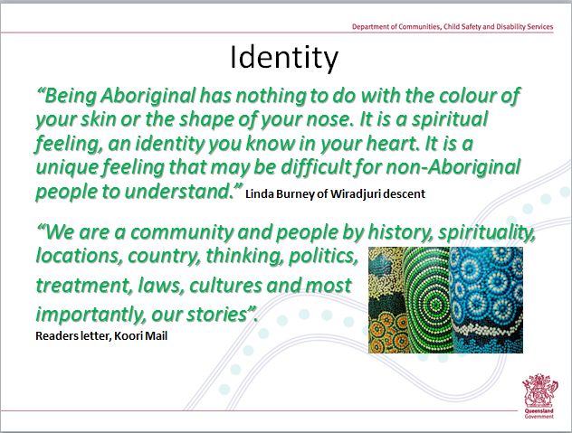
10 mins | Slide 15: Domains of child’s cultural needs  - This diagram begins to unpack what Aboriginal and Torres Strait Islander people mean when they refer to a child’s cultural needs.  - Culture has many elements. The 6 areas represented in this diagram are not discrete areas, which are separate or disconnected from each other. In reality they are all interconnected and overlap:  - The child’s history – refers to where the child comes from.  This means the child having knowledge about both the history of Aboriginal and/or Torres Strait Islander people as well as the child knowing their own extended family history - about the child’s own family tree and the stories that go with their families.  - Their personal identity – refers to who you are.  This is belonging to a cultural group - that is, about the child knowing that they are Aboriginal and/or Torres Strait Islander; and knowing that they are also part of a particular group/clan/family/community. It’s about the child’s knowledge of and pride in this identity and these connections. The development of a personal cultural identity includes being taught the knowledge, customs and languages of their group, and from this the child will be able to learn who they are within their group.  - The child’s family, extended family and community – is about the child knowing who they ‘belong’ to.  Children need to know who their family are and their family heritage. This is why the genogram work is so very important because it provides the map of who is in the child’s extended family. Also, the Aboriginal and Torres Strait Islander concept of family is very different to the Australian one. Family comprises a very broad sense of relatives, kin and other community members. The terms of ‘auntie’, ‘uncle’, ‘sis’, ‘bruz’ and ‘cuz’ have wide and varied meanings and are not necessarily the literal meanings – that is, that someone referred to as a brother is really the biological brother. These family members also have certain roles and responsibilities to the child, which are different to those in the traditional ‘white’ families.  - Land and water – is about the child knowing about ‘their Country’ - where they belong. Children need to know about the area of land or water that they are connected, by virtue of being a member of a particular community or language group. This might even include the need for the child to know about the customs of their own community and significant or sacred sites. At a broader level, they need to understand the environmental connections and how their ancestors cared for the land over thousands of years.  - Cultural expression – how culture can be expressed.  Cultural expression can be about the unique language used by a particular community that the child belongs to. It can also mean the general English words and phrases that are commonly used by Aboriginal and Torres Strait Islander peoples, and the child needs to be familiar with these terms – such as ‘deadly’, ‘yarning’, ‘mob’, ‘gammon’, ‘Sorry business’, ‘lingo’. There may also be a visual representation to cultural expression as well. This could include such things as dance or art and what they mean.  - Cultural values, beliefs and practices –about the cultural beliefs and ceremonies; about their totems and how these connect to land and water and the child’s responsibilities toward their totem. It includes stories about Dreamtime and Creation.  - Some children come into your placement already having strong connections to their family and culture; while others may not be culturally connected at all. For those children with a tenuous relationship with their culture, they more concerted efforts. | 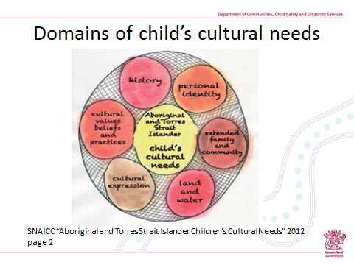

The remainder of the workshop requires attendance of between 3 to 5 selected guests, who will speak about their experiences, ideas and resources they have used to assist an Aboriginal and Torres Strait child to maintain connections to their culture and community.
It is highly recommended that guests include at least one non-Indigenous carer who has solid experiences looking after an Aboriginal or Torres Strait Islander child. Other guests could be drawn from any combination of:
- an Aboriginal or Torres Strait Islander carer who is providing care for an Aboriginal and/or Torres Strait Islander child
- a Co-ordinator or Support Worker from the local Indigenous Foster and Kinship Care Service
- a Co-ordinator from the local Recognised Entity.
16 Introduction of guests (10 minutes)
Introduce each guest – their name, role, and if a carer how long they have been a carer; the age and gender of the Aboriginal or Torres Strait Islander child/ren they are caring for or have provided care for. For staff members of the Recognised Entity or Indigenous Foster and Kinship Care Service – their introduction could make reference to where they work, their role, how long they have been there. Invite each guest to provide additional information about themselves.
Explain to participants the role of the guests:
- That they have been invited to attend the remainder of the session because of the experience and knowledge they have acquired, due to their direct hands on role in working with Aboriginal and/or Torres Strait Islander children, assisting them in their connections and cultural identity.
- For the next activity they will each be joining a table group, contributing to and stimulating your discussions.
17 Handout of resources (10 minutes)
Distribute ‘Handout 8: Enabling Aboriginal and Torres Strait Islander Children to Maintain Connections’. Distribute any additional information about resources in your own locality or community – for instance pamphlets on local Indigenous Health Centre or other such services; the Recognised Entity; local cultural events and the like.
Handout 8 provides a starting point to stimulate how carers can strengthen the cultural connections for the child in your care. It’s focus is more on the ‘daily care’ actions and covers 9 different activity streams:
- Use of media | 6. Other activities
- Use of music | 7. Sport
- Books | 8. Local cultural centres
- Games/toys | - Local cultural festivals
- Language

Allow 5 to 10 minutes for participants to read and discuss the handout and local materials provided. The invited guests can stimulate and focus the discussion at their respective table groups
Emphasise the following points:
- This information is not a comprehensive resource list.
- Many of the resources are readily/easily accessible online, regardless of whether you live in Coolangatta, Cape York or Charleville.
- The information in the handout is intended to be a prompt, a starting point for ideas, and a resource to enable carers to connect some of the dots, with the help of the internet and other resources.
Respond to the discussion and/or questions that are generated. Invite guest members to make comment about information in the handout, especially if they have accessed or used any of the resources. Although they may have shared this with the table group they are seated at, there will be benefits for everyone to hear their input.
The key message is that there are a broad range of things that a carer can do for the child on a daily basis that assist in promoting the child’s culture. They don’t require great effort on anyone’s part – often times it’s about conscious substitution.
18 Activity two (30 minutes)
The purpose of this activity is for experienced carers and agency staff members to talk about what they have actually done to enliven the cultural identity development and cultural connections for Aboriginal and Torres Strait Islander children and young people in their care. For instance the actions they have taken; the resources they use; a descriptive account of how they put these into practice; information about the child’s responses/impacts.
Distribute Activity Two: Cultural Connections, which provides 4 vignettes of Aboriginal and/or Torres Strait Islander children ranging in age from 3 to 15 years. Acknowledge that limited information is provided about the child – and that this is purposeful so as not to be overly distracted by the factitious child’s specific information.
Allocate one vignette to each table group and provide butchers paper and felt tip pens for their recording purposes.
Explain the activity:
Read aloud the task and provide tables 5 to 10 minutes for them to generate and document their ideas. Explain that they can use Handout 5 for guidance, but should not be restricted to that. Participants will also use their own experiences regarding children they have cared for and draw on the expertise of the guest panel member. Remind table groups that they will be asked to provide information back to the big group – so they will need to document their ideas and nominate a spokesperson to provide feedback.
Facilitate feedback
Allocate a further 15 minutes for this process, which is about 3 minutes for each vignette. Ask one group to provide a summary of their vignette and then to outline their ideas. See if other tables have comments or ideas that they would like to add. Move onto the next table and repeat the process to all vignettes have been completed.
Story telling by guests: What I have done (30 minutes)
Guests can be encouraged to bring examples that will showcase an aspect of the work they might have done with/for an Aboriginal and/or Torres Strait Islander child. For instance, this might be a Life Diary or similar work.
If work examples are shared, remind participants of their confidentiality obligations under the Child Protection Act 1999, as the information will be specific to a child in the custody or guardianship of the Chief Executive, who is living in their community.
Wrap up (10 minutes)
Wrap up can be completed a number of different ways, depending on time and group size. One suggestion is that the facilitator revisits the slide on the learning outcomes to check-in that these have been addressed during the session. In style ask each participant to identify a key learning for them from today’s session, what they will take away from the workshop - go around the room until everyone has had the opportunity to provide make comment.
ADDITIONAL FACILITATORS NOTES
SLIDE 5: ‘Lessons from the past’ VIDEO RECORDING
The video recording could be either be viewed in its entirety, with the group debrief and reflection/discussion at its conclusion. Alternatively the facilitator may elect to pause the recording at key points. For example this could occur midway at the end of chapter 4 following Donna’s description of her ‘new’ family – which finishes with “And I got used to a new type of food, had European food, and um, but I was very lonely cause I’d gone from a very strong extended family to this nuclear family with just parents and me”.
Alternate process
If you are unable to view the recording, give participants handout 1 to read through (this is the transcript of the recording). If this process is used, the facilitator may instruct participants to stop reading at sections throughout the transcript as noted above.
Suggestions to prompt participant reflection and discussion include:
- What were some of the contrasts between Donna’s life in her community at Coonamble and that with her foster family? How challenging do you think this would have been for Donna? How differently could we handle such a situation today, to assist Donna’s adjustment?
Coonamble | Foster family
Happy; large family with six siblings and lots of cousins. | Lonely.  There was only her and her foster mother and father.  No other children in the house to play with.
A natural environment – particularly its physicality. | First exposure to buildings and city smells.  The cars and traffic.  Everybody wore shoes.
Shared care with grandmothers and Aunties having direct responsibilities – such as singing the children to sleep.  Male community members away from the camp for long periods. | Scared of foster father because she was not used to adult males.  Took months to adjust.
- What were some of the emotions/views that Donna had about being Aboriginal, and why could Donna be feeling this way? What could we do today, to strengthen Donna’s cultural identification and her cultural connections?
- Anger: she recollected when 9 years old, feeling angry with “her mob” because no one had come to get her.
- Denial: she said at 13 years of age she was in denial and would not disclose or acknowledge that she was Aboriginal. She did not attempt to become friends with the other two Aboriginal girls at high school.
- Shame: this response goes hand in hand with the denial and was partly exacerbated by the name calling and teasing that she experienced as a school child because she was Aboriginal.
- Isolation: Donna recalled that she didn’t have any contact with (directly or indirectly) with any Aboriginal person until she was a teenager (over ten years since she left her community) until an Aboriginal singer was on the TV (and she could see the physical resemblances to her Uncles). She had no cultural exposure, no contact with positive cultural role models – her life was really one of a cultural vacuum.
- Lonely, empty and not belonging: Donna describes feeling like this as a young woman – when she was married and had a baby. She says that she felt that there was something missing, that she didn’t belong. She says, quite powerfully “It had felt like I had lived my whole life sitting on the fence at white society and I knew I didn’t belong and I just lived in my own bubble, my own world”.
- Ask participants to comment on:
- when Donna found her mother and kin; why it may have taken Donna 35 years to come to terms with women wearing red hats.
SLIDE 6: OVER-REPRESENTATION
A number of recent reports and academic articles on this topic are available online:
- Queensland Child Protection Commission of Inquiry “Taking Responsibility: A Roadmap for Queensland Child Protection”. June 2013.http://www.childprotectioninquiry.qld.gov.au
- Australian Institute of Family Studies “Child Protection and Aboriginal and Torres Strait Islander Children” June 2013. http://www.aifs.gov.au/
- Healing Foundation. “Our Children, Our Dreaming: A call for a more just approach to Aboriginal and Torres Strait Islander children and families”. http://healingfoundation.org.au/
- National Child Protection Clearinghouse “Child Protection and Aboriginal and Torres Strait Islander children” April 2011. http://www.aifs.gov.au/
- Combined Voices Policy Monograph. “Addressing the over-representation of Aboriginal and Torres Strait Islander children in Queensland’s child protection system”. January 2010. http://www.combinedvoices.org.au
For contextual information: The final report prepared by the Queensland Child Protection Commission of Inquiry (as referenced above), pages 351-352 includes the following extracts:
- “The over-representation of Aboriginal and Torres Strait Islander children at all stages of the child protection system, especially in long-term alternative out-of-home care, is a major concern with Aboriginal and Torres Strait Islander children entering care at an earlier age and staying longer. Nearly 40 per cent of all children in out-of-home care are Aboriginal or Torres Strait Islander, while less than 7 per cent of Queensland’s children are Aboriginal and Torres Strait Islander Aboriginal and Torres Strait Islander children are now nine times more likely to be living in out-of-home care”.
- “The over-representation of Aboriginal and Torres Strait Islander families in the child protection system is being driven by a complex array of interconnected factors. Social disadvantage lies at the core, with stressors being higher rates of poverty, mental illness, alcohol and drug misuse, family violence, and teenage parenthood. These factors are exacerbated by a much wider breakdown in community functioning in some remote and discrete communities.
The intergenerational effects of past policies have made a major contribution to the risks, including the effects of forced removals and the dormitory system on parenting, which has led to multiple generations of families becoming involved in the child protection system. These policies have also resulted in the disempowerment of community leaders, leading to a breakdown in social norms in some parts of the state, including norms around parenting.
System factors in the child protection system also play a role: an over-reliance by the statutory child protection system on high-end (tertiary) responses and a lack of meaningful collaboration between government services on the one hand and Aboriginal and Torres Strait Islander agencies on the other. This lack of meaningful collaboration is of particular concern.
The Commission has also heard that misperceptions about child-rearing practices in Aboriginal families can also lead to incorrect assumptions about children’s protective needs in some circumstances. In many Aboriginal families, children are encouraged to be independent, self-regulating, and self-reliant – more so than typical for many non-Indigenous children. Different parenting practices can be inappropriately and incorrectly construed as neglectful, particularly in the context of chronic poverty”.
SLIDE 7: MIND YOUR LANGUAGE
- Provide information about the three part criteria used to if a person is Aboriginal or Torres Strait Islander – descent; self-identification and community recognition – and outline why ‘proof’ or written confirmation of Aboriginality is sometimes required for Aboriginal and Torres Strait Islander people.
SLIDE 8: CHILD PLACEMENT PRINCIPLE
Discussion activity:
If it is considered that the group discussion activity following the distribution of ‘Handout One: Child Placement Principle’ would be assisted with some further structure, table groups could be asked to focus their discussion to any of the following topics:
- What does this mean for me as a carer?
- Focus on the meaning and implications of subsection (7).
- Alternatively ask them to be alert to the word ‘must’ and seek out what ‘must’ be done and by whom.
If participants ask about the meaning of the phrase ‘optimal retention’, as used in section 83(5)(b): According to the dictionary, ‘optimal’ means the best or most favourable. So in making a decision in whose care to place a child, the department has to consider whether the proposed placement would provide the best result for the child, specific to their cultural identity and cultural connections.
- Sections 83 (6) and (7) were introduced into legislative changes in 2006. It is possible that some children were placed with non-Indigenous carers prior to that time.
- As at June 2012, Aboriginal and Torres Strait Islander children in out-of-home care in Queensland were placed in a range of environments, including:
- 21% of children were with Aboriginal or Torres Strait Islander kin carers.
- 19% were placed with ‘other’ Aboriginal or Torres Strait Islander carers.
- 13% were placed with non-Indigenous family members.
- 40% were placed with ‘other’ non-Indigenous carers.
Note: This data is taken from a report by the Productivity Commission “Report on Government Services 2012” Table 15A.23
SLIDE 9: ELEMENTS OF THE CHILD PLACEMENT PRINCIPLE
In response to the question ‘What else makes reference to the cultural needs of an Aboriginal or Torres Strait Islander child?”
The section relevant to carers is the Standards of Care, with one of these standards being the need to meet the child’s cultural needs – section 122(d).
The additional sections of the Child Protection Act 1999 that have impact on carers include:
- section 5C: Additional Principles for Aboriginal and Torres Strait Islanders;
- section 6: Recognised Entities and decisions about Aboriginal and Torres Strait Islander children;
- section 83: Additional provisions for placing Aboriginal and Torres Strait Islander children in care (this is the Child Placement Principle);
- section 88: Chief Executive to provide contact between Aboriginal and Torres Strait Islander child and child’s community or language group.
SLIDE 11: ACTIVITY
First statement - “Cultural connections are not as important for urbanised Aboriginal and Torres Strait Islander children, as they don’t have distinct cultural traditions and kinship systems”.
- Aboriginal and Torres Strait Islander people living in urban contexts may not portray stereotypical images of what Indigenous Australians look like or live like, but a person doesn’t stop being Aboriginal or Torres Strait Islander just because they live away from their own country or language/community group. Aboriginal and Torres Strait Islander people, regardless of where they are living, have a shared identity, culture and set of values that underpin their views, behaviours etc – these are expressed through family obligations and responsibilities, and many retain strong territorial affiliations.
- The highest proportion of Indigenous Australians live in major cities and large towns. According to the Census data, only 24% of Aboriginal and Torres Strait Islander children and young people live in remote locations – with the remaining 76% living either in capital cities and regional towns.
Second statement: “Very young Aboriginal and Torres Strait Islander children in out-of-home care (that is, those who are under 4 years) do not require as much regarding their culture, because they are too young to understand”.
- Early childhood educators would strongly challenge that statement, and propose just the opposite – that it is critical for very young children to be provided with cultural information. There are a range of ways to introduce or expose culture to babies and toddlers (be it the Aboriginal culture, African cultures, any of the eastern cultures) or any culture that is not the dominant culture of the society in which that child is living.
- Listening to and learning about Aboriginal culture at an early age is fascinating and fun. All babies and toddlers enjoy music and songs, picture board books, story books, nature walks/stories. There is an excellent and growing range of Aboriginal books and songs for children of all ages and also many that are specific to the Torres Strait Islander culture – these are so easy to access via libraries, shops or online. You can simply substitute with books and music and songs that have Aboriginal or Torres Strait Islander themes. So if, in a typical week your one year old has 10 story books read to them and they listen to 40 songs – simply substitute some of these with Indigenous stories and songs. (There will be more specific information provided later about such resources).
Third statement: “If the child’s parents specifically tell the department that they do not want the child placed with Aboriginal or Torres Strait Islander carers, then this means that the requirements for the Child Placement Principle (that is, for the connection to family, community and culture) will no longer apply to that child”.
- While it is true that the department has to seek and incorporate the views and wishes of the child’s parents, this does not mean that these wishes are dominant over everything else. The most important requirement, above all others, is for the department to determine what is in the child’s best interests. For children who are more removed from cultural opportunities (ie they are living on a daily basis in a non-Indigenous household), then their needs for cultural development and cultural connections require more concerted efforts not less.
Fourth statement: “If the child is having a monthly family contact visit with his mother who is an Aboriginal woman, then that contact is sufficient for the child’s cultural connections and for the development of their cultural identity”.
- This is a common perception. It is true that parents are in a prime position to talk about their cultural experiences and stories, and to impart to their child a sense of cultural pride. But the opposite can also be true for the parents of children in care – especially where their own upbringing and/or other experiences may have left them being disconnected from their culture, or, they may carry feelings of shame or embarrassment about their culture. If that were to be the case, the mother would not be at all inclined to assist with the child’s cultural development and identity.
- In this particular statement, it indicates that the child’s contact with the mother and this alone will be sufficient. It is unlikely that this will be sufficient to wholly replace the need for other cultural development opportunities/activities for the child. This will particularly be the case if the contact is infrequent (ie monthly or longer) or for brief periods of time (ie one hour), or if it is restricted by an artificial environment – ie if it is supervised, or in an environment such as a departmental office.
SLIDE 12: THE CHILD’S CULTURAL SUPPORT PLAN
Statement from ‘Understanding ‘Aboriginal-Self’ to prompt and inform practice to improve outcomes for Aboriginal and Torres Strait Islander children and families’ by Helen Callaghan – Aboriginal and Torres Strait Islander Regional Practice Leader, Nth Queensland region.
- In order to support and build a positive cultural-identity for the Aboriginal & Torres Strait Islander child, it must be acknowledged that Aboriginal & Torres Strait Islander peoples, present as a collective. Any attempts to remove culture, family & community from Aboriginal-self will lead to a distortion of cultural-identity. To better inform practice work in partnership with the individual family. Ask who they deem important in the makeup of Aboriginal- Self.
- The Aboriginal Self was developed by Nyrell Pattel (2007)
  - Self: what are the physical, spiritual, social emotional wellbeing needs of this child… do they have a disability/mental illness/ are they reaching millstones/ do they display healthy connectedness with the wider family…(remembering when measuring an Aboriginal and Torres Strait Islander child who are we measuring them against? Indigenous vs Non-Indigenous, is that a fair comparison? Essentially we are looking for the strengths and needs of this child here.
  - Family & Culture: What are the family and cultural implications I need to be aware of for this family? Who are the family members and what are their roles in the child's life and family unit? What's their connection to the child, who would need to be involved in contact with this child to support cultural identity, connective cultural relationships and cultural values for this child?
  - What are the cultural factors I need to consider? What traditions, lore's, values and beliefs of this family do I need to be aware of? This is looking at the strengths and needs of this family and culture, their survival and resilience. What is this family’s story? What cultural and family norms do I need to be aware of in order to make a thorough assessment of this family and culture. E.g. attachment, overcrowding, harm is harm when we can see it and measure it there is no disputing that. But in relation to neglect, what does that look like? What do I need to be mindful of when apply western tools and frameworks for assessments.
  - Community: We are looking at the makeup of the wider community, community members, elders, council, the strengths and needs of that community. Where are additional supports and services, what's available? Where are the gaps and what are the barriers. Eg costs of food (Palm Island bread $5 or more, expenses of travel and other resources. What is the history of this community, what is normal for this community and how does that fit within our Western Society.
  - Western Society: how will this family's needs be addressed within our laws, courts, and department. How will this family be represented in assessments and western frameworks- what cultural & child rearing norms do I have to be mindful of when making assessments. What community factors do I need to consider in my assessments? Have I had discussions and collaborated with other Aboriginal & Torres Strait Islander staff and Services to assist with decision making.
A child’s cultural identity development won’t magically happen just because the child is having occasional contact with an Aboriginal or Torres Strait Islander family member. It requires a purposeful approach with involvement and support from a range of people – most importantly this would be the child’s family and/or community. For children who are very disconnected from their culture, it may be necessary to involve others, such as Indigenous staff and specialist services.
For information to explain Handout 4: An example of a Cultural Support Plan for Julie Smith:
- The first two shaded blocks (to provide the name of the child’s clan or language group and the next one on the name of the parents and siblings mob) require the department to lead and co-ordinate. This information is not always easy to find – and in some instances can take months/years to fully establish - particularly where parents have disconnected from or have limited knowledge of or identification with their community.
- The third shaded area is about identifying the range of activities to assist the child to attain or sustain their sense of culture. For Julie Smith this included:
  - her travel to NSW so that she can both establish and maintain links to her traditional country and to her kinship networks;
  - her attending local, state and national cultural events such as NAIDOC festivities and the more local Dreaming Fest;
  - the development of a life booklet with photos and stories of Julie’s family.
- The next question is highly relevant for carers – it is about identifying the supports you need in order to meet the child’s cultural needs. Amongst other things, for Julie’s carer this included:
  - being mentored by an Aboriginal carer or worker
  - being accompanied by an Indigenous person when attending community events – possibly to assist with introductions or to provide direct cultural coaching to the carers.
  - being provided with a calendar of local Indigenous events, and a list of local Indigenous services
  - being provided with resources – books, internet materials, a map of Aboriginal Australia and information about the local community group.
- The final requirement of the Cultural Support Plan is about outlining others who will be involved in supporting the child to develop their cultural identity. It is preferable that these are extended family members, but it may also include services – for instance Julie’s GP is mentioned as she is works for the local Indigenous Health Service. As already mentioned, the department is responsible for making these decisions.
SLIDE 15: DOMAINS OF CHILD’S CULTURAL NEEDS
For further information refer to the report on “Aboriginal and Torres Strait Islander Children’s Cultural Needs” produced by the Secretariat of National Aboriginal and Islander Child Care (SNAICC). This is the source document for the diagram and the content of this slide and is available online through the SNAICC website http://www.snaicc.org.au/.
SNAICC developed this diagram as a way of representing the dynamics of an Aboriginal and Torres Strait Islander child’s cultural needs. They say that the diagram is not to be approached as a formula or recipe for approaching cultural connection work with a child, but rather it is a way of thinking and reflecting about what cultural work could be undertaken.

