Positive and Protective
Self protection - Disability

Participant Workbook

Information for participants

How to use this workbook:

This workbook has been developed to support your learning while attending this training.

It is your opportunity to jot down ideas, points of interest and notes for when you want to transform what you have learnt into ACTION!

The workbook can also be used for your ongoing professional development.

Share your workbook with peers, colleagues or partner. We encourage you to discuss your day of training with others.

Most importantly, use the strategies in this workbook to promote a positive and proactive approach to supporting the healthy sexual development of the children and young people in care that you support.

All children and young people have the right to know about their bodies and to learn how to develop healthy relationships.

I didn’t know I could ask them about sex.
They (carers) talked about their family and stuff but never about contraception, or saying yes, or saying no.
Taken from a presentation given by Family Planning Queensland at the Child Safety Research Forum, Brisbane 2008. Meeting our obligations: Understanding and responding to the sexuality needs of children and young people in care.

© True Relationships and Reproductive Health 230 Lutwyche Road
Windsor 4030 Australia

Phone: +61 7 3250 0240
info@true.org.au www.true.org.au

This work is copyright. Except under the conditions of the Copyright Act 1968, written permission should be sought from the copyright owners to use any part of this work for reselling, distribution or use in resource development.
Permission to photocopy activities and worksheets is granted.

Every reasonable effort has been made to obtain permissions relating to information reproduced in this publication. Requests and enquiries concerning reproduction and rights should be email to publications@true.org.au
Disclaimer
True Relationships and Reproductive Health (True) has taken every care to ensure that the information contained in this publication is accurate and up to date at the time of being published. As information and knowledge is constantly changing, readers are strongly advised to confirm that the information complies with present research, legislation and policy guidelines. True accepts no responsibility for difficulties that may arise as a result of an individual acting on the advice and recommendations it contains.

Positive and Protective: Disability v1-2016 2
Document uncontrolled when printed

Activity 1 What is sexuality?

This workshop, Identifying and Responding to Sexual Behaviours, focuses on support for foster and kinships carers of children and young people in the area of sexual behaviours.

When talking about sexual behaviours it is important to establish what sexuality is and what is normal, healthy sexual behaviour and development and to accurately and proactively respond to sexual behaviours that may be of concern. Promoting healthy sexuality requires us to think about sexuality as far more than just a physical activity.

Write down some key words or a sentence about what sexuality means.

Activity 2 Social learning and sexuality

How, when and where do we learn about sexuality? Think about the social influences on learning about sexuality. They may include; media, religion, family, peers, school, law, and culture.

Write some examples of what each of these may teach a child or young person in care (e.g. media may tell us that it is important to be attractive to succeed in life).

Activity 3 Values and attitudes

It is essential to be aware of your own values, attitudes and beliefs about sexuality in order to manage responses to sexuality in positive and supportive ways.

How might your personal values and beliefs affect how you interpret sexuality issues?

Circle the responses that you believe may impact on your values and attitudes about sexuality.

- personal background
- health and wellbeing
- religious beliefs
- cultural background
- perception of societal norms, rules and laws
- use of media/popular culture
- experience of safety or abuse
- experience of relationships
- experience of being a young person
- experience of being a parent or carer
- experience of being male or female
- experience of sexual identity
- other

How do your organisational values and culture affect the support provided to children and young people in relation to sexuality?

Activity 4 – Rationale for self protection education

Children and young people in care may have complex support needs in the area of sexuality and self-protection education. It is important that all children have the opportunity for learning about self protection and staying safe.

What are some of the benefits of self protection education?

Activity 5– Increased vulnerability

Why are children and young people with disability more vulnerable to sexual abuse?

Activity 6 – Sexual abuse

The indicators of sexual assault may also represent signs of other forms of abuse or medical conditions. The presence of one or several indicators of abuse is not evidence that sexual abuse is occurring or has occurred, but they do act as a mechanism to signal the need for monitoring to occur. The presence of a cluster of indicators or of specific indicators, eg, sexually transmitted infections, would suggest the need for investigation by the relevant authority.

Write down some if the indicators of sexual abuse.

Responding to a disclosure
Disclosures of sexual abuse may occur when talking about self protection. All disclosures should be taken seriously, the young person should be believed, and it is important to know policy and procedure in relation to reporting

Activity 7 – Reducing the risk

Participants will be allocated one of the following categories for this activity. Tick which category you will be addressing:

- Children in care
- Foster/Kinship carers
- Organisations  Society

Participants are to consider their topic. List a range of strategies which could be implemented to reduce sexual abuse to young people in care.

Activity 8– Self protection education topics

Participants will be allocated one of the following self protection topics for this activity. Tick which topic you will be addressing:

  - Bodies and being private
  - Feelings and warning signs
  - Relationships and touch
  - Getting help and feeling safe

List a range of strategies for how you could teach children and young people in your care about the self protection topic you have been given.

Sexuality education is about supporting a child’s sexual development in a gradual, safe, healthy and positive way. Talking about sexuality and self protection is an ongoing responsibility, not just a one-off talk about the facts. As carers, you can support the development of self protection skills through your everyday interactions with the children and young people in your care.

Activity 9 – Talking about bodies and being private

Using anatomically correct language for body parts normalises these body parts, gives messages that these body parts are not embarrassing or shameful and communicates that it is ok to talk about these parts.

Why is it important to talk about bodies as part of a self protection program?

It is also important for children and young people to understand the difference between public and private. The rules about public and private relate to:
    - body parts
    - places
    - behaviours
    - discussions or talk

Activity 10 – Public & Private Signs

The following Public and Private signs are examples of a concrete resource that participants can use with the children in their care. The private sign can be very handy to stick on the doors of private rooms around the house

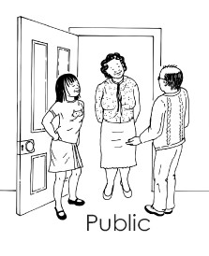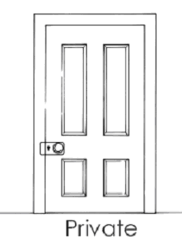

These cards are adapted from FPQ (2007) Every Body Needs to Know. Brisbane: Family Planning Queensland

Activity 11 – Being private

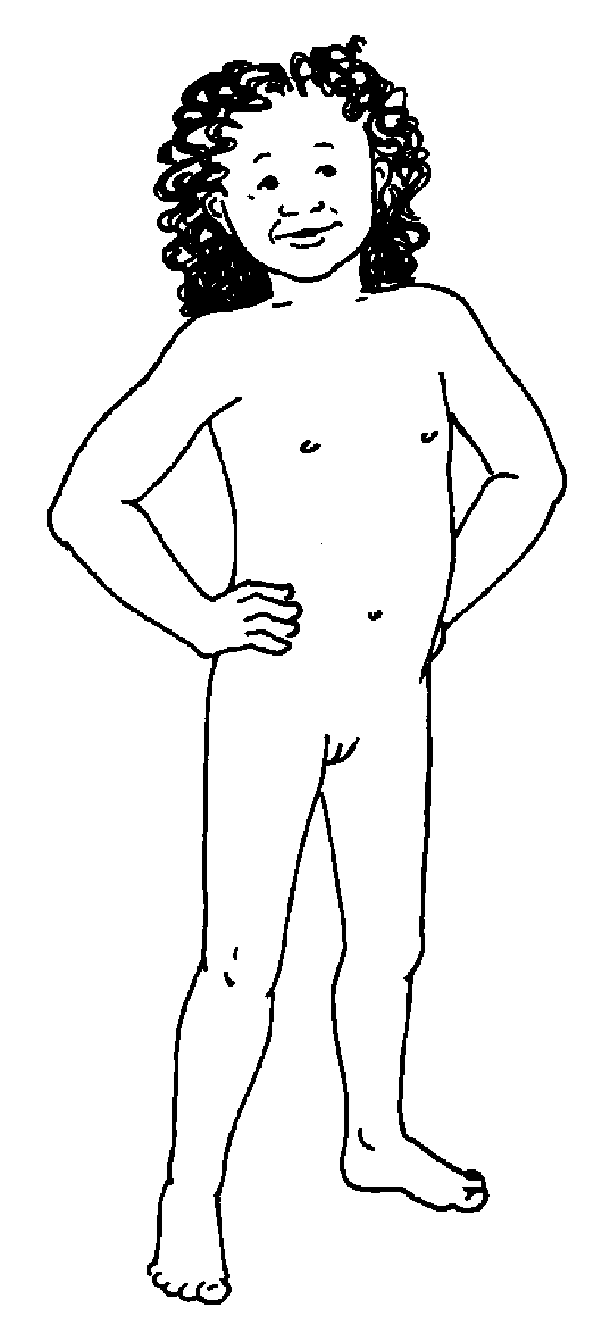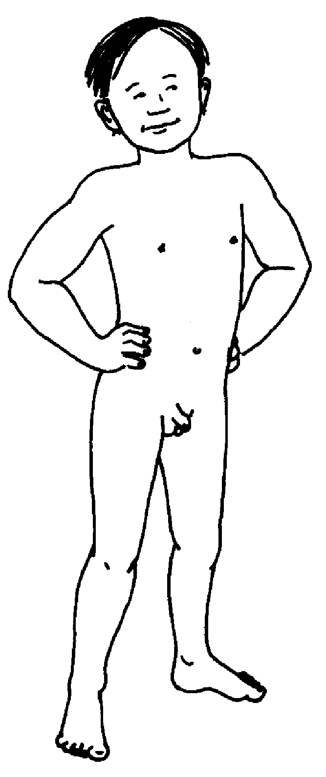Draw the underwear over the private body parts.

This activity is adapted from FPQ (2007) Every Body Needs to Know. Brisbane: Family Planning Queensland

Participant Workbook

Activity 12 – Relationships ladder
Fill the steps of the ladder with the names or pictures of the people that fit in each section. The relationships ladder can be used to discuss the qualities of the people in level and the types of activities and personal space that is ok. For example: In the Love section are people who are kind and trustworthy and who can hug and kiss us. 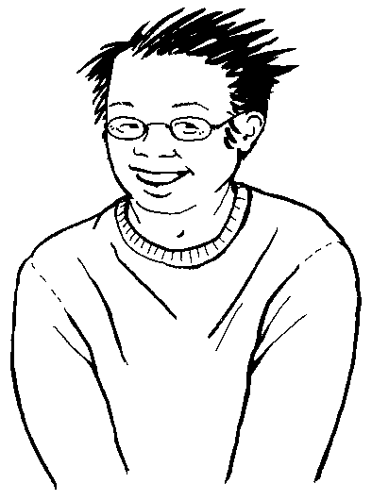

YOU

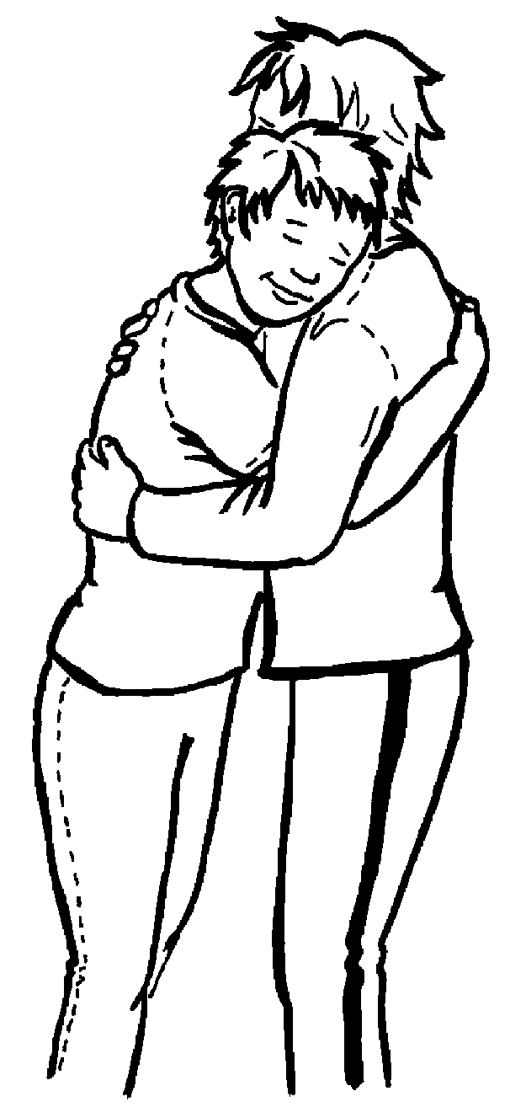

Love
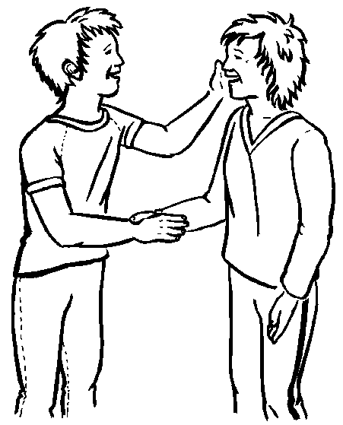

Like

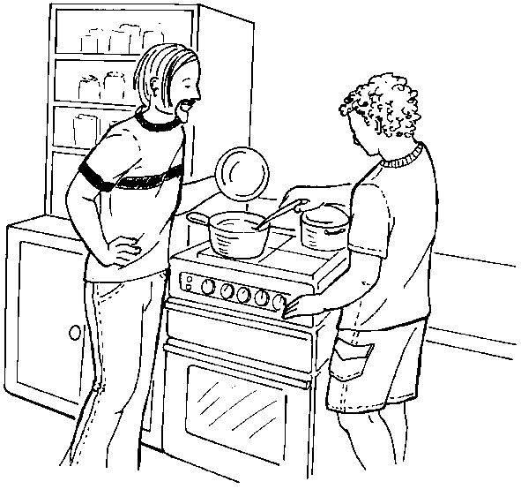

Staff

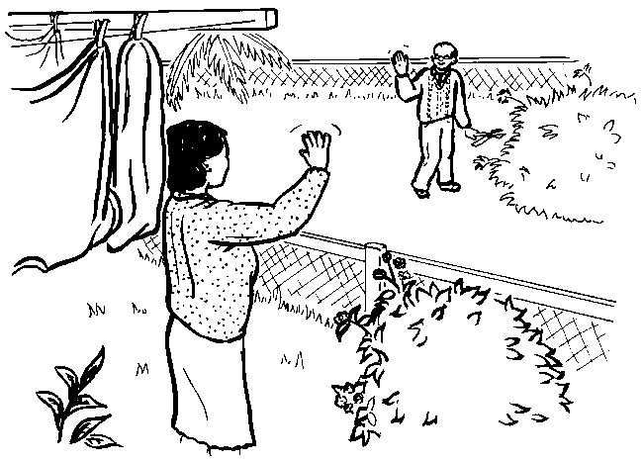

Know

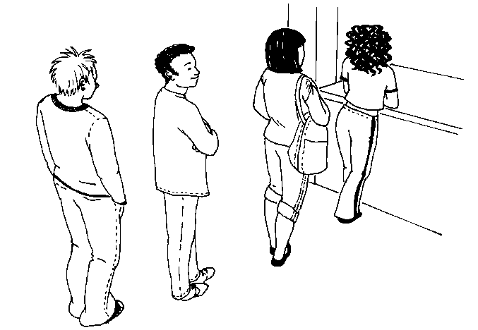Positive and Protective: Disability v1-2016 9 Document uncontrolled when printed

Don’t Know

Activity 13– Talking about relationships and touch

Children and young people with disability in care have the same types of relationships as other young people. They may also have a lot more people in their lives that are involved as a result of care.

Why is it important talk about relationships and touch as part of a self protection program?

Rules about touch
It is an important part of self protection education for children in care to be able to recognise when touch is OK or if it is a NO touch.

The following cards below are examples of a concrete resource that participants can use with people with a disability to discuss the rules about sexy touch.

Cards below adapted from FPQ (2007) Everybody Needs to Know. Brisbane: Family Planning Queensland
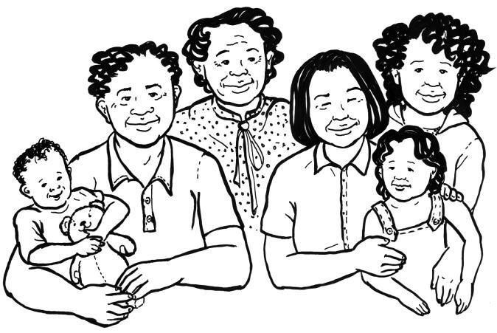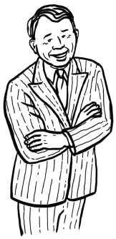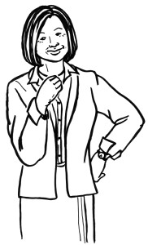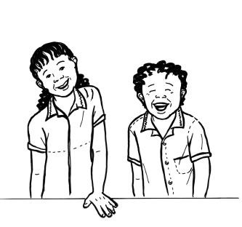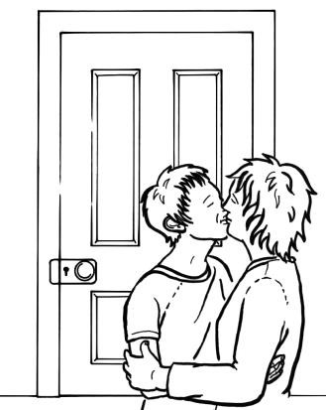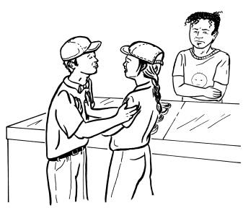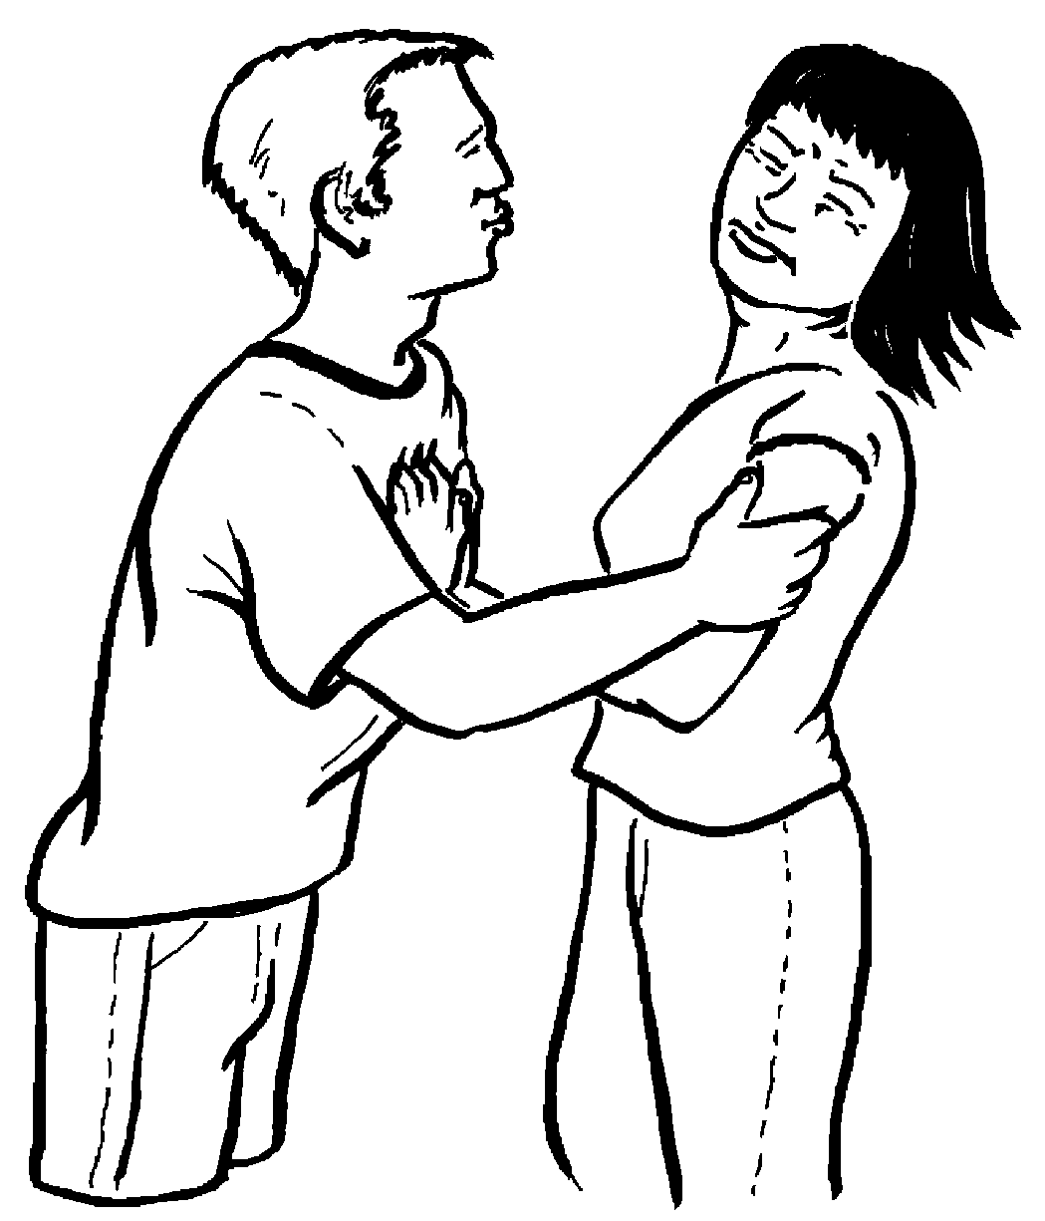

Both people want to be sexy

Sexy touch is private

Both people are old enough

Not in the same family

Activity 13 – Feelings and warning signs
It is important to discuss all feelings and not just scared feelings, when teaching self protection strategies.

Why is it important talk about different feelings as part of a self protection program?

Activity 14 – Feelings shield (part 1)

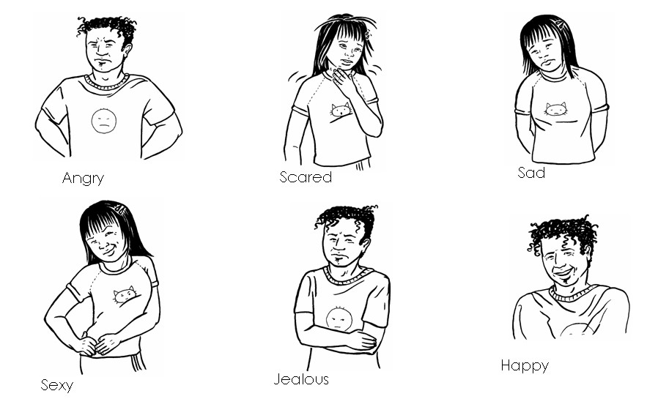Cut out the feelings to glue on the Feelings shield on the next page.

Activity 14 – Feelings shield (part 2)

Happy
Sad
Angry
Scared
Sexy
Jealous

This activity is adapted from FPQ (2007) Every Body Needs to Know. Brisbane: Family Planning Queensland

Activity 15 – Identifying early warning signs

When explaining sexual touch, it is important not to discuss this in terms of good and bad touch. The physical feelings relating to sexual assault do not always feel bad. A person may however have early warning signs and feel unsafe. This is why talking about a range of feelings is necessary. Children and young people need to know it is good to tell someone they trust about any feelings they might have. Teaching young people to recognise early warning signs is vital in learning to know when they feel unsafe, or confused, or require support.

List as many possible early warning signs as you can think of and draw these on to the body outline.

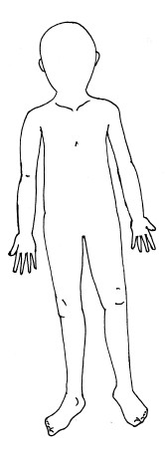

The activity is adapted from: FPQ (2007) Bodies and Relationships Essentials Education
Brisbane: Family Planning Queensland

Activity 16 – Getting help and feeling safe

Teaching self protection skills is about giving children and young people the information and skills they need to feel safe and get help.

Why is it important to teach problem solving as part of a self protection program?

Activity 17 – Safety networks

Participants are asked to complete this activity as if they were a child.
Brainstorm the trusted adults that you know personally who you could talk to, to ask for help if you were ever in a situation where you felt scared or unsafe, or who you could tell if you had been in a situation where your private body parts had been looked at or touched.

Write the names of your five trusted adults on the fingers of one hand. Brainstorm a list of official people in the community you may not know personally but who could also help. Write these names in the fingers of the other hand.

Activity 18 – Looking after you

Working and caring for children and young people who have experienced abuse can be very challenging. It is essential for all carers to have strategies in place to support themselves in times of high stress, in order to be able to still help the children and young people who you support.

What strategies do you use to look after yourself?

