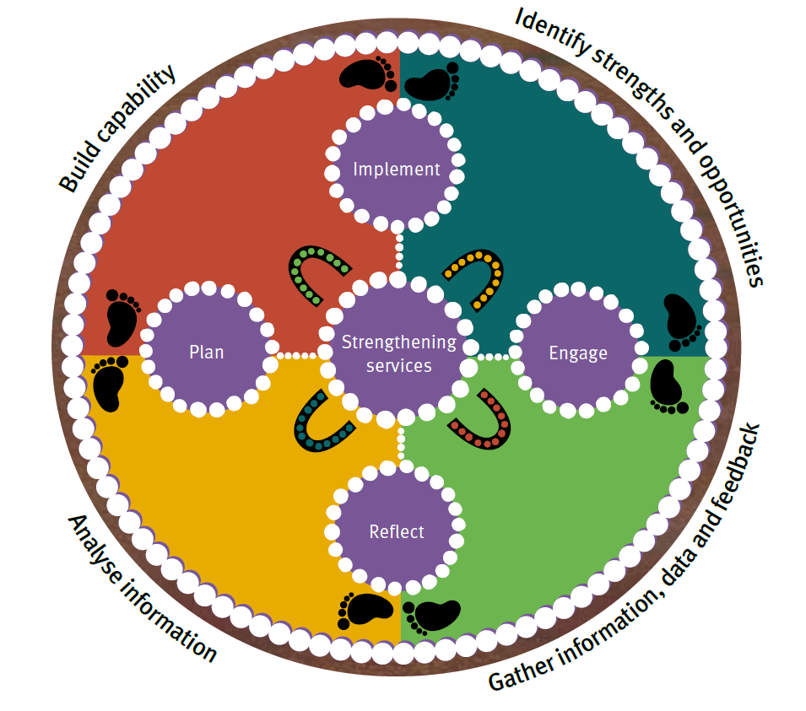
The program intends to achieve this by:

- Ensuring child protection services are of a consistently high standard and are sustainable.
- Supporting continuous improvement and strengthening practice, business systems and processes.
- Modelling the Strengthening families Protecting children Framework for practice.
- Ensuring a strong focus on improving practice and support for Aboriginal and Torres Strait Islander children, young people, parents and families.
- Influencing changes to policies and procedures to support staff to deliver effective services.
- Making assessments about performance against standards and focusing on outcomes for children, young people, parents and families.
Quality Improvement Program

The Department of Child Safety, Youth and Women (the department) has established a Quality Improvement Program (QIP) aimed at improving outcomes for children, young people, parents and families.
What is the Quality
Improvement Program?

The QIP is a series of activities designed to enhance the quality and effectiveness of service delivery for children, young people, parents and families within the child protection system.

The program has 4 main areas of focus:
- Ensuring quality practice and support that results in better outcomes for children and young people.
- Effective business systems that promote quality practice — focusing on leadership, staff training and support, stakeholder engagement, appropriate information sharing, financial management and complaints.
- Enhancing data quality and performance to assist Child Safety Service Centres (CSSCs) to identify areas for improvement and opportunities to enhance service delivery.
- Staff development opportunities which build leadership and the capability to better respond to the needs of children, young people, parents and families.

Quality Improvement
Program activities

The QIP activities support a child protection system which enables children and young people to be cared for, protected, safe and able to reach their full potential.

There are 5 main activities within the program.

1. Continuous Quality Improvement process

The Continuous Quality Improvement (CQI) process is a collaborative process with the CSSC to assess service delivery against standards and quality indicators. The process aims to identify strengths, areas of effective practice and opportunities for improvement. All child protection service delivery units starting with CSSCs across the state will participate in a CQI process. This process will result in the development and implementation of a CSSC improvement plan to continue to build on what is working well and respond to areas for improvement.

2. Focused analysis

A focused analysis is an in-depth analysis of a specific area of service delivery to identify areas for improvement.

3. Priority analysis

A priority analysis is undertaken when a CSSC or a region identifies an area which requires additional support to improve service delivery.

4. Data quality and performance

A key activity of the QIP is to strengthen data quality and enhance the department’s capability in analysing, monitoring and reporting on the performance of the system.

5. Management and leadership development

A further activity of the QIP is to build the existing suite of leadership programs to provide targeted management and leadership development programs for child safety staff, particularly those in leadership positions.

What changes might I see?

The QIP will help the department gather information, review current practice, systems and processes, and use data and analysis to identify what works well and areas for improvement. The implementation of the program activities will result in:
- robust and effective business processes and resource management
- well-developed leadership and management capability
- a strong focus on operational performance, including data analytics
- good quality practice expertise that ensures child protection services are of a consistently high standard
- improved outcomes for children, young people, parents and families.

How can I find out more?

Email QIP@csyw.qld.gov.au
www.csyw.qld.gov.au/qip

