Mandatory Reporting—Department of Education

The **Unify Program** has commenced a four-year program to replace its Integrated Client Management System (ICMS), the core information system used by the Department of Children, Youth Justice and Multicultural Affairs.

The Unify Program will streamline processes and introduce more contemporary technology to support improved engagement with children, young people, families and carers.

What is Mandatory Reporting?

Under the Child Protection Act 1999, mandatory reporters include teachers who are employed at a school. Mandatory reporters must report to Child Safety when there are concerns a child has experienced significant harm caused by physical or sexual abuse and the child doesn’t have a parent willing and able to keep them safe.

The Mandatory Reporting—DoE module of the Unify solution is a reliable delivery channel for Department of Education (DoE) student protection reports. It is critical that this exchange of information occurs in a way that is reliable and secure and helps DCYJMA or other services to provide accurate and timely responses to children and families.

Solution features

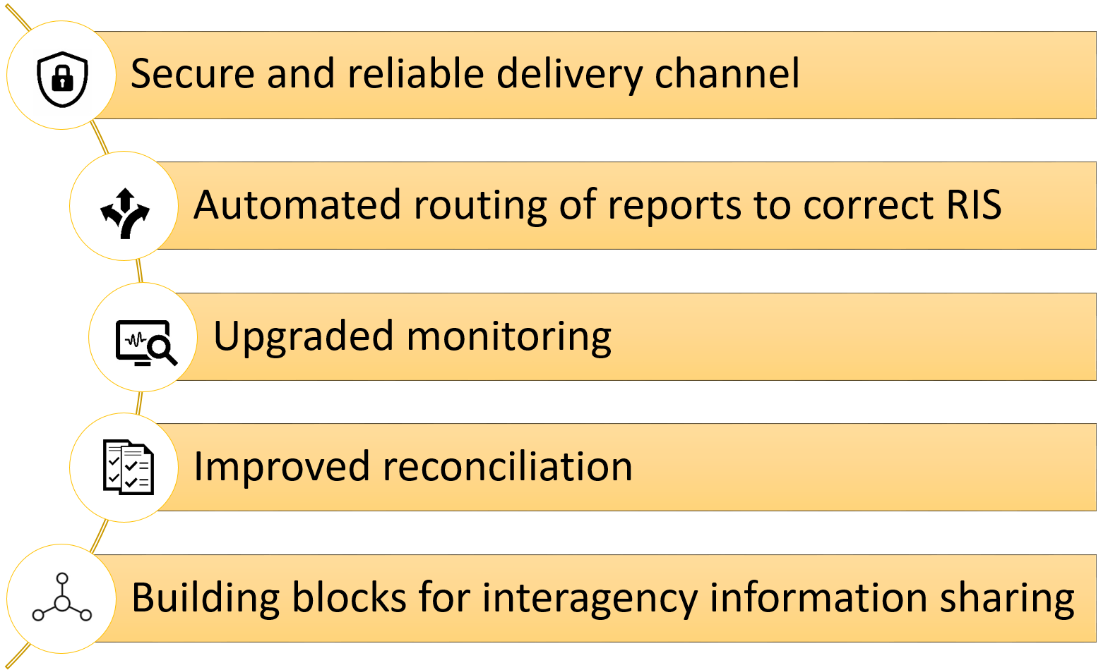

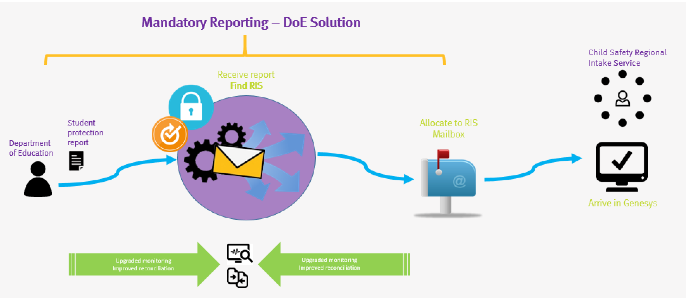

What’s different?

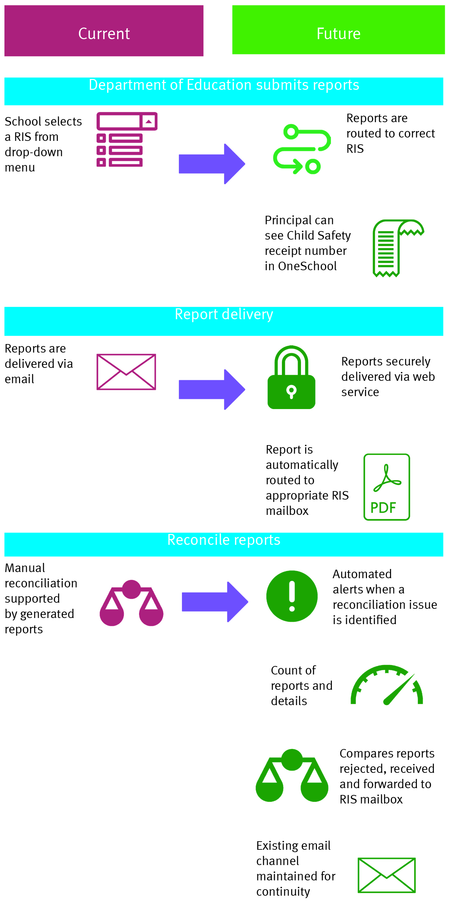

Future opportunities for future stages of Mandatory Reporting

Supporting the outcomes of the Intake review

Effective self-service methods to support notifiers to report an issue, such as updates to the Child Protection Guide

Reliable and consistent reporting channels for notifiers

Consistent receipt channel by RIS staff

Support a managed clarification messaging process that doesn’t rely on email

Strong links to Intake to support outcome reporting

Optimisation of reports routed to RIS or the secondary sector

Improved ability to identify client journeys through the service system

How can I find out more?

Email: [Unify@cyjma.qld.gov.au](mailto:Unify@cyjma.qld.gov.au)