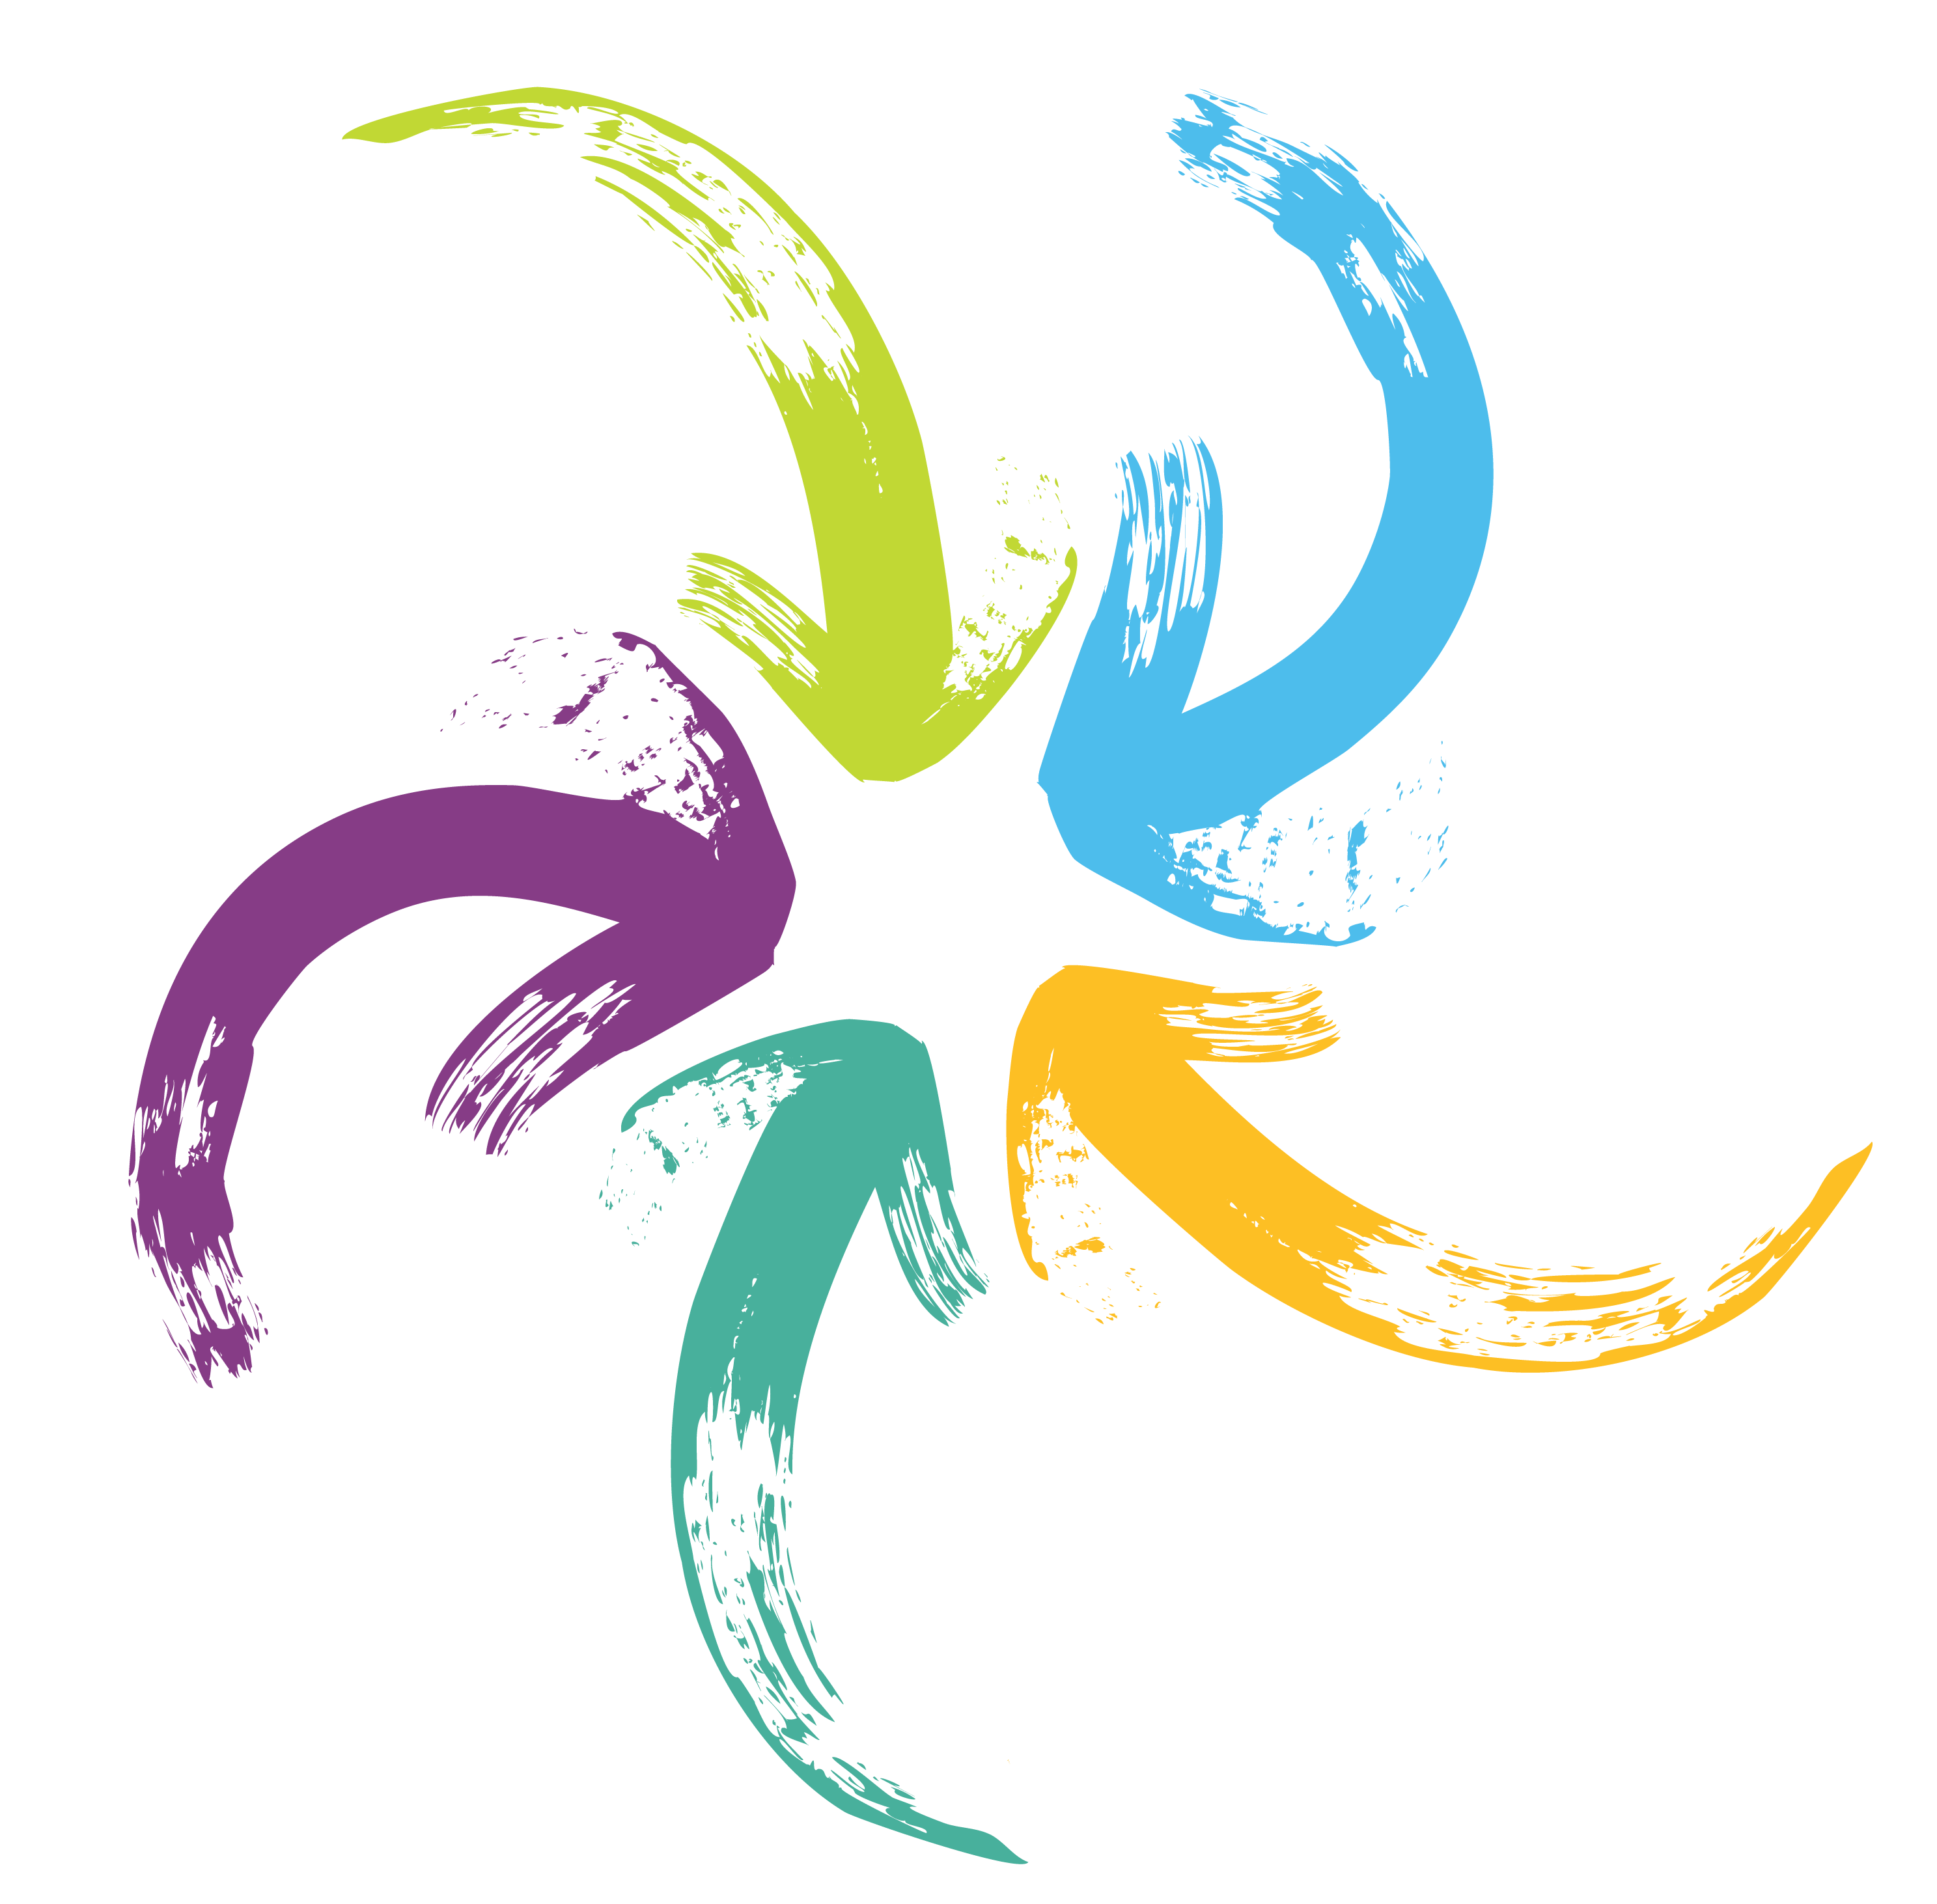

“To ensure Queensland families, children and young people are cared for, protected, safe and able to reach their full potential through improved capability for our frontline staff, government agencies and partners to share information and integrate service delivery.”
The Department of Children, Youth Justice and Multicultural Affairs (DCYJMA) is undertaking a four- year journey to replace our existing integrated client management system (ICMS). It is more than just the replacement of the core Child Safety and Youth Justice ICT system it has a broad focus on:
supporting staff
continuing service reforms, and
enabling more streamlined processes.
The new system will also Improve information sharing and collaboration across Queensland Government and with the social services and justice sectors. This new core Child Safety and Youth Justice system is called Unify.
It will build on the work already well underway with digital initiatives such as iDOCS, OurChild, CarerConnect, KicBox, CourtShare and CSXpress.
Our staff and stakeholders will play a crucial role in the success of this Program.

It aims to:
Implement a new contemporary and coordinated case management system for vulnerable children, young people and families.
Improve how we do business.

It will be:
Client-centric: supporting targeted, needs- based responses to children, young people, parents, families, carers and communities while delivering earlier and more effective interventions
Data driven: improving how we manage data to enable the effective monitoring of outcomes and ensuring that future investment is directed to what works; and
Integration-enabling: designed around collaboration and information sharing, enabling connected and integrated responses to clients across government agencies and non- government partners.

What does it involve?
The Program will be delivered in three stages over four years and within each stage it will involve three key areas of focus -
Child and Family Unify Project: A Queensland where our children are safer.
Youth Justice Unify Project: Improved pathways for youth to transition into the community.
Technology Foundations: platform, data and integration services to migrate from existing systems.

Key benefits
The Program will deliver significant benefits to clients and the community. It will improve the efficiency and effectiveness of service system and the ability to make changes to the Information and Communication Technology (ICT) system, to align to legislation, policy and practice.
Benefits include:
- Clients are able to access and contribute content: Increased ability for clients to access and contribute appropriate information about themselves and the services received or needed
- Better client service matching: Improved ability to analyse outcomes and compare effectiveness of service provision
- Better department investments: Increased ability to draw insights from data to better align risks and need, and enable more informed decision investment decisions
- More time for service delivery: Easier to use system, giving users access to the right information, at the right time, and for the right purpose
- Better resource allocation: Improved ability to plan and manage performance, resource allocation, and workload effectively
- Expanded sharing capability: Improved access to relevant information about a client, as well as for government agencies and funded servicers to access and contribute to this view
- Better monitoring and reporting: Improved access to information ‘on demand’ and in ‘real time’ for service delivery and reporting
- Greater system adaptability: System is easily adaptable to policy, legislation and business process change
- More scalable system: Improved system scalability that is more responsive to evolving business, client groups or service provider needs.

What does success look like for the Program?
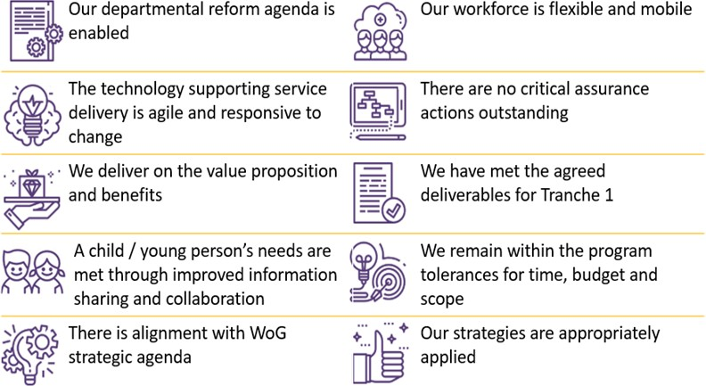

Next steps
The Restorative Justice product is going live in September 2021. Work continues on developing and delivering new Child Safety functionality including:
- Streamlined care arrangement referral processes to assist in faster identification and matching of available foster carers and care providers
- Improved information sharing and collaboration with Education, Queensland Police Service, Queensland Health, early childhood and doctors
- Enhanced system supported intake functionalities including interface between Unify and Genesys, pre-population of certain requests for information and referrals

How can I find out more about Unify?
If you have a question or would like to know more about Unify:
email the Unify team - Unify@cyjma.qld.gov.au

