# About Unify

* A four year program to replace the Integrated Client Management System (ICMS).
* It's more than just the replacement of the core Child Safety and Youth Justice ICT system - it will have a broad focus on supporting staff, continuing service reforms and enabling more streamlined processes.
* Unify will improve information sharing and collaboration across Queensland Government, social services and justice sectors while engaging with young people, families, carers and services.
* Unify will also implement a contemporary case and client management system that will enable the best outcomes for vulnerable children, young people and their families.

# What Success Will Look Like

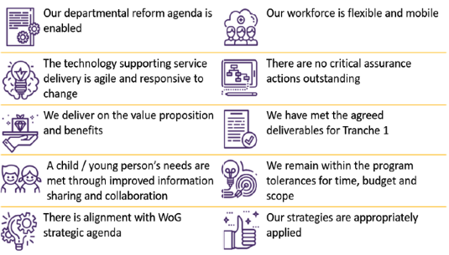

# Program Benefits

*Enabling connections for children, young people and families.*

V4 August 2021

|  |  |  |
| --- | --- | --- |
| **1** | Client's able to access and contribute content | Increased ability for clients to access and contribute appropriate information about themselves and the services received or needed |
| **2** | Better client service matching | Improved ability to analyse outcomes and compare effectiveness of service provision |
| **3** | Better department investments | Increased ability to draw insights from data to better align risks and need, and enable more informed investment decisions |
| **4** | More time for service delivery | Easier to use system, giving users access to the right information, at the right time, and for the right purpose |
| **5** | Better resource allocation | Improved ability to plan and manage performance, resource allocation, and workflow effectively. |
| **6** | Expanded sharing capability | Improved access to relevant information about a client, as well as for government agencies and funded service providers to access and contribute to this view. |
| **7** | Better monitoring and reporting | Improved access to information 'on demand' and in 'real time' for service delivery and reporting. |
| **8** | Greater system adaptability | System is easily adaptable to policy, legislation and business process change. |
| **9** | More scalable system | Improved system scalability that is more responsive to evolving business, client groups or service provider needs. |

# Unify Timeline

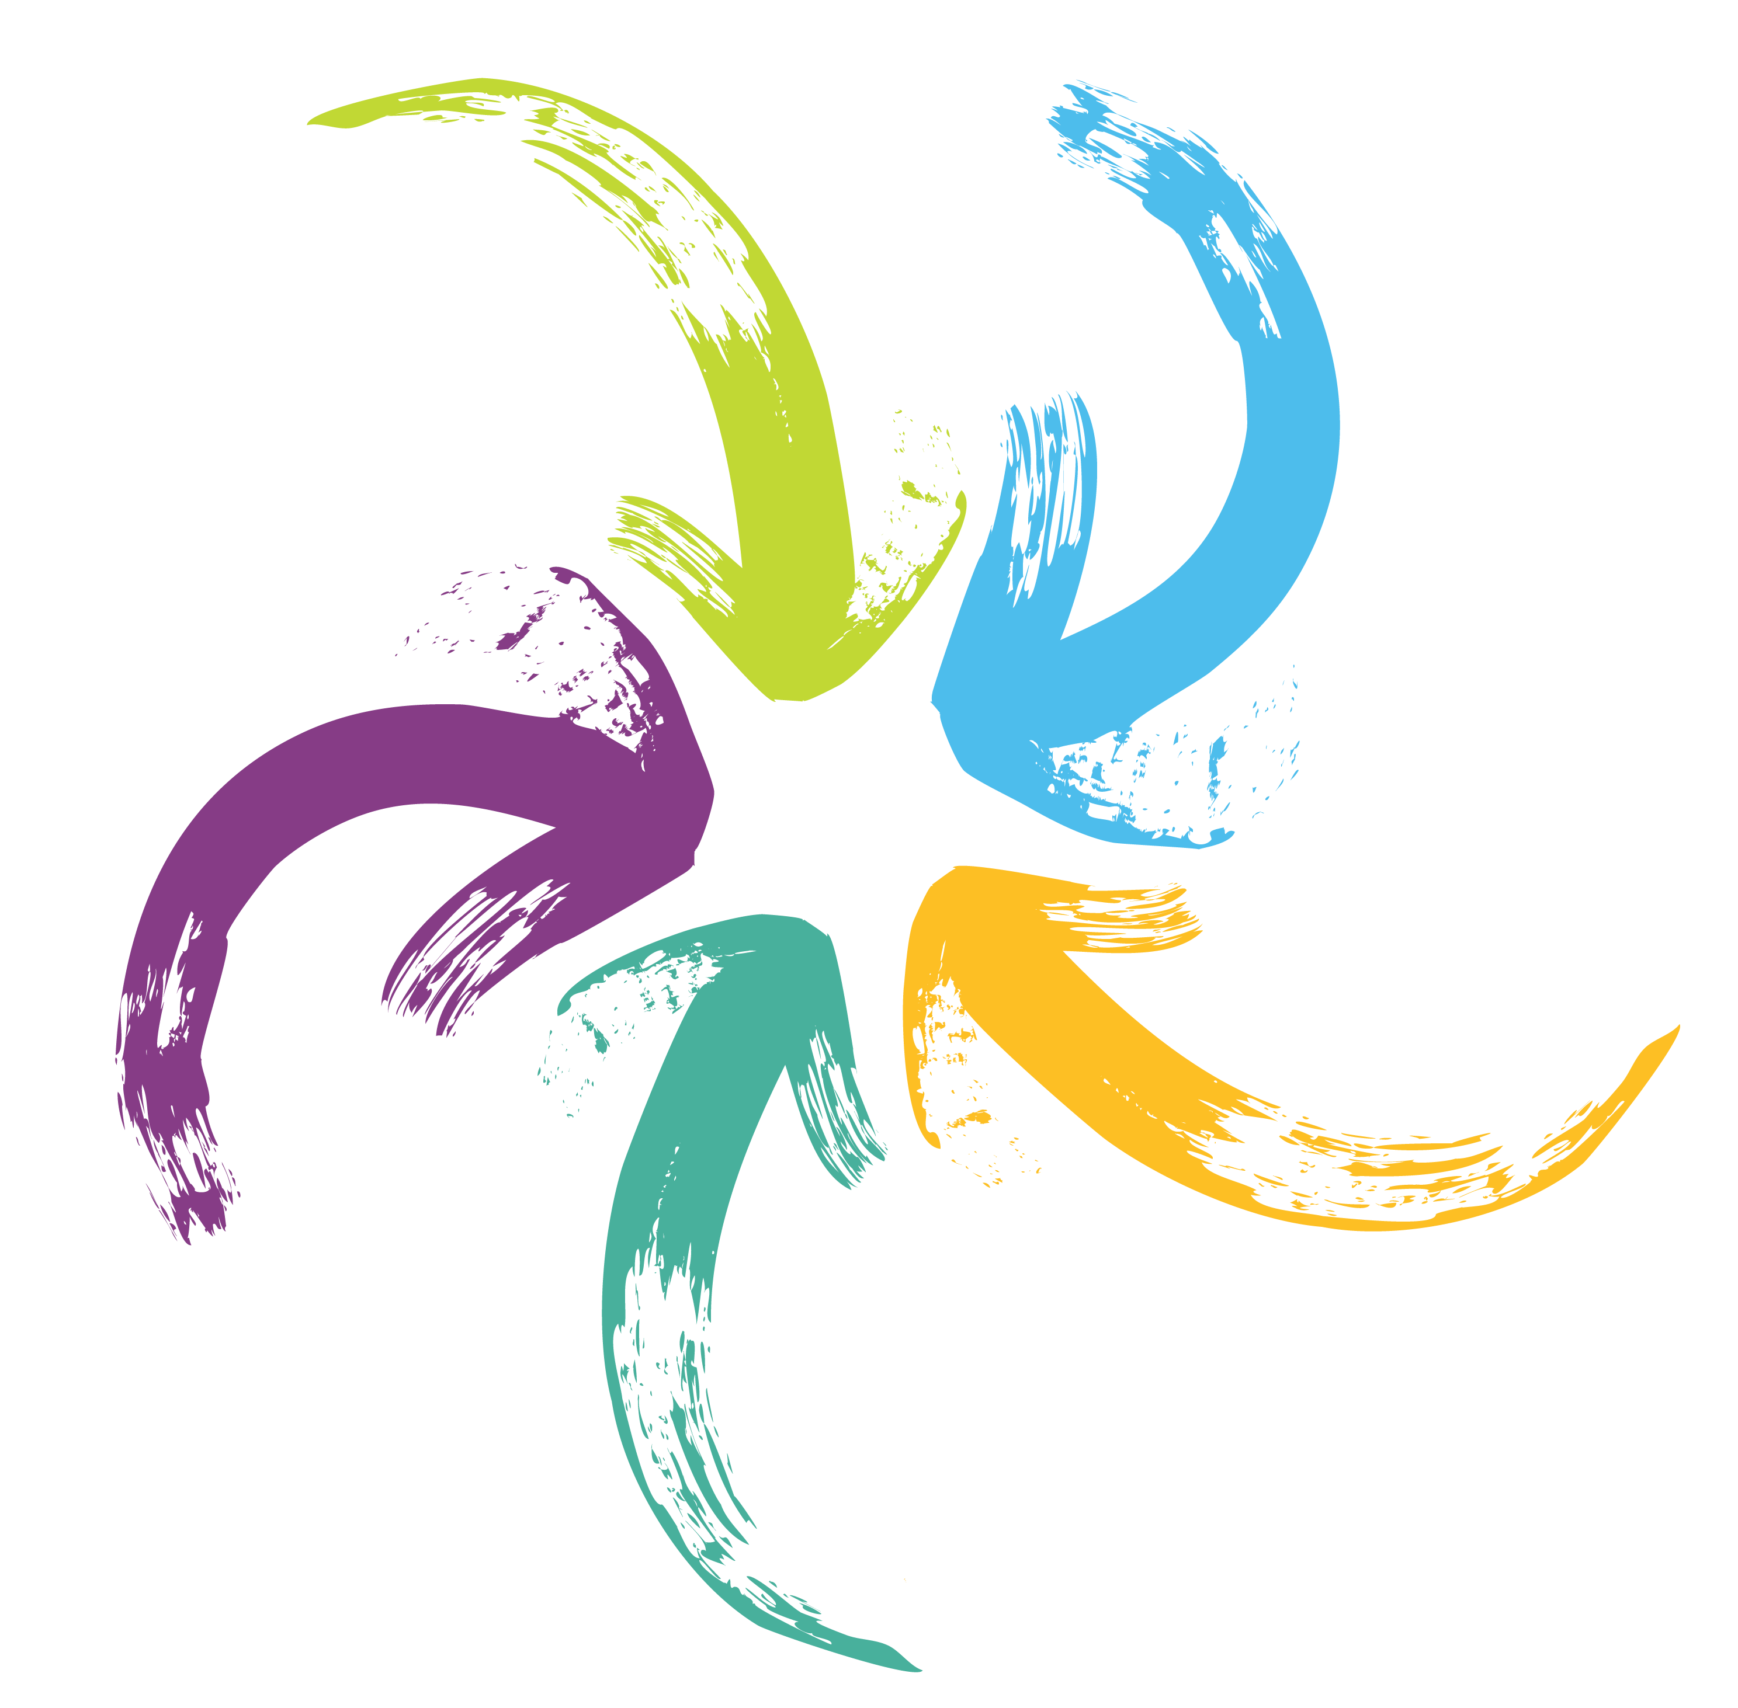We’re taking a staged approach to deliver new and improved services and products.

**Stage 1**

**Stage 2**

**Stage 3**

Building a   
client-centric system

Transforming the Business

Embedding the new ways of working

# Program Leadership Team

The program leadership team consists of two Accountable Officers, two Lead Suppliers, and three Program Directors.



# Applying a Cultural Lens

One of the Program Principles is: Culture and Diversity is central to the design, development and delivery of Unify.

Unify has embedded a Cultural Advisor to ensure the Program remains accountable to this principle. The Cultural Advisor aims to ensure **culturally appropriate representation** occurs at all levels of the Program's governance and engagement.

## Got a question?

Email: **UnifyCC@csyw.qld.gov.au**



# System Foundations

# Activities

The new system puts clients at the heart   
of everything we do.

The foundations around which the system   
will be built are:

• People

• Cases

• Activities

# People

• Organisation

# Organisation

# Cases

*Ensuring Queensland families, children and young people are cared for, protected, safe and able to reach their full potential through improved capability for our frontline staff, government agencies and partners to share information and integrate service delivery.*

[Unify@cyjma.qld.gov.au](mailto:Unify@cyjma.qld.gov.au)

# Organisations

# Cases