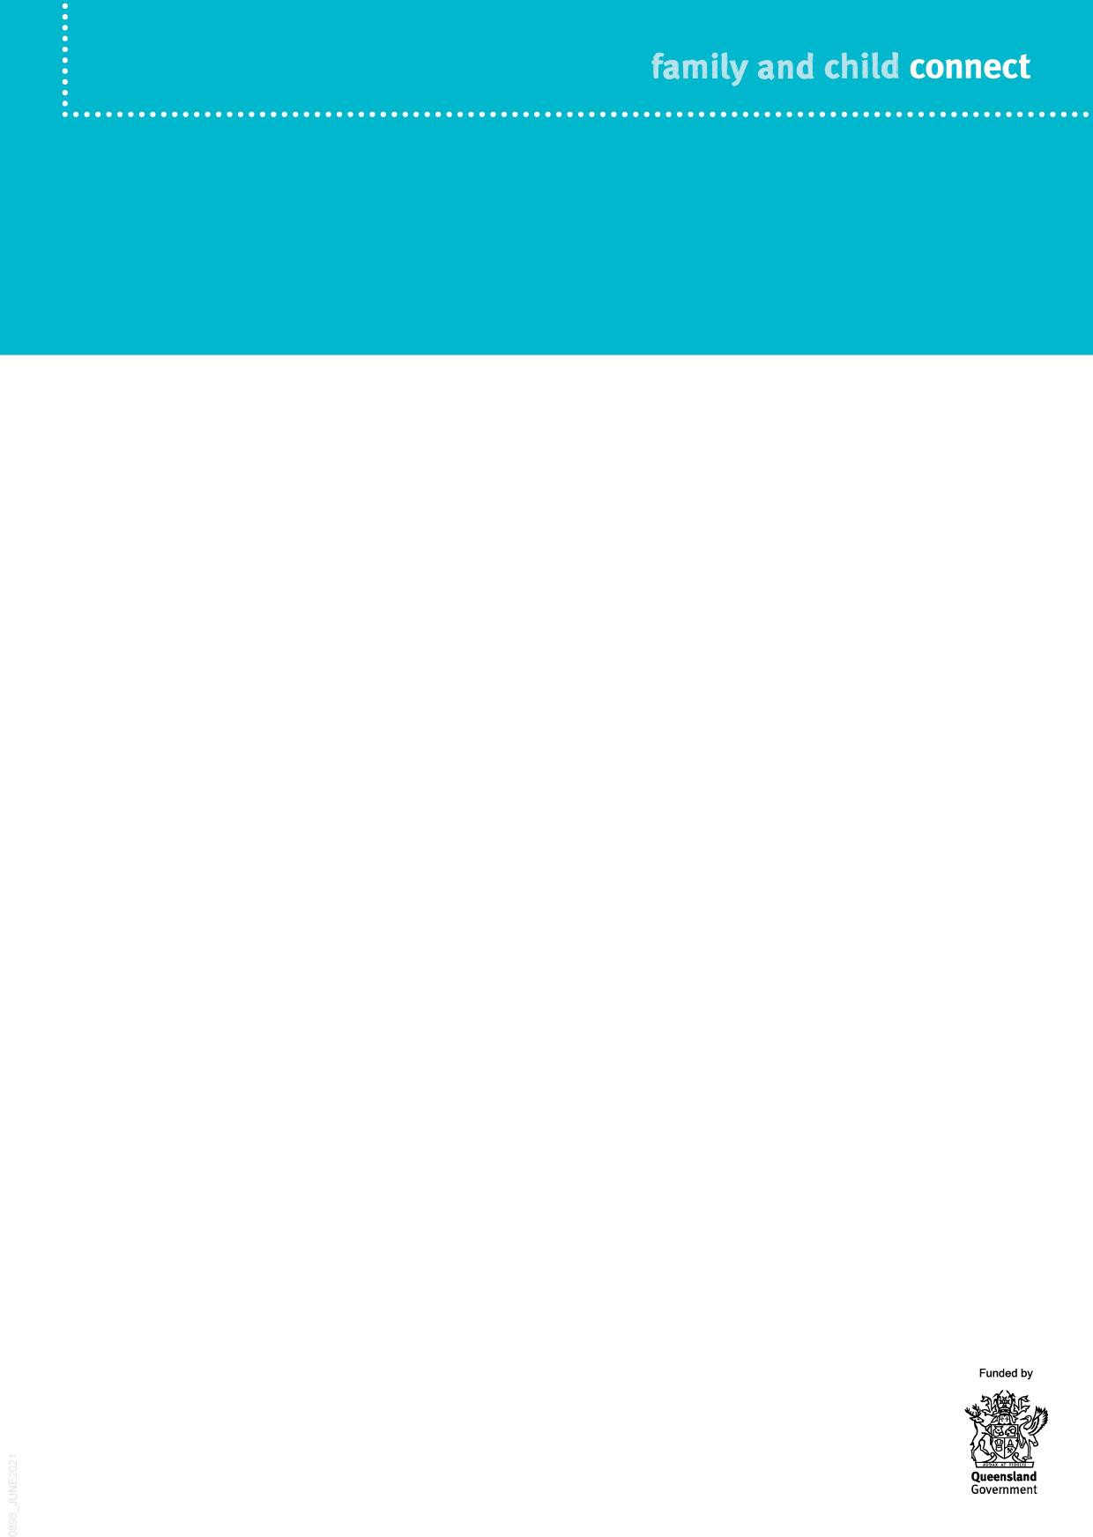

**Principal Child Protection Practitioner**

**Family and Child Connect is an easily accessible referral point for professionals working with families who may need support.**

A Principal Child Protection Practitioner is an experienced practitioner employed by the Department of Children, Youth Justice and Multicultural Affairs (the department), supporting Family and Child Connect, as well as Intensive Family Support and Aboriginal and Torres Strait Islander Family Wellbeing Services.

The Principal Child Protection Practitioner works collaboratively with local government and non-government service providers to support the earlier and more effective intervention with children and families who have been referred for help. The Principal Child Protection Practitioner provides consultancy and advice on child protection matters, as well as education on statutory child protection processes and responsibilities.

Responsibilities

The Principal Child Protection Practitioner is responsible for:

Torres Strait Islander Family Wellbeing Services.

Building the child protection expertise of these services and broader intensive secondary service providers through training and professional development initiatives.

Providing training and education (and/or training and education resources) to schools, early childhood education providers, police and health professionals, on reporting/referral behaviour to support adherence to the Child Protection Guide.

Performing a cross sector co-ordination role, establishing and maintaining effective working relationships with Family and Child Connect, Intensive Family Support and Aboriginal and Torres Strait Islander Family Wellbeing Services, broader intensive secondary services, and other government and non-government agencies to promote better collaboration between services and with the department.

Participating in meetings with these services, broader intensive secondary services, and other government and non-government organisations including the LLA, as a representative of the department.

•

•

•

•

•

Providing expert generic child protection advice and case consultation services to Family and Child Connect, Intensive Family Support and Aboriginal and

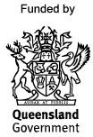

Family and Child Connect service locations

Family and Child Connect operate in the following catchments:

Further information

For more information about Family and Child Connect, go to the website: [www.familychildconnect.org.au](http://www.familychildconnect.org.au/)

•

Beenleigh/Bayside (provided by The Benevolent Society)

Brisbane North, South and South-West (provided by Kurbingui Youth & Family Development and Mercy Community) Browns Plains/Beaudesert (provided by Mercy Community)

Cairns (provided by Act for Kids, Mareeba Community Centre and Community Support Centre Innisfail) Gold Coast (provided by Act for Kids) Ipswich (provided by Kummara) Logan (provided by The Benevolent Society)

Mackay (provided by Act for Kids and Girudala Community Co-operative Society)

Maryborough/Bundaberg (provided by Churches of Christ Care)

Moreton Bay (provided by Mercy Community) Rockhampton/Gladstone/Emerald (provided by UnitingCare Community) South Burnett (provided by South Burnett CTC)

Sunshine Coast including Gympie (provided by Act for Kids) Toowoomba/Roma (provided by Mercy Community / Lifeline Darling Downs) Townsville (provided by Mercy Community)

Cape York/Torres Strait (13FAMILY calls covered by Cairns)

Mount Isa/Gulf (provided by Save the Children)

•

•

•

•

•

•

•

•

•

•

•

•

•

•

•

•