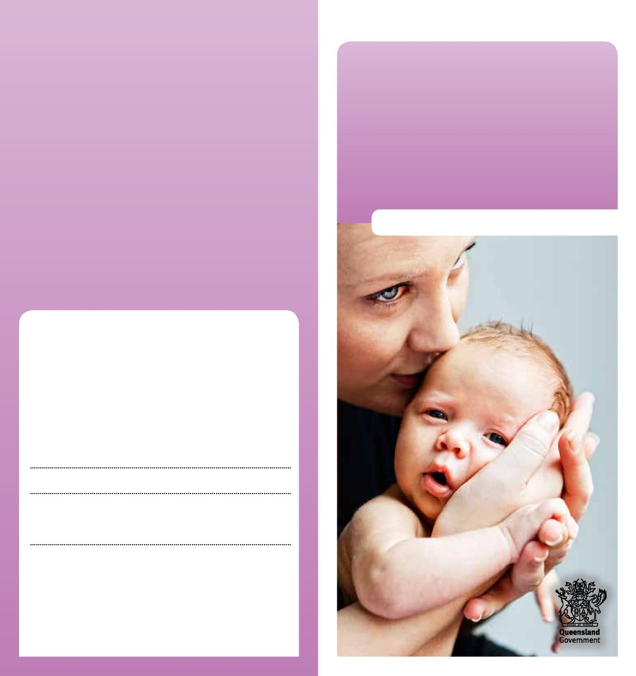
Department of Children, Youth Justice and Multicultural Affairs
Support
service case
Information for pregnant women
More information
We recognise that this may be a worrying time for you, and we want t work with you to do what’s best for your child. You can talk to us at any time about what’s happening.
Child Safety Officers:
Senior Team Leader:
Child Safety Service Centre:
Phone:
Child Safety After Hours Service Centre: Phone: 3235 9999 or freecall 1800 177 135
0959_JULY2022

Support Service Case

Caring for children and keeping them safe and well is very important. Sometimes, a pregnant woman may need some help to protect and care for her child after her baby is born.
If we’re worried about your unborn child, we may talk to you about a support service case.
What is a support service case?
A support service case is a way of working with you when we’ve assessed that your unborn baby will need protection after birth, and we want to help you make the changes needed to safely care for your child.
This may include supporting you or referring you to community support services to get the help you need.
A support service case is a voluntary agreement you have with us that lasts until your child is born.
Under a support service case, there are no court orders.
How does it work?
We’ll work with you and your family to develop a support plan that:
- sets out the changes you’d like to make to protect your unborn child
- shows the steps you can take
- includes the community support services who can help you.
We’ll meet with you regularly to make sure you’re getting the support you need. We’ll also review your support plan, if required.
Our child safety officers will keep working with you until you’ve made the changes in your support plan.
How does a support service case end?
A support service case ends when your baby is born. At that time, we’ll make an assessment about your family situation to see if we need to work with you in a different way to care for your child.
If you change your mind about working with us, the support service case will end. We’ll provide information about other community support services who can help you.

