Who are older Queenslanders?

To progress towards an age-friendly Queensland, we need to understand the characteristics of Queensland’s older population and some of the underlying demographic changes that are contributing to the ageing of Queensland’s population.

This fact sheet looks at the current population of older Queenslanders, where they live across the State, their cultural diversity, and their projected growth over time.

**Who do we mean by older Queenslanders?**

For this fact sheet, older Queenslanders (or seniors) refers to persons aged 65 years and over, unless specified otherwise in the text and charts.

# Queensland’s older population is increasing

The number of older Queenslanders has increased significantly over the last 45 years, reaching an estimated 800,000 persons in 2019, including 91,800 persons aged 85 years and older (Figure 1).

Over this period, the share of Queensland’s older population aged 85 years and over almost doubled from 6.5% in 1974 to 11.5% in 2019.

**Figure 1: Estimated population of older Queenslanders, selected years**

Over the past two decades, population ageing, driven by sustained low fertility and increasing life expectancy, has contributed to proportionally larger increases in older Queenslanders compared with younger age groups (Figure 2). Overseas migration, and to a lesser extent interstate migration, have also contributed to the population growth in older Queenslanders.

This ageing of the population has seen the share of Queensland’s population aged 65 years and over steadily increasing, reaching 15.7% in 2019 (Figure 3).

**Figure 2: Estimated population change by age group, 1999–2019**

As further cohorts of baby boomers (those born between the years 1946 and 1964) turn 65 over the next decade, this age group is projected to increase more rapidly. By 2049, 1 in 5 Queenslanders (or 21.9%) are projected to be aged 65 years or over.

The share of Queensland’s population aged 85 years and over has also been steadily increasing and is projected to reach 4.5% by 2049.

**Figure 3: Estimated and projected population of older Queenslanders, selected years**

Over the next 30 years the number of older Queenslanders aged 65 years and over is projected to more than double, reaching around 1.7 million persons by 2049. The number of Queenslanders aged 85 years and over is projected to reach more than 350,000 persons by 2049.

# Older Queenslanders are living longer

Life expectancy for both men and women continues to increase. Although women on average tend to live longer than men, men’s life expectancy is increasing at a greater rate than women’s.

**What do we mean by life expectancy?**

Life expectancy refers to the *average* number of additional years a person of a given age and sex might expect to live. It does not equate to the number of years of life any one person or group of persons will *actually* live.

In 2017, a 65-year old woman could expect to live, on average, to 87.5 years of age compared with 84.7 years for a woman aged 65 years in 1995 (Figure 4).

In 2017, a 65-year old man could expect to live, on average, to 84.6 years of age compared with 80.9 years for a man aged 65 years in 1995.

**Figure 4: Life expectancy at age 65 years by sex, 1995–2017**

The increases in life expectancy at age 65 years are mainly due to improvements in aged care management, a decline in the number of deaths from chronic conditions such as heart disease, cancer and strokes (because of medical advances), and behavioural changes such as improvements in diet and lower rates of smoking1.

In fact, persons aged 65 years and over made the largest contribution of any age group to overall life expectancy gains experienced in Queensland over the 20-year period to 2015 (Figure 5).

**Figure 5: Contribution of older Queenslanders to life expectancy gain, 1995–2015**



Higher female life expectancy significantly impacts the male to female ratio of older Queenslanders, with the number of males for every 100 females reducing from age 75 onwards (Figure 6). For example, two-thirds (65.5%) of women aged 65 years in 2017 are expected to reach their 85th birthday compared with half of their male counterparts (52.0%).

However, greater gains in male life expectancy has contributed to the male to female ratio increasing since 1995, a trend expected to continue over the short-term as improvements in male life expectancy continue to outpace those for females.

**Figure 6: Number of males per 100 females by age group, 1995 and 2019**



Looking ahead, improvements in life expectancy are expected to continue, driven by further advancements in medical technology and improvements in lifestyle behaviours.

# Older Queenslanders are culturally diverse

## Older Aboriginal and Torres Strait Islander Queenslanders

Older Aboriginal and Torres Strait Islander persons contribute greatly to the cultural diversity of Queensland’s senior population and play an important role in maintaining cultural and language systems for Aboriginal and Torres Strait Islander peoples.

**Who do we mean by older Aboriginal and Torres Strait Islander Queenslanders?**

For this fact sheet, older Aboriginal and Torres Strait Islander Queenslanders refers to persons identifying as being of Aboriginal and Torres Strait Islander origin that were aged 50 years and over, unless specified otherwise in the text and charts. This age bracket is chosen to reflect the fact that, generally, ageing-related conditions affect Aboriginal and Torres Strait Islander Queenslanders at a younger age than non-Indigenous Queenslanders.

In 2016 there were an estimated 32,400 older Aboriginal and Torres Strait Islander Queenslanders, with more than 7 in 10 (73.0%) aged between 50–64 years (Figure 7).

**Figure 7: Estimated population of older Indigenous Queenslanders, 2016**

The proportion of persons aged 50 years and over was significantly lower within Queensland’s Aboriginal and Torres Strait Islander population compared with the   
non-Indigenous population (Figure 8). Only 0.2% of Queensland’s Aboriginal and Torres Strait Islander population were aged 85 years and over.

**Figure 8: Proportion of population aged 50 years and over, 2016**



The lower proportion of older persons reflects the higher fertility and mortality rates and lower life expectancy of Aboriginal and Torres Strait Islander Queenslanders.

In 2016, a 50-year old Aboriginal and Torres Strait Islander woman could expect to live, on average, to 79.3 years of age, 2.9 years longer than her male counterpart (Figure 9). While life expectancy for Aboriginal and Torres Strait Islander Queenslanders has been increasing, there remains a significant gap compared with non-Indigenous Queenslanders, with the age group 55–79 years contributing to over half of the gap2.

**Figure 9: Life expectancy at age 50 years for Indigenous persons by sex, 2016**

Language is an important part of cultural identity for older Aboriginal and Torres Strait Islander people. The 2016 Census revealed 8.5% of older Aboriginal and Torres Strait Islander Queenslanders spoke an Australian Indigenous language in addition to English at home, with the majority of this group reporting they speak English well or very well.

## Culturally and linguistically diverse older Queenslanders

Queensland’s older population is made up of people from many different cultural and linguistic backgrounds. The 2016 Census found that almost 1 in 3 (28.8%) older Queenslanders were born overseas, from across 170 countries, compared with 22.3% of Queenslanders aged under 65 years.

Of those older Queenslanders born overseas, more than half (57.9%) were born in countries from which Australia receives, or has received, significant numbers of overseas settlers who are likely to speak English3.

England was the top source country for overseas-born older Queenslanders, accounting for almost 1 in 10 of the total senior population (9.2%) (Figure 10).   
One-quarter of all overseas-born seniors arrived in Australia between 1966–1975.

**Figure 10: Snapshot of overseas-born Queensland seniors, Census 2016**

The 2016 Census found 8.1% of older Queenslanders spoke a language other than English at home, with around three-quarters of this group reporting they speak English well or very well. The top five languages other than English spoken at home by Queensland seniors were Italian, German, Cantonese, Greek and Mandarin.

# Most older Queenslanders live in the south east

Consistent with the geographic distribution of Queensland’s total population, the largest numbers of older persons live in south east Queensland, with the local government areas (LGAs) of Brisbane, Gold Coast, Moreton Bay, Sunshine Coast, Logan, Toowoomba and Redland recording the largest numbers in 2016 (Appendix A).

In contrast, when looking at the LGAs with the highest proportions of older people in 2016, all LGAs with at least 20% older residents were located outside of south east Queensland, except for Noosa (Figure 11). Hinchinbrook and Fraser Coast had the highest proportions of older persons, accounting for around 1 in 4 of their residents.

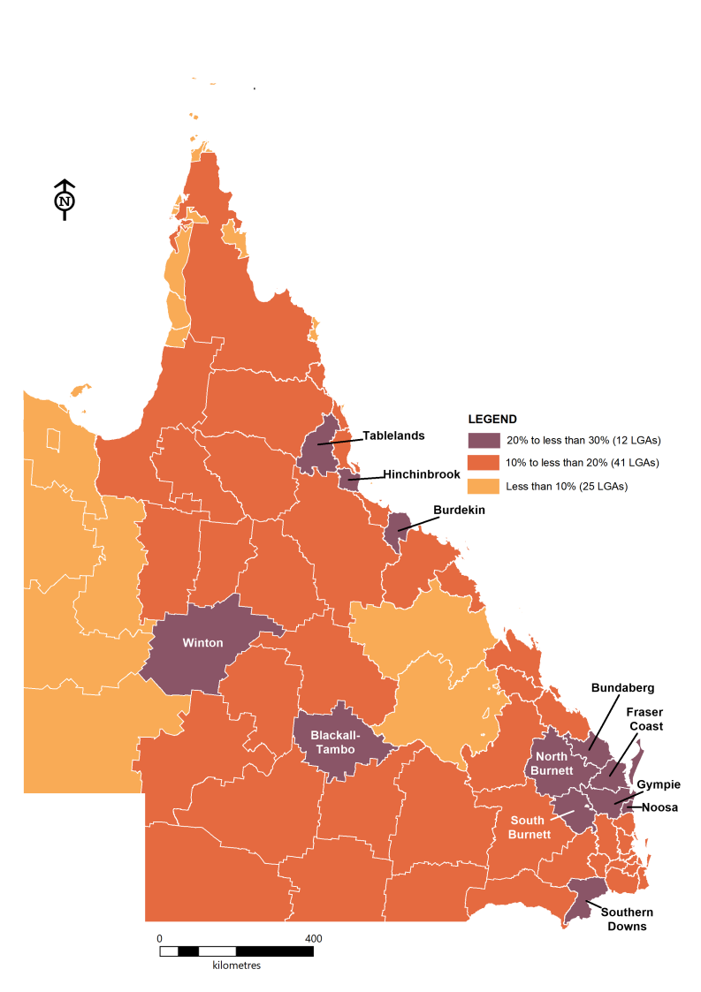**Figure 11: Estimated share of population aged 65 years and over, by LGA, 2016**

**Top 10 LGAs by % 65 years and over**

|  |  |  |  |
| --- | --- | --- | --- |
| **Rank** | **LGA** | **Number 65+**  35.0  33.2  32.5  31.9  31.6 | **% 65+** |
| **1** | Hinchinbrook (S) | 2,878 | 26.2 |
| **2** | Fraser Coast (R) | 26,260 | 25.5 |
| **3** | Noosa (S) | 12,558 | 23.3 |
| **4** | North Burnett (R) | 2,446 | 23.0 |
| **5** | Tablelands (R) | 5,754 | 22.8 |
| **6** | Bundaberg (R) | 21,122 | 22.4 |
| **7** | Southern Downs (R) | 7,901 | 22.2 |
| **8** | South Burnett (R) | 7,211 | 22.1 |
| **9** | Gympie (R) | 10,953 | 21.8 |
| **10** | Winton (S) | 243 | 21.1 |
| *(R) = Regional Council (S) = Shire* | | | |

By 2036 it is projected that eight LGAs will have more than 30% of their residents aged 65 years and over, with Fraser Coast projected to become the LGA with the highest proportion, followed by Hinchinbrook (Figure 12). Blackall-Tambo is projected to become the LGA with the highest proportion of persons aged 85 years and over (Appendix A).

**Figure 12: Projected share of population aged 65 years and over, by LGA, 2036**

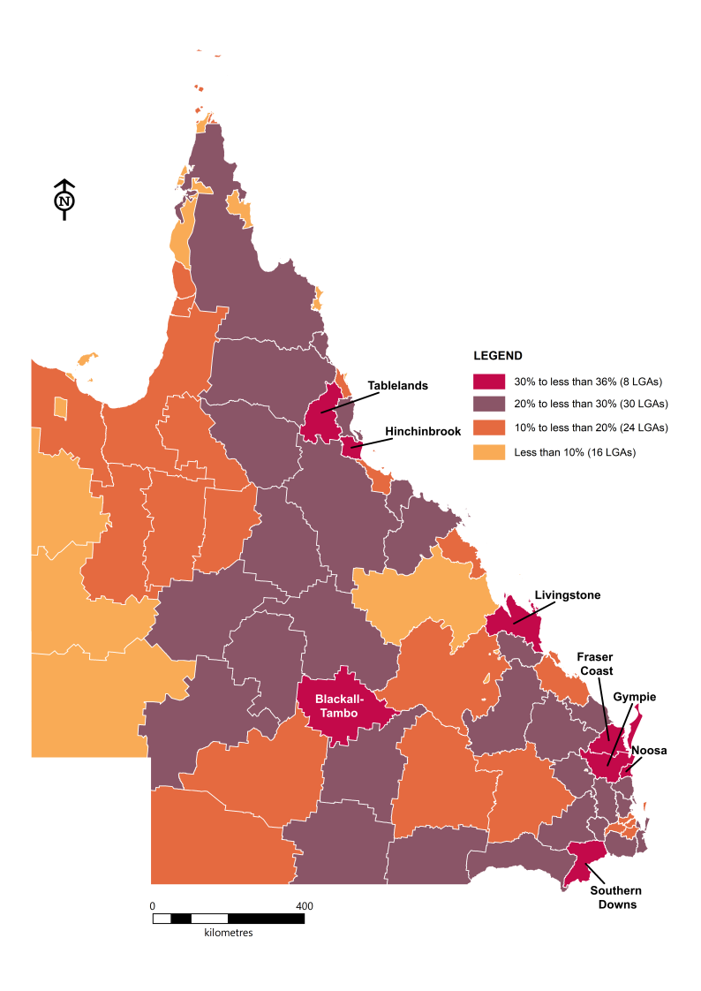

**Top 10 LGAs by % 65 years and over**

|  |  |  |  |
| --- | --- | --- | --- |
| **Rank** | **LGA** | **Number 65+**  35.0  33.2  32.5  31.9  31.6 | **% 65+** |
| **1** | Fraser Coast (R) | 43,995 | 35.0 |
| **2** | Hinchinbrook (S) | 3,075 | 33.2 |
| **3** | Southern Downs (R) | 12,458 | 32.5 |
| **4** | Noosa (S) | 20,201 | 31.9 |
| **5** | Livingstone (S) | 16,262 | 31.6 |
| **6** | Tablelands (R) | 9,002 | 30.8 |
| **7** | Gympie (R) | 17,940 | 30.7 |
| **8** | Blackall-Tambo (R) | 513 | 30.6 |
| **9** | South Burnett (R) | 10,788 | 29.7 |
| **10** | Flinders (S) | 358 | 29.7 |
| *(R) = Regional Council (S) = Shire* | | | |

Appendix A: Older persons by LGA, 2016 and 2036

|  |  |  |  |  |  |  |
| --- | --- | --- | --- | --- | --- | --- |
| **LGA name** | **Population aged 65 years and over** | | | **Population aged 85 years and over** | | |
| *In alphabetical order* | 2016 | 2016 | 2036 | 2016 | 2016 | 2036 |
|  | Number | Proportion | Proportion | Number | Proportion | Proportion |
| Aurukun (S) | 41 | 3.1 | 9.9 | 0 | 0.0 | 0.6 |
| Balonne (S) | 660 | 14.8 | 26.1 | 61 | 1.4 | 3.4 |
| Banana (S) | 1,947 | 13.4 | 22.3 | 200 | 1.4 | 4.0 |
| Barcaldine (R) | 511 | 17.6 | 28.3 | 47 | 1.6 | 4.3 |
| Barcoo (S) | 40 | 14.7 | 27.9 | 2 | 0.7 | 2.4 |
| Blackall-Tambo (R) | 404 | 21.0 | 30.6 | 37 | 1.9 | 6.4 |
| Boulia (S) | 40 | 9.2 | 7.7 | 0 | 0.0 | 1.3 |
| Brisbane (C) | 143,925 | 12.1 | 16.2 | 21,068 | 1.8 | 2.7 |
| Bulloo (S) | 41 | 11.5 | 13.1 | 4 | 1.1 | 2.1 |
| Bundaberg (R) | 21,122 | 22.4 | 28.5 | 2,333 | 2.5 | 4.4 |
| Burdekin (S) | 3,558 | 20.5 | 27.1 | 460 | 2.7 | 4.0 |
| Burke (S) | 25 | 7.3 | 12.2 | 0 | 0.0 | 4.1 |
| Cairns (R) | 19,659 | 12.2 | 18.2 | 1,876 | 1.2 | 2.5 |
| Carpentaria (S) | 272 | 13.3 | 16.9 | 6 | 0.3 | 1.6 |
| Cassowary Coast (R) | 5,539 | 18.9 | 26.7 | 657 | 2.2 | 4.0 |
| Central Highlands (R) | 2,067 | 7.2 | 15.3 | 128 | 0.4 | 2.0 |
| Charters Towers (R) | 2,136 | 17.7 | 24.6 | 189 | 1.6 | 4.2 |
| Cherbourg (S) | 57 | 4.4 | 3.9 | 5 | 0.4 | 0.0 |
| Cloncurry (S) | 267 | 8.5 | 12.3 | 13 | 0.4 | 1.2 |
| Cook (S) | 680 | 15.8 | 25.9 | 32 | 0.7 | 3.3 |
| Croydon (S) | 34 | 11.5 | 17.5 | 6 | 2.0 | 3.8 |
| Diamantina (S) | 17 | 5.7 | 4.5 | 0 | 0.0 | 0.0 |
| Doomadgee (S) | 30 | 2.0 | 1.7 | 0 | 0.0 | 0.3 |
| Douglas (S) | 1,941 | 16.1 | 27.3 | 154 | 1.3 | 3.5 |
| Etheridge (S) | 156 | 19.3 | 27.8 | 3 | 0.4 | 2.9 |
| Flinders (S) | 305 | 19.3 | 29.7 | 32 | 2.0 | 3.6 |
| Fraser Coast (R) | 26,260 | 25.5 | 35.0 | 2,519 | 2.4 | 5.3 |
| Gladstone (R) | 6,285 | 10.0 | 17.1 | 467 | 0.7 | 2.2 |
| Gold Coast (C) | 91,782 | 16.0 | 20.0 | 11,902 | 2.1 | 3.2 |
| Goondiwindi (R) | 1,829 | 16.9 | 25.0 | 192 | 1.8 | 4.2 |
| Gympie (R) | 10,953 | 21.8 | 30.7 | 1,051 | 2.1 | 4.3 |
| Hinchinbrook (S) | 2,878 | 26.2 | 33.2 | 413 | 3.8 | 6.1 |
| Hope Vale (S) | 56 | 5.5 | 7.6 | 6 | 0.6 | 1.2 |
| Ipswich (C) | 20,526 | 10.3 | 14.9 | 2,148 | 1.1 | 2.1 |
| Isaac (R) | 1,089 | 5.1 | 8.0 | 55 | 0.3 | 0.8 |
| Kowanyama (S) | 30 | 3.1 | 11.7 | 3 | 0.3 | 1.3 |
| Livingstone (S) | 6,301 | 17.1 | 31.6 | 676 | 1.8 | 5.5 |
| Lockhart River (S) | 37 | 5.0 | 4.3 | 2 | 0.3 | 0.3 |
| Lockyer Valley (R) | 6,179 | 15.6 | 22.4 | 578 | 1.5 | 3.5 |
| Logan (C) | 36,241 | 11.5 | 17.5 | 3,206 | 1.0 | 2.4 |
| Longreach (R) | 544 | 14.6 | 26.4 | 57 | 1.5 | 4.2 |
| Mackay (R) | 14,773 | 12.6 | 19.3 | 1,555 | 1.3 | 2.9 |
| Mapoon (S) | 18 | 5.7 | 9.4 | 1 | 0.3 | 0.9 |
| Maranoa (R) | 1,835 | 14.2 | 17.9 | 244 | 1.9 | 2.9 |
| Mareeba (S) | 4,064 | 18.4 | 25.6 | 367 | 1.7 | 3.9 |
| McKinlay (S) | 100 | 12.3 | 19.7 | 6 | 0.7 | 2.8 |
| Moreton Bay (R) | 66,272 | 15.1 | 21.6 | 7,406 | 1.7 | 3.3 |
| Mornington (S) | 62 | 5.2 | 7.5 | 0 | 0.0 | 0.4 |
| Mount Isa (C) | 1,319 | 6.7 | 9.7 | 61 | 0.3 | 0.9 |
| Murweh (S) | 664 | 15.1 | 22.5 | 99 | 2.3 | 3.1 |
| Napranum (S) | 29 | 2.9 | 7.3 | 0 | 0.0 | 0.6 |
| Noosa (S) | 12,558 | 23.3 | 31.9 | 1,371 | 2.5 | 5.3 |
| North Burnett (R) | 2,446 | 23.0 | 29.1 | 293 | 2.8 | 5.2 |
| Northern Peninsula Area (R) | 97 | 3.3 | 8.1 | 4 | 0.1 | 0.9 |
| Palm Island (S) | 62 | 2.4 | 10.5 | 0 | 0.0 | 0.6 |
| Paroo (S) | 300 | 18.0 | 28.8 | 28 | 1.7 | 3.3 |
| Pormpuraaw (S) | 42 | 5.4 | 14.1 | 0 | 0.0 | 1.3 |
| Quilpie (S) | 106 | 12.8 | 19.4 | 7 | 0.8 | 2.7 |
| Redland (C) | 26,298 | 17.3 | 27.2 | 3,315 | 2.2 | 4.3 |
| Richmond (S) | 103 | 12.8 | 17.7 | 1 | 0.1 | 2.6 |
| Rockhampton (R) | 11,659 | 14.3 | 22.5 | 1,539 | 1.9 | 3.9 |
| Scenic Rim (R) | 8,035 | 19.6 | 28.1 | 817 | 2.0 | 4.8 |
| Somerset (R) | 4,514 | 17.9 | 26.2 | 344 | 1.4 | 3.6 |
| South Burnett (R) | 7,211 | 22.1 | 29.7 | 698 | 2.1 | 4.4 |
| Southern Downs (R) | 7,901 | 22.2 | 32.5 | 894 | 2.5 | 5.5 |
| Sunshine Coast (R) | 59,563 | 19.7 | 24.9 | 7,709 | 2.5 | 4.4 |
| Tablelands (R) | 5,754 | 22.8 | 30.8 | 618 | 2.5 | 4.6 |
| Toowoomba (R) | 28,128 | 17.1 | 22.9 | 3,786 | 2.3 | 4.1 |
| Torres (S) | 188 | 4.9 | 11.8 | 10 | 0.3 | 1.0 |
| Torres Strait Island (R) | 223 | 4.7 | 10.7 | 4 | 0.1 | 1.1 |
| Townsville (C) | 22,037 | 11.5 | 17.3 | 2,155 | 1.1 | 2.5 |
| Weipa (T) | 92 | 2.3 | 12.2 | 0 | 0.0 | 0.6 |
| Western Downs (R) | 5,115 | 15.0 | 18.3 | 582 | 1.7 | 2.7 |
| Whitsunday (R) | 4,822 | 14.0 | 20.2 | 397 | 1.1 | 2.7 |
| Winton (S) | 243 | 21.1 | 29.4 | 27 | 2.3 | 5.0 |
| Woorabinda (S) | 33 | 3.3 | 7.7 | 0 | 0.0 | 0.8 |
| Wujal Wujal (S) | 13 | 4.5 | 3.3 | 4 | 1.4 | 0.0 |
| Yarrabah (S) | 82 | 3.0 | 7.9 | 0 | 0.0 | 0.5 |
| *(C) = City     (R) = Regional Council     (S) = Shire    (T) = Town* | | | | | | |

References

1. Australian Bureau of Statistics (ABS) 4125.0, *Gender Indicators, Australia*, Jan 2013, published 30 January 2013.
2. Queensland Health, *Closing the gap performance report 2016*, published March 2017.
3. Based on the concept of ‘main English-speaking countries’ as outlined in ABS 3415.0, *Migrant Data Matrices*, 2017, published 19 July 2017. See data note (h) for a list of countries included in this estimate. The list is not an attempt to classify countries based on whether English is the predominant or official language of each country and it is important to note that being from a country not included in this list does not imply a lack of proficiency in English.

Data notes

1. All data in this fact sheet were the most recent at the time of preparation and represent Queensland-specific data. Data in this fact sheet may differ from data in other publications due to revisions and different calculation methods.
2. All charts and maps have been produced by the Queensland Government Statistician’s Office.
3. Population data refers to the estimated resident population (ERP) at 30 June (the official measure of the population). ERP data are final for 1972 to 2016 and subject to revision for 2017 to 2019.
4. Projected population data are based on medium series projections and reflect the outcomes of applying a set of assumptions about the future direction of fertility, mortality and migration to a base population. These population projections do not attempt to directly measure any future changes in economic, social and political implications that may influence future population growth and distribution and they should not be interpreted as precise point estimate forecasts or predictions.
5. Life expectancy data is based on three years of data ending in the year shown and assumes a continuation of the male or female age-specific death rates for that given period throughout a person’s lifetime.
6. All Census analysis is based on usual resident counts at 9 August 2016.
7. The Census estimate for overseas-born excludes the following codes; ‘Australia, (includes External Territories), nfd’, ‘Australia’, ‘Norfolk Island’, ‘Australian External Territories, nec’ and ‘Not stated’.
8. The Census estimate for born in a main English-speaking country includes the following codes; ‘New Zealand’, ‘United Kingdom, Channel Islands and Isle of Man, nfd’, ‘England’, ‘Isle of Man’, ‘Northern Ireland’, ‘Scotland’, ‘Wales’, ‘Guernsey’, ‘Jersey’, ‘Ireland’, ‘Canada’, ‘United States of America’ and ‘South Africa’.
9. Census estimates for overseas-born, language spoken at home and proficiency in English have been based on exclusion of ‘Not stated’ from the denominator (‘Inadequately described’ is also excluded from the denominator for language spoken at home). Readers should note that proficiency in English has a high ‘Not stated’ component.

Data sources

ABS 1269.0, *Standard Australian Classification of Countries*, 2016, published 27 June 2016.

ABS 1270.0.55.003, *Australian Statistical Geography Standard: Volume 3 – Non ABS Structures*, July 2016, published 13 September 2016.

ABS 3101.0, *Australian Demographic Statistics*, Jun 2019, published 19 December 2019.

ABS 3235.0, *Population by Age and Sex, Regions of Australia*, 2018, published 29 August 2019.

ABS 3302.0.55.001, *Life Tables, States, Territories and Australia*, 2016-2018, published 30 October 2019.

ABS 3302.0.55.003, *Life Tables for Aboriginal and Torres Strait Islander Australians*, 2015-2017, published 29 November 2018.

ABS 3302.0, *Deaths, Australia*, 2005, published 30 November 2006.

ABS *Census of Population and Housing*, 2016, Tablebuilder Pro. Findings based on use of ABS Tablebuilder data.

*Queensland Government population projections*, 2018 edition, published 1 March 2019.

© The State of Queensland (Queensland Treasury) 2020

The Queensland Government supports and encourages the dissemination and exchange of information. However, copyright protects this publication. The State of Queensland has no objection to this material being reproduced, made available online or electronically but only if it is recognised as the owner of the copyright and this material remains unaltered.

**Licence**

**[](http://creativecommons.org/licenses/by/4.0)**This document is licensed under a Creative Commons Attribution (CC BY 4.0) International licence.

To view a copy of this licence, visit http://creativecommons.org/licenses/by/4.0

**Attribution**

This fact sheet has been prepared by the Queensland Government’s Statistician’s Office, Queensland Treasury on behalf of the Department of Communities, Disability Services and Seniors.

Content from this fact sheet should be attributed to: Queensland Government Statistician’s Office, Queensland Treasury, *Who are older Queenslanders? fact sheet*, March 2020.

**Disclaimer**

All data and information in this report are believed to be accurate and have come from sources believed to be reliable. However, Queensland Treasury does not guarantee or represent that the data and the information are accurate, up to date or complete, and disclaims liability for all claims, losses, damages or costs of whatever nature and howsoever occurring, arising as a result of relying on the data and information, regardless of the form of action, whether in contract, tort (including negligence), breach of statutory duty or otherwise.