for children and young people charged with offences committed before they turned 18
Childrens Court

Bail
Your court case may not be not be finished the first time you go to court. You will have to come back to court another day. You may be given bail or you may be taken to custody until you go to court again.
Most young people are given bail unless they have:
- been charged with certain types of offences
- been charged with more offences while on bail
- not gone to court when they were supposed to.
You should ask your lawyer or the duty lawyer any questions about bail.

Need more information?

Web
www.qld.gov.au/youthjustice
www.cyjma.qld.gov.au

The material presented in this publication is distributed by the Queensland Government for information only and is subject to change without notice. The Queensland Government disclaims all responsibility and liability (including liability in negligence) for all expenses, losses, damages and costs incurred as a result of the information being inaccurate or incomplete in any way and for any reason. © State of Queensland 2019

Types of proceedings
Not all proceedings are the same. The most common ones are described below.

Trial/summary hearing
If you plead not guilty your court case may go to trial. A trial in a Childrens Court is called a summary hearing. The magistrate will hear all the evidence if your charge is one the Childrens Court can deal with. The magistrate will decide if you are guilty.

Sentencing
If you plead guilty or are found guilty of an offence, the court will decide what sentence to give you.
The magistrate will think about:
- what your lawyer says
- what the prosecutor says
- information from a Youth Justice officer
- what your offences are
- any offence history you may have.

Committal proceeding
You have the right to hear the evidence against you first if your case is going to a higher court. This happens at a committal proceeding in front of a magistrate.

Most court matters for children and young people are dealt with by the Childrens Court.
The head of the Childrens Court is a magistrate. They decide what will happen.

Legal representation
You should have a lawyer. You should talk to your lawyer before you talk to a Youth Justice officer.
Most courts have a duty lawyer who can give you initial advice and speak for you in court. The duty lawyer service is free. It is only available on Childrens Court days for short court appearances. The duty lawyer is allowed to help with adjournments or pleading guilty. They cannot represent you during trials or committal proceedings.
A magistrate may adjourn (put off until later) your case so you can arrange a lawyer.
Other legal help includes:
- Youth Legal Aid (1300 651188/ www.legalaid.qld.gov.au)
- Youth Advocacy Centre (07 33561002/ www.yac.net.au) – mostly Brisbane
- Aboriginal and Torres Strait Islander Legal Service (www.atsils.com.au)
- community legal service – some areas
- private lawyers.
Your lawyer may want to speak to your parents. They may also want to speak to you on your own.

Going to court
You will be given a time and date when you must go to court. You must be there on time and tell court staff that you have arrived.
Many courthouses have a registry office where you can get information. Some courts also have volunteer court support staff to help you.
Youth Justice officers, who work for the government, will be at court. They may want to talk to you and explain what will happen in court. You should tell the Youth Justice officer or court registry if you don’t have a lawyer.
If you already have a Youth Justice officer, they may be at court and able to help you.

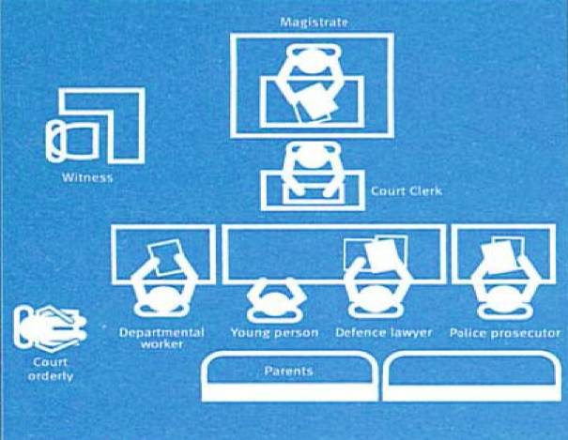
The courtroom
This picture shows you what a courtroom might look like. People will sit in different places in some courtrooms.
The magistrate sits at the front of the courtroom. The police prosecutor and your lawyer sit at a long desk called the bar table. You sit there too. If your parents/ carers are with you, they will sit behind you.
Other people are not usually allowed in the Childrens Court courtroom.

What happens in court
When you go to court, you are known as the defendant.
You must call the magistrate Your Honour.
Your lawyer may ask for your case to be adjourned if it is your first time appearing in court, or they are not ready for the case to be heard. If your lawyer is ready, the court will ask if you plead guilty or not guilty.
Your charges can be dealt with in different ways. Some are dealt with by a magistrate. More serious charges go to a higher court. Your lawyer will tell you what will happen.
The magistrate may ask you or your parents questions. They may give you the chance to speak if there is anything you want to say.
The police prosecutor will give information to the court about the offence you are charged with. The Youth Justice officer is there to give information to the court. Your lawyer will speak for you.
If you have questions about what happened in court you should talk to your lawyer or the Youth Justice officer.

