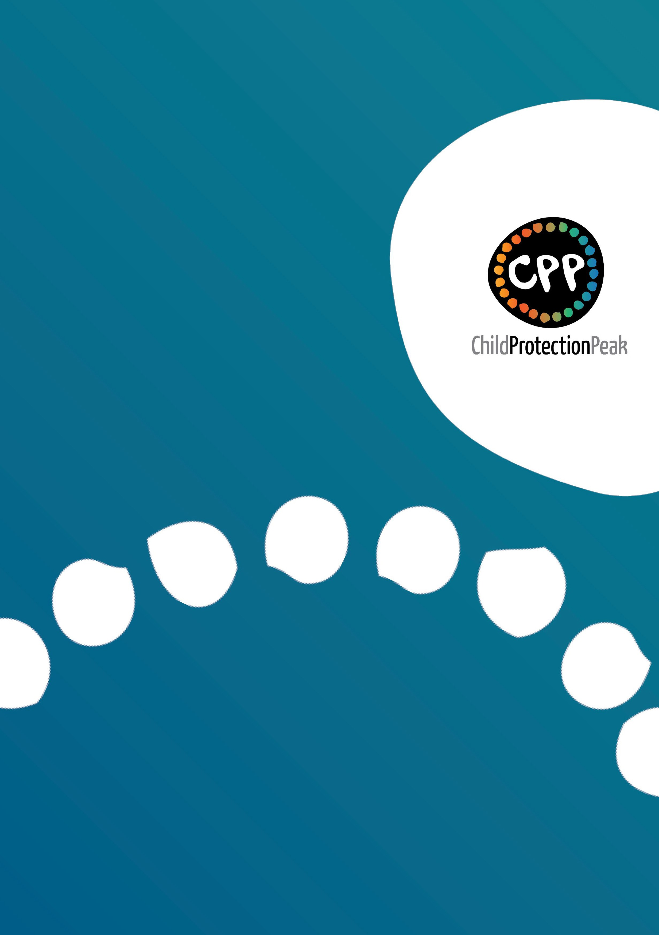

Queensland Aboriginal and Torres Strait Islander Child Protection Peak Limited

BREAKING CYCLES 2023-25 ACTION PLAN CO-DESIGN PROJECT
Consultation Findings Report
September 2022

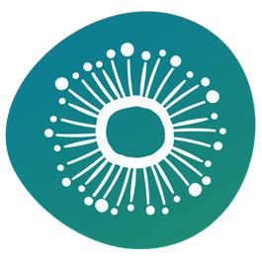
INTRODUCTION

BACKGROUND

The Our Way Strategy is a 20-year approach to close the gap in life outcomes for Aboriginal and Torres Strait Islander children and families, and to eliminate the disproportionate representation of Aboriginal and Torres Strait Islander children in out-of-home care within a generation. Breaking Cycles 2023-2031 is the second implementation phase of the Our Way Strategy and focuses on ‘changing the way that services are designed and delivered’.
Since the development of the Our Way Strategy, the Queensland Government has committed to the National Agreement on Closing the Gap. The refreshed agreement includes the four priority reforms of building the community-controlled sector, establishing formal partnerships and shared decision-making, transforming government organisations and sharing data at regional levels, alongside 17 targets including, for the first time, a target to reduce the over-representation of Aboriginal and Torres Strait Islander children in out-of-home care by 45% by 2031.
To successfully achieve the vision and goals of the Our Way Strategy and commitments under the National Agreement on Closing the Gap, transformative systems change as part of the Breaking Cycles phase will be critical.

BREAKING CYCLES 2023-25 CO-DESIGN
A review and analysis of existing national and state strategies, frameworks, action plans, policy documents, reports and evaluations was undertaken at the commencement of this project. Priority was given to those documents that elevated the voices of Aboriginal and Torres Strait Islander peoples, families, communities, organisations and leadership.
The key themes identified through the earlier document review process were reiterated during consultations with communities, the sector, peak organisations and Family Matters Queensland leaders.
Consultations again highlighted the importance of enabling self-determination and cultural authority, increasing accountability and transparency, investing in prevention and early intervention, addressing socioeconomic drivers of contact with the child protection system, transforming policy and practice that contributes to over-representation in out-of-home care, improving cultural safety in government and mainstream organisations, and building the Aboriginal and Torres Strait Islander workforce.
The majority of data gathered during the consultations was from communities. As such, the most prominent themes emerging from the data analysis are those related to service design, delivery, funding and staffing. These issues are important and should be considered within Breaking Cycles 2023-25. But we must not lose sight of the fact that structural change in the way governments work with Aboriginal and Torres Strait Islander peoples, communities and organisations is

central to the success of Our Way and Closing the Gap. Significant structural reform and transformation at the systems level will enable and empower the Aboriginal and Torres Strait Islander sector to design and deliver programs and services at the local community level that will lead to better life outcomes for their children and families.
The findings of community consultations are consistent with that of the external evaluation of Our Way Changing Tracks. It is clear what needs to be done. The gap is not between what we know and do not know; it is between what we know and are prepared to do.

CO-DESIGN APPROACH
The purpose of community consultation was to increase local ownership of and engagement with the Our Way Strategy by ensuring that the voices of Aboriginal and Torres Strait Islander young people, families, communities, organisations and leaders from across Queensland are reflected in the Breaking Cycles 2023-25 Action Plan. The cultural authority of the action plan comes from elevating and privileging Aboriginal and Torres Strait Islander lived experience, knowledge, wisdom and expertise when it comes to developing solutions that make sure our children grow up safe in family, community and culture.
In total, more than 950 people participated in the community consultation process through a range of engagement strategies.
The majority of community engagement occurred through local-level community consultations. With funding from the Queensland Government Department of Children, Youth Justice and Multicultural Affairs, QATSICPP and Family Matters Queensland partnered with Aboriginal and Torres Strait Islander community-controlled organisations to lead community consultations across Queensland. Following an Expression of Interest process, one-off grants of between $5,000 and $10,000 were provided to organisations to engage with their communities to identify local community needs, aspirations and priorities in relation to the safety, development, wellbeing and protection of their children and families.
Between late June and early September 2022, 11 partner organisations, spread across the six departmental regions, led consultations in more than 25 communities across the state. The majority of local-level consultations occurred in regional and remote communities. Community-controlled organisations were empowered to engage with their communities in ways that they knew would work best including individual interviews, focus groups, yarning circles, community forums, meetings, surveys or yarning as part of routine service activities. They brought together diverse voices including young people, parents, carers, community members, service providers, Elders and Traditional Owners.
An additional four organisations had initially expressed an interest to lead consultations in their communities and regions but later withdrew due to limited staffing availability, the impact of COVID-19 waves during the winter period and other community business. Senior leadership from these organisations were still invited to attend the Breaking Cycles Flagship Forum to encourage engagement in the co-design process.

In addition to local-level community engagement, targeted strategic-level consultations occurred with the Queensland Aboriginal and Torres Strait Islander Coalition, Family Matters Queensland Leadership Group and QATSICPP staff group. These consultations were externally facilitated to enable rich discussion and meaningful participation by all parties.
A dedicated youth engagement strategy was also developed to ensure the voices of Aboriginal and Torres Strait Islander young people were included in the co-design process. Drawn from the Solid Voices of Tomorrow Group and the Queensland Indigenous Youth Leadership Program, 14 young people were identified and participated in a series of individual interviews and yarning circles. The young people will also participate in the Breaking Cycles Flagship Forum.
Finally, an online survey was used to capture the thoughts, ideas and insights of people who couldn’t participate in other community engagement strategies. The survey was promoted via social media and through established networks.
Appendix 1 – List of co-design partner organisations and communities they engaged with. Appendix 2 – List of consultation questions used to guide local and strategic level conversations.

QUALITATIVE ANALYSIS METHODOLOGY
All consultation data was subjected to thematic analysis using NVivo qualitative data analysis software.
Initial nodes and sub-nodes were created based upon the QATSICPP NVivo Codebook and findings of the earlier evidence review. Consultation data was coded to the relevant nodes, with nodes and sub- nodes merged, reorganised and renamed over time to refine the node hierarchy. The nodes were subsequently organised into overarching themes and sub-themes. Themes and sub-themes were selected based on frequency (those that appeared commonly across the consultations) and uniqueness (those that appeared less frequently but which provided a unique insight or interesting point of difference).
The Project Lead tested the final themes with the Project Working Group, Family Matters Leadership Group and QATSICPP Project Team to ensure they were consistent with their knowledge of the issues.

KEY FINDINGS

SYSTEM LEVEL

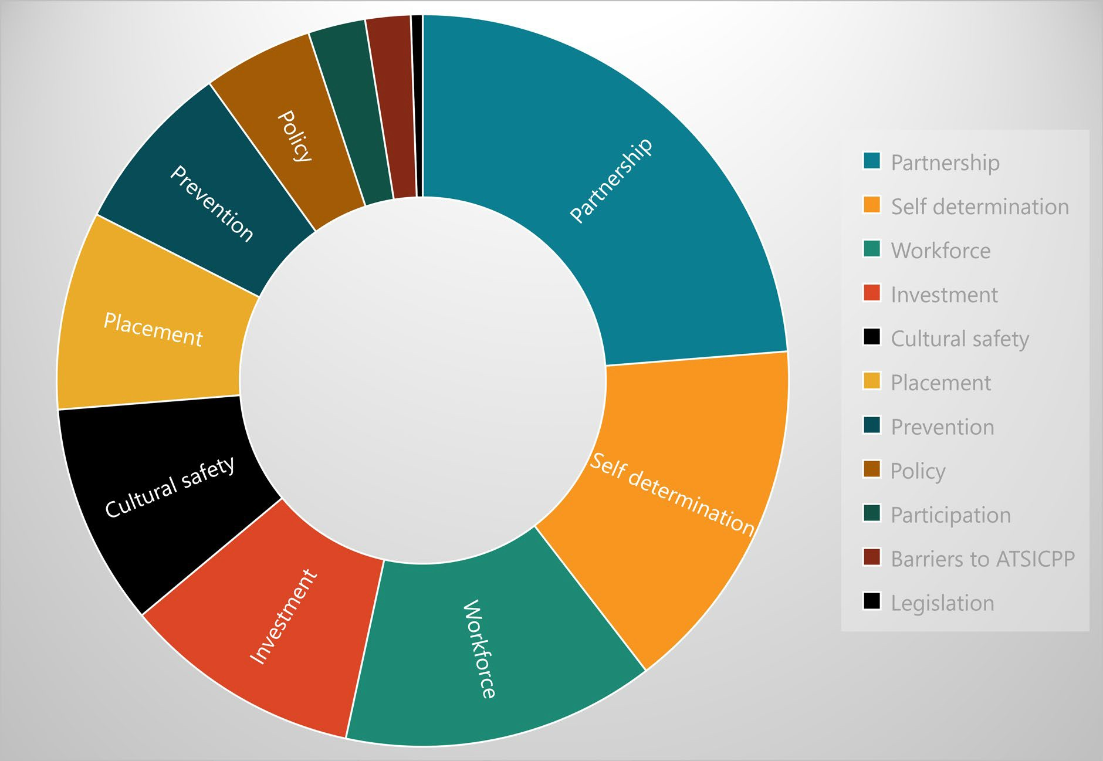
Figure 1: System level themes

Self-Determination
Self-determination is the collective right of Aboriginal and Torres Strait Islander peoples to determine and control their own destiny. It is a recognition that Aboriginal and Torres Strait Islander communities are best placed to make informed decisions about the safety, development, wellbeing and protection needs of Aboriginal and Torres Strait Islander children.

“Give us authority to make decisions and lead change.”
“Trust First Nations peoples and their leaders to provide solutions … dismantle systems designed to disregard the strength, knowledge and wisdom of the world’s oldest living culture. Stop! being risk adverse to transferring power of decisions that affect First Nations to First Nations.”

“Co-design is key to this issue, actually asking community what solutions will fix community issues … Co-design and listening to community is at the core as it works to empower mob by changing systems that are designed to oppress and disempower.”

We heard:
- The Our Way Strategy is supposed to be about doing business Our Way. That means Aboriginal and Torres Strait Islander peoples, communities, organisations and peaks determining and driving solutions to their identified needs, aspirations and priorities, in partnership with the Queensland Government but not subservient to it.
- The Breaking Cycles priority focus areas should be determined by the peak organisations [Queensland Aboriginal and Torres Strait Islander Coalition], in consultation with the Queensland Government. Government should not tell us what is important to us.
- Local communities should be responsible for determining local needs, designing and commissioning local responses, and monitoring outcomes and progress towards established targets, supported by the relevant peak organisations and government departments. This will involve working in partnership with local or regional shared decision- making structures or, where they do not currently exist, supporting the establishment of such structures. It will also require a significant change to the current approach to investment and commissioning.
- The expansion of Delegated Authority across the state has the potential to fundamentally shift the balance of power and control back to communities and community-controlled organisations where it belongs, if ‘government gets out of the way and doesn’t try to obstruct’. To date, government has been too slow – and at times resistant – to change the status quo. Significant practice, policy and cultural change within government is required to ensure the success of Delegated Authority.
- Families and communities appreciate the role of the Family Participation Program (FPP) in involving children, families and community in the child protection decision-making process and empowering them to have voice in decisions that affect them. Self-determination could be further enabled by investing to scale up the program, to ensure Aboriginal and Torres Strait Islander family-led decision-making is enabled at all points along the child protection continuum.

Partnerships
Genuine partnerships between governments and Aboriginal and Torres Strait Islander communities, organisations and leadership enable self-determination and are critical to the success of Our Way and Closing the Gap. Central to effective partnerships is trust, respect, safety, communication, collaboration and relationships.

“Government and mainstream services need to acknowledge and trust the work that Aboriginal and Torres Strait Islander services and workers do in the community.”
“All services need to constantly invest in partnerships with a true commitment and shared vision for the community.”
“Partnerships are difficult. Relationships need to be nurtured.”
“Trust [enables the] freedom and flexibility to provide localised responses done Our Way.”

We heard:
- Trust is an enabler. We underestimate what trust can achieve. When there are trusting relationships between government, the sector, communities and families, good work happens. Without trust, everything is challenging.
- There is a sense that despite positive legislative changes and policy directives, governments do not actually trust Aboriginal and Torres Strait Islander peoples and organisations to lead change. Institutional racism and unconscious cultural biases is interfering with good intent. There continues to be a mistrust of government in communities.
- Power imbalances between government and Aboriginal and Torres Strait Islander organisations continues to be a serious issue that undermines self-determination and genuine and effective partnerships. Transforming relationships between government and Aboriginal and Torres Strait Islander organisations will require significant change to the established power structures and a more equitable sharing of power.
- Partnerships require time, effort, commitment and resources. They must also operate within a culturally competent framework. The Aboriginal and Torres Strait Islander sector must be adequately resourced and empowered to participate in partnerships and integrated service models.
- There are examples of effective partnerships at the local level but these are often dependent on the individuals involved. When individuals change, the partnership is at risk. Formal partnership agreements between services, organisations and governments increase sustainability and success.

Accountability and Transparency
Our Way is about shared responsibility and accountability. Obligations to kin, community and Country is a central tenet of Aboriginal and Torres Strait Islander cultures. Aboriginal and Torres Strait Islander peoples and organisations understand this deeply. For too long, Aboriginal and Torres Strait Islander communities and organisations have been accountable to governments, without a sense of reciprocity. This must change.
Shared transparency requires an openness to new ways of working together. It means sharing information and data to enable informed decision-making by government and Aboriginal and Torres Strait Islander communities, organisations and leadership. Transparency builds trust.

“State or national level reporting provides opportunities to hide. But if localised, there is less chance to hide.”
“Accountability needs to go beyond data sharing. This is what the data is, this is our plan to deal with the issue, this is how we are tracking.”
“Accountability needs to be elevated beyond a yearly report card that gets produced and nothing happens with it. We need reporting at regular intervals and at the highest levels of government.”
“Community need to know government is listening to them – come to community and talk to the people, build trust over time and do not expect community to accept without consultation first – inform and engage community in the process.”
“A lot more visual presentations and face to face meetings. Pages of documents, frameworks and reporting is important, but when reporting back to the community there needs to be creativity and thought put into the feedback in order for the importance to shine through and the interest and awareness to grow.”
“Communication forums at local levels, with mechanisms in place to share data and support cross- sector discussions about shared priorities and [what needs to happen to create] better outcomes for families.”
“Data can tell good news stories about what is working well. We want to know what is working so can scale up or look for ways to expand.”

We heard:
- Shared accountability means:
  - government is accountable to communities, the sector and peak organisations
  - peak organisations are accountable to their members and communities
  - the sector is accountable to families, communities and government
  - families and communities are accountable to each other.
- The sector is held accountable to governments through funding contracts, performance reporting and audit processes. Yet there are no mechanisms to hold governments accountable to communities or the sector. We should co-create performance indicators for government departments to demonstrate how they are transforming their organisations and the way they work with Aboriginal and Torres Strait Islander peoples, communities and organisations – and hold them to account if they fail to meet them.
- We need different levels of accountability – whole-of-government, statewide accountability and local or regional level accountability – to the Our Way Strategy.
  - What mechanisms are available to hold Queensland Government accountable to their commitments under Our Way? What is the role of the Queensland First Children and Families Board, Queensland Family and Child Commission and Human Rights

Commission? How do we strengthen the powers and oversight of these bodies to increase whole-of-government accountability?
  - How can we use local or regional decision-making structures to increase accountability of government and the sector at the community level? How can we tell the Our Way story in a meaningful, localised way so that communities are empowered and enabled to understand the issues and determine their own solutions?
- To increase accountability and transparency, Breaking Cycles targets and associated performance measures must be clearly stated and defined, co-created with the sector, and align to what communities and organisations have said is important to them.
- Communities and organisations want access to local and regional data held by governments about what is happening for their children and families to enable informed decision-making. Data needs to be accurate, timely, accessible, relevant and meaningful, and should align to co-created and agreed performance measures and targets. Communities and organisations are clear that this is our data and must be shared transparently, honestly and respectfully. Local or regional level data sharing and reporting increases accountability and transparency.
- Communities and organisations want ‘real-time’ access to information and data, disaggregated to the local level. They want to sit at the table with their government colleagues to come to a shared understanding of local issues or trends and jointly decide on the best response.
- Annual performance reporting has its place but to make this more meaningful, performance reporting should be done in collaboration with the sector and include the perspectives and experiences of Aboriginal and Torres Strait Islander peoples, communities and organisations. This validation measure would test if what governments claim as achievements is actually creating meaningful, positive change for children, families, communities and organisations.

Communities want governments to report back to them about progress made towards Our Way and Closing the Gap targets through a range of mediums.
  - Written documents should be simple, easy to read and understand, and display information visually. They should be widely distributed via both social media and traditional news media (print, television and radio) and available in hard copy at the services and spaces Aboriginal and Torres Strait Islander peoples and families visit.
  - Most importantly, communities want opportunities to come together to yarn about these important strategies. Communities want governments to come to them to talk, both following the development of the action plan to understand what has been agreed and how it will be operationalised at the local and regional levels, and at regular intervals over the life of Our Way to monitor progress over time. This should involve and be supported by local Aboriginal and Torres Strait Islander organisations and peaks.

Policy Alignment
The socioeconomic structural drivers that contribute to Aboriginal and Torres Strait Islander children and families in contact with the child protection system are well-known and documented. The complexity of these interrelated issues requires commitment, coordination and innovation across government. All government departments with responsibility for community, cultural and economic development, housing, health, disability, education, child protection and justice, together with Aboriginal and Torres Strait Islander communities, organisations and peaks, must be active partners in Our Way.

“There was genuine buy-in at the start of Our Way but over time, responsibility has shifted to just them [child protection]. It needs to go back to being a cross-government initiative where everyone has responsibility.”
“Need to get other government agencies to genuinely collaborate with our peaks and services, not just give lip service.”
“Why is Our Way sitting in Child Safety? It is misleading, stops it from being a joined-up approach. Resources in government and power in Parliament need to be brought together to solve very entrenched issues.”

We heard:
- There is a great deal of excitement and activity happening in the policy space, both at state and national levels. We need to think carefully about how best to position Our Way within other policy initiatives such as the Voice to Parliament, Path to Treaty, Local Thriving Communities, National Agreement on Closing the Gap and National Framework for Protecting Australia’s Children.
- Serious consideration should be given to aligning the Breaking Cycles priority focus areas, actions and targets to the Closing the Gap priority reforms and targets. This would act to:
  - protect Our Way from being easily dismantled in the event of a policy shift
  - increase the accountability of Queensland Government to report on progress made towards Our Way targets at a national level
  - reduce duplication or competing policy agendas and priorities
  - leverage Closing the Gap to fund Breaking Cycles initiatives.
- The level of transformational change required to fully realise the vision of Our Way and to meet Closing the Gap priority reforms and targets is immense. Change management expertise – separate from practice or policy expertise – should be embedded within government and the sector to support the transition.
- While the sector is generally supportive of the Director General’s commitments to increase kinship care, reduce residential care and transition funding to the community-controlled sector, there is a concern about the lack of information about how such significant reforms will be successfully achieved. There is an urgent need for a reform implementation plan, co- created by government, the sector and peak organisations.

- Our Way was conceived as a whole-of-government strategy to improve the life outcomes for Aboriginal and Torres Strait Islander children and families in Queensland, yet many government stakeholders who play important roles in the lives of our children, families and communities do not seem to be engaged or committed to the strategy. There is a call to elevate the status of Our Way to a central coordination and accountability body, with greater involvement and commitment from the Premier and Cabinet.
- Most state government departments have strategies and action plans relating to Aboriginal and Torres Strait Islander peoples, each with their own advisory boards or consultative bodies. Yet there appears to be very little communication and collaboration between these structures. Developing ways to better coordinate these advisory mechanisms, particularly at the regional level, would seem to be important to ensure there is a unified approach towards meeting our Closing the Gap commitments.

Investment and Commissioning
Empowering Aboriginal and Torres Strait Islander communities and organisations to make decisions about how best to use resources to support their children and families would enable self-determination and demonstrate a commitment to fundamentally change the nature of the relationship between government, communities and the sector.

“The level of investment has to meet the aspirations.”
“Give the money to community as we know what to do. There is so much red tape that doesn’t allow services to be responsive and flexible and creative.”
“Design responses that target the problems and effect change over time with short and long term goals in mind. Strategies need to be flexible, not bound by strict criteria and program specifications.”
“An understanding of the challenges and barriers for families living in remote locations in Queensland and the large geographical areas of service delivery. Get real and provide adequate funding for these services … to provide quality service delivery and care instead of missing essential supports due to not having enough funding, resources or staffing.”
“More space for innovation, we are not being creative with what we are funding – for example, cultural healing solutions.”

We heard:
- Our Way is a 20-year strategy, yet government is still caught in short-term funding cycles. We must think generationally if we are going to overcome the levels of intergenerational disadvantage and trauma in families and communities.
- We need to prioritise investment in Aboriginal and Torres Strait Islander owned and led organisations and in Aboriginal and Torres Strait Islander designed and delivered solutions.

- Community-controlled organisations are not adequately resourced to meet the demand for their services, nor for the full scope and complexity of the services they provide. We need fairer funding models for the work they do to improve outcomes for our children, young people, families and communities, particularly in remote contexts.
- Community-controlled organisations need long-term, secure funding contracts. Local solutions are often funded as a pilot or trial even though the issues they seek to address are intergenerational and entrenched. Not enough time and resources is allowed for organisations to demonstrate outcomes. When local responses are successful, funding is removed as the problem is seen be solved. There seems to be limited recognition or understanding of the need to create sustained, generational change.
- Communities do not want a one-size fits all, statewide rollout of government designed and developed initiatives, services or programs. They want local responses to local issues, determined, designed and delivered by local people.
- Governments use funding contracts and reporting systems as a way to control organisations. Current arrangements limit the capacity and capability of organisations to provide culturally-centric, flexible and responsive services. It is an ongoing colonising practice and demonstrates a lack of trust and belief in communities and organisations that we can do good work, done Our Way.
- Performance measures need to be co-created with Aboriginal and Torres Strait Islander organisations and peaks to ensure they are culturally-informed and outcome-focused.

Cultural Safety and Competency
Ongoing systemic and structural racism, cultural bias, lack of cultural safety and cultural incompetence in government and mainstream organisations continue to impede the success of Our Way.

“Deal with structural and systemic racism and resistance to hearing and responding to First Nations voices.”
“Less racist policies and measures of safety and wellbeing for First Nations families. The legislation is clear and supportive but the tools used to determine safety and wellbeing of children and families are stacked toward a very white, middle-to-upper class or higher socioeconomic cohorts measure of living standards. Not everyone is born with that privilege.”
“Address racism in a proactive way by educating non-Indigenous [people] about the systemic and generational effects of colonisation that is still occurring today.”
“Representation and culturally safe services is so important.”

We heard:

- Aboriginal and Torres Strait Islander peoples and families continue to experience interpersonal and institutional racism when accessing government and mainstream non-government services.
- There is a gap between the stated policy intent of Our Way and practice and partnerships at the local and regional level. This lack of congruence places practitioners, services and organisations in difficult positions, leading to poor outcomes for children and families.
- Aboriginal and Torres Strait Islander community-controlled organisations are seen and experienced as culturally safe by Aboriginal and Torres Strait Islander children, young people, families and communities. There is a preference for accessing services and programs designed and delivered by local people for local people.
- We should consider implementing the Family Matters Reflective Practice Tool across all services funded to support Aboriginal and Torres Strait Islander children and families as a strategy to improve the cultural competency of government and mainstream organisations.

Workforce Development
A strong, supported, empowered Aboriginal and Torres Strait Islander workforce is essential to improving safety, development and wellbeing outcomes for Aboriginal and Torres Strait Islander children and families.

“Educated and culturally aware ground level workers that are able to give our families guidance and support and the right information to strengthen relationships, connections and families.”
“More supports in schools to address high levels of trauma. We don’t have anyone specifically trained in how to address trauma in a school setting. If you want to keep our kids in school, we need teachers and support workers trained in trauma.”
“Cultural training that takes more than a few hours to go through. This is often done to ensure boxes are ticked with no real understanding of intergenerational trauma, equity and equality.”

We heard:
- Communities want to see more Aboriginal and Torres Strait Islander people employed across the full spectrum of services that play a role in the lives of our children and families. This includes early childhood centres, primary and secondary schools, hospitals and health services, social and emotional wellbeing services, disability services, housing providers, child and family wellbeing services, youth services, and the Police, Courts and justice services.
- Representation at all levels of an organisation improves cultural safety and competency. Aboriginal and Torres Strait Islander people must be employed in frontline, policy and leadership roles. Designating roles as Identified Positions is seen as one way to increase representation at all levels of the workforce.

- The transition of decision-making authority, resources and responsibility for service design and delivery to the community-controlled sector will require a significant investment in the size and capabilities of the Aboriginal and Torres Strait Islander workforce.
- Communities and organisations want to build and strengthen their local workforce through ‘Grow Our Own’ initiatives, place-based workforce strategies that focus on attracting, developing, supporting and retaining local people to grow a capable and sustainable workforce. They also want to see greater pathways into employment for Aboriginal and Torres Strait Islander people through school-based and full-time traineeships, accredited vocational training, university places, student placements, and on-the-job mentoring and coaching.
- Career pathways, remuneration and benefits are important to attract and retain a skilled workforce. Current funding levels and models make it difficult to compete with other industries.
- Our Elders should be appropriately remunerated for the time, wisdom and expertise they generously share to support our children and families.
- Family Wellbeing Services (FWS) could be strengthened by embedding specialist positions and up-skilling staff in the areas of mental health, substance abuse and trauma recovery and healing. The Family Partnership Program (FPP) could be strengthened by ensuring all staff have received training in Aboriginal and Torres Strait Islander family-led decision-making.
- Everyone who plays a role in supporting our children and families need to understand developmental, complex and intergenerational trauma and have the knowledge and skills to provide trauma-informed care and responses.
- There is a strong need for ongoing cultural competency training for the non-Indigenous workforce through delivery of localised training programs aimed at changing attitudes, beliefs and practice. Training must include education about the truth of our history and the legacy that colonisation and past government policies has had on Aboriginal and Torres Strait Islander peoples, families and communities.
- We could upskill local community members to create support networks that operate outside of formal services and are available to act as ‘first responders’. Trained community members could be called upon to assist in instances of domestic and family violence, mental ill-health or substance use, to help families deal with difficult situations safely and sensitively, before assisting them to access appropriate follow-up supports and services.

Barriers to Implementing the ATSICPP
The Aboriginal and Torres Strait Islander Child Placement Principle (ATSICPP) is the cornerstone of Australian law and policy acknowledging the importance of family, cultural and community connections to the identity and wellbeing of Aboriginal and Torres Strait Islander children who come into contact with the statutory child protection system. The principle is based strongly on the presumptions that removal of an Aboriginal and Torres Strait Islander child from their family should be an intervention of last resort, and that reunification of a child that has been removed must be a high priority.

“How can we expect practitioners to do it [implement the Child Placement Principle] if it is not occurring at all levels of the system?”
“There needs to be better support programs before we even get to that stage [child protection notification]. A family can just ring up and say, you know what, I’m really struggling and I need support, without it even being in Child Safety’s hands.”

What we heard:
- There is an urgent need to shift and balance systems away from crisis and punitive responses to a focus on holistic prevention, early intervention and targeted support for children and families experiencing vulnerability and disadvantage.
- We need to invest in our families and communities, rather than out-of-home care. If even a fraction of the resources given to foster and residential care was directed to wrap-around supports to address the social and cultural determinants of health and wellbeing, our children and families would thrive. Investing in families reduces the trauma of separation and removal and leads to improved physical health, social, emotional and productivity outcomes over the course of a child’s life.
- Failing to invest in prevention and early intervention ultimately costs governments more over the course of a child’s life. Our Way is a generational strategy. It is acknowledged that the scale of investment needed in these early phases is significant but should ultimately reap cost savings for future generations. Governments need to be willing to invest in solutions that they may not fully see the benefits of during their term in office.
- Family Wellbeing Services (FWS) are funded to work across the child protection continuum, from universal prevention to tertiary interventions. However, limited staffing and resources places them in a predicament – these services know they need to direct their energies towards prevention and early intervention activities in order to break the cycles of trauma, disadvantage and disconnection in their communities, but are pulled to respond to families in crisis or already in contact with the child protection system due to the urgency of their situations. FWS must be adequately resourced for the full scope and complexity of the services they are expected to provide.
- Child protection needs to communicate with our parents and families better. Help them to understand concerns and worries early in the process and link them in with local services that can support them to make change. Engage the Family Participation Program (FPP) early and ongoing throughout the process to enable genuine participation and family-led decision making.
- We need more Aboriginal and Torres Strait Islander kinship carers. Both formal and informal kinship carers need to be supported to care for their families with practical and financial assistance. Supporting family caring arrangements keeps children out of the child protection system and out-of-home care. Approve more than one kinship carer so that care responsibilities can be shared across the kinship system.

- Government must improve the Blue Card system so that more of our family and community members can safely look after our children.
- Delegated Authority early adopter sites have demonstrated their capacity to implement the ATSICPP, specifically the participation, partnership and connection elements. Self- determination is critical to the success of Delegated Authority. Governments must be willing to share power and decision-making with organisations taking on these responsibilities and trust that they know how to do their business.

SERVICE LEVEL

Service Design
We heard:
- Services need to:
  - be empowered and enabled to deliver supports Our Way
  - be culturally competent – Aboriginal and Torres Strait Islander practitioners and leadership, male and female staff, cultural protocols, culturally-centric service models, involvement of Elders
  - be adequately resourced
  - be flexible – home and school visiting, extended operating hours, crisis response
  - be responsive – to local community needs and issues, tailored to individual families
  - be accessible – co-located with other services, provide transport or outreach
  - offer a range of holistic, integrated supports
  - collaborate and coordinate responses with government and non-government partners
  - be promoted within the community.

Support Needs

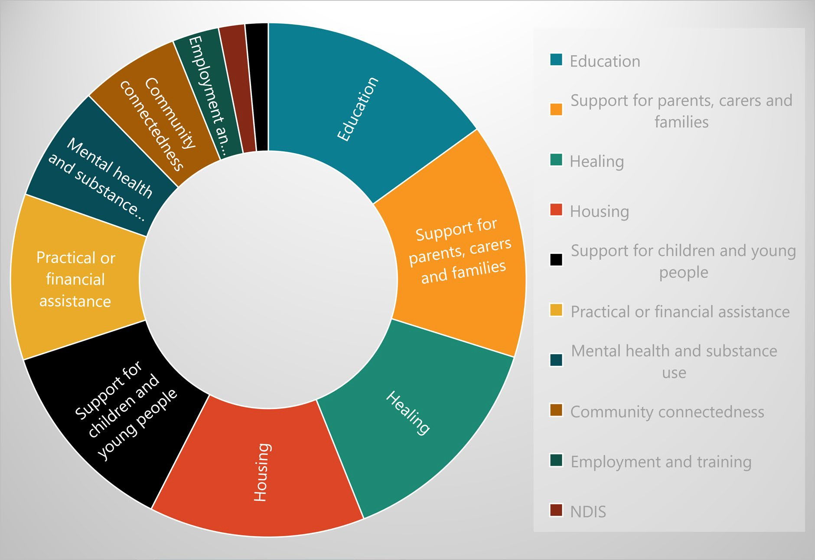
Figure 2: Support needs themes

Housing
We heard:
- Overcrowding and homelessness is a significant issue in many communities and a major driver of children and families coming into contact with the child protection system.
- There is an urgent need to increase public and community housing stock across Queensland.
- Existing properties need regular maintenance or upgrades to be safe and fit-for-purpose.
- We need more community-controlled housing support services to assist families to access and maintain public, private and community rental tenancies.
- The private rental market is becoming increasingly unaffordable for families. Uncapped rental increases are forcing families out of their homes and communities.
- We need pathways to home ownership to create generational wealth and financial security.
- We need Safe Houses in remote communities for women and children escaping domestic violence so that they do not need to leave their family and community support networks.

- Family members who take on the care of children for short periods should not be burdened with rent increases by housing providers. Family caring for family is part of our kinship system. It keeps children safe and connected with their family, community and culture, and out of the out-of-home care system. Rental increases act as a barrier to family caregiving arrangements.

Education
We heard:
- Access to and positive engagement with culturally safe, high quality early childhood, primary and secondary education is vital for our children’s future.
- The high cost of early childhood education and care excludes many families for accessing these services, impacting on children’s development and school readiness.
- The education curriculum must be respectful and inclusive of Aboriginal and Torres Strait Islander histories, cultures, languages and ways of learning.
- Our children need to be supported to succeed at school. They need teachers and administrators who understand the struggles and complexities of their home lives. They need Aboriginal and Torres Strait Islander staff (teachers, teacher aides, support workers) in the school environment to create culturally safe and welcoming spaces and support student engagement and learning. Some may need access to targeted learning support including extra classroom support and tutoring.
- Through partnerships with community-controlled health services and universities, schools can become hubs for accessible allied health services – occupational therapy, speech therapy, psychology, audiology, optometry, physiotherapy, podiatry, dental.
- For children struggling to engage and achieve at school due to underlying conditions (eg. ADHD, ASD, FASD, SLD), comprehensive assessment, diagnosis and early intervention – rather than punitive behavioural approaches (suspension and expulsion) – is essential.
- Many families and communities are concerned about the high rates of school suspensions and expulsions, particularly early in a child’s schooling experience.
- Older students would benefit from mentoring programs, careers guidance and initiatives designed to support a positive transition from high school to further training and education.
- Yarning groups and cultural activities and programs within schools support cultural connectedness and social and emotional wellbeing for our young people.
- A number of communities are interested in or actively exploring options to establish Aboriginal and Torres Strait Islander designed and led independent schools for their children.
- We need to support parents and families to be involved with their child’s school and education, particularly if they themselves had limited and/or negative school experiences.

Support for parents and families
We heard:
- We want to support our parents and families Our Way – design, develop and deliver programs and services that are culturally safe and grounded, that nurture connections between parents and carers to create communities of support, and that are guided by trusted Aboriginal and Torres Strait Islander workers and Elders.
- We should offer support from pre-conception, throughout pregnancy and parenthood.
- We need to support our parents and families to care for and support their child’s development and wellbeing at different ages and stages across the lifespan.
- We want more Aboriginal and Torres Strait Islander designed and delivered playgroups, parenting groups and programs, family centres and kindergartens.
- We need to strengthen and support the whole kinship system who play important roles in growing children up safe and connected– mums and dads, aunties and uncles, grandparents, older siblings, kin carers.
- We need male and female workers to support our families. Fathers need support too.
- We must make sure first time parents and younger parents are supported.
- Services need to be available on evenings and weekends so that parents who work can still access supports or participate in group activities.
- Many families and communities experience intergenerational poverty and disadvantage. Flexible funding packages would enable services to purchase goods and services to address social determinants of health or buy-in specialist and intensive supports and services, as needed. Parents and kinship carers need timely access to income support through Centrelink. Families would benefit from access to financial literacy programs and financial counselling.

Support for children and young people
We heard:
- Our children would benefit from financial assistance to participate in extra-curricular activities that encourage engagement and participation in positive social and recreational activities outside of school – sport, music, drama, creative arts, dance, clubs and programs. Many of these activities are expensive and beyond what families can afford.
- Enhancing our neighbourhoods with child and family friendly spaces and facilities would promote a sense of community – parks, playgrounds, sporting grounds, community gardens, men’s sheds, family centres. We want safe, welcoming spaces where children and families can play, connect and socialise.
- We want opportunities for our babies, children and young people to connect to their culture and community, learn and experience the strength of our cultural ways, and develop a sense of pride and belonging in their identity as Aboriginal and Torres Strait Islander peoples.

- We want opportunities to be on Country with our children and families. Camps and cultural activities and programs are important to our children’s health, development and wellbeing.
- There is concern and worry that our young people are getting into trouble and dangerous situations, particularly at night and on the weekends when many services are closed. This brings them into contact with the Police and youth justice system. We need youth services that operate at the times when young people most need their support – outside of regular business hours. We need safe spaces for young people to come together, connect with each other and have fun in safe ways. We need mentoring and peer support programs to help them find their way.
- Accessing the NDIS for our children is incredibly difficult. We need more culturally safe services to help families navigate the NDIS system and ensure our children and young people have access to and receive high quality disability supports and services.

Mental health and substance use
We heard:
- Many of our people are struggling with mental health and substance use issues. There are not enough culturally safe programs and services in communities to meet the need.
- Services are needed across the whole lifespan – children, young people and adults.
- Services need to be both clinical (psychology and psychiatry) and non-clinical (social and emotional wellbeing and healing). They need to consider the whole person – physical, mental, emotional, cultural and spiritual.
- Providing access to counselling in the school setting is highly valued.
- To be most effective, visiting services must be regular and prioritise continuity of care.
- Individual support is important but we need family focused and inclusive approaches that support couples and family or kinship groups.
- Group programs and yarning circles bring people together to support the healing journey.
- A number of communities would like to explore the establishment of wellbeing or healing centres within their community or on Country.

Culture and healing
We heard:
- Healing is:
  - cultural preservation and revitalisation – histories, languages, lore, beliefs, values, stories, totems, practices, ceremonies
  - being on Country and looking after Country

  - holistic approaches that strengthen the physical, mental, emotional, social, cultural and spiritual aspect of a person, family and community
  - self-determination and voice
  - truth-telling and education for the whole nation.
- It is important that healing:
  - is for available for everyone, from our young children through to our Elders
  - is used to strengthen and nurture our children and families, not just available when they face difficulties or in trouble.

Community connectedness
We heard:
- It is important for mob to come together in positive ways, not just in the tough times. It has been great to see more community events that celebrate Aboriginal and Torres Strait Islander cultures. This builds and strengthens our children, young people, families and communities.
- Family and community outings, camps, events, gatherings and celebrations create a sense of cohesion and connectedness. They bring together our children and young people with their parents, kin and Elders. They help us to see each other in different ways, strengthening the bonds and relationships that will support us through tricky times. They create space for fun, play, enjoyment, pleasure and laughter.
- Coming together is a way to teach and share culture with our children and young people through our traditional foods, song, dance, storytelling, art and ceremony.
- Coming together supports health and wellbeing by encouraging healthy lifestyles and acting as a diversion from unhealthy or unsafe activities.

APPENDIX 1
BREAKING CYCLES 2023-25 CO-DESIGN PARTNER ORGANISATIONS

Organisation | Communities
Central Queensland Indigenous Development | Rockhampton Woorabinda Emerald Hervey Bay  Bundaberg
Cherbourg Regional Aboriginal and Islander  Health Service | Cherbourg
Gallang Place Aboriginal and Torres Strait Islander Corporation | Greater Brisbane  South East Brisbane Ipswich
Girudala Community Cooperative Society | Mackay Bowen  Proserpine and Cannonvale  Scottville and Collinsville
Goondir Health Services | Dalby  Oakey
Kambu Aboriginal and Torres Strait Islander Corporation for Health | Ipswich Gatton Laidley  Esk
Kurbingui Youth and Family Development | North Brisbane
Mudth-Niyleta Aboriginal and Torres Strait  Islander Corporation | Sarina
Mulungu Aboriginal Corporation | Mareeba Atherton Kuranda  Mossman Daintree
Mura Kosker Sorority | Thursday Island Badu Island  Mabuiag Island
North Coast Aboriginal Corporation for Community Health | Nambour Caloundra  Gympie

APPENDIX 2

LOCAL-LEVEL CONSULTATION QUESTIONS
- What is working well in our community to grow up our children?
- What more could we add to existing services and programs to better support our families?
- What do we need so we can look after our children – keep them with kin and in community – and stop them from going into care?
- What needs to happen in our community to close the gap on the important issues for our children and families? (education, health and wellbeing, housing, employment, justice)
- What does government and mainstream services need to do differently to better support our children and families?
- How do we want government to report back to us about the Our Way Strategy?
- Of everything we’ve talked about, what are the things we agree are the most important and could make a real difference for our children and families in the next 3-5 years?

STRATEGIC-LEVEL CONSULTATION QUESTIONS

Family Matters Queensland
- What does governance accountability for the Our Way Strategy look like?
- What might it look like to have an action plan with greater weight across other government portfolios such as Health, Housing, Education, Justice?
- What are the measures of success we can identify for systems change from a policy, practice and legislative perspective across each three-year plan?

Queensland Aboriginal and Torres Strait Islander Coalition
- What are the intersections between national and state priorities and obligations that we need to be aware of with regard to Our Way and Breaking Cycles?
- Strategically, how can the peaks coordinate the approach to multiple policy levels and place accountability where it is needed?
- What are the game changers – priorities needed for transforming government system to have effect?

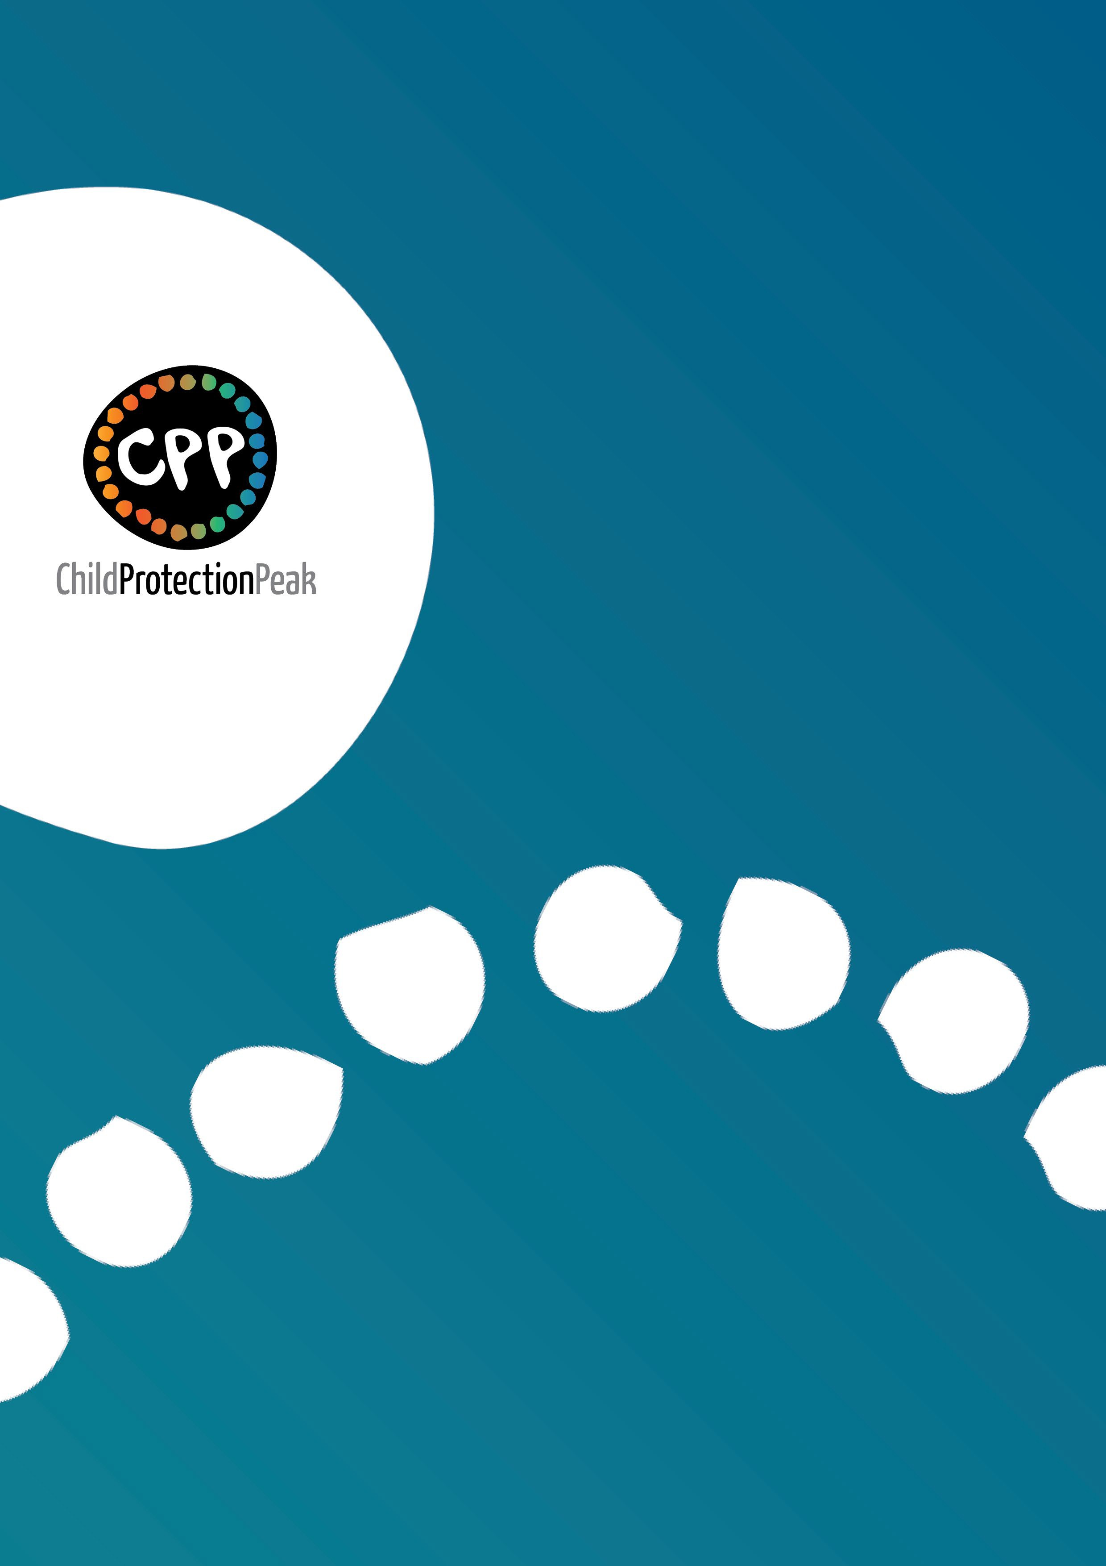

Queensland Aboriginal and Torres Strait Islander Child Protection Peak Limited
www.qatsicpp.com.au

