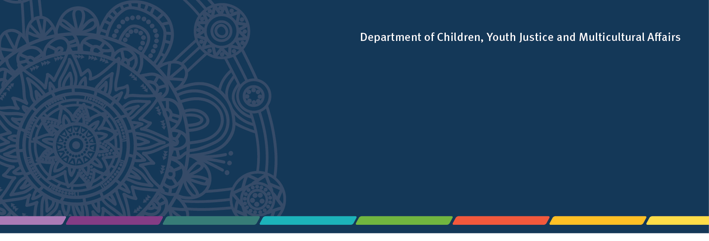

Youth Justice

Community Partnership
Innovation Grants

Program Information and
Grant Guidelines
2022-23

- Applications open Wednesday, 2 November 2022
- Applications close 11.59pm, Monday 30 January 2023

Background - Working Together Changing the Story
The Queensland Government is committed to reducing youth offending. The Youth Justice Strategy 2019–2023: Working Together Changing the Story, guides the government’s approach to reducing youth offending and improving community safety across Queensland.

Risk-taking behaviour and experimentation is a normal part of a child’s or young person’s development, however for some young people these behaviours can impact their health and wellbeing, and escalate to youth offending. When this occurs, it causes harm to individuals and anxiety in communities.

Many young people who demonstrate anti-social behaviour stop or reduce the frequency and type of their offending because they have a solid foundation and network of community support that guides them towards more positive behaviour as they mature towards adulthood.

This is where more localised, community-designed and delivered solutions are needed. These often-vulnerable young people need positive connections and support from a broad range of community members and organisations to intervene early to reduce youth offending.

What is community partnership innovation?
Community partnership innovation is a different way of working together to prevent youth offending and increase community safety. It requires government and community to engage more directly at a local level to design and deliver solutions using local community and industry knowledge and support, helping to ensure responses meet the needs of young people, their families and the broader community.

It is about building community confidence and safety by:
- building on strengths within a community
- creating community networks and connections
- delivering locally driven responses to support young people to realise goals
- investing in things that will make communities safe, now and in the future.

For young people, it is about making a difference to their lives by:
- re-connecting or strengthening their connection with family, community and culture
- supporting them to address their health and wellbeing needs (including healing from trauma)
- supporting them to reconnect with education, training and/or employment
- helping them to make a positive contribution to the community.

- Community Partnership Innovation Grant funding objectives
The objective of the grants is:
- to better understand the issues specific to a location and how communities would like to act to reduce youth offending in their area to improve community safety
- to encourage and support Queensland communities to build on their community experience and knowledge
- to contribute to achieving positive outcomes for young people.

What funds are available?
Round 2 of the Community Partnership Innovation Grants (2022-23) will provide up to $3 million in
funds for short term or one-off local projects in communities across Queensland, with funding of
up to $300,000 per project available.

The project must commence from 31 March 2022 (you must include the date you expect the project to finish in your submission).

There is no guarantee or commitment of additional funding beyond the one-off grant in 2022–23.

Geographic catchment areas
Applicants may apply for grant funding in one or multiple locations, including statewide.

If your proposal covers multiple locations, be very clear in your application to identify the common elements and funds shared across the locations, and how the project will operate differently to meet the local issues specific to each individual location.

What do I need to include in my application?
Your application should include the following:
- Describe how your new idea/concept has a measurable impact against one or more of the four pillars (listed in item 2). Include details in your response that have not been tried or previously available in your community.
- Detail your approach on how your model/program/project will respond to local youth crime matters in your community:
  - describe the methods used to constructively engage with your community to understand what the community feels needs to happen to respond to youth crime issues (who did you meet with?)
  - Illustrate what the localised concerns are as a result of your community engagement (what did the community agree on to be a great way forward?)
  - describe your approach on how your proposal will address these concerns identified by the community
  - provide a description outlining who else will be involved in the delivery of your response and provide evidence of their commitment
- Provide details on how your idea/concept is culturally safe and includes localised partnerships with Aboriginal and Torres Strait Islander peoples and communities.

Your response to each of the above should be no more than 500 words.

How will your application be assessed?
An initial check will be conducted by the department to ensure eligibility of the applicant and to confirm the application aligns with the funding requirements.

Eligible applications will be progressed to an Assessment Panel who will assess each application against the following criteria:

- Addressing the funding objective and local community priority/ies
- How strongly the proposed project aligns with the funding objectives and local community priorities.
- Benefits and delivery of the project
- The application is inclusive, based on sound evidence of need, clearly outlines how the project is to be delivered, and is clear about the outcomes to be achieved.
- Value for money/cost effectiveness
- The extent to which the project has been costed realistically (including justification of budget items), provides value for money (as demonstrated in the project budget) and any value-adds contributed by the organisation at no cost to the department.

The Assessment Panel will recommend funding allocations through a merit-based process, taking into consideration how strongly the application addresses the above criteria and the applicant’s capacity to plan and deliver the proposed project.

Individual and joint or combined applications will be assessed equally by the Assessment Panel.

Successful applicants will be notified from March 2023.

Please note that funding decisions are final and unsuccessful applications are not able to be reconsidered for funding in 2022–23.

PLEASE NOTE: If currently funded Youth Justice organisations have any overdue progress or acquittal reports or have not contacted the department to discuss alternate arrangements for the submission of an overdue report, they may not be considered for round 2 funding.

What funding cannot be used for
Funding provided through the grants can only be used for the purpose of delivering the Community Partnership Innovation project. The following costs or use of funds will not be allowed:
- salaries and organisational running costs for existing staff performing usual business operations
- acquittal, auditing or reporting costs
- auspicing fees (for anything other than this specific project)
- existing debt or loan repayments
- gifts of any sort (e.g. gift bags, door prizes, raffle prizes, giveaways, tickets to events)
- purchase of assets (assets include capital items with a useful life of more than 12 months).

Who is eligible to apply?
Applicants can be a single organisation or individual, joint partners, or combined organisations.

Aboriginal and Torres Strait Islander Community Controlled Organisations and Indigenous businesses are encouraged to apply.

Nomination of a lead organisation or agency is required for joint and combined applications.
As the lead agency will be legally accountable for the activity and grant expenditure they must:
- be an incorporated not-for-profit, registered business or legal entity; or
- have an auspice agreement with any of the above entities.

Lead agencies must also:
- have a registered and current Australian Business Number (ABN) or Australian Company Number (ACN) and be registered for GST
- have experience delivering services in Queensland
- hold public liability insurance to the value of not less than $10 million, or provide evidence of plans to obtain insurance to the value of not less than $10 million to cover the proposed project
- have no overdue reports, or service delivery or performance issues for funding previously or currently provided by the Department of Children, Youth Justice and Multicultural Affairs

If your organisation is not incorporated or you do not have an active ABN, you can ask an eligible incorporated not-for-profit organisation, which has operations or already delivers services in Queensland, to auspice your project.

If successful in receiving funding, the auspicing organisation will be required to enter into a service agreement, receive the funding and disburse this to the applicant organisation at the start of the project, and submit report/s. The auspicing organisation must have no overdue reports or performance issues related to funding previously or currently provided by the department.

How to apply
Read these guidelines carefully to determine the eligibility of your organisation and whether your application meets the relevant program/funding requirements for project funding.

- Complete and submit your application online by 11.59pm, Monday 30 January 2023 through SmartyGrants. Visit https://yj.smartygrants.com.au/yjcommunitypartnershipgrant2

- In exceptional circumstances, the department may consider an alternative method of submitting an application. Please email the department by no later than 5pm Monday
9 January 2023 at YJ_Grants@cyjma.qld.gov.au to enquire.

- You will receive an acknowledgement email from SmartyGrants once you submit your application.
- If you do not receive an acknowledgement email, your application has not been submitted. Check your application for errors and resubmit. If your application does not submit, contact SmartyGrants Technical Support (refer to section 12 for contact information).

- The SmartyGrants system will automatically shut off at midnight, Monday 30 January 2023 and will not allow applications to be submitted.
- To ensure fairness to all applicants, applications and supporting documentation will not be accepted after the closing date.

Contractual requirements of successful applications
All successful applicants will be required to:

- Enter into a contract with the Department of Children, Youth Justice and Multicultural Affairs and comply with the requirements and conditions of the agreement including:
- relevant laws and regulations (including working with children such as a Blue Card, and child protection policies and procedures)
- performance and financial reporting requirements and timeframes, including financial acquittals
- the principles of the Human Rights Act 2019 to respect, protect and promote the human rights of participants. Visit https://www.qld.gov.au/law/your-rights/human-rights for more information

Before accepting funds, it is recommended you carefully read the agreement, including project deliverables, to ensure all information is correct. For examples of possible agreement templates visit Streamlined agreements - Department of Children, Youth Justice and Multicultural Affairs (cyjma.qld.gov.au)

- Complete documentation and return to the department, including:
- an Electronic Funds Transfer form that provides the department with the applicant’s bank account details required for the direct deposit of the funds (please upload as part of your application)
- an Agreement to Issue Recipient Created Tax Invoice form which allows the department to create an invoice on the applicant’s behalf (please upload as part of your application)
- relevant funding documentation.
Successful applicants who do not submit the completed documentation by the due date are indicating their non-acceptance of this funding and the offer may be withdrawn.

- Acknowledge the Queensland Government funding with the use of the Queensland Government crest (logo) on all promotional material associated with your funded project. Versions of the logo will be provided to you by the department.

- Request approval from the department for any proposed change to the funded project, including any changes to the project activities. The organisation must receive approval from the department BEFORE any changes can be implemented. Not receiving approval or notifying the department is in breach of the service agreement and may require the applicant to return some or all funding.

Please ensure when delivering project activities, that funded organisations stay updated with COVID Safe requirements. For further information, please visit Queensland Health’s website at.www.health.qld.gov.au/

Successful applications may be advertised in Queensland Government publications and websites. An applicant must inform the department if the organisation does not want their contact information made public.

Further information and assistance
Ensure that you check for updates and information about the 2022–23 Community Partnership Innovation Grants on www.cyjma.qld.gov.au/yjcommunitypartnershipgrant

Answers to any frequently asked questions will be regularly posted on the site.
Questions about the grants must be submitted to the department by 5pm AEST on Monday 23 January 2023.

Should you require further assistance, please email: YJ_Grants@cyjma.qld.gov.au.

If you need assistance with your SmartyGrants account, or for any technical issues, contact SmartyGrants Technical Support on (03) 9320 6888 or service@smartygrants.com.au. Support Desk Hours are from 9am – 5pm AEST, Monday to Friday.

If you have difficulty understanding this publication or other funding documents and need language assistance, please call the Translating and Interpreting Service (TIS National) on 13 14 50 and ask them to telephone the Queensland Department of Children, Youth Justice and Multicultural Affairs on 13 QGOV (13 74 68).

