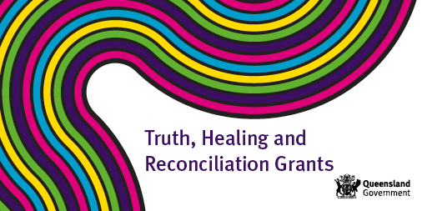

Truth, Healing and Reconciliation Grants Program 2020/21

What’s available? One-off funding of up to $10,000 or $15,000 for a joint application.

Who is eligible? Funding is available to Queensland organisations and institutions for activities that will contribute to truth, healing and reconciliation of people with a lived experience of institutional child abuse.

What activities will be funded? Activities may include projects, events or initiatives that acknowledge and raise awareness of institutional child abuse and its impact. Potential activities could include:
- Initiatives that educate and share the stories of people with lived experience in a safe and supportive way (e.g. truth telling, oral histories and creative art performances) such as exhibitions of art or writing, videos or podcasts.
- Memorials, monuments or commemorative events that are of significance to those with lived experience.
- Reunions and other events that are of importance to those with lived experience.

Where can I find the application guidelines: Guidelines are available at www.csyw.qld.gov.au/fundingavailable

How do I submit an application? Applications can be submitted electronically through https://csyw.smartygrants.com.au/THRT202021

What is the application period? Grants open Thursday 4 February 2021 and close Wednesday 14 April 2021.

How will I know I am successful? Organisations will receive an email advising the outcome of their application.

How can I apply or get more information: For more information contact the Redress Coordination/Secretariat Unit via email at taskforce.secretariat@csyw.qld.gov.au

