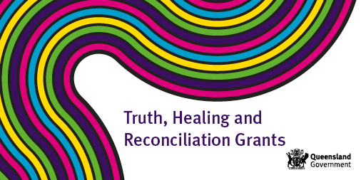

Truth, Healing and Reconciliation Grants Program 2022

What’s available? One-off funding of up to $10,000 or $15,000 for a joint application.

Who is eligible? Funding is available to Queensland organisations and institutions for activities that will contribute to truth, healing and reconciliation of people with a lived experience of institutional child abuse.

What activities will be funded? Activities may include projects, events or initiatives that acknowledge and raise awareness of institutional child abuse and its impact. Potential activities could include:
- Initiatives that educate and share the stories of people with lived experience in a safe and supportive way (e.g. truth telling, oral histories and creative art performances) such as exhibitions of art or writing, videos or podcasts.
- Memorials, monuments or commemorative events that are of significance to people with lived experience.
- Reunions and other events that are of importance to people with lived experience.
- Activities that promote cultural and community change in responding to people with lived experience of institutional child abuse and/or protecting children today.

Where can I find the application guidelines: Guidelines are available at www.cyjma.qld.gov.au/truth-healing-reconciliation-grants-program

How do I submit an application? Applications can be submitted electronically through https://cyjma.smartygrants.com.au/thr2022

What is the application period? Grants open Wednesday 6 April 2022 and close Wednesday 8 June 2022.

How will I know I am successful? Organisations will receive an email advising the outcome of their application.

How can I apply or get more information: For more information contact the Redress Coordination/Secretariat Unit via email at Taskforce.Secretariat@cyjma.qld.gov.au

