Incident management for residential care services

Version 2 (April 2019)

Table of contents
Purpose 3
Scope 3
Incident management 4
Actions to take throughout the incident management process 4
Communicate and consult 4
Monitor and review 5
Steps in the incident management process 5
Step 1. Identify risk factors and warning signs 5
Step 2. Identify if there is a risk of an incident occurring or an incident has occurred 6
Step 3. Assess the incident 6
Step 4. Respond to the incident 7
Incidents requiring possible mental health support 8
Medical conditions that are not emergencies but could be serious 8
When consent is required for treatment in emergencies 8
Step 5. Report on the incident 8
Reporting requirements 8
When an incident report is required 9
What to include in the report 9
How to report 9
When to report to the Child Safety After Hours Service Centre (CSAHSC) 9
Complete the incident report 10
Record keeping, privacy and confidentiality 10
Links 10

Purpose
The safety, wellbeing and best interests of a child are the paramount principle for the administration of the Child Protection Act 1999 (the Act). To support this paramount principle, the Department of Child Safety, Youth and Women (the department) is committed to supporting care services to provide safe homes for children and young people in alternate care.
This document supports care services in managing incidents and in determining the types of incidents which should be reported to the department.
Broadly, incidents which should be reported to the department relate to extraordinary events, actions or changes in a child’s or young person’s circumstances which:
- impact, or have the potential to impact, their safety, wellbeing and best interests or the safety, wellbeing and best interests of another child or young person in care, and/or
- significantly disrupt a care service’s capacity to provide care to a child or young person.

Care services are still required to follow their own policies and procedures to alert internal parties, as required, to ensure effective operational responsiveness.

Scope

These guidelines apply to the following parties:

- Children who are placed in non-family based care under section 82(1) of the Act.
- Licensed non-family based care services (and associated staff) which provide direct care to children and young people placed under the authority of section 82(1) of the Act and other persons involved with these care services, for example, administrative staff and contractors.

Incident management
The incident management process is outlined in the following visual representation:

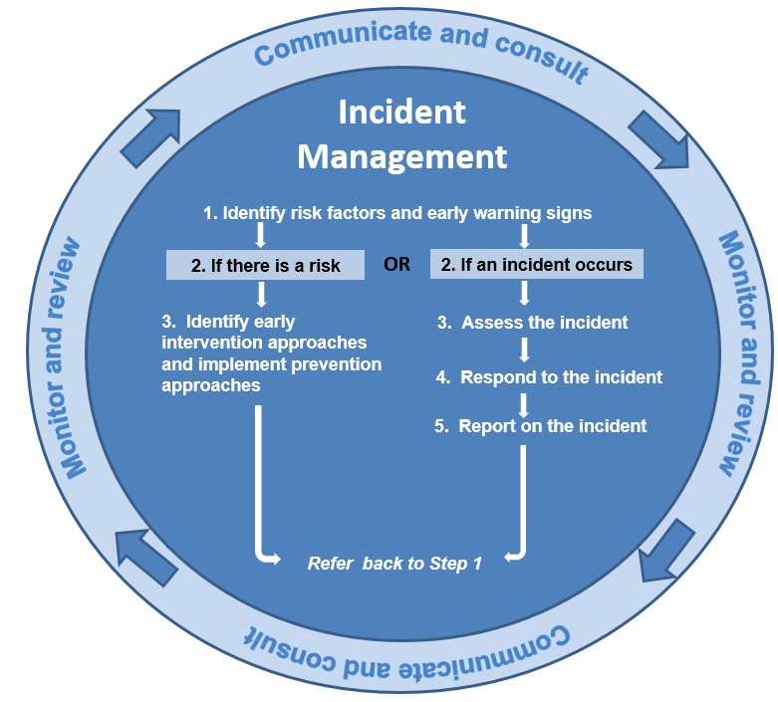

Actions to take throughout the incident management process
The incident management process has some actions which are taken throughout the process rather than as sequential steps. These actions relate to communicating and consulting plus monitoring and reviewing.

Communicate and consult
Ongoing communication and consultation should be used to:

- understand roles and responsibilities
- raise concerns and share views in a timely manner
- identify drivers of behaviours

- determine and assess needs and case planning and management priorities
- support strategies that create and maintain a safe and healthy environment
- ensure cultural supports for Aboriginal and Torres Strait Islander children and families
- encourage development and learning opportunities
- identify ways to mitigate future incidents.

Monitor and review
Ongoing monitoring and review of the care environment, the standard of care provided and actions taken to manage behaviour are vital for case planning and management and incident management.
Ongoing monitoring and review should be used to:

- identify new risks which can be managed to reduce the potential of escalating into incidents
- ensures that standards of care are met
- support changes in response to strategies and decisions which are justified and defensible.

Steps in the incident management process
The following steps in the incident management process are provided as a guide. Care services should also refer to their internal policies and procedures when managing incidents.
Note: When caring and working with children in care, care services must understand and respond to trauma-related needs and other complex needs using a therapeutic approach.

Step 1. Identify risk factors and warning signs
Incidents may occur as a result of an accident; potential or actual harm to the safety, wellbeing and best interests of a child or young person in care; or behaviour of a child or young person in care.
It is important not to assume that incidents are the result of poor behaviour. Rather, risk factors and warning signs need to be identified, and underlying causes examined, in order to tailor appropriate responses.
This is to ensure the safety of the child or young person involved, and that necessary reporting is completed as part of effective incident prevention.

When caring for a child or young person it is important to:
- be aware of any agreements made by stakeholder groups, or care teams as it relates to the response to the needs of the young person
- be aware of the child protection history that will contribute to a better understating of a trauma informed response
- be aware of any concerns that may impact the behaviour of the child or young person such as disability, intellectual impairment, current significant illnesses or injuries
- ensure Aboriginal and Torres Strait Islander children and young people are connected to culture
- understand that children and young people may have vulnerabilities which may not be overt, for example, due to a medical condition or a perception that they are more resilient due to life experiences

- use a consultative and holistic approach to engage with the young person in order to gather information and focus on their needs
- build a positive relationship based on trust and respect, communicate effectively using active listening and be consistent regarding rules and expectations, words and actions.

Methods to gather information relating to a child or young person to assist with identifying risk factors and warning signs include:
- using active engagement skills, listening to concerns and involving young people in decisions that affect them
- reviewing case plans and file notes to understand previous trauma and interactions, including incidents, and identifying what worked well and what didn’t work well in terms of responses
- having purposeful interactions with significant people in their lives such as siblings, parents, other relatives, carers, household members, teachers and doctors.
- observing interactions with others and any patterns of behaviour which may be precursors to potential incidents e.g. negative experiences during family contact.

The care service needs all of the relevant information relating to the child or young person to make sure there is an appropriate trauma informed response, as agreed by the care team. Examples of information to gather to assist with identifying risk factors and warning signs include:
- any previous trauma or incidents within the family home and / or alternate care environment
- their previous environment or environments in relation to, for example, their parents and other role models and the family context and functioning
- their history including values and social and cultural backgrounds.

Relevant information should be provided to the Child Safety Service Centre (CSSC) to inform case plans.

Step 2. Identify if there is a risk of an incident occurring or an incident has occurred
Identifying whether there is a risk of an incident occurring or if an incident has occurred will determine the appropriate response and reporting requirements.

If there is a risk, identify early intervention approaches and / or implement prevention approaches and consider previous trauma experienced by the child or young person and recommendations put forward by the care team. Strategies should be therapeutic in nature and take into account trauma-related needs and other complex needs, to support early intervention and prevent incidents occurring or escalating.
If an incident occurs, follow steps 3 to 5 of the incident management process with communication, consultation, monitoring and reviewing continuing as part of appropriate care and incident management.

Step 3. Assess the incident
The assessment of incidents will affect how they will be responded to and reported, noting that a number of serious events may occur during an incident. Incidents may be isolated or may occur multiple times with varying characteristics and degrees of severity. Incidents should be assessed with the safety, wellbeing and best interests of the child or young person in mind.

When assessing incidents, determine the incident category by choosing the incident type that best describes the incident, behaviour or circumstance that had the greatest impact and take action to manage any immediate safety and welfare first.
In an emergency, contact Queensland Ambulance, Fire or Police Services by dialing 000. See the ‘When to contact emergency services’ under ‘Step 4 – Respond to the incident’ for more information.

Step 4. Respond to the incident
Care services should follow their policies and procedures and the care team’s agreed case plan to determine the appropriate response. If unsure, care services should seek advice from their non- government organisation or the CSSC.

Generally, policies and procedures of care services would include steps to:
- manage immediate safety needs
- make the environment safe
- manage the needs of people involved
- identify the cause of the incident and take corrective action to prevent future incidents, where possible.

When to contact emergency services

Some incidents may require the involvement of emergency services such as the Queensland Ambulance, Fire or Police Services. In emergencies, dial 000 immediately.
The decision to involve the police requires careful consideration of any harm that has occurred or may occur, the person’s vulnerability and whether the police are the appropriate party to respond to the situation.

The police should never be used as a ‘behavioural management’ intervention and should not be contacted to respond to situations that can and should be managed by care service staff, even where the behaviour of the young person has an element of criminality, such as damage to property.
If you believe the matter requires attention, but do not require police attendance at the residence, please contact Policelink on 131 444.

Contacting the police – An emerging issue

There has been a marked increase in the number of incidents referred to the police involving a child or young person in care displaying behaviour which would ordinarily be managed by parents or other responsible parties.
Contact with the Youth Justice system may stigmitise the child or young person and limit their future opportunities for positive community participation, increase unwarranted disruption to family, community and cultural engagement and future educational and employment opportunities, and increase demand for long-term interventions provided by the State.

Contacting the police does not absolve care services of their responsibilities to continue to manage incidents. Care services work as part of a broader therapeutic response and should work with other professionals to proactively manage challenging behaviours. Where police are involved, the department should ensure the young person is supported in accordance with legal requirements protecting their rights. For example, a support person should be present during police questioning and when obtaining police bail in the event police are disinclined to grant bail on the basis of lack of appropriate accommodation or support around compliance with bail conditions.

Incidents requiring possible mental health support

Where a child or young person requires mental health support, consider contacting an appropriate mental health service for advice and direction or agency support staff who may transport children and young people to access mental health support services.
Where incidents involve a risk of harm, the Queensland Ambulance Service may engage the police for additional assistance.

Medical conditions that are not emergencies but could be serious

For incidents which are not emergencies but advice is needed regarding an appropriate course of action, Queensland Health has a dedicated phone line, 13 HEALTH (13 43 25 84), 24 hours per day, seven days per week. Qualified staff are available to provide confidential and supportive advice regarding health concerns. However, 13 HEALTH is not a diagnostic service and should not replace medical consultation.

When consent is required for treatment in emergencies

In life threatening, emergency situations, where appropriate consents cannot be obtained prior to treatment, or the time taken to obtain appropriate consent would jeopardise the life of a child or young person, doctors have the legal authority to proceed with treatment.

Step 5. Report on the incident

Reporting requirements

Legislation, service agreements and the Human Services Quality Framework (HSQF) provide the primary bases for reporting requirements.

Legislation

Care services must meet the standards of care, as outlined in Part 1 of the Act, when caring for a child or young person placed in care. The statement of standards, as part of the standards of care, are outlined in s122 of the Act.

Care services must report any harm or reasonable suspicion of harm to a child or young person in care to the department regardless of how the harm was reportedly caused or by whom. Section 9(1) of the Act defines ‘harm’ as, ‘any detrimental effect of a significant nature on the child’s physical, psychological or emotional wellbeing’.

The care service licensee must ensure that there is an appropriate procedure for staff to report any reasonable suspicion of harm. The mandatory reporting obligations are outlined in s13F of the Act.

Service agreements
Care services have legislative obligations and terms within their service agreements. For example, the standard terms within the service agreement require care services to report an incident to the department within a specified period of time (e.g. within four hours or by 5pm on the next business day) after the service becomes aware of:
- an incident that affects, or is likely to affect, the delivery of any of the services
- an incident relating to any services or service users, covered by the service agreement, that requires an emergency response including as a fire, natural disaster, bomb threat, hostage situation, death, serious injury, or threat of death or serious injury, of any person or any criminal activity
- an incident that may relate to any service users subject to interventions by the department, staff and carers
- a matter where significant media attention has occurred or is likely to occur.

The Human Services Quality Framework

Care services must comply with the requirements outlined in the HSQF. The HSQF is the department’s system for assessing and promoting improvement in the quality of human services.

When an incident report is required

The two primary categories of incidents to report to the department are Category 1 – Critical Incidents and Category 2 – Major Incidents. Refer to the Incident reporting guide for residential care services regarding when an incident report must be completed.

What to include in the report

The incident report should include the relevant, factual details of the incident including:

- who was involved including who was injured and the nature of the injury or injuries, if applicable
- where the incident occurred including specific environmental characteristics. For example, the particular room or rooms where the incident occurred
- when the incident occurred including the duration of the incident with start to finish times
- how the incident occurred including the sequence of events leading up to the incident, during the incident and immediately following the incident
- what action was taken in response to the incident.

How to report

Refer to the Incident reporting guide for residential care services for more information regarding how to report different categories of incidents.

When to report to the Child Safety After Hours Service Centre (CSAHSC)

Care services should contact the CSAHSC for Category 1 – Critical Incidents which occur outside working hours and after having provided for the immediate safety and welfare needs of impacted individuals. The CSAHSC provides after hours:
- statutory responses regarding critical and immediate child protection and youth justice issues across the state
- advice and support relating to children subject to child protection orders or ongoing intervention by Child Safety Services, where an immediate response is required.

The CSAHSC operates during public holidays and CSSC closure periods and can be contacted on 1800 177 135 or 07 3235 9901.

Complete the incident report

Objective language should be used when reporting an incident and any actions taken in response to the incident. The report must be legible, dated and presented in the required format.

Record keeping, privacy and confidentiality
Care services must ensure that the management system used to respond to and report incidents is clearly defined, documented, communicated and reported to appropriate parties including the CSSC, and that it maintains appropriate controls in relation to the privacy and confidentiality of stakeholders, particularly a child or young person in care. This includes ensuring that personal and sensitive client information, including incident reports, are securely stored and transmitted.

Accurate and complete documentation must be maintained to ensure accountability, transparency, due diligence and legislative requirements with regard to decision making pertaining to standards of care. If circumstances described in an incident report are alleged and yet to be proven then this should be accurately recorded in the written report.
Confidentiality must be maintained when making a report to other parties including external agencies. Failure to do so could prejudice any subsequent investigation and legal processes and could cause unnecessary trauma to individuals including the child or young person.

Links
- Child Protection Act 1999
- Child Protection Regulation 2011
- Critical Incident Reporting policy (departmental policy)
- Child Safety Practice Manual
- Human Services Quality Framework
- Incident reporting guide for residential care services
- Investment specifications
- Non-Government Service Provider Basic Recordkeeping Guide
- Reporting missing children: Guidelines for approved carers and care services

