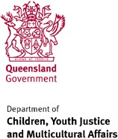
Letter of compliance

27 September 2021

The Honourable Leanne Linard MP Minister for Children and Youth Justice Minister for Multicultural Affairs

Dear Minister

I am pleased to submit for presentation to the Queensland Parliament the 2020-21 Annual Report and financial statements for the Department of Children, Youth Justice and Multicultural Affairs.

I certify that this annual report complies with:

- the prescribed requirements of the Financial Accountability Act 2009 and the Financial and Performance Management Standard 2019, and

- the detailed requirements set out in the Annual report requirements for Queensland Government agencies.

A checklist outlining the annual reporting requirements can be found in Appendix 4 of this annual report.

Yours sincerely
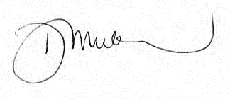
Deidre Mulkerin Director-General
Department of Children, Youth Justice and Multicultural Affairs

3

