Strategic Overview
This Annual Report represents the first full financial year of operation for the Department of Child Safety, Youth and Women. I am particularly impressed with how we have strengthened our commitment to listening to our clients, partners and communities and building stronger partnerships as we work together to improve outcomes for vulnerable Queenslanders.
Michael Hogan, Director-General
My thanks to the many hard working and dedicated colleagues and teams who have supported me and worked together to achieve success in promoting our strategic agenda and delivering our core business.
Our service delivery
At the centre of everything we do is our commitment to delivering services in a way that has a real and positive impact on our most vulnerable children, young people, women and families. Because of the department’s hard work we are seeing the rate of children coming into care slowly decrease, including for Aboriginal and Torres Strait Islander children. At the same time we are seeing more carers, particularly kin carers coming on board.
We are at the halfway point of our reform journey, Supporting Families Changing Futures. As at 30 June 2019, 72 of the 82 recommendations from the Queensland Child Protection Commission of Inquiry (Carmody Inquiry) led by the department are completed with the remaining ten in progress. Over the next five years of the ten year reform program – 2019-20 to 2023-24 – work will continue to embed existing reform and further strengthen the child protection system.
Our department is making significant progress in responding to all recommendations from the Apelt Review – Strengthening Capacity across Queensland’s Child Protection System. Our commitment to increasing support for our vulnerable families and addressing pressure points in the child protection system has seen 13 of the 14 recommendations completed with the remaining recommendation, to implement a new integrated client management ICT system, well underway.
Stopping domestic and family violence is a key priority for our department and we continue our commitment to the Queensland Domestic and Family Violence Prevention Strategy with 52 shelters providing approximately 310 places of accommodation per night. This will increase to 320 places per night when new shelters in Caboolture and the Gold Coast commence operations.
In September 2018, the first Annual Youth Statement reporting on the progress of the Queensland Youth Strategy was released with 125 of the 129 actions reported as being on-track or completed. The department continued to lead the strategy creating opportunities for young people to participate in decision making and have a voice in developing relevant government policies, programs and services.
The department is leading implementation of the response to four of the recommendations from the Anti-Cyberbullying Taskforce Report and also supporting another three initiatives. We are initiating a public awareness and education campaign for adults, children and young people; delivering an online portal and a grants program; and supporting parents and carers to actively engage in prevention of bullying and cyberbullying.
We continued to lead the implementation of, and engagement with stakeholders on the Queensland Women’s Strategy. The department will continue to work with all government portfolios through the Women on Boards initiative to increase the number of women on Queensland Government bodies, to achieve gender parity by 2020.

Youth Justice Services
The establishment of the Department of Youth Justice in 20 May 2019 brought with it a dedicated focus for delivering the whole-of-government Youth Justice Strategy. The new department is well positioned to deliver the reforms that will change the life stories and opportunities for Queensland children and young people at risk and in trouble. Our two agencies will continue to work side by side delivering important services and initiatives for children, young people and families. My deepest appreciation and admiration goes to the youth justice teams for their amazing work supervising and supporting young people.
Our valued staff
The department’s senior leaders are committed to providing a positive and supporting workplace culture for staff so that they can thrive while doing their valuable work to create brighter futures for the most vulnerable Queenslanders.
The department has invested in the development and capability of our staff, recognising their contributions and enabling them to partner effectively and drive innovation and improvement.
The health and wellbeing of our staff is a core priority and we continue to invest in safe, rewarding and flexible workplaces.
Our cultural capability
As a department we respect cultural authority and the knowledge of Aboriginal and Torres Strait Islander peoples. We have continued to build our cultural capability so we can better support communities to develop and maintain cultural identity and connections through our work.
The First Nations Council provided strong leadership of the cultural capability of the department as custodians of the Aboriginal and Torres Strait Islander Cultural Capability Action Plan. The First Nations Council will continue to provide their valuable collective cultural wisdom, knowledge and guidance to decisions, strategies, initiatives, policies and programs into the future.
Our future state
Our new strategic plan provides a strong vision and purpose, clear objectives and strategies for the department and demonstrates how we contribute to Advancing Queensland Priorities. In developing this plan we have taken the time to listen to and learn from children, young people, women and families; together with committed partners and dedicated staff members.
Furthering this engagement and partnering positively with parents, families, communities and service organisations is key to achieving our vision for the department. We will continue to build and nurture these relationships and networks as we deliver more inclusive approaches to the increasingly complex needs of our clients and communities.
Like all genuinely mutual and productive relationships, engagement with Aboriginal and Torres Strait Islander communities needs to be based on respect which is offered and earned. We remain deeply committed to building our cultural capability and ensuring we provide responsive, tailored and respectful services at all times.
I look forward to continuing to work with our staff, our partners and our clients to achieve better outcomes for Queensland children, young people, women, men and families.

Snapshot our department

Our department and our clients
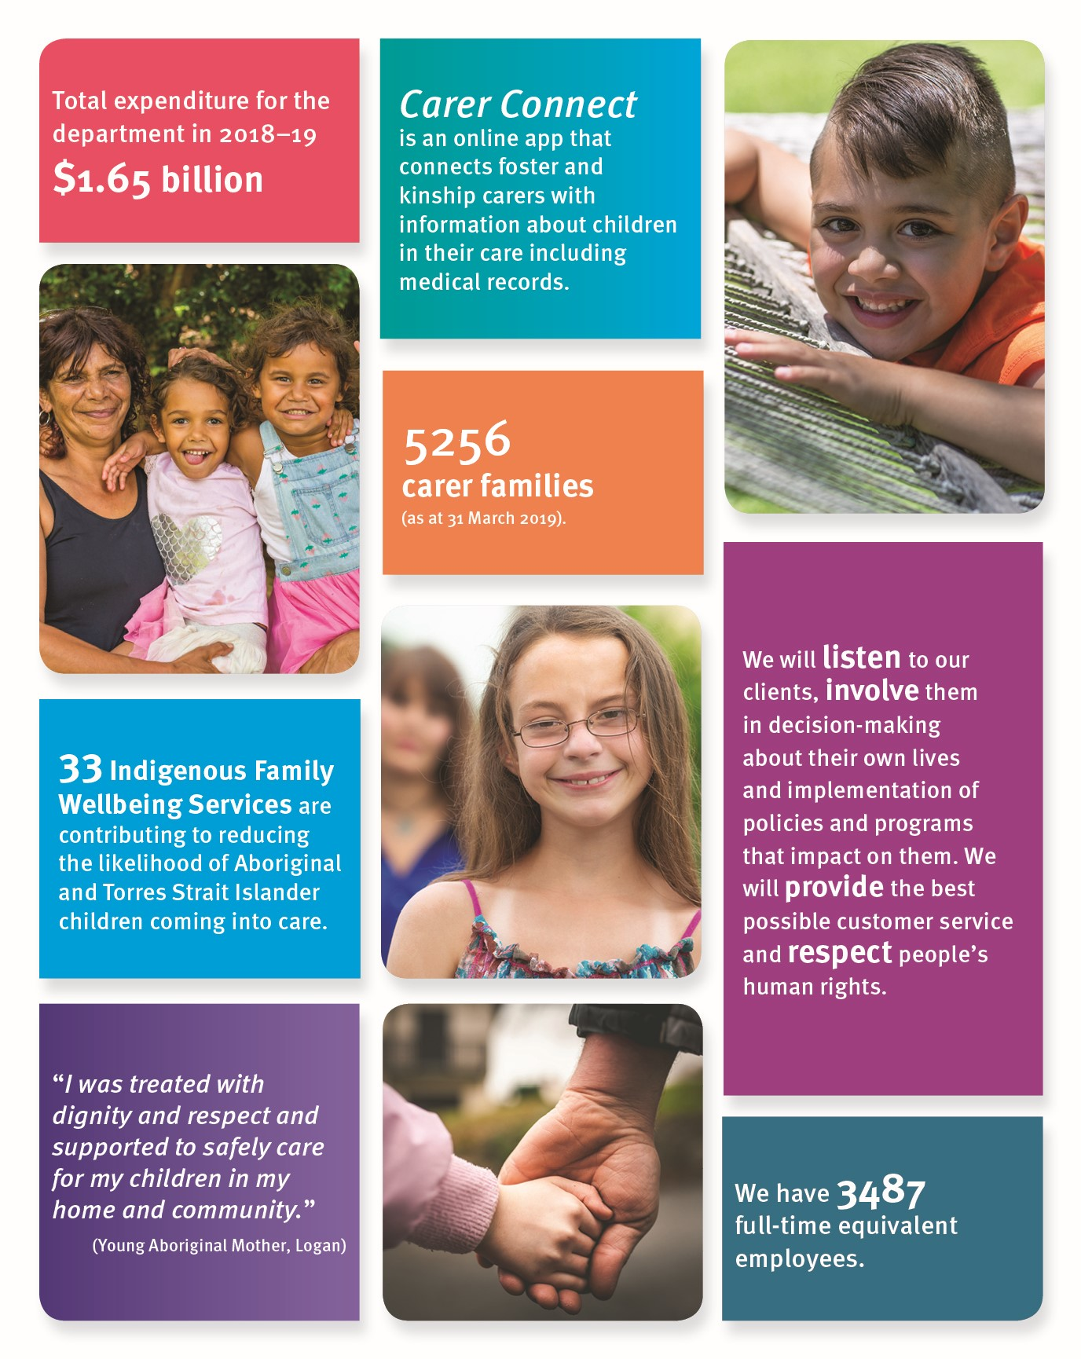
Our work and our impact
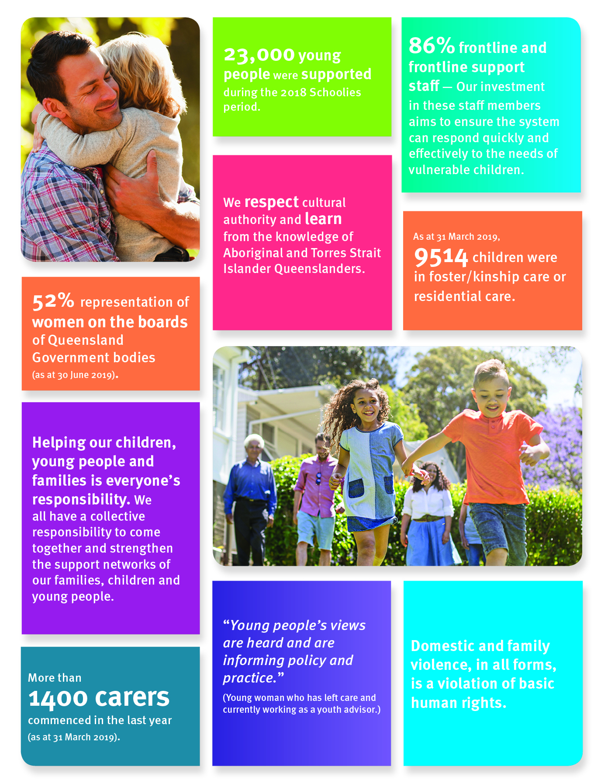
Summary of financial performance
This summary of financial performance reflects the period from 1 July 2018 to 30 June 2019. A comprehensive view of the department’s financial performance is provided in the Financial Statements section of this annual report.
Operating result
The operating result for the department is a loss of $11 million for the year ending 30 June 2019. The loss in operating result includes a non-cash expense of $10.4 million for the loss in valuation of Brisbane’s Children Court land and buildings.
Operating Result | 2018-19  Actual  $’000 | 2018-19  Adjusted Budget¹  $’000
Total income | 1,640,512 | 1,599,682
Total expenses | 1,651,590 | 1,599,682
Operating result | (11,078) | -
Income
The department’s primary source of income is appropriation revenue provided by the Queensland Government for provision of services.

Revenue for the department totalled $1,640.5 million against the adjusted budget of $1,599.7 million. The variance of $40.8 million (2.55 per cent) is mainly due to increased appropriation and user charges.
Sources of income | 2018-19  Actual  $’000 | 2018-19  Adjusted Budget¹  $’000
Appropriation revenue | 1,608,387 | 1,584,681
User charges and fees | 26,482 | 14,500
Grants and other contributions | 2,126 | 431
Other revenue | 3,511 | 70
Other gains² | 6 | -
Total income | 1,640,512 | 1,599,682
Notes:
- These figures represent budgeted figures as published in the latest Service Delivery Statement tabled in Parliament.
- Gain on sale of plant and equipment.
Expenses
Our department provides a wide range of services to the community, delivered by contracted non-government organisations and through direct service delivery. As a result, our two largest expense categories are supplies and services, and employee expenses.
Expenditure for the department totalled $1,651.6 million against the adjusted budget of $1,599.7 million. The variance of $51.9 million (3.25 per cent) is mainly due to higher supplies and services expenditure and losses on sale of revaluation of assets.
Assets
As at 30 June 2019, the department held assets valued at $168.3 million. Assets totalling $348.4 million were transferred to the Department of Youth Justice as part of the machinery-of-government changes effective 1 June 2019. Assets mainly include cash, receivables, property, plant and equipment and non-current assets held for sale.
Liabilities
Our total liabilities as at 30 June 2019 were $52.3 million. Our liabilities consist primarily of payables for service procurement and provisions for employee entitlements.
Financial position
As at 30 June 2019, the net assets position was $116 million.
Changes in equity | 2018-19  $’000
Balance as at 30 June 2018 | 447,236
Operating result | (11,078)
Net increase in asset revaluation surplus | 535
Net equity adjustments | 12,887
Net transfers out/in to other Queensland Government entities | (333,550)
Balance as at 30 June 2019 | 116,030

Statement by the Chief Finance Officer
In accordance with the requirements of the Financial Accountability Act 2009, the Chief Finance Officer has provided the Director-General with a statement confirming the financial internal controls of the department are operating efficiently, effectively and economically in conformance with Section 54 of the Financial and Performance Management Standard 2019.
The Chief Finance Officer has fulfilled the minimum responsibilities as required by the Financial Accountability Act 2009.

