Child and Family Services
Our objectives
Enable children and young people in care to thrive, and to transition successfully to adult life.
Transform child protection to enable children and families to maintain safety, wellbeing and belonging.
Value, engage and increase the number of foster and kinship carers.
Transform family and parenting supports so that children and families receive assistance when they need it.
Our strategies

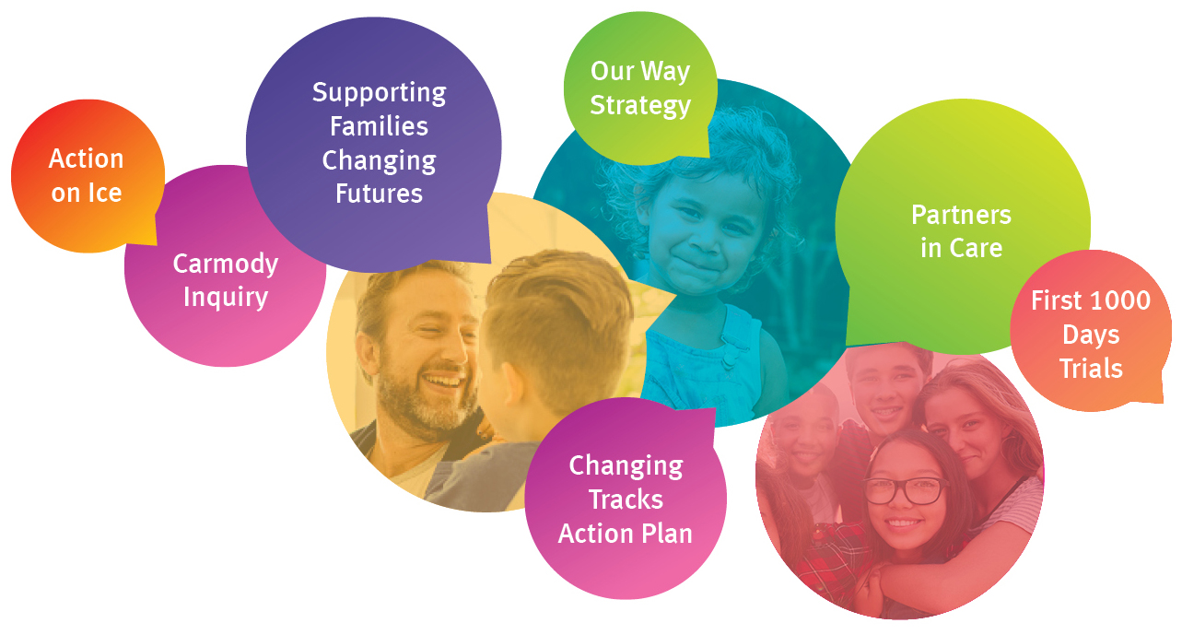

Our performance indicators
- Reduce child abuse and neglect.
- Improve wellbeing of children in and transitioning from care into adulthood.
- Reduce the disproportionate representation of Aboriginal and Torres Strait Islander children and families in the child protection system.

Our achievements
- Facilitated implementation of the Supporting Families Changing Futures reform program in collaboration with other agencies.
- Continued to embed the strengths based, safety oriented child protection practice framework.
- Delivered high-quality statutory child protection services.
- Progressed the Our Way strategy and Changing Tracks action plan to reduce the disproportionate representation in child protection and improve life outcomes for Aboriginal and Torres Strait Islander children and families.
- Funded and supported family based and non-family based care and transition services delivered by carers and non-government organisations.
- Established a Social Benefit Bond with Uniting Care Queensland, aimed at increasing rates of reunification for children in care to return safely to family, with a focus on Aboriginal and Torres Strait Islander children and families.
Improving frontline services
The Queensland Child Protection Commission of Inquiry (Carmody Inquiry) and subsequent government responses set out an ambitious 10 year roadmap for reform. Implementation through the Supporting Families Changing Futures reform program is on track – the first five year implementation period ends 30 June 2019. The department has lead responsibility for 82 of the 121 recommendations. As at 30 June 2018, 45 have been completed with the remaining 37 underway. For further information on the entire reform program visit: https://www.csyw.qld.gov.au/campaign/supporting-families.
The department facilitated the continuing implementation of these reforms, including our role in the Action on Ice Package, with an additional $7.4 million over three years from 2017-18. Ice and other forms of methamphetamine continued to cause serious damage to families, particularly those with children aged under five. The latest data has shown close to one in three children who came into the care of the department during the past year had a parent with current or previous methamphetamine use.
The department focused on boosting dedicated frontline staff across the state to deliver increasing support for families and to address pressures in the child protection system. An additional 234 frontline and frontline support positions at 30 June 2018 provided a significant boost to resourcing, ensuring regions could respond more quickly to reports of child abuse and neglect, and address areas of emerging or predicted need over the coming years.
Child safety officers worked collaboratively across government and the non-government sector to address the complex and interrelated needs of clients and communities. Twelve Child Safety Officer Health Liaison positions were funded to work in Hospital and Health Service catchments for earlier intervention and better case management with children and families known to the department.
Three new Joint Response teams from Child and Family Services and the Queensland Police Service in Toowoomba, Townsville and on the Gold Coast have been established, while an additional four child safety officers were stationed at Police Headquarters at Roma Street. Two senior child safety officers have also been located in the Youth Detention Centres, with funding from the implementation of recommendations of the Independent Review of Youth Detention.
Looking forward to 2018-19, a further 59 frontline and frontline support positions have been approved to continue reducing the pressure on the child protection system and to provide better services and support to Queensland’s most vulnerable children.
The department will also continue implementing actions from reviews and reports, including from the Royal Commission into Institutional Responses to Child Sexual Abuse.
Aboriginal and Torres Strait Islander children
Addressing the disproportionate representation of Aboriginal and Torres Strait Islander children and families in the child protection system remained a key priority. The Our Way strategy and its Changing Tracks action plan (in partnership with Family Matters – a national campaign) aims to improve life outcomes for vulnerable Aboriginal peoples and Torres Strait Islander peoples.
The delivery of Family Wellbeing Services by Aboriginal and Torres Strait Islander community-controlled organisations received continued support with 2,722 families referred for the 12 month period to 31 March 2018. The services operate as child and family hubs within communities, offering universal family support as well as more intensive assistance for families experiencing greater levels of vulnerability, including those in the child protection system.
The department has also introduced a number of initiatives through the Queensland Government Empowering Families Innovation Fund. The fund aims to get organisations to look at new and innovative ways of reducing the disproportionate representation of Aboriginal and Torres Strait Islander children in the child protection system and achieve better outcomes for Indigenous children in Queensland.
Eight early childhood development coordinators were funded to improve Aboriginal and Torres Strait Islander families’ engagement with the early childhood education and care system and to support Family Wellbeing Services to promote early learning.
The department also partnered with the University of Melbourne’s Health Equity Unit to implement the First 1000 Days Australia Program, helping children get the best start in life. The program supports local initiatives that promote the cultural strength of Aboriginal and Torres Strait Islander families, enabling children to grow up safe and cared for with family and community.
In 2018-19, the department will continue to deliver collaborative support for Aboriginal and Torres Strait Islander parents to ensure children grow up safe and cared for in family, community and culture.
Foster and kinship carers
Queensland has more than 5200 foster and kinship carer families who undertake one of the most important roles in our community – providing a safe, caring environment for more than 8300 children and young people in home-based care.
The department continued its investment in the rollout of the Supporting Families Changing Futures reforms. Foster and kinship carers transitioned to non-government agencies to better support them in their caring role and enable frontline staff to focus on supporting vulnerable children and young people.
Partners in Care is a Queensland foster and kinship care engagement program exploring how the department can better support children in care as well as those who care for them. Workshops were held across the state, designed and delivered in partnership with Foster Care Queensland, and Regional Action Plans were developed, focusing on improving partnerships between the department, non-government services and carers.
The department provided foster and kinship carers with an early childhood education and care fee gap payment (a minimum of $40 per week for eligible services) enabling greater access to child care and kindergarten. The department also supported a recruitment campaign in partnership with Foster Care Queensland to encourage more families to become foster and kinship carers.
Improving support for foster and kinship carers as they help protect Queensland’s most vulnerable children will remain a focus in 2018-19.
Performance scorecard
Service standards and other measures | Notes | 2016-17  Actual | 2017-18  Target/Est | 2017-18  Actual
Child and Family Services¹
Rate of substantiated harm per 1000 children (0-17 years of age) | 2, 3, 4 | 5.1 | 4.9 | Not available
Rate of children subject to protective orders per 1000 children (0-17 years of age):
- All children | 2, 3 | 8.5 | 8.7 | Not available
- Aboriginal and Torres Strait Islander children |  | 45.4 | 47.6 | Not available
- Non-Indigenous children |  | 5.3 | 5.4 | Not available
Rate of children entering out-of-home care per 1000 children (0-17 years of age):
- All children | 2, 3, 5, 6 | 2.1 | 2.0 | Not available
- Aboriginal and Torres Strait Islander children |  | - | 10.3 | Not available
- Non-Indigenous children |  | - | 1.3 | Not available
Percentage of Aboriginal and Torres Strait Islander children placed with kin, other Indigenous carers or Indigenous residential care services | 7 | 56.7% | 59% | Not available
Proportion of children on a care and protection order exiting care after 12 months or more who had 1 or 2 placements | 8 | 37.5% | 38% | Not available
Out-of-home expenditure per placement night | 9 | $158 | $157 | Not available
Notes:
- This service area was transferred from the former Department of Communities, Child Safety and Disability Services following machinery-of-government changes in December 2017. For information on performance prior to this date, please refer to the annual reports of the former Department of Communities, Child Safety and Disability Services.
2017-18 actual end of year performance results for Child and Family service standards are not available for inclusion in the annual report. This data is expected to be published on the department’s website by October 2018.
- Using a 'rate per 1000’ as the unit of measure allows for changes in population to be taken into account from year to year.
- The Department of Child Safety, Youth and Women is the lead agency for child protection and is responsible for coordinating actions to reduce the rate of children in the tertiary child protection system. Action by other government agencies and non-government agencies to support vulnerable families earlier will contribute to reducing these rates over time.
- This measure is a partial indicator of effectiveness in protecting children and assisting families to protect and care for their children outside of the statutory system.
- Reducing the number of children entering out-of-home care, as a result of child and family reforms, is expected to occur over several years. It is anticipated that the rate will stabilise in the short term, then decrease in the long term through the implementation of the series of initiatives as part of the child and family reforms and the Our Way strategy and its Changing Tracks action plan.
- Data prior to 2017-18 is not broken down into specific groups.
- The measure reports the placement outcomes of Aboriginal and Torres Strait Islander children. When an Aboriginal and/or Torres Strait Islander child needs to be placed in care, the department seeks to maintain a placement with kin, Indigenous carers or Indigenous residential care services.
- The department seeks to provide stable environments for all children in care. Placement stability is influenced by the child or young person’s needs and capacity of the carers. Long term historical data shows a downward trend in the proportion of children on a care and protection order exiting care after 12 months or more who had one or two placements. This reflects, in part, longer periods for which children are in care and the corresponding increased likelihood of multiple placements. This trend is expected to stabilise as child and family reforms take effect.
- Total expenditure includes all departmental costs associated with the provision of services to children in care. Performance reported against this measure may differ to that in the national Report on Government Services (RoGS) as a result of the application of national counting rules to Queensland data for the national report.

