Women, Violence Prevention and Youth Services
Our objectives
Prevent and respond to domestic and family violence and sexual assault.
Enable young people experiencing vulnerability to address risk factors.
Ensure women and girls, and young people across all cultures, backgrounds and age groups, fully participate in the social and economic opportunities for our community.
Our strategies

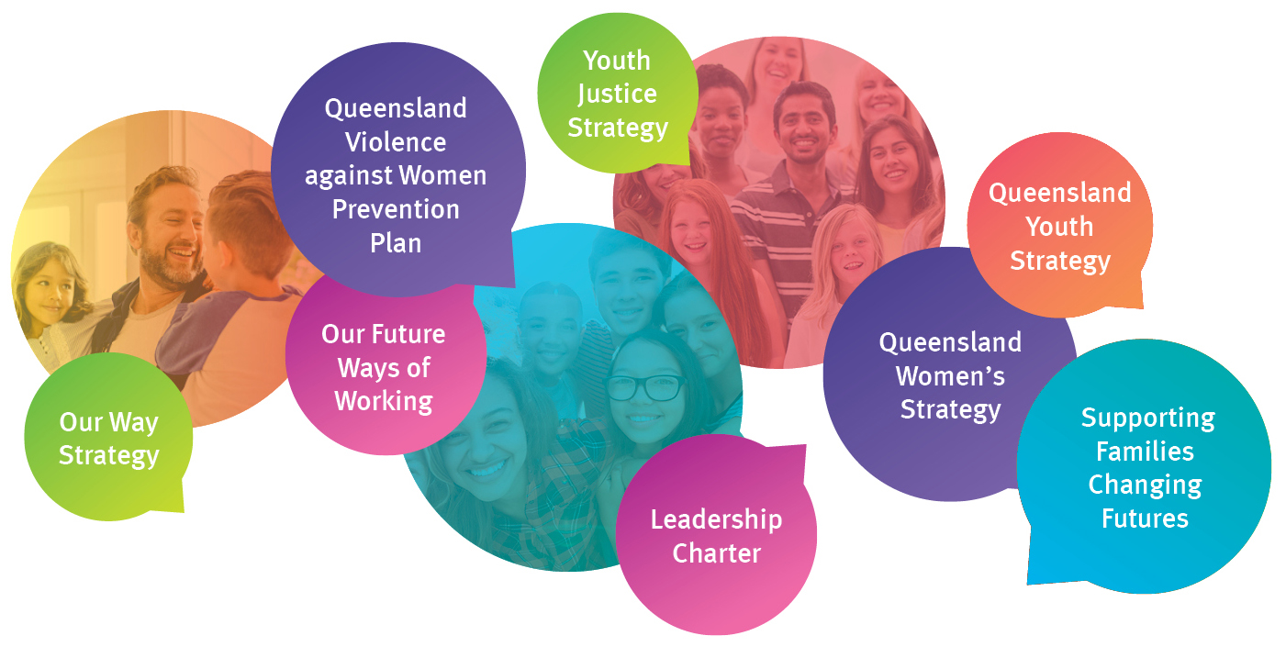

Our performance indicators
- Enable gender equality for women and girls.
- Increase the percentage of women appointed to Queensland Government Boards.
- Ensure the needs of users of domestic and family, and sexual violence counselling services, and youth support services are met.

Our achievements
- Contributed to the Government’s efforts to prevent and respond to domestic and family violence
- Continued to implement relevant actions under the Queensland Domestic and Family Violence Prevention Strategy and the Queensland Violence against Women Prevention Plan.
- Coordinated whole-of-government implementation of actions under the Third Action Plan of the National Plan for Reducing Violence against Women and their Children.
- Commissioned additional domestic and family violence and sexual assault services.
- Implemented community inclusion, participation and resilience strategies to benefit women and children.
- Continued to implement the Queensland Youth Strategy across government to support young people to achieve their full potential.
- Continued to implement the Queensland Women’s Strategy across government and community to achieve gender equality in Queensland.
Preventing domestic and family violence
The department focused on contributing to preventing and responding to domestic and family violence, including implementing actions in the Queensland Domestic and Family Violence Prevention Strategy and commissioning of additional domestic and family violence services.
Further investment grew total funding to $89.5 million over five years for the department to respond to a number of the recommendations of the Not Now, Not Ever: Putting an End to Domestic and Family Violence in Queensland report and implement the Queensland Domestic and Family Violence Prevention Strategy.
The department continued its investment in new and enhanced domestic and family violence services, including counselling and support services for victims, children and young people, court-based support, sexual assault services, post-crisis recovery support and telephone services.
Three new High Risk Teams (HRTs) in Brisbane, Ipswich and Cairns commenced operations in 2018 to enhance existing integrated responses in those locations. Two more HRTs in Mackay and Caboolture will commence operations in early 2019. The teams respond to victims, and their children, at high risk of serious harm or death due to domestic and family violence to increase victim safety and perpetrator accountability. HRT members include our department, Queensland Police Service, Department of Health, Department of Justice and Attorney-General, Queensland Corrective Services, Department of Housing and Public Works and a specialist domestic and family violence service.
In 2018-19, the department will continue to lead the implementation of 27 of the Not Now, Not Ever report recommendations. The recommendations are aimed at integrating service responses and investing in specialist domestic and family violence services to enhance protection and support for victims and their families, and to improve support for perpetrators to stop using violence.
Fighting sexual violence in Queensland
The department continued the Government’s ongoing efforts to tackle the complex and entrenched issues of sexual violence in Queensland’s communities, including through facilitating and implementing relevant actions under the Queensland Violence against Women Prevention Plan.
In 2017-18, the department funded nine child sexual abuse support organisations and 29 sexual assault support service outlets. Queensland also committed to opt in to the National Redress Scheme and announced $500 million for eligible applicants who have experienced institutional child sexual abuse. The department will lead and coordinate the Queensland Government’s participation in the National Redress Scheme. This will provide support through a monetary payment, access to counselling and psychological care, and the option to receive a direct personal response from the institution responsible.
In June 2018, the Queensland Government accepted or supported in principle more than 240 recommendations of the Royal Commission into Institutional Responses to Child Sexual Abuse and allocated $10.1 million for sexual assault services in the 2018-19 State Budget.
Enabling young Queenslanders to be heard and to thrive
The department is committed to assisting young people at risk and experiencing challenges who need support and during 2017-18 it committed $20.6 million to the Youth Support Program. The program was delivered in 92 locations across Queensland to support vulnerable young people to positively connect with family, community, education, employment and housing, and to achieve healthy and violence free lives.
The department is the lead agency in the continued implementation of, and engagement of stakeholders for, the Queensland Youth Strategy, which sets the government’s vision for young people to be active participants in Queensland’s economic, civic and cultural life.
Complementing this strategy is the youth eHub, an online initiative where young people can have a say on issues that impact them. More than 1000 young people (aged 13 to 25 years) are registered on the eHub, forming a pool that government can engage with on a variety of topics. So far eHub has hosted 14 projects and activities led by different agencies around topics including cyberbullying and women in STEM (Science, Technology, Engineering and Mathematics).
Also, from 6 to 15 April 2018, the department delivered the inaugural Queensland Youth Week, celebrating and acknowledging the contributions young people make to our community and encouraging them to speak out and have their voices heard.
In 2018-19, the department will continue to provide strong foundations and pathways for young Queenslanders by encouraging them to be heard and make safe and positive life choices through appropriate services, investments and partnerships.
Promoting the rights and interests of Queensland women and girls
The department has continued to support the implementation of the Queensland Women’s Strategy 2016-21, celebrating what has been achieved and providing a plan for government, business and the community to work together to achieve gender equality in Queensland.
The focus has been on the four priority areas of the Queensland Women’s Strategy: participation and leadership; economic security; safety; and health and well-being. Annual Gender Equality report cards show some groups of Queensland women, particularly those from low socioeconomic backgrounds, experience significant disadvantage compared with others, which increases the impacts of gender inequality particularly in these priority areas.
The department has continued to deliver the Women on Boards initiative aimed at increasing the number of women on boards in the public, private and not-for-profit sectors. Research has shown that diversity of gender on boards provides financial, performance and social benefits. As an illustration of the initiative’s success the number of women members of Queensland Government bodies increased to 46 per cent as at 30 June 2018 compared to 37 per cent in 2015-16.
The annual Queensland Women’s Week was held in March 2018 celebrating the health and wellbeing of Queensland women and girls. More than $150,000 in grants was awarded to organisations across Queensland to help deliver events to mark Queensland Women’s Week.
The department will continue to engage Queenslanders in achieving gender equality and respect for women and girls in 2018-19. It will enable women’s leadership and participation, and engage with agencies and the community to implement the Queensland Women’s Strategy.
Performance scorecard
Service standards and other measures | Notes | 2016-17  Actual | 2017-18  Target/Est | 2017-18  Actual
Women, Violence Prevention and Youth Services¹
Percentage of women appointed to Queensland Government Boards | 2 | 49% | 50% | 47.5%
Number of domestic and family violence counselling service users with cases closed/finalised as a result of the majority of identified needs being met | 3, 4 | - | - | 28,040
Percentage of youth receiving Youth Support services whose majority of needs have been met | 4, 5 | - | - | 57%
Average cost per hour of Youth Support service delivery | 6 | - | $145 | $122
Notes:
- This is a new service area and was transferred from the former Department of Communities, Child Safety and Disability Services following machinery-of-government changes in December 2017. For information on performance prior to this date, please refer to the annual reports of the former Department of Communities, Child Safety and Disability Services.
- This measure is a whole of government result monitoring progress for achieving gender equity targets for boards of management approved by the Queensland Government. Gender diversity is recognised as a key determinant in productivity and the provision of better services.
The measure refers to all significant appointments made in the financial year on all Queensland government bodies on the Queensland Register of Appointees other than those ‘out of scope’ government bodies and positions. The following are considered ‘out of scope’: (i) bodies established to meet inter-jurisdictional agreements; (ii) full-time or part-time statutory office holders; (iii) courts and tribunals; and (iv) government and non-government ex-officio positions.
- The domestic and family violence counselling service users who have their case plans closed/finalised at a time in which it is assessed that the majority of identified needs have been met. Needs are considered met when the client has achieved the goals that have been identified in their case plan. These needs may include: (i) increased understanding of the impact of domestic and family violence; (ii) understanding where the responsibility for violent behaviour sits; (iii) how to use the safety plan to reduce risk; (iv) being aware of available resources and how to access help/support; and (v) a professional assessment of reduced risk of domestic and family violence occurring.
Based upon the individual’s needs, a service user can have a case closed more than once over the reference period. The count of cases does not therefore equal the number of unique individuals to receive services. Due to the complexity of domestic and family violence issues, a baseline of service users was developed in 2017-18.
- This measure was baselined and established in 2017-18 so there is no target for 2017-18 (baseline) and there are no reporting figures for previous years.
- This measures the percentage of Youth Support, Program Support and Case Management and Integrated Response service users who had their case plans closed/finalised as a result of majority of needs being met. Cases remain open during the period of time clients are receiving services until the majority of needs are deemed to have been met. Needs are considered met when the young person has self-assessed they have achieved the goals that they have identified in their case plan. These needs may include stable housing/accommodation, employment, engagement with education, re-connection with family, drug and alcohol support, mental health support and domestic and family violence support.
- This measure is calculated by dividing the total amount of funding provided by the department to funded service providers by the total amount of service delivery hours reported across funded service types. Service types are: (i) Information Advice and Referral; (ii) Support and Integrated Response; and (iii) Support and Case Management. The average cost of services is determined by factors such as the volume and mix of service types, the location of services being delivered (e.g. urban, regional, remote) and geographical coverage (e.g. place-based or multiple locations). The average cost per hour has been calculated on established funding arrangements.

