Youth Justice Services
Our objectives
Deliver a world class youth justice system that effectively addresses youth crime.
Deliver better outcomes for people in the justice system.
Keep the community safe by working together to prevent offending by young people.
Enabling young people who have offended to rehabilitate and reconnect to a life without crime.
Our strategies

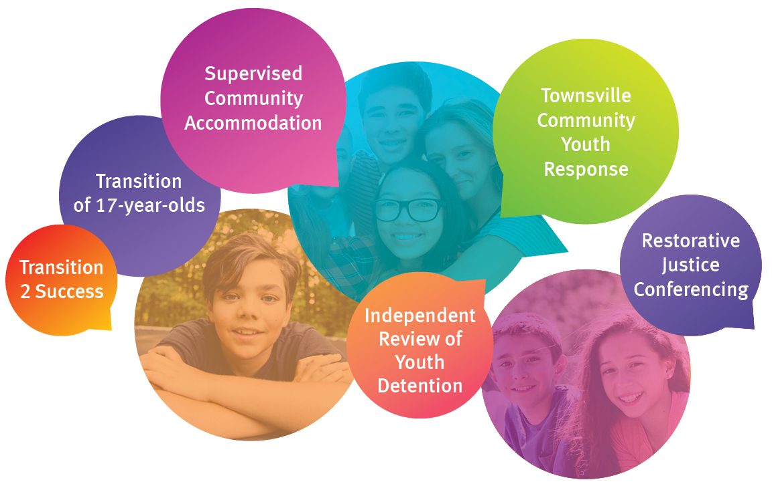
Our performance indicators
- Reduction in reoffending.
- Successful completion of community-based orders.
- Participation in restorative justice conferencing.
- Youth detention centre utilisation.

Our achievements
- Completed transitioning 17-year-olds from Queensland’s adult justice system to the youth justice system.
- Continued implementing the Government's response to the Independent Review of Youth Detention to improve practices and services pivotal to the safety, wellbeing and rehabilitation of young people in youth detention.
- Established a Social Benefit Bond with Life Without Barriers, aimed at reducing reoffending rates for young people.
- Continued partnering in the whole-of-government critical intervention strategies under the Community Youth Response initiative in Townsville.
- Continued the Restorative Justice program and the reinstated court ordered youth justice conferencing.
- Continued the Transition 2 Success program (T2S) to provide alternative education and vocational training to young people in the youth justice system.
- Continued to upgrade the security management system at the Brisbane Youth Detention Centre, including construction of a new 6 bed facility.
Transition 2 Success
Transition 2 Success (T2S) is a vocational training and therapeutic service, which aims to reduce recidivism by providing young people in the youth justice system with access to education and vocational activities.
T2S builds partnerships with local community organisations to aid in delivery of the service. The service currently operates in ten locations around the state: Aurukun, Townsville, Rockhampton, Bundaberg, Hervey Bay, Caboolture, Sunshine Coast, Western Districts, Ipswich and Gold Coast.
As at 30 June 2018, there were 339 enrolments in a T2S course with 276 (81 per cent) participants completing one or more certificates. Other positive outcomes included:
- 77 enrolments transitioned to employment
- 49 enrolments transitioned to vocational training
- 60 enrolments transitioned back into education
- 105 have transitioned into a further T2S course.
An independent, interim evaluation of the effectiveness of the program found encouraging results, with 80 per cent of all young people having not reoffended within six months after completing a T2S course.
Transition of 17-year-olds
The department completed transitioning 17-year-olds from Queensland’s adult justice system to the youth justice system. The Youth Justice and Other Legislation (Inclusion of 17-year-old Persons) Amendment Act 2016 commenced on 12 February 2018, bringing Queensland into line with other Australian states and territories, and United Nations conventions.
From 12 February 2018, any new proceeding for an offence allegedly committed by a 17-year-old is under the Youth Justice Act 1992. All adult court proceedings against 17-year-olds were transferred to the Children’s Court and all 17-year-olds on adult community-based orders are now supervised by Youth Justice Services.
The Youth Justice (Transitional) Amendment Regulation 2018 allows the chief executive to consider the best interests of the young person and the security and management of detention centres before transferring a 17-year-old from an adult prison to a youth detention centre.

Independent Review of Youth Detention
The Government accepted all 83 recommendations of the Independent Review of Youth Detention to improve practices and services pivotal to the safety, wellbeing and rehabilitation of young people in youth detention. As at 30 June 2018, 43 recommendations were completed and 40 recommendations are in progress as part of a comprehensive program of work due to be completed over the next two years.
A total of 43 of the 53 new staff funded by the program have been appointed in youth detention centres and to various programs to support the implementation and the delivery of new services, with recruitment for the remaining positions underway.
The program has already changed the way detention centres consider cultural safety and cultural competency, including the expansion of on-centre cultural units. Detention centre-based speech and language pathologists were introduced and access to mental health professionals increased.
Improved behaviour development processes were also introduced to better support young people and help staff prevent and reduce severity of incidents, including a restorative practice framework and improved incentives systems. Quarterly updates can be found on the department’s website.
Preventing and responding to youth crime
The department is committed to holding young people accountable for their behaviour while addressing the underlying causes of their offending. The department’s evidence-based policies aim to improve long-term outcomes for young people in the youth justice system and improve community safety.
The department’s restorative justice conferencing holds young offenders directly accountable, bringing them together with victims of crime, family and legal representatives to address their offending. Restorative justice conferences divert young people from the criminal justice process at the earliest opportunity, increasing court efficiency, reducing costs and reducing reoffending.
Unstable or unsuitable accommodation is one of the reasons for high remand numbers in Queensland. Supervised Community Accommodation (SCA) is designed to support young people charged with current court matters who may not have a safe place to live. SCAs provide an alternative for young people to participate in programs and services, and help them follow bail conditions. Services are co-delivered between government and non-government organisations to support young people through periods of transition and target risks of reoffending. Four SCAs are in operation: two in Townsville and two in Logan.
Other place-based initiatives draw on services across government and the community to address youth offending. The Townsville Community Youth Response Initiative includes: the After-Hours diversion program, provided by the Townsville Aboriginal and Islander Health Service; Specialist High Risk Childrens Court List; cultural mentoring provided through the Yinda Program; and flexible learning education, provided by the Townsville Flexible Learning Centre.
Announced as part of the 2018-19 State Budget, the department is seeking the views of young people, their families, members of the public and industry experts to contribute to a Youth Justice Strategy. The strategy will provide a whole-of-government roadmap for preventing and responding to youth crime in Queensland. It aims to reduce reoffending by five per cent by 2020-21, reduce the number of remanded young people in custody and address the disproportionate representation of Aboriginal and Torres Strait Islander young people in the youth justice system.

Performance scorecard
Service standards and other measures | Notes | 2016-17  Actual |  | 2017-18  Target/Est |  | 2017-18  Actual
Youth Justice Services¹
Percentage of orders supervised in the community that are successfully completed:
- Aboriginal and Torres Strait Islander young offenders | 2 |  | 78% |  | 79% |  | 79%
- Other young offenders |  |  | 81% |  | 85% |  | 85%
- All young offenders |  |  | 80% |  | 80% |  | 81%
Proportion of young offenders who have another charged offence within 12 months of an initial finalisation for a proven offence | 2, 3, 4, 5 |  | 74% |  | 73% |  | 74%
Youth detention centre utilisation rate | 2, 6, 7 |  | 84% |  | <85% |  | 95%
Percentage of youth justice conferencing participants (including the victim) that are satisfied with the outcome | 2, 8 |  | 94% |  | 96% |  | 95%
Rate per 10,000 young people (aged 10-17 years) in detention:
- Sentenced detention | 2, 9 |  | - |  | 0.9 |  | 0.8
- Remanded in custody |  |  | - |  | 3.6 |  | 3.9
Notes:
- This service area was transferred from the Department of Justice and Attorney-General following machinery-of-government changes in December 2017. For information on performance prior to this date, please refer to the annual reports of the Department of Justice and Attorney-General.
- From February 2018, young people who offend at the age of 17 years are dealt with in the youth justice system following changes to the Youth Justice Act 1992. The results for previous years include young people aged 10-16 years. The 2017-18 Actual figures include young people aged 10-16 years from June 2017 to January 2018, with the addition of young people aged 17 years from 12 February 2018.
- This annual measure reports on recidivism. Measuring recidivism is complex due to the varying nature, detection and processing of offending and offenders, and the variety of ways to measure reoffending. Youth justice uses a prevalence measure. Because recidivism can only be reported 12 months after the reference period, this measure will be reported each year using data from the previous year. The impact of any new youth justice interventions will not be fully reflected in reoffending data for a minimum of two years after implementation.
- This effectiveness measure reflects the offending of all young people in Queensland who have had a proven charge, regardless of whether or not they had prior contact with the youth justice system or had received youth justice services. It is a measure that not only identifies youth justice performance, but also the whole-of-government response to criminogenic forces.
This measure counts young people who are sentenced in court in the reference period. This includes young people who are sentenced in court for the first time ever during the reference period, and young people with a court case that precedes their first-occurring sentencing appearance in court during the reference period.
- The 2016-17 actual for this measure differs to the previously published figure in the Department of Justice and Attorney-General annual report. At the time of publication, the latest available data was an estimated actual for the proportion of young people who reoffended during 2016-17 following an initial finalisation for a proven offence in 2015-16.
- This annual measure reports on youth detention centre utilisation rate. Centre utilisation is an indicator of the department's efficient use of publicly funded resources to ensure sufficient beds are available to make provision for safely detaining varying cohorts of young people within detention (e.g. offenders of different ages; boys and girls; offenders with significant risk factors; offenders requiring different security levels; young people on remand and those who have been sentenced). Centre utilisation rate is defined as the number of detainees in all detention centres as a proportion of the number of permanently funded beds. Utilisation rates that are below full capacity are required in detention centres to ensure a safe environment for young people and staff and to optimise rehabilitation for young offenders.
- The actual result for 2017-18 does not reflect the additional investment in bed capacity, which will be operational during 2018-19. This additional bed capacity will support the 2018-19 target of <85%.
- This measure has been discontinued following review of the survey tool used to collect data for this measure. The survey is voluntary, and new data collection approaches are being considered, as part of an evaluation of restorative justice, to better capture the views of all conference participants.
- This measure has been discontinued as it does not accurately measure the effectiveness of youth justice services delivered by this department. Youth detention numbers are heavily influenced by other agencies’ policies and practices.

