Child Protection Reform Amendment Act Implementation

Preparation for the final stage of changes from the Child Protection Reform Amendment Act 2017 is well underway, with a particular focus on ensuring the child protection sector is ready for these changes, likely to come into effect at the end of this month.
Formal approval is being sought for the commencement date, with advice expected to be received within the next two weeks. Once approval has been received, confirmation will be published on the department’s website (https://www.csyw.qld.gov.au/), via a special edition of the Support Families, Changing Futures e-newsletter and via email to funded Non-Government Organisations (NGOs).
The legislative amendments will have varying levels of impact on NGOs, depending on the type of services provided. Many will be interested in the changes to Information Sharing, and all funded NGOs will need to be aware of, and working to incorporate in their practices, the five elements of the Aboriginal and Torres Strait Islander Child Placement Principle.
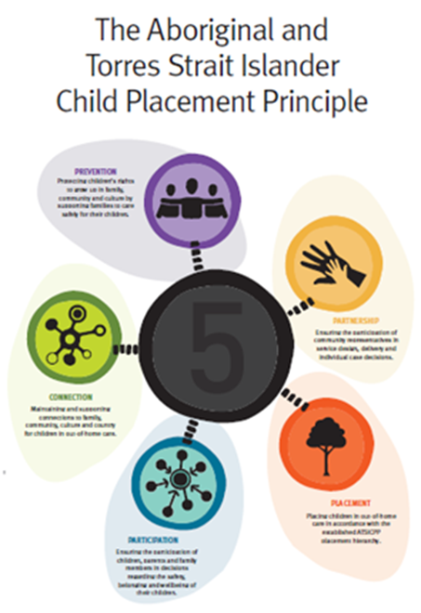
To assist NGOs prepare for the changes, a special Let’s Get Ready Guide has been developed which provides information about the changes and links to helpful resources. The guide will be available online here and can be downloaded, printed and shared with NGO staff.
Modified Capability Development being undertaken for departmental staff has also been made available to funded NGOs, and material can be sought from your local contract manager.
Resources
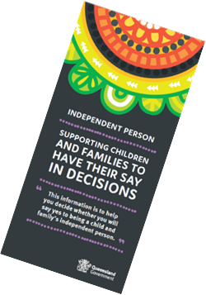
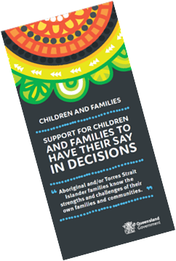
Other resources to support the changes are being finalised, including an Information Sharing Guideline and animation, and brochures to support conversations regarding the independent person. These will be published on the department’s website (https://www.csyw.qld.gov.au/) closer to commencement, however in the meantime you can view the videos to support conversations about the independent person here:
- Information for children and families
- Information for independent persons

A CPRAA overview video has been developed specifically for those working within the child protection sector, and NGOs are welcome to share this amongst their staff. The video can be found online here.
A re-cut version targeted toward the community is also available for sharing via the internet or social media, should you wish to do so. This can be found here.
Frequently Asked Questions for carers and care services were provided to attendees at the 2018 National Foster and Kinship Care Conference, which took place in early September. These are also available online.
Information on both the department’s website and the Queensland Government web franchise (https://www.qld.gov.au/) is being updated, particularly in relation to information sharing, permanent care orders and the independent person, and will be available to the community from the date of commencement.
Update of Investment Specifications
Investment specifications and program resources are being updated in line with the amendments to ensure all funded NGOs align their processes and practice with the legislative amendments.

Family Participation Program
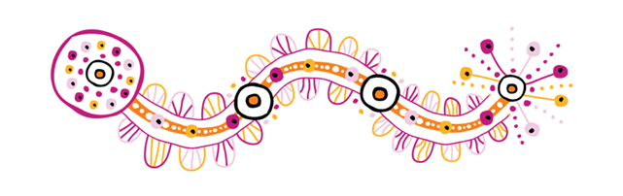Procurement of service providers for the Family Participation Program is finalised. Successful services should now have been notified of the outcome. Induction for services is taking place and training on Family-Led Decision-Making, developed in collaboration with SNAICC and the Queensland Aboriginal and Torres Strait Islander Child Protection Peak (QATSICPP), is also due to commence soon.
More Information
Further information and resources will be available on the department’s internet site as they are developed:
www.csyw.qld.gov.au/child-safety-legislation-reform
If you have any questions in the lead up to commencement of the provisions, please contact the CPRAA Implementation Team:
☎: (07) 3238 7666
✉: CPAreform@csyw.qld.gov.au

