Title: Birth parent participation in the placement decision Policy No: CPD 633-1
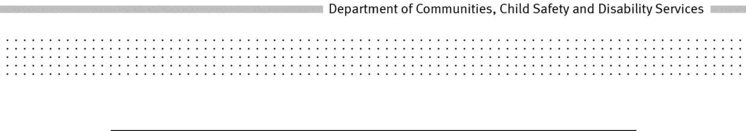
POLICY
Policy Statement:
The Department of Communities, Child Safety and Disability Services will consider the expressed placement preferences of birth parents when selecting a couple from the suitable adoptive parent register to be a child’s prospective adoptive parents.
Principles:
- The wellbeing and best interest of an adopted child, both through childhood and the rest of his or her life, are paramount considerations in all adoption matters.
- An adopted child should be cared for in a way that ensures a safe, stable and nurturing family and home life.
- Identifying the best possible placement for a child must be balanced between the child’s placement needs, birth parent’s expressed placement preferences and couple’s approved capacity and preferences.
- Adoption Services are responsible for making the final placement decision in regards to a child, however placement preferences and other contextual information provided by the birth parents will be taken into consideration when the placement decision is made.
Objectives:
To ensure the wellbeing and best interests of children requiring an adoptive placement are met by securing the best possible adoptive placement for a child requiring an adoptive placement.
To support birth parents to contribute to the decision making process regarding which couple may best be able to meet the long term care needs of their child.
Scope:
Adoption Services is responsible for selecting a couple from the suitable adoptive parent register to be a child’s prospective adoptive parents in a way that best promotes the child’s wellbeing and best interests.
This policy does not apply to the selection of persons to be assessed to meet the needs of a particular child (section 89).
The Adoption Act 2009 facilitates the selection of a couple from the suitable adoptive parents register to be a child’s prospective adoptive parents in a way that best promotes the child’s wellbeing and best interests by making provision for:
- the selection of a couple who have indicated a willingness to parent a child with the identified needs of the child requiring an adoptive placement and who have

been assessed as having the capacity to parent a child with the identified needs of the child requiring an adoptive placement and
- whose characteristics can provide the child with an adoptive placement which, in comparison with other adoptive placements, is most consistent with the preferences expressed by the child's birth parents.
Adoption Services will respect that the birth parents are able to choose to contribute their views and wishes and express their preference for a particular couple to adopt their child based on the profiles presented to them for consideration.
To the extent appropriate to the child’s ability to understand, Adoption Services will support the child to participate in adoption processes and to form and express views in relation to the proposed adoption and will consider the child’s views when making decisions.
Roles and Responsibilities:
Adoption Services will consider the expressed placement preferences of birth parents when selecting a couple from the suitable adoptive parent register to be a child’s prospective adoptive parents.
Adoption Services must take into account the information provided by birth parents and their preferences regarding the upbringing they would like for their child who is to be adopted, such as the child’s religious upbringing, characteristics of the adoptive parents and family and the degree of openness.
When making this decision, Adoption Services will take into account all matters outlined in the Adoption Act 2009, and to the child’s particular needs relating to the following matters:
- the child’s age and gender
- any Aboriginal, Torres Strait Islander or other cultural background of the child
- any existing or possible future medical condition or disability of the child
- the child’s education
- the child’s cultural background
- whether the child has a sibling who has been adopted or is proposed to be adopted
- the child’s social background
Adoption Services will make a special consideration when placing the child with a sibling as it would ordinarily be in a child’s best interests to be placed with the same family as any sibling of the child who is also to be adopted or has previously been adopted.
Authority:
Adoption Act 2009, Sections 153, 155, 156, 157
Delegations:
Regional Executive Director, South East Region
Regional Director, Child Safety South East Region
Assistant Regional Director, Child Safety South East Region
Manager, Adoption Services

Records File No.: 68/270/82318-P1
Date of approval: 11 July 2014
Date of operation: 15 July 2014
Date to be reviewed: 15 July 2017
Office: Communities, Child Safety and Disability Services
Help Contact: Client Services and Practice Reform
Links:
Adoption Practice Manual
Related Adoption policies
The wellbeing and best interest of the child in adoption (626)
Regular re-assessment of persons whose names are included in the suitable adoptive parents register (623)
Michael Hogan
Director-General

