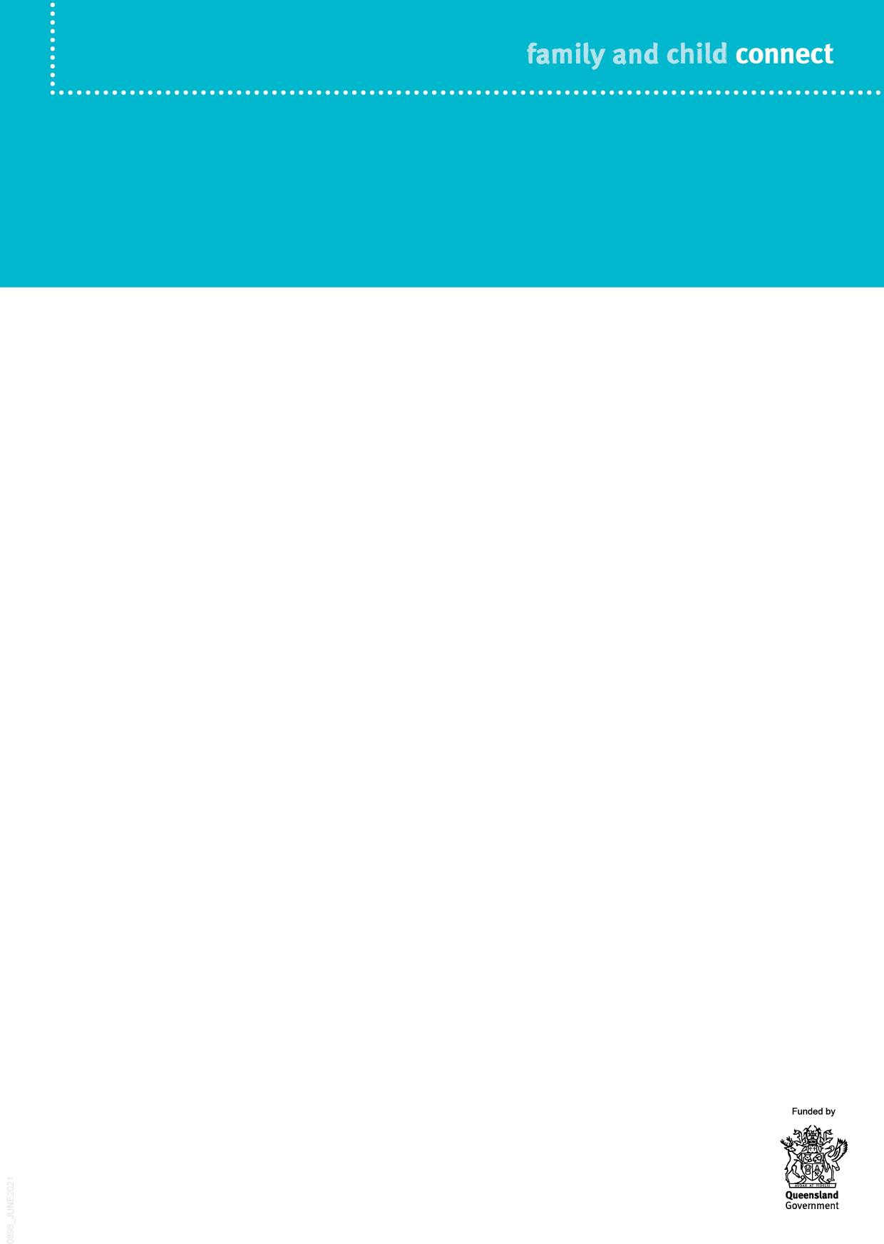

**What is Family and Child Connect?**

**Family and Child Connect is an easily accessible referral point for professionals working with families who may need support.**

The Role of Family and Child Connect

The role of Family and Child Connect is to:

•

provide information, and advice based on an assessment of the family’s needs

engage with families and refer them to support services

support a Local Level Alliance of government and non-government services.

Family and Child Connect provides information and advice to people seeking assistance for children and families where there are concerns about their wellbeing. Families can also contact Family and Child Connect themselves for advice and help.

•

•

Each Family and Child Connect is supported by a Principal Child Protection Practitioner employed by the Department of Children, Youth Justice and Multicultural Affairs, to assist with identifying and responding to more serious concerns that may require child protection intervention.

Referring to Family and Child Connect

Unless you are from a prescribed entity, the family’s consent must be obtained prior to referring a family to Family and Child Connect. If the family does not consent, a referral cannot be made.

A specialist domestic and family violence practitioner works within each service to advise and assist on domestic and family violence matters.

While prescribed entities can refer without consent, families are more likely to engage with Family and Child Connect if their consent has been obtained.

While serious concerns should be reported directly to the department, families who are at risk of entering or re-entering the child protection system if they don’t receive support, can be referred to Family and Child Connect.



When a referral is made to Family and Child Connect, an initial assessment of the concern is undertaken, and a range of responses are considered. These responses may include:

1. **Information and advice**

Family and Child Connect provides information and advice to the referrer on how they may respond. This may include advice on how to keep the family engaged, and information on local support services that may be of help.

1. **Referral to a support service**

Family and Child Connect assists the referrer to refer the family to a support service. Family and Child Connect may assist the referrer to gain the family’s consent to the referral and facilitate engagement between the referrer and the support service to ensure a smooth process.

1. **Active engagement and referral to support services**

Where families have multiple or complex needs, Family and Child Connect engages them in a more detailed needs assessment and seeks their consent to be referred to Intensive Family Support or other service.

1. **Report to Child Safety**

If Family and Child Connect receives information to suggest that a child may be in need of protection, a report will be made to Child Safety.

The Principal Child Protection Practitioner based at Family and Child Connect can assist to identify concerns which should be reported to the department and facilitate this reporting process.

Local Level Alliance

Family and Child Connect supports local level alliances of government and non- government services within the community to ensure vulnerable children and families receive the right mix of services at the right time.

Family and Child Connect service locations

Family and Child Connect operate in the following catchments:

•

Beenleigh/Bayside (provided by The Benevolent Society)

Brisbane North, South and South-West (provided by Kurbingui Youth & Family Development and Mercy Community) Browns Plains/Beaudesert (provided by Mercy Community)

Cairns (provided by Act for Kids, Mareeba Community Centre and Community Support Centre Innisfail) Gold Coast (provided by Act for Kids) Ipswich (provided by Kummara) Logan (provided by The Benevolent Society)

Mackay (provided by Act for Kids and Girudala Community Co-operative Society)

Maryborough/Bundaberg (provided by Churches of Christ Care)

Moreton Bay (provided by Mercy Community) Rockhampton/Gladstone/Emerald (provided by UnitingCare Community) South Burnett (provided by South Burnett CTC)

Sunshine Coast including Gympie (provided by Act for Kids)

•

•

•

•

•

•

•

•

•

•

•

•



•

Toowoomba/Roma (provided by Mercy Community / Lifeline Darling Downs) Townsville (provided by Mercy Community)

Cape York/Torres Strait (13FAMILY calls covered by Cairns)

Mount Isa/Gulf (provided by Save the Children)

•

•

•