Carer Connect – Ready Response pilot.

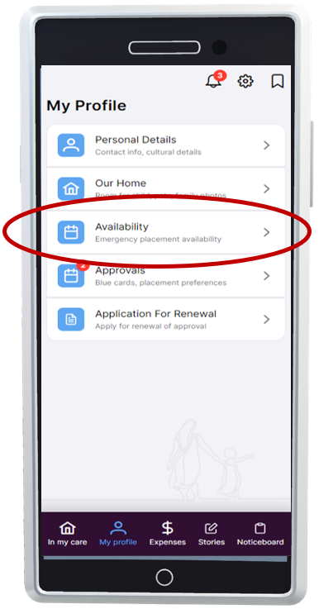
Information for foster carers

What is the Ready Response pilot?
- The ability for you to nominate when you can provide short-term emergency and/or same day care arrangements.

- Your nominated availability will be shared with your agency and the Department to help improve care arrangement responses.

- When needed the Department may contact you directly to discuss an emergent care arrangement request based on your nominated availability.

- Additional financial support for up to 7 days will be provided when care arrangements are supported by identifying your availability using the app and when you are nominated by agencies or contracted directly by the department.

Why are we piloting Ready Response?
To reduce the number of children and young people needing to be placed in short term residential care due to limited carer capacity.

Who is participating in the pilot (which regions)?
The following regions are participating in the pilot: North Queensland, Sunshine Coast and Central, Brisbane Moreton Bay, South East and South West.

When does the pilot start:

Go live date will be 20th November 2023 / Activation of pilot is from 4th December 2023

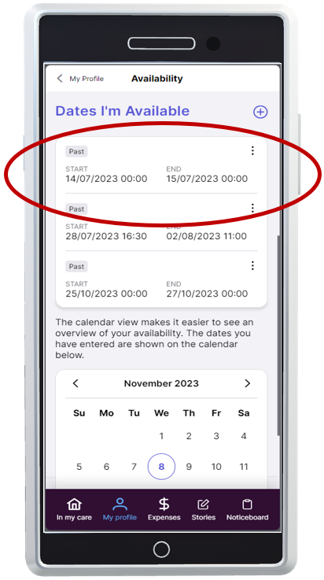

What makes you eligible as a foster carer for Ready Response?
- have a current approved Foster Carer Agreement that supports emergency care (same day and/or after-hours considerations).

- be registered and use Carer Connect to identify your availability in advance and let us know how you would want to be contacted via the app.

- agree for your regional PSU/PSS or Child Safety After Hours Service to contact you directly about any placement requests.

- input your availability in Carer Connect up to 1 month in advance, including if you can care for sibling groups and provide transport (these are options)

- participation is voluntary and carer led, that means that you will have control over your own availability.

Important to remember:
Foster carers must continue to respond to a care arrangement request via the usual referral process with their foster care agency. Agencies will be notified of availability promoted by carers and may nominate carers as a Ready Response care arrangement option through normal processes. Ready Response will only be used by the Department in response to emergent need.

