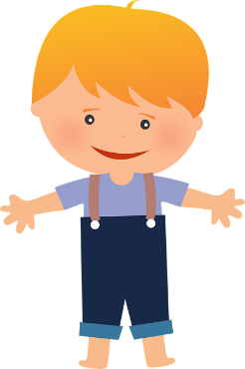

**Child’s Questionnaire**

My name is

I am

years old

My birthday is

My favourite food is

When I grow up, I want to be a

My favourite show is

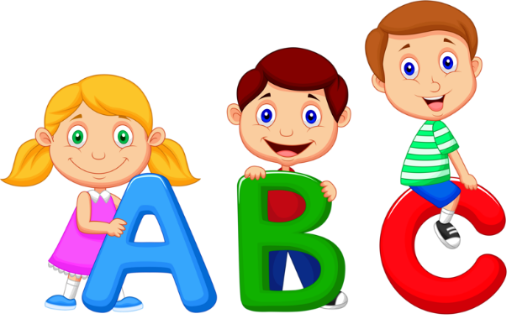

My favourite thing to do with my friends is

My favourite thing to do with my family is

Something I would like to do with my family more is



If a new child was feeling sad, I could cheer them up by

Some of the good things about having a new child to stay with us will be

Some of the things that will be different in our house when a new child stay’s will be

I feel happy when

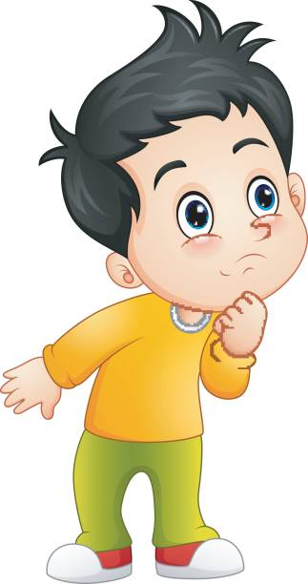

I feel sad when

Sometimes it might be difficult to have a new child stay with us because