Module three
Early days in a care arrangement
Session Plan

3 Hours
Method of Delivery
Learning Outcomes
Assessment

The assessment necessary for each participant will be based on:
- Participation in discussions and training activities
- Completion of worksheets at the end of the session; and
- Completion of a self- assessment pro forma.
At the end of this module participants will be able to:
- Explain why children can require care arrangements
- Demonstrate knowledge of how children come into care and who is involved in decision making.
- Identify the needs of children in care, and the roles and responsibilities of foster carers in meeting those needs.

Lecture
Small / large groups
Brainstorm
Activities

Resources
Handouts – multiple copies of: | - Ways to assist in connecting with and Aboriginal and Torres Strait Islander child or young person
- Decision making for children and young people (FS) | - Statement of Standards plus examples
- Maintaining Confidentiality (fact sheet) | - Principles of the Act
- Support for Carers (fact sheet) | - Ensuring children and young people have a voice
- Support for carers (fact sheet) | - Encouraging a child’s sense of safety and identity
- Community Visitors Program from OPG website | - My journey in care
- Checklist for accepting a care arrangement | - Crucial role of Education
- Placement agreement template | - Exercise on the Principles of the Act
- Accepting a care arrangement – what do I need to consider | - Policy – Participation in decision making children and young people in care

- Power Point slides
- Whiteboard/pens
- CSPM:
- Procedure – Support a child in care
Resources can be obtained from CSSC staff or via a search of the Child Safety internet, Infonet or within the CSPM.

Resources can be obtained from CSSC staff or via a search of the Child Safety Internet or within the Child Safety Practice Manual

2 mins | Acknowledgement of Country  I would like to respectfully acknowledge the Traditional Owners of the land on which we are meeting today and acknowledge that Aboriginal and Torres Strait Islander peoples are the custodians of this country and recognise their connections to land, sea, water and sky. We pay our respects to Insert Local tribal/language group, their continued culture and to their Elders past, present as well as those emerging leaders of tomorrow.  Pause  Thank you
 | Show slide 1  Distribute name tags | Slide 1  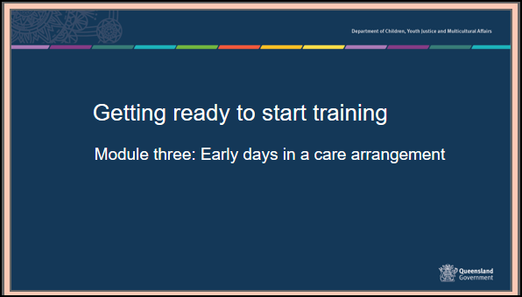
25 mins | Housekeeping, introductions, and training assessment expectations  Housekeeping details – provide the location of exits and toilets, information on breaks and catering, arrangements for smokers and phone messages. Include fire, evacuation and emergency exit and meeting points as well as any other WH&S procedures required.  Introducing each other - Use your own icebreaker or the example below  Get participants to introduce themselves to the person sitting next to them and tell them one fun activity they have done with a child or young person. Report back to the group.  Group Rules  These should be sourced from the group - ask what people would need from the group in order to feel comfortable. Ensure that the following are covered:  - Confidentiality – any information that is shared in the group will be confidential to the group – however, link to the need to respect confidences in a placement situation.  - Mutual respect and tolerance for a diversity of opinions, cultural backgrounds, and experiences.  - Punctuality and respectful processes in discussion.
 | Show slide 2  Provide a brief overview of the previous two modules  Overall aim of Foster Carer Training: Getting ready to start training.  Getting ready to start training is presented in 4 modules of 3 hours each.  - Context of Foster Care Module one-.  - An understanding of the process of how children and young people come into care and the impact of this process, and why children and young people require a care arrangement.  - Understanding the past for a child or young person  - An understanding of trauma and related behaviours for a child or young person who is in care arrangement.  - Early days in a placement - you are here  - Developing knowledge and skills required to meet the physical, emotional and social needs of children and young people in care and an understanding of the importance of participation by children and young people and their families in decision making.  - Quality care - working together  - Have an understanding of the importance of partnerships between children, their families, foster and kinship carers and workers, (both in the government and non-government sectors), and their roles and responsibilities when working together as a team. | Slide 2  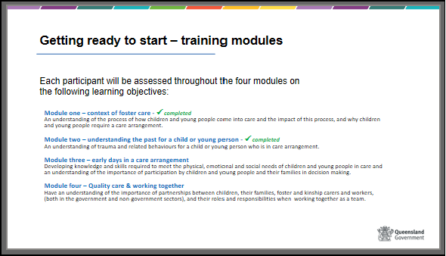
 | Show slide 3  Learning outcomes – module 3  This module will provide information to assist you in understanding what information you need to be aware of when accepting a care arrangement for a child or young person.  At the end of this module you will be able to: as per slide | Slide 3  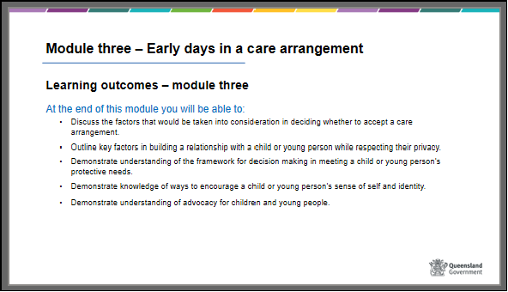
30 mins  40 mins  30 mins  40 mins  30 mins  10 mins | Show slide 4  Early days in a care arrangement – Content and timeframes  This module of the training will cover some of the things you need to know before you accept a care arrangement for a child or young person.  - Accepting a care arrangement - What do I need to take into consideration when accepting a care arrangement?  - Building relationships - building a relationship with a child or young person  - Privacy and confidentiality – respecting a young person’s privacy  - Case Planning & Decision making - how to meet the child or young person’s needs  - Promoting a positive sense of self and identity for a child or young person  - Advocacy for children and young people | Slide 4  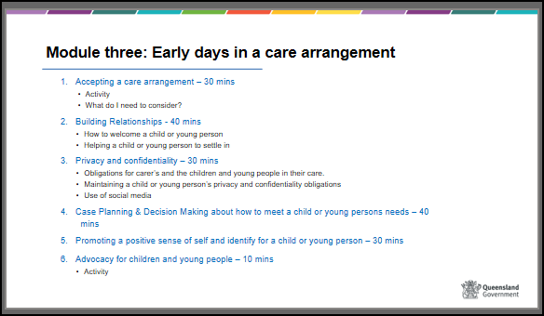
 | Show slide 5  Refer to separate activities resource for instructions on activity  Activity – Parental Reflection | Slide 5  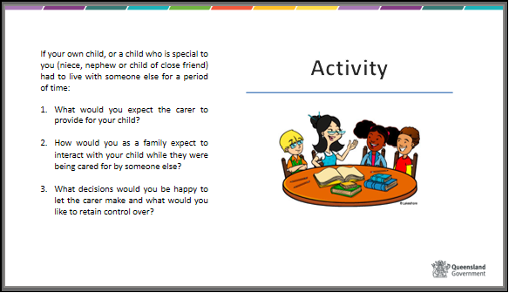
30 mins | Show slide 6 & 7  Care Arrangement – accepting a child or young person into your care  Handout – Charter of Rights, Statement of Standards & Principles of the Act  (Refer to handouts or the posters regularly in this section.)  As discussed in Module one, it is Child Safety’s responsibility to ensure a child placed in care is cared for in a way that meets the child’s rights, the Principles of the Act and the legal standards of care in the Child Protection Act 1999. These standards of care are called the Statement of Standards.  Carers also have a legal obligation to provide care which is consistent with the Charter of Rights, the Principles of the Act and the Statement of Standards.  The Charter of Rights, Principles of the Act and Statement of Standards all guide the role and responsibilities of both Child Safety and carers. Throughout the training we have been covering these areas and showing you how to incorporate these frameworks into your day to day activities as a carer.  For example:  - Positive Behaviour Support assists with the requirement to receive positive guidance to help change inappropriate behaviour (Statement of Standards (g)).  - Maintaining relationships with family assists with meeting Principle 2 (f) (ii) and Statement of Standards (j)).  In Module one we discussed the Principles of the Act including:  - The welfare and the best interests of the child are paramount – 1.  - The views of the child and family are considered, and they have the opportunity to take part in making decisions that affecting their lives - 2 (ii) (iii).  - Preferred way of meeting a child’s wellbeing is through the support of the family – 2 (c).  - The child needs to maintain contact with their family and social contacts, including their ethnic and cultural identity – f (ii)  Carers must “understand and be committed to” the principles outlined in this session.  The principles reflect certain values about families, the community, and the role of the state in intervening in the lives of families. Our values about families and the community come from a range of sources - personal experience, our education, our culture, our religious and spiritual beliefs.  Ask participants to consider:  - Do your values about families sit comfortably with the principles of the Child Protection Act? Give actual examples where possible from within your own family or family of origin.  - Are there any conflicts or concerns between these principles and your own point of view?  As well as the Principles of the Act, carers need to understand and be committed to the Statement of Standards in the Child Protection Act 1999, which we will look at next.  Trainers are to refer back to the Charter of Rights and Principles of the Act and provide the Statement of Standards. Allow participants to review these and highlight some from the handout relevant to the group. | Slide 6  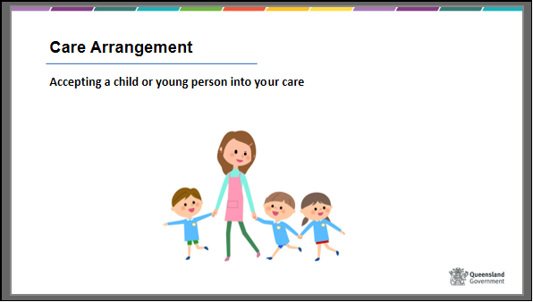  Slide 7  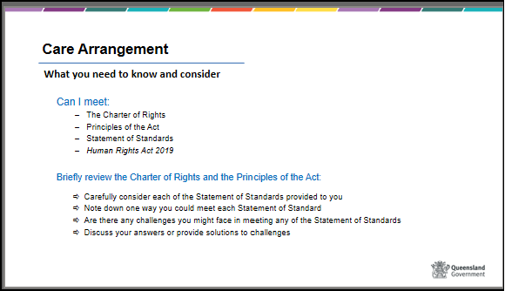
 | Show slide 8  Refer to separate activities resource for instructions on activity  Activity – applying the Statement of Standards | Slide 8  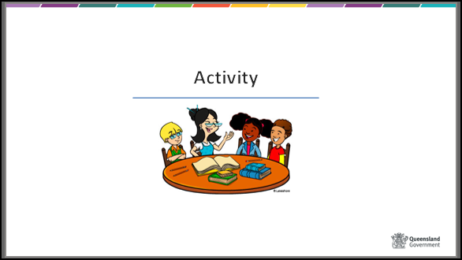

 | Show slide 9  Foster carer agreement  A Foster Carer Agreement is developed through discussions between the carer, their foster and kinship care service and Child Safety. It can be completed as part of the approval process, or as soon as possible following the issuing of the certificate of approval and prior to a child or young person being placed with the carer. It is reviewed at least one year from the date of the carer’s initial approval and every two years thereafter. It may also be reviewed as a result of a change in carer circumstances or if a carer has not met the standards of care, following the outcome of a standards of care review or the investigation and assessment of a harm report.  Handout – provide a copy of a foster carer agreement and discuss the key sections  The agreement includes:  - Care arrangement considerations  - such as language, culture, school catchment  - information about your immunisation views and the immunisation status of you and the children in your care  - placement types you won’t consider  - practical limitations – such as bedrooms, car capacity, carer’s work  - Care arrangement capacity  - the number of children you are able to care for  - A develop and support plan  - What you need; how will this be met; who will assist; timeframe  - Support plan and network  - elements of support that are identified  - other specific supports needed.  The renewal of you as a foster carer includes the assessment of your continued suitability, whether you have met the standards of care for children placed with you during the preceding one or two year period and whether you continue to meet the legislative and policy suitability requirements.  When it is indicated that the standards of care have not been met for a child, Child Safety Services will respond through the matters of concern process to ensure the safety and well-being of the child. Matters of concern will be discussed in more detail in Module four.  Provide examples of Breaches of the Statement of Standard if relevant at this time. | Slide 9  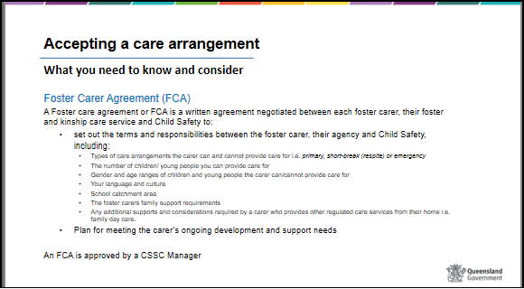
 | Show slide 10  Information provision to parents  An experienced foster carer presenter could present/ assist with this session and give case examples to participants.  Child Safety have a legal requirement to inform parents of where and with whom their child/ren will be living when  they are placed into a care arrangement; this requirement can be found in the Child Protection Act 1999 under section 85 and 86. In making decisions about where a child or young person on a child protection order is placed, consideration must be given to possible safety issues when necessary identifying information about the care arrangement is given to the child’s family.  Child Safety have processes in place to assess the risks to the child or young person or to anyone else living with them, including the carer and the carer’s family, when needing to advise the parents of their child’s living arrangements.  A risk assessment is the purposeful process of gathering information on the child, parent, the family, and their environmental context to determine the probability and degree to which a child may be harmed in the future. The risk assessment can include the persons criminal history and their likelihood to use violence, discipline techniques, attitudes to those in authority, drug and alcohol misuse and impacts and the risk to the carer and child if on contact.  Should Child Safety assess that there are significant risks to the child or young person as well as the carer and carer family Child Safety is able to withhold this information from parents.  Unless otherwise indicated because of particular safety concerns, parents must be told who is caring for the child and where that care is being provided.  A ‘Record of assessment of placement information to parents’ form will be completed. Carers must be given this information and can refuse a care arrangement if they do not agree with disclosure of details to parents in this instance.  Where children or young people on a child protection order are placed in a care arrangement for longer than 6 nights (including short breaks) and a decision made by Child Safety to withhold full or partial information around the care arrangement from the parents including who will be caring for the child or young person is a reviewable decision, meaning that this decision can be reviewed by QCAT (or Child Safety) at the parent/s or child/young person’s request. | Slide 10  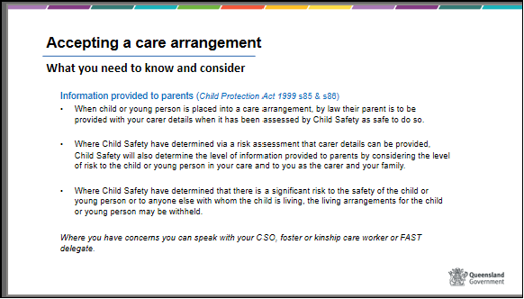
 | Show slide 11  Accepting a carer arrangement – what do you need to consider?  When you are approved as a foster or kinship carer you will at some stage be called to care for a child or young person. This might be when you least expect it so it is important that you are prepared and consider the timing for you and your family. This next section will provide you with some questions to ask so that you make the best decision for you, your family and the child.  BRAINSTORM – What information do you think you may need before accepting a care arrangement?  Refer to separate activities resource for instructions on activity  Show slide 12  As well as asking questions to prepare yourself you will need to prepare your family carefully for the placement. Some of the following points will help.  - Provide key information e.g. how long it is likely to be for, what the goal is for the placement. Why the child entered care and how this may impact on their behaviour and disciplinary methods.  - e.g. If severely neglected, time out might not be appropriate for that particular child.  - Talk through how the placement will affect your family  - e.g. house rules, disclosures by the child or young person, why the foster child or young person may be treated differently, acknowledgment of possible difficulties.  - Discuss confidentiality issues – what to tell school friends, relatives etc  - Who else in the family can be involved e.g. grandparents?  - What might be the impact on your family’s wider social network | Slide 11  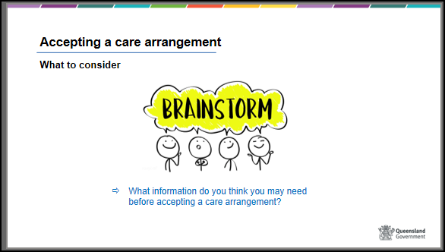  Slide 12  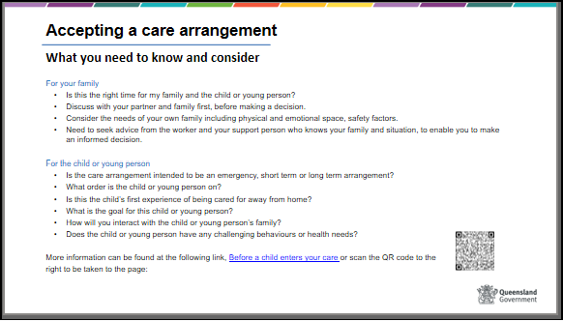

 | Show slide 13  Placement Agreement  A placement agreement is a written agreement between Child Safety and carers for a child in care’s care arrangement.  A placement agreement must be developed for each child or young person placed in a care arrangement. Ideally a placement agreement should be completed prior to a child or young person entering your care, however if this is not possible the placement agreement should occur within 3 business days of the child or young person being in your care. The CSO is responsible for organising a placement meeting to develop the placement agreement.  The placement agreement includes important information regarding the daily care of the child or young person in your care and can include:  - any special health needs  - behaviour management requirements  - family contact arrangements, including who is responsible for transport etc  - any additional financial requirements that may be required i.e. if a young person requires medication that is over and above what is provided in the carer allowance.  - Any additional resources of services you may require as a carer to meet the specific needs of the child or young person i.e. if the child has high medical needs the placement agreement might indicate ways to assist in meeting these medical needs  In some occasions a placement agreement may not contain a lot of information regarding the needs of a child or young person, especially if they are new into care, in these cases the placement agreement should be reviewed as required when new information becomes available regarding the child or young person’s needs.  If you haven’t received a written placement agreement it’s important to contact the CSO or your foster and kinship service, to ensure you receive a copy to help with the child’s care arrangement and to have your support needs and services documented.  The placement agreement can also be uploaded to the Carer Connect app once it has been approved. | Slide 13  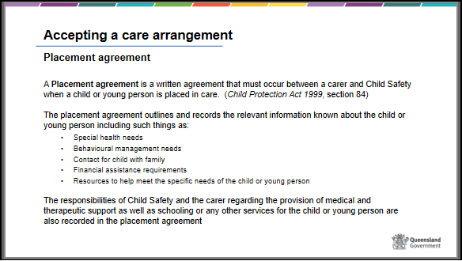

 | Show slide 14  Summary – accepting a care arrangement  Allow participants some time to review the summary and provide a brief summary for this section. Allow participants to ask any remaining queries. | Slide 14  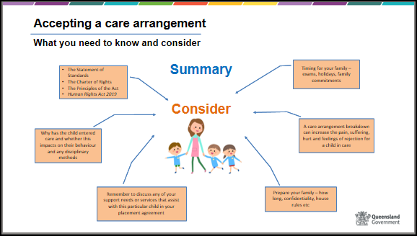
40 mins | Show slide 15  Building Relationships & Confidentiality  Optional Activity – Refer to separate activities resource for instructions on activity  Once you have accepted a care arrangement it is important to think about how the child will be feeling and the needs of the child when they first arrive at your home. Remember that the child will not know you, where things are kept or the spoken and unspoken routines and rules of the house. This section will provide some ideas around how to help welcome a child. | Slide 15  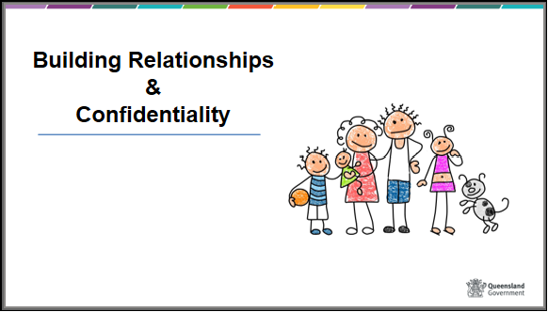

 | Show slide 16  Actions and feelings  Be aware of your actions when a child or young person arrives at your home and have an understanding of what they may be feeling upon their arrival, provide them with some basic information such as:  - Tell the child or young person who you are and what they can call you and introduce any other members of the home.  - Make the child or young person feel less of a stranger by telling them about the house, family members, pets, and routines.  - Be aware of first impressions – the child or young person may be feeling vulnerable – or may be hostile if they have had bad experiences before. Your behaviour and attitude – the way you say things and your manner is important. Be warm and welcoming.  - Tell the child or young person what arrangements have been made to maintain contact with their family – when and how this will happen.  - In consultation with the worker, clearly outline what is happening and what is likely to happen in the future.  What makes you feel respected and understood?  Discuss communication – what we say, the way we say it, the opportunities we give others to communicate back to us, and the body language we use.  You can help children and young people feel respected and understood by:  • Listening carefully – sitting at eye level, nodding, appropriate facial expressions  • Letting them talk about their concerns in their own way – not interrupting or putting words in their mouth.  • Acknowledge feelings – e.g. “I can see why you are upset about that, but have you thought about - - -“  • Giving plenty of opportunity for the child or young person to ask questions  • Explaining what you can realistically do.  • Being honest and not making promises unless you can keep them.  • Not dismissing their worries or minimising them. | Slide 16  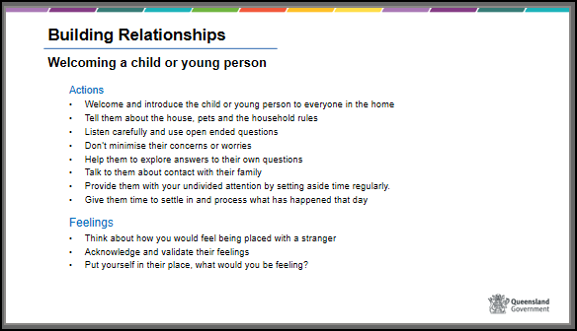

 | Show slide 17  Be aware of what a child or young person may be feeling as they enter your home, they could be new into care or have experienced disruptions from previous care arrangements. A child or young person may have many emotions on entering a new living environment and may be:  - experiencing trauma  - separated from their siblings and are worried and afraid for them  - grieving for their parents, siblings, family, friends and pets  - feeling scared, nervous, angry and unsure  Don’t expect children and young people to feel welcomed straight away, they have more than likely experienced significant changes over the last 24 hours and will need time to adjust to a new care environment and space to process what they have recently experienced. Be sure to:  - make yourself available to the child or young person and given them your full attention  - let them know what to call you and introduce the other household members and pets (if any)  - show them to their room and provide a tour of the house  - Try to get to know them, what foods do they like? do they have any allergies? do they need anything?  Show slide 18  Children and young people may arrive with some belongings or they may arrive with little or nothing at all. It’s important to understand that children and young people will treasure any belongings they come with as this will be their link to their family and their memories, so should be respected at all times.  Children and young people’s belongings should move with them when and if they leave your care, including items purchased using the fortnightly caring allowance specifically for the child or young person, this includes all personal items such as:  - clothing, shoes, bags, hairbrushes, toothbrushes and any personal hygiene items  - any sheets, towels, blankets, pillows and doona’s that have bought specifically for the child or young person  - If you purchase the child or young person a gift, it is a personal item and belongs to the child or young person.  - Any photo’s or memorabilia of the child or young person, including school photo’s, photo albums made for the child or young person or items received by the child or young person.  - Electronics, bikes, scooters, roller skates, balls, toys etc that have been bought for the child or young person are also considered personal items and must stay with the child or young person.  Items that are used by all members of the household that have not been bought specifically for the child or young person, such as towels, sheets, play equipment etc are not considered personal items. | Slide 17  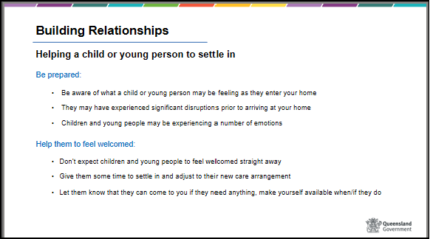  Slide 18  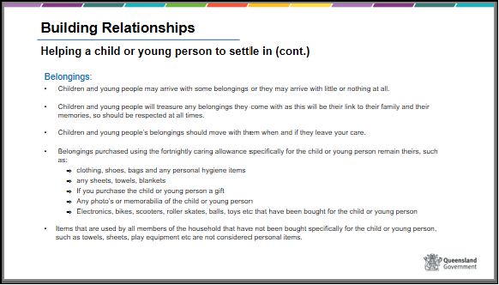
 | Show slide 19  Helping an Aboriginal and/or Torres Strait Islander child or young person to settle in  Handout - Ways to assist in connecting with an Aboriginal and Torres Strait Islander child or young person  Ideally the Child Placement Principle which was discussed in module one will be followed when placing Aboriginal or Torres Strait Islander children who require a care arrangement, however in those instances where this may not be an option in the first instance it’s important to have an understanding of what and Aboriginal or Torres Strait Islander child or young person may be feeling when being placed in the care of people outside of their family or community.  Refer to the handout when discussing ways to support an Aboriginal or Torres Strait Islander  Refer participants to the Secretariat of National Aboriginal and Islander Child Care SNAICC website https://www.snaicc.org.au/ if they would like to find out more information about supporting Aboriginal or Torres Strait Islander children and young people. | Slide 19  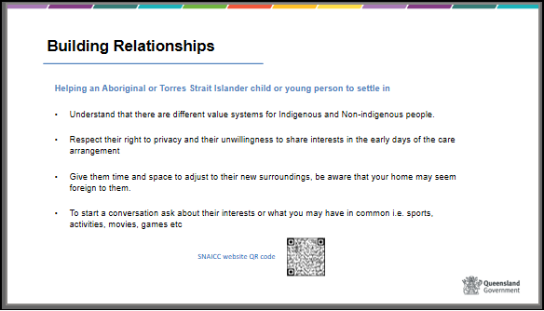
 | Show slide 20  Recap  - The way you listen and encourage children and young people to talk to you about themselves is a powerful method for establishing trust.  - Make it clear you are willing for the child or young person to express their feelings but don’t try to force someone to talk.  - Help children and young people explore their own solutions to problems rather than giving advice or solving the problem for them. Assist them work out the implications of different decisions.  - Make sure there is some time each week when you can give the child or young person your undivided attention – preferably in a relaxed atmosphere, maybe doing something together.  Refer to the QR code or website identified on the slide for more information. | Slide 20  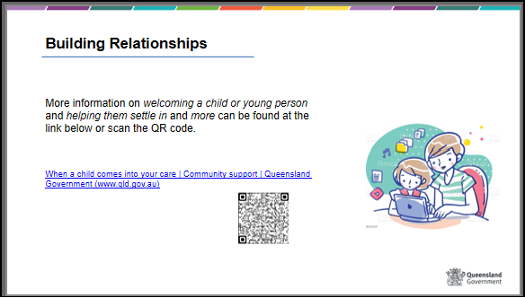

30 mins | Show slide 21  Privacy and confidentiality | Slide 21  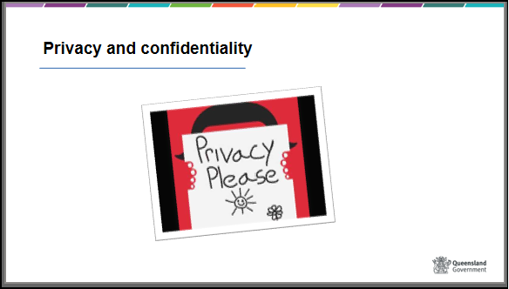
 | Show slide 22  Privacy and confidentiality - Carers  - Child Safety is regulated by the Information Privacy Act 2009 when collecting and handling your personal information, including its use and disclosure.  - Child Safety only collects your personal information if it is directly related to the function of being a carer, such as the protection and wellbeing of a child and to help us to assess your suitability to be a carer.  - Child Safety are committed to protecting your privacy when dealing with your information.  The QR code has been provided should participants want to view the Information Privacy Act 2009 | Slide 22  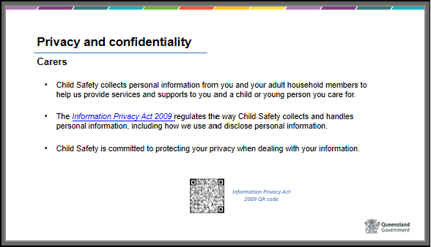

 | Show slide 23  Privacy and confidentiality - Children in care  Handout:  - Maintaining confidentiality – fact sheet  - The importance of confidentiality  Remind carers that they have a legal obligation to respect the privacy of children in their care and point out that this obligation continues after a child has left their care regardless of how much time has passed.  Think about privacy as including physical privacy, communications privacy and information privacy.  Talk about some of the examples of ways to respect a child’s privacy:  - Respecting a child’s personal belongings and space. Think of ways they could do this in their home environment.  - Respecting a child’s right to privacy in their relationships and communications with others, in an age appropriate way. Think about when this might be challenging for carers.  Keep a child’s information confidential. Think about how you might have this conversation when helping a child or young person to understand that some things cannot be kept secret (e.g. disclosures of harm)  Highlight different ways of protecting a child’s privacy.  Show slide 24  Keeping a child’s information confidential is another way of protecting privacy and building trust with a child.  The child or young person needs to feel that their information and the things they tell you are valued pieces of information and will not be shared unnecessarily.  Think about a time when you found out someone you know told another person something about you or your child that you didn’t want shared. Think about how that felt to you and how it may also feel to a child or young person when you share their person information.  In addition, carers are bound by the Child Protection Act 1999 in relation to confidentiality (section 187). You must not use or disclose information about another person’s affairs that you acquire in your capacity as a carer, or give access to documents containing that information, to anyone else.  There are some exceptions, including:  • to the extent necessary to perform your functions as a carer or  • for purposes related to the child’s protection or wellbeing  • if required or permitted by law, or  • to the extent that the information is about the person.  There are legal implications to not maintaining the confidentiality of a child or young person’s information (i.e. a fine or up to two years imprisonment).  Highlight to carers that if they pass information onto another person, that person may also have confidentiality obligations, whether or not they are aware of them and may also incur a fine or imprisonment if they breach them. | Slide 23  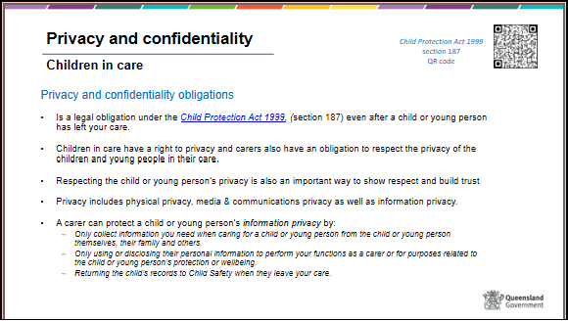  Slide 24  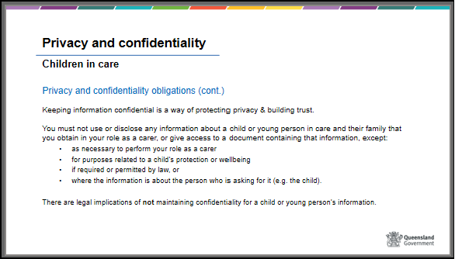
 | Show slide 25  BRAINSTORM – Privacy and Confidentiality  Refer to separate activities resource for instructions on activity | Slide 25  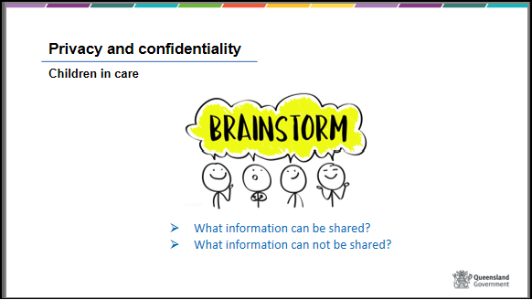

Recap – privacy and confidentiality

Trainer to highlight the key points in the Maintaining Confidentiality fact sheet.

Note that the principals of maintaining confidentiality extend to your children and household members.

Prepare your own children for disclosures that may be made by a child in your care as children and young people will often tell other children or young people before they tell an adult.

Consider the following points when helping your child to prepare for keeping information confidential:
- Explain to your child/re that the child in care has the right to privacy and that information about them must not be shared with friends or any other people because this would make the child feel unhappy and betrayed.
- Share general information about why children and young people come into care in a respectful and age appropriate level.
- Tell your own child that children and young people in care may have had difficult or hurtful experiences that may cause them to behave in unfamiliar ways.
- Tell your own child that it is important for them to let you know if a child in your care says something to them that is confusing or upsetting, even if they are asked to keep it a secret.

If you have any doubts about what you can or cannot share, please contact your child safety officer or foster or kinship care service for advice
 | Show slide 26  Use of social media  Child Safety understands the importance of social media for children and young people and are aware that they can often enjoy being included in social media to celebrate activities, achievements and as a member of a carer family.  It is not against the law for a photograph or information about a child in care to be posted on social media, however, it is unlawful to identify a child as being in care, or to include information that is likely to lead to the identification of a child as being in a child in care or a child connected to the child protection system.  Being aware of what information you are posting on social media, that may include a child in care may not in a single incidence identify that child or young person as being in care however in conjunction with all your previous information you have posted may indirectly lead to that child or young person being identified as a child in care.  Refer to information on the slide and discuss any questions or queries from participants.  Show slide 27  Social media – carer obligations  Discuss the information on the slide and refer participants to additional information on social media guidelines found at the QR code provided or at the website link at the bottom of the slide. | Slide 26  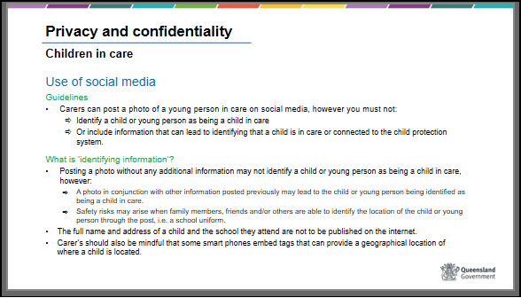  Slide 27  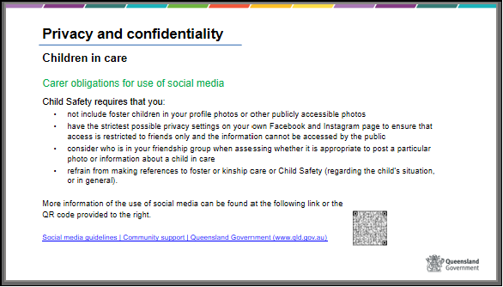
40 mins | Show slide 28  Case planning & decision making | Slide 28  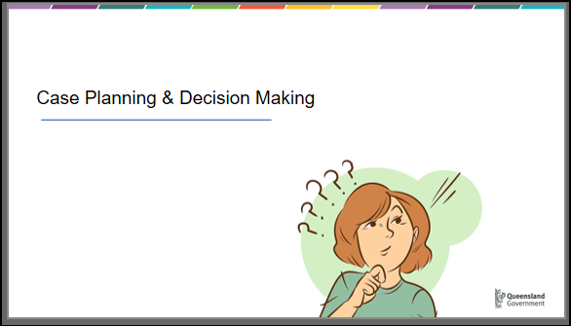
 | Show slide 29  Case planning  Child Safety decides what the child or young person’s needs are while in care (education, health, cultural needs), contact with family and when they are able to return home. This often occurs with information gathered from key persons involved with the child or young person, for example from the child, parents, family, the court, teachers, counsellors and you.  The coordination of this information gathering, the assessment of needs and service delivery is called case management. A CSO will case manage the child or young person who is placed in your care. A case plan is developed for each child which records most of the decisions made and outlines how the needs of the child or young person will be met.  The case plan is a written document which provides a clear statement about why the child or young person is in need of protection, provides key information about the child or young person and records the roles and responsibilities of all participants in addressing the child's protection and care needs during ongoing intervention. All activities, actions, discussions and contact with the child and family will be guided by the case plan while it is in effect. For example - the cultural events a child or young person may attend in their cultural support plan, who will have contact with the child and how frequently.  All stakeholders, including the child and their family, carers, community support people, services that are working with the child and Child Safety officers who work with the child, will be involved in developing the case plan through a Family Group Meeting.  A family group meeting is a way of engaging children, members of their family group and wider network of support and service providers in the case planning process.  Carers play an integral role in providing immediate care for the child, reporting on their needs and having input to how those needs might be met in case planning forums. In addition, carers can play an important role in assisting a child to maintain connections with their family, and engaging the family in activities with the child, to enhance reunification plans where applicable. | Slide 29  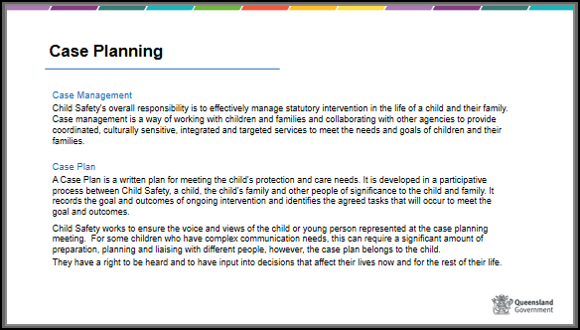

 | Show slide 30  HANDOUT - Refer participants to the handout: “Crucial role of education”.  Education Support Plan  The trainer should highlight the critical nature of educational support and explain that research reveals that children and young people in care do not receive the same educational opportunities as their peers. Also highlight the importance of sharing these plans with the child or young person where they are able to understand and participate in the development of the plan.  Children in care are less likely to do well at school and are more likely to leave at an earlier age without qualifications.  In response to these issues, Child Safety provides funding to the Education Queensland to develop an education support plan (ESP) in collaboration with Child Safety to ensure a child in care is enrolled and participating in an educational program that meets their individual learning needs, maximises their educational potential and improves their wellbeing. All children subject to an interim or finalised child protection order granting custody or guardianship to the chief executive are eligible for an ESP.  Contact the young person’s school if you have not heard from them about the Education Support Plan. These plans will be re-visited annually or in response to changes in the child’s circumstances or need.  Cultural Support Plan  The cultural support plan is a key part of the case planning process for every Aboriginal or Torres Strait Islander child or young person.  It aims to keep children and young people connected to their culture, families and communities, regardless of their care arrangement location. If you are not Aboriginal or Torres Strait Islander and the child or young person is, then the care arrangement will most likely be short-term.  The development of the cultural plan provides the family the opportunity to participate in family led decision making and where possible is led by an Aboriginal or Torres Strait Islander person.  The cultural support plan is an essential tool that:  - details information about the child’s family, community, and personal history  - helps increase the knowledge and understanding of the child’s place in their family, kinship, and community structure  - helps nurture and support the child while strengthening their cultural identity and connections  - assists with the child’s understanding of their community networks and cultural heritage  - documents arrangements for connection time with family, kin, Elders, and community members of significance to the child and each of the parents  - identifies opportunities for the child to participate in activities and experiences that will preserve their connection with family, community, and culture  - helps ensure that important cultural and family information is accurately recorded and maintained for the child. This is particularly the case for those who are too young to contribute to their own cultural support plan or for those who do not want to identify with their community or culture at this time.  Cultural Support Plans should also be completed for children and young people from culturally and linguistically diverse (CALD) backgrounds.  In situations where children and young people are placed in care, it is necessary to ensure that they maintain their links with their family and kin and with their ethnic, religious and cultural identity and values. The cultural support plan should indicate who and how the links with a child’s cultural background and identity will be supported.  Show slide 31  BRAINSTORM – Cultural support planning requirements by carers  Refer to separate activities resource for instructions on activity | Slide 30  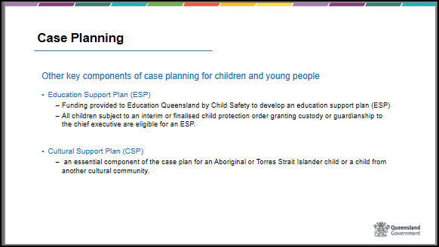  Slide 31  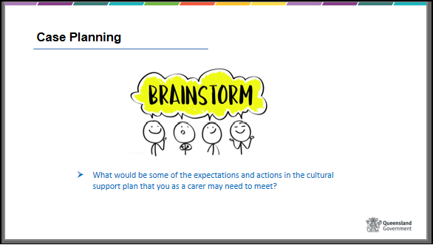

 | Show slide 32  Child Health Passports  The child health passport is a folder containing the child's health information that Child Safety provides to a carer to assist them in meeting the child's day-to-day health needs.  Contents include the child information form, health plan, photocopy of the Medicare card, and information relating to specific health needs of the child. The passport moves with the child if the child moves to another care arrangement and a copy is provided to the parent when the child returns home or to the young person when they transition from care.  Family contact  Child Safety works with children and young people and their families to support children and young people to return safely home as soon as possible. It is also Child Safety’s role to make sure that the child or young person remains connected to his/her family, culture and community, regardless of where they are living at any given point in time.  Family contact is a significant part of working with a child and their family. At times, arranging and organising contact can be challenging for a range of reasons, family may be late, not turn up or the child is concerned about who is coming and how to relate to their family after they were placed out of home. It is important to remember that a lot of pain and grief may be involved and to support the contact as much as possible even when it is sporadic or challenging.  Experienced carers could provide examples and solutions.  Because carers have the day to day care of the child or young person, they are often in the best position to promote this connection and make sure parents continue to be involved with daily decisions and care arrangements.  In the case of Aboriginal and Torres Strait Islander children and families it is important to remember that connection to family and culture is very important.  Examples of ways you could encourage this are: encourage links with any significant people in the child or family’s network or tribal group attend, connect with the Cultural practice advisor or CSSO and events such as NAIDOC week and sports events. | Slide 32  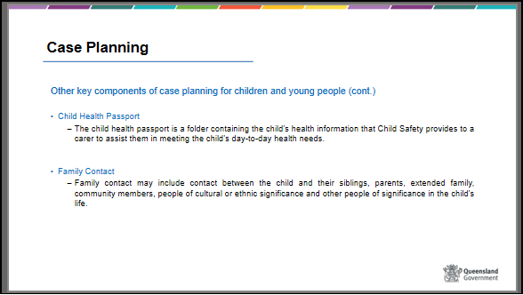

 | Show slide 33  BRAINSTORM – Connecting with family and community – carers role  Refer to separate activities resource for instructions on activity | Slide 33  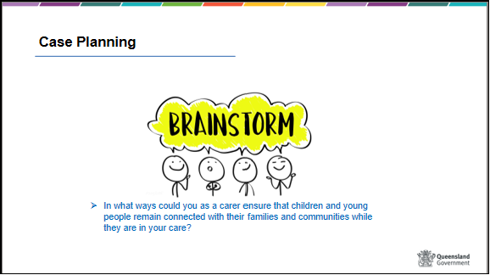
 | Show side 34  Decision making  HANDOUT – Carer information sheet – Decision making for children and young people  Experienced foster carer trainer will have input to this session and give practical examples.  Decisions can be made by the child’s parents, the carer or Child Safety staff and depends on what legal arrangement has been put in place for the child or young person.  The person with legal authority to make a decision (or provide consent) for a child in care will vary, depending on:  - the nature of Child Safety’s intervention  - the type of decision needing to be made – is it a custody or guardianship matter  - who has custody of the child or young person?  - who has guardianship of the child or young person  - if the CE has guardianship, who has the delegation to make the decision i.e. CSSC manager, Team Leader, Regional Director etc. | Slide 34  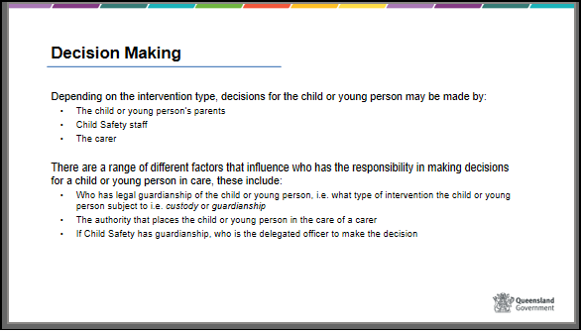

 | Show slide 35  Refer to separate activities resource for instructions on activity  Activity –Decisions parents make | Slide 35  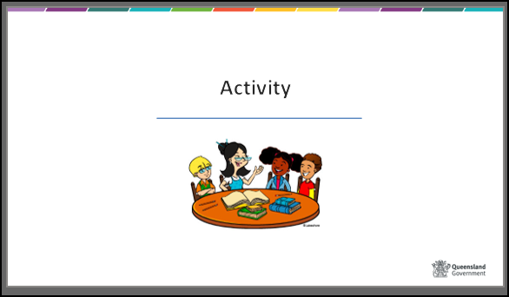
 | Show slide 36  Family led decision making (FLDM)  Family led decision making is a practice approach to help families take the lead in making decisions and taking action to meet their child or young persons needs. Family led decision making is used in Family Group meetings and other meetings while the child or young person is in care.  The principles and values around FLDM recognise that families are the experts in their own lives, with family choice and self-determination being essential and given the opportunity and support families are competent and capable to developing plans to resolve danger and reduce the risk to their child or young person’s protective needs. | Slide 36  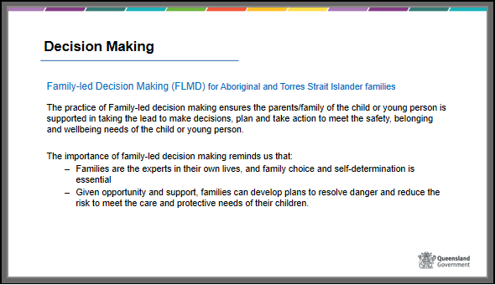

 | Show slide 37  Everyday decisions – custody matters  Generally, decisions about day to day care needs apply to a custody order with broader wellbeing and development decisions applied to a guardianship order.  A carer is responsible for making daily care decisions for a child or young person and should act as any reasonable parent would, whilst also listening to and taking into account the child or young person’s views and wishes (age appropriate).  Daily care decisions can include:  - Household routines, e.g., meals, nutrition, homework and bed and bath times  - Household rules and expectations  - The child or young person’s appearance, such as:  - Clothing, grooming and hygiene  - Routine haircuts (trims, styles) – except for first hairs cuts as for some family’s haircuts can have cultural or religious significance  - Variations to school routine  - Daily travel arrangements  - Providing pocket money consistent with your family practices  - Accompanying you on outings and social events when it doesn’t impact family contact  - Arranging for the child or young person and their friends to visit each other  In some circumstances it may be agreed that instead of the carer making all custody decisions, the parents or Child Safety will decide or have input into specific decisions, especially if the decision is considered contentious such as medical decisions, education decisions, decisions about sport and recreational activities or decisions about the young person’s personal appearance. | Slide 37  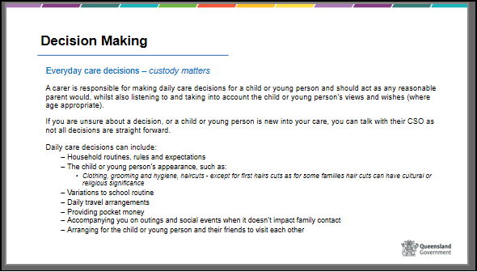

 | Show slide 38 & 39  Advise participants that they can access the ‘Information for existing carer’s resource on Child Safety’s website or scan the QR code to obtain the information shown on the slides. This resource will be a valuable resource should participants be approved as carers.  Go through the information as per the slide as discuss the content, advise participants that custody decisions to be made by either the parents or a delegated officer will be discussed with the carer and documented in the placement agreement or case plan.  The Act states that a child should be kept informed of matters affecting him or her wherever appropriate, according to their ability to understand.  The Act also states that “if a child is able to form and express views about his or her care, these views must be given consideration, taking into account the child’s age or ability to understand”.  This is also reinforced in the Charter of Rights for a child in care. | Slide 38  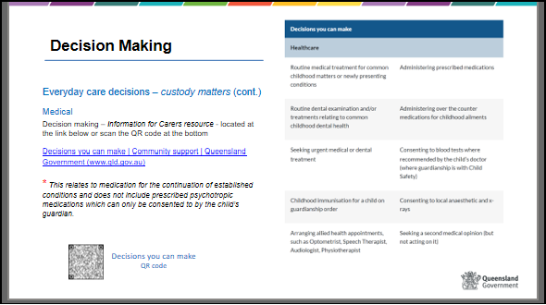  Slide 39  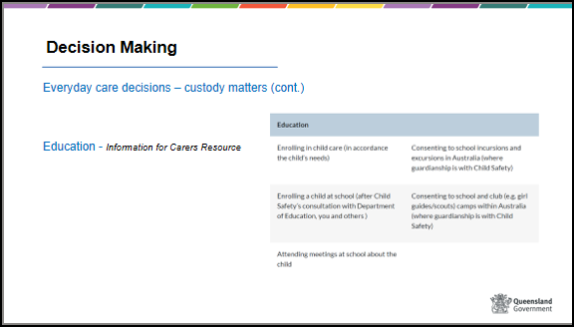

 | Show slide 40  Long term care and development – guardianship matters  When Child Safety have a guardianship order, which automatically includes custody, carers may have an increased level of decision making.  Guardianship decisions are related to a higher level of decision making and refer to the wellbeing and development of the child, including:  - invasive medical treatment, DNA testing, blood tests  - Enrolling a child in a school  - High risk activities or sport and recreational activities  - Religious activities not consistent with the child’s or parents’ beliefs  - Travel that impacts on family contact/connections or overseas travel  Aboriginal and Torres Strait Islander children and young people  Where custody decisions regarding Aboriginal and Torres Strait Islander children and young people are being made that may have a significant impact to their life, opportunity should be provided for the child and their family to participate in the decision making process supported by an Independent person. | Slide 40  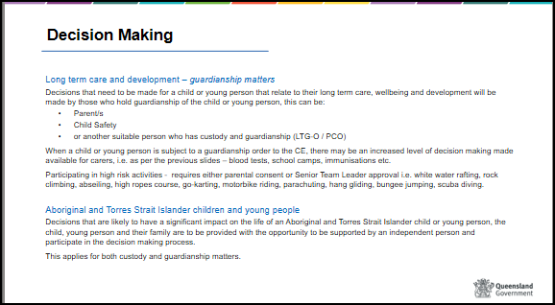
 | Show slide 41  Refer to separate activities resource for instructions on activity  Activity – review activity - Decisions parents make | Slide 41  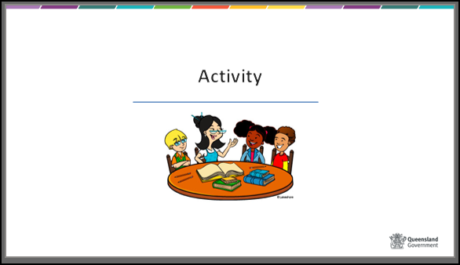

30 mins | Show slide 42  Promoting a positive sense of self and identity for a child or young person in care  We have talked about communication skills being important in establishing a relationship with a child or young person. These skills remain important in developing ongoing relationships with children and young people, their families and other people who are important to them. | Slide 42  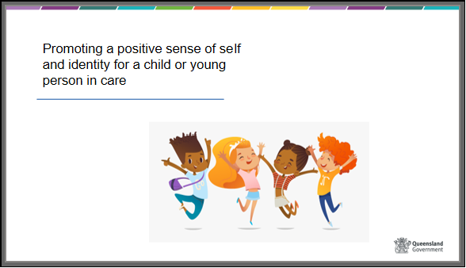
 | Show slide 43  There is a need to continue to build and maintain trust and understanding and demonstrate respect for children and their families. This will encourage children to feel positive about themselves and have a sense of their own identity.  In order to develop a positive sense of self it is important not to develop inappropriate dependencies – it is about helping children and young people grow and move towards independence, positive interdependence with others, and not to lean on you as the one who knows best.  Helping a child or young person work out what they need themselves, and assisting them find resources to do this, will encourage a sense of achievement and develop skills that are useful in other situations. Help them explore their own solutions to problems rather than giving advice or solving the problems yourself. | Slide 43  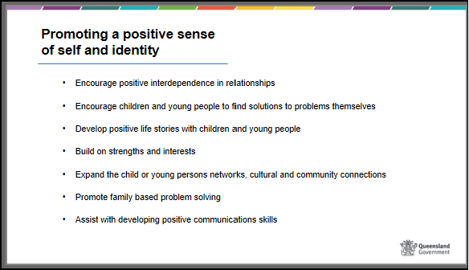
 | Show slide 44  Refer to separate activities resource for instructions on activity  BRAINSTORM – How could you assist a child or young person to develop a positive sense of self-esteem? | Slide 44  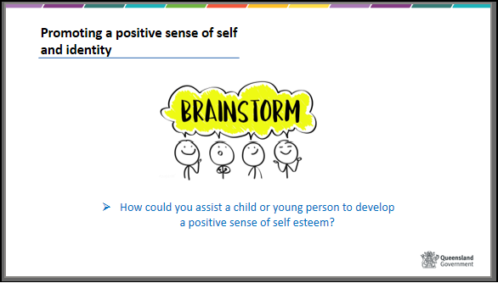

 | Show slide 45 & 46  Promoting a positive sense of self and identity, Aboriginal and Torres Strait Islander children and young people.  HANDOUT –  - “Ensuring children and young people have a voice” &  - “Encouraging a child’s sense of safety and identity.”  - Give carers a copy of my journey in care  Encouraging a sense of identity for an Aboriginal or Torres Strait Islander child or young person.  In the case of Aboriginal and Torres Strait Islander children and families it is important to remember that connection to family and culture is very important and you play a very important role by ensuring family and community contact happens.  Examples of ways you could encourage this are:  - encourage links with any significant people in the child or family’s network or tribal group,  - connect with the Cultural Practice Advisor or CSO at your CSSC for ways to link a child or young person to family and culture  - ask the child or young person what they would like to do to continue to connect with their family or community, or what activities they would like to attend  - attend events such as NAIDOC week and  - sports events  Trainers can also refer to Foster their Culture: Caring for Aboriginal and Torres Strait Islander children in out-of-home care, 2008, Secretariat of National Aboriginal and Torres Strait Islander Child Care  SNAICC resources and tools can be accessed via www.snaicc.org.au | Slide 45  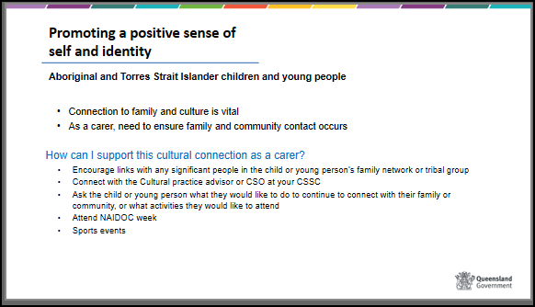  Slide 46  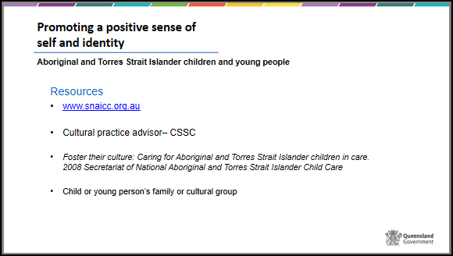

10 mins | Show slide 47  Advocacy  Carers need to be able to advocate on behalf of children and young people. Advocacy can take many forms. | Slide 47  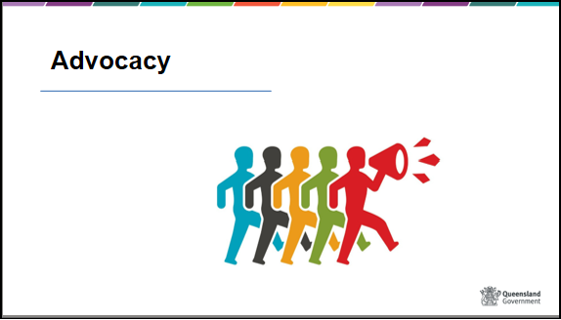
 | Show slide 48  Definition - Advocacy is the effort of a person who pleads another’s case in support of something. | Slide 48  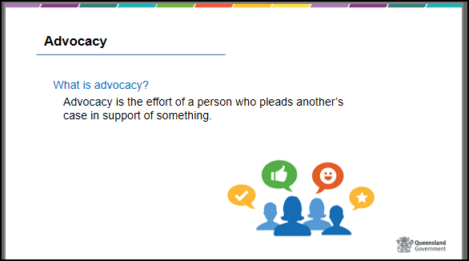
 | Show slide 49  Refer to separate activities resource for instructions on activity  BRAINSTORM – How do you advocate for your own child, or children in your family? | Slide 49  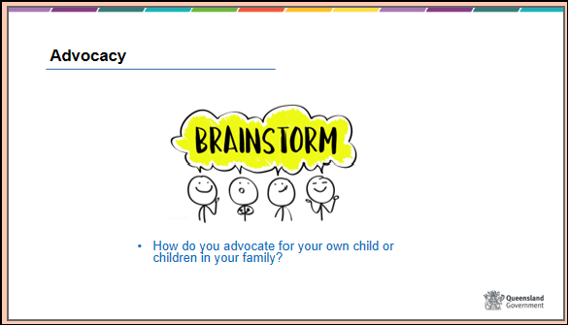

 | Show slide 50  What are some of the things you might need to advocate on behalf of a child or young person?  Examples could include family contact, conflict resolution, educational support, special interests, and health issues.  Experienced carer to outline examples of occasions when they have had to advocate for a child in their care.  The Charter of Rights might inform these discussions.  As carers you will have a sound understanding of the needs of children in your care, and you will contribute to case planning forums where those needs will be discussed. This will be an opportunity for you to advocate on behalf of the child or young person.  Where a child is old enough, they should be provided the opportunities to participate and be involved in decision making forums. The following policy outlines our responsibility to do this and the practice paper  HANDOUT –  - Policy - Participation in Decision-Making - Children and Young People in Alternative Care 369  - Practice resource: Participation of children and young people in decision-making | Slide 50  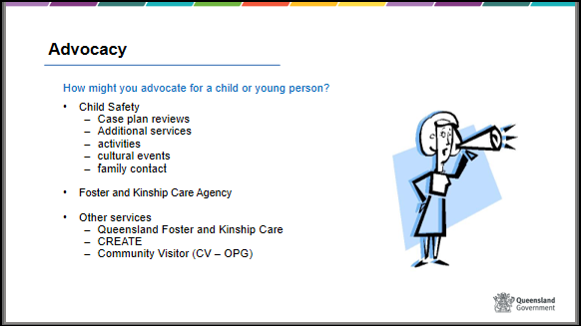
 | Show slide 51  If you do have a concern, enquiry or complaint it is best to attempt to address it with the child’s CSO first. If you are not satisfied with the response you are able to then talk about your concerns with a team leader or CSSC manager. Child Safety will handle your complaint promptly, confidentially and fairly.  If the matter is still not resolved satisfactorily, you can speak to an officer in Child Safety Complaints Unit, Complaints and Review.  If you are still not satisfied, Child Safety may consider conducting a departmental review of your complaint.  Alternatively, you can speak to one of the following external agencies:  - Queensland Foster and Kinship Care  - CREATE  - Office of the Public Guardian  - Queensland Civil and Administration Tribunal  - Queensland Ombudsman  Explain briefly what each organisation does - HANDOUT– complaints brochure | Slide 51  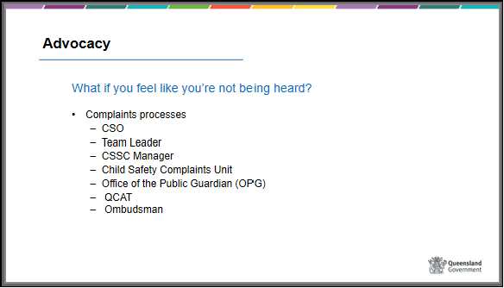
 | Show slide 52  Community Visitor Program (CV – OPG)  The Office of the Public Guardian (OPG) is the key organisation that promotes and protects the rights and interests of all children and young people in Queensland. A child or young person, or an adult acting on their behalf, can make a complaint to the OPG about a service from any government department.  Priority is given to matters involving children or young people who receive services or support from the Child Safety. If you feel that Child Safety has not responded appropriately in meeting the needs of a child in your care, you may advocate on their behalf to the OPG.  One of the functions of the OPG is to administer the Community Visitor program. Community visitors will visit all children in care arrangements on a monthly basis to support and advocate for children and young people.  Their role will be to maintain contact with children and young people and provide advocacy and support. Community Visitors also play in important role in ensuring that children feel safe in their care arrangements with carers.  As a carer, it is important that you assist any children and young people in a care arrangement with you to participate positively in this process.  Information about the OPG is available on www.publicguardian.qld.gov.au or they can be contacted on 1300 653 187 | Slide 52  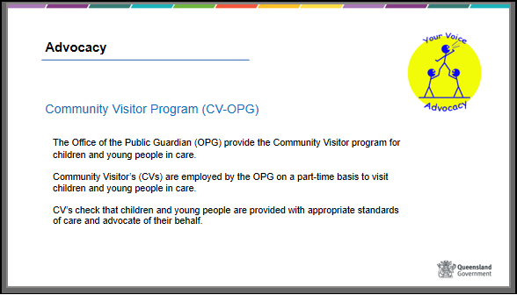

 | Show slide 53  Refer to separate activities resource for instructions on activity  Activity – return to exercise one | Slide 53  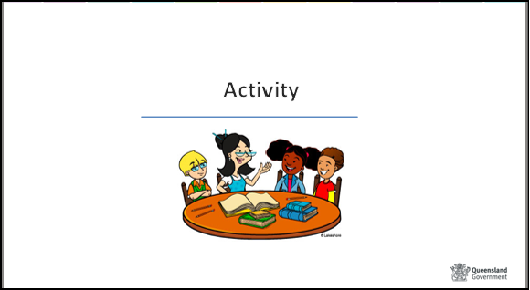
 | Show slide 54  Learning Outcomes  Display Slide “Learning outcomes” and summarise the main points discussed in each outcome. | Slide 54  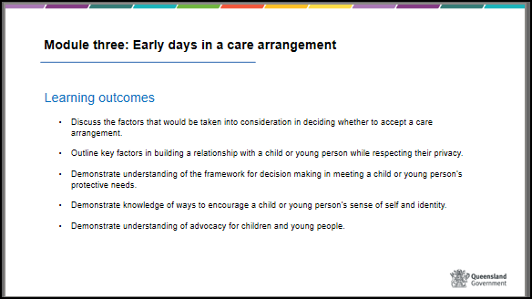
 | Show slide 55  Please complete the worksheet and self-assessment proforma for assessment purposes and return at the next session. Should there be any discussion arising from your responses, there will be an opportunity to meet with trainers for review purposes.  HANDOUT - “Worksheet Questions – Module 3” and “Self-Assessment - Reflections”.  Refer to 3.4 Assessment.  Reminder to collect worksheet questions and self-assessment proforma – Module two. | Slide 55
Resources can be obtained from CSSC staff or via a search of the Child Safety Internet or within the Child Safety Practice Manual

