Positive and Protective
Preparing for puberty

Participant Workbook

Information for participants

How to use this workbook:

This workbook has been developed to support your learning while attending this training.

It is your opportunity to jot down ideas, points of interest and notes for when you want to transform what you have learnt into ACTION!

The workbook can also be used for your ongoing professional development.

Share your workbook with peers, colleagues or partner. We encourage you to discuss your day of training with others.

Most importantly, use the strategies in this workbook to promote a positive and proactive approach to supporting the healthy sexual development of the children and young people in care that you support.

All children and young people have the right to know about their bodies and to learn how to develop healthy relationships.

I didn’t know I could ask them about sex.
They (carers) talked about their family and stuff but never about contraception, or saying yes, or saying no.

Taken from a presentation given by Family Planning Queensland at the Child Safety Research Forum, Brisbane 2008. Meeting our obligations: Understanding and responding to the sexuality needs of children and young people in care.

© 2016 True Relationships and Reproductive Health 230 Lutwyche Road
Windsor 4030 Australia

Phone: +61 7 3250 0240info@fpq.com.au www.true.org.au

This work is copyright. Except under the conditions of the Copyright Act 1968, written permission should be sought from the copyright owners to use any part of this work for reselling, distribution or use in resource development.
Permission to photocopy activities and worksheets is granted.

Every reasonable effort has been made to obtain permissions relating to information reproduced in this publication. Requests and enquiries concerning reproduction and rights should be email to publications@true.org.au
Disclaimer
True Relationships and Reproductive Health (True) has taken every care to ensure that the information contained in this publication is accurate and up to date at the time of being published. As information and knowledge is constantly changing, readers are strongly advised to confirm that the information complies with present research, legislation and policy guidelines. True accepts no responsibility for difficulties that may arise as a result of an individual acting on the advice and recommendations it contains.

Activity 1 What is sexuality?

This workshop, Identifying and Responding to Sexual Behaviours, focuses on support for foster and kinships carers of children and young people in the area of sexual behaviours.

When talking about sexual behaviours it is important to establish what sexuality is and what is normal, healthy sexual behaviour and development and to accurately and proactively respond to sexual behaviours that may be of concern. Promoting healthy sexuality requires us to think about sexuality as far more than just a physical activity.

Write down some key words or a sentence about what sexuality means.

Activity 2 Social learning and sexuality

How, when and where do we learn about sexuality? Think about the social influences on learning about sexuality. They may include; media, religion, family, peers, school, law, and culture.

Write some examples of what each of these may teach a child or young person in care (e.g. media may tell us that it is important to be attractive to succeed in life).

Activity 3 Values and attitudes

It is essential to be aware of your own values, attitudes and beliefs about sexuality in order to manage responses to sexuality in positive and supportive ways.

How might your personal values and beliefs affect how you interpret sexuality issues?

Circle the responses that you believe may impact on your values and attitudes about sexuality.

- personal background
- health and wellbeing
- religious beliefs
- cultural background
- perception of societal norms, rules and laws
- use of media/popular culture
- experience of safety or abuse
- experience of relationships
- experience of being a young person
- experience of being a parent or carer
- experience of being male or female
- experience of sexual identity
- other

How do your organisational values and culture affect the support provided to children and young people in relation to sexuality?

Activity 4 Puberty True or False

Mark the following statements about puberty as True (T) or False (F)

- Males and females reach puberty at the same time
- As bodies change during puberty, feelings change to
- Everyone wants to have a boyfriend/ girlfriend when they reach puberty
- Boys sometimes experience some breast development at puberty
- The changes that happen to our bodies at puberty are caused by hormones
- It is ok to touch the private parts of your body if you are in a private place

Activity 5 – Puberty changes
Puberty is the period of time when a person changes from a child into an adult. Changes are physical, emotional and social.

Most girls will notice their bodies starting to change around the age of 10 or 11 and most boys will notice changes around the age of 12 or 13. However, there is a great difference in age range and all young people will experience puberty differently.

Draw the physical puberty changes onto the male and female body pictures. This is an example of an activity that carers can use in communicating about puberty with the children and young people in their care.

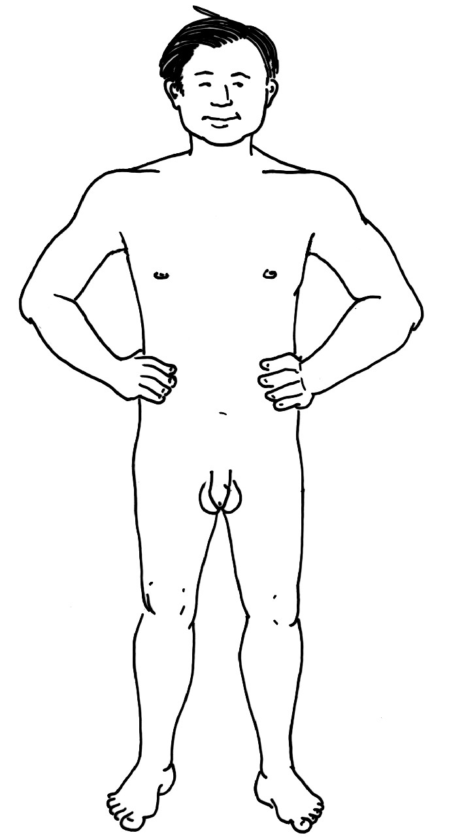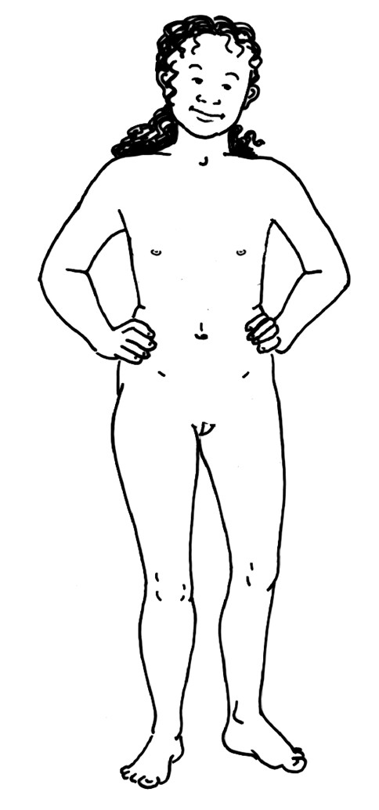

It can be challenging to clearly describe the social and emotional changes that may occur during puberty. What are some of these changes and how could you raise them with a child or young person in your care?

Activity 6 – Key discussions points

Write down 2 or 3 key points for discussion with children and young people in your care regarding the following puberty topics.

Periods

Wet Dreams

Healthy Relationships

Sexual attraction

Masturbation

Activity 7 – Supporting and addressing relationships and sexuality education needs (Part 1)

Scenario 1
Betty is 10 years old. Until recently she lived with her biological father and brother. She has been in care for three months. Recently, Betty has been spending a lot of time in the toilet and bathroom at home. School reports that she has been going to the school nurse to get pads for when she has her periods. At home she has never talked about periods or used the pads from the bathroom cupboard.

Scenario 2
Robert is 15 years old. Recently he has started talking about his girlfriend Trudi (14), another young person in emergency temporary care at the same foster home. When doing the washing a few days ago a condom fell out of his pocket and into the wash. Going past his room one evening you notice his door is shut and you hear him and Trudi together.

Scenario 3
Alberto is 12 years old and has a mild intellectual disability. He has been in foster care for ten years. Alberto likes to spend a lot of time on the computer especially surfing the internet. Recently the house received a bill for a website called xtra blu addressed to Alberto.

Scenario 4
Ben, aged 13 spends a lot of time alone in the bedroom he shares with two other foster children. He often shuts and locks the door. When the foster carer knocks on the door he tells her to go away. She has noticed lately that he is putting his sheets and pyjamas in to the washing basket to be washed every morning.

Scenario 5
Aesha, aged 12, likes to read and play the piano. She has been in care for five years with her little brother, Dano. After dinner Aesha approaches you privately and asks how she will know if she is gay. She says that sometimes she thinks she would like to kiss her best friend Suzie.

Activity 8 – Supporting and addressing relationships and sexuality education needs (Part 2)

If sexuality issues arise for a young person during puberty, it is important to look at strategies that will assist the young person, the family and the service providers who work with them.

Use one of the scenarios provided to complete the following questions. Scenario number:

- What are the issues in the scenario?

- What strengths or abilities does the young person in the scenario have?

- What could you say or do to support the young person?

- What services or support people could help you or the young person with the issue?

Activity 9– External referrals
In pairs, discuss at least one external person/organisation that you could access to support the child or young person from one of the scenarios.

Activity 10 – Techniques for answering questions

Below are some techniques that can be useful in responding to questions.

Turning the question around
This technique is particularly useful for values based questions. Example: Q What is the best age to have sex?
A That‘s a good question. What do you think?

Continuum
This technique is also a useful response to values based questions. It presents the range of attitudes and values that can be held about an issue.

Example: | Q | Is abortion ok?
 | A | Some people believe that abortion is never ok. Other people
believe that it is the woman’s right to choose. Other people believe that it depends on the circumstances.

I don’t know
It is honest and acceptable to admit a lack of knowledge. A question can be an opportunity for the carer and the child to investigate the answer together.
Example: Q When a woman has Artificial Insemination, how do they put the fertilised egg back into her body?
A That’s a really good question, but I’m not really sure of the answer. Maybe we could find out the answer together or, I’m not sure, but I’ll find out for you.

The straight forward answer
This technique gives an honest, straightforward answer.

Example: | Q | What is a homosexual?
 | A | A homosexual is a person who is attracted to people of the same
 | sex.

Referring to rules about privacy
This is relevant when someone asks a personal question and you prefer not to answer.

Example: | Q | How old were you when you first had sex?
 | A | That is a personal question, and I’d prefer not to answer it.
Remember it is important to respect other people’s privacy.

Activity 11 – Answering questions

Record an example of a question about puberty that a child or young person might ask?

Using the techniques for answering questions in the previous exercise, write an answer to the questions above.

Activity 12 – Looking after you

Working and caring for children and young people who have experienced abuse can be very challenging. It is essential for all carers to have strategies in place to support themselves in times of high stress, in order to be able to still help the children and young people who you support.

What strategies do you use to look after yourself?

