Positive and Protective
Identifying and responding to sexual behaviours in children and young people

Participant Workbook

Information for participants

How to use this workbook:

This workbook has been developed to support your learning while attending this training.

It is your opportunity to jot down ideas, points of interest and notes for when you want to transform what you have learnt into ACTION!

The workbook can also be used for your ongoing professional development.

Share your workbook with peers, colleagues or partner. We encourage you to discuss your day of training with others.

Most importantly, use the strategies in this workbook to promote a positive and proactive approach to supporting the healthy sexual development of the children and young people in care that you support.

All children and young people have the right to know about their bodies and to learn how to develop healthy relationships.

I didn’t know I could ask them about sex.
They (carers) talked about their family and stuff but never about contraception, or saying yes, or saying no.

Taken from a presentation given by Family Planning Queensland at the Child Safety Research Forum, Brisbane 2008. Meeting our obligations: Understanding and responding to the sexuality needs of children and young people in care.

© 2016 True Relationships and Reproductive Health 230 Lutwyche Road
Windsor 4030 Australia

Phone: +61 7 3250 0240
info@fpq.com.au www.true.org.au

This work is copyright. Except under the conditions of the Copyright Act 1968, written permission should be sought from the copyright owners to use any part of this work for reselling, distribution or use in resource development.
Permission to photocopy activities and worksheets is granted.

Every reasonable effort has been made to obtain permissions relating to information reproduced in this publication. Requests and enquiries concerning reproduction and rights should be email to publications@true.org.au
Disclaimer
True Relationships and Reproductive Health (True) has taken every care to ensure that the information contained in this publication is accurate and up to date at the time of being published. As information and knowledge is constantly changing, readers are strongly advised to confirm that the information complies with present research, legislation and policy guidelines. True accepts no responsibility for difficulties that may arise as a result of an individual acting on the advice and recommendations it contains.

Activity 1 What is sexuality?

This workshop, Identifying and Responding to Sexual Behaviours, focuses on support for foster and kinships carers of children and young people in the area of sexual behaviours.

When talking about sexual behaviours it is important to establish what sexuality is and what is normal, healthy sexual behaviour and development and to accurately and proactively respond to sexual behaviours that may be of concern. Promoting healthy sexuality requires us to think about sexuality as far more than just a physical activity.

Write down some key words or a sentence about what sexuality means.

Activity 2 Social learning and sexuality

How, when and where do we learn about sexuality? Think about the social influences on learning about sexuality. They may include; media, religion, family, peers, school, law, and culture.

Write some examples of what each of these may teach a child or young person in care (e.g. media may tell us that it is important to be attractive to succeed in life).

_

Activity 3 Values and attitudes

It is essential to be aware of your own values, attitudes and beliefs about sexuality in order to manage responses to sexuality in positive and supportive ways.

How might your personal values and beliefs affect how you interpret sexuality issues?

Circle the responses that you believe may impact on your values and attitudes about sexuality.

- personal background
- health and wellbeing
- religious beliefs
- cultural background
- perception of societal norms, rules and laws
- use of media/popular culture
- experience of safety or abuse
- experience of relationships
- experience of being a young person
- experience of being a parent or carer
- experience of being male or female
- experience of sexual identity
- other

How do your organisational values and culture affect the support provided to children and young people in relation to sexuality?

Activity 4 Child and adolescent sexual development

Like all areas of development, sexual development is a natural process all humans go through. Note down some of the physical, social and behavioural developmental changes relating to sexuality which are experienced in each of the following age groups.

0 to 4 years

5 to 9 years

10 to 13 years

14 to 17 years

Activity 5 Adolescent sexual behaviour

The research tells us that children and young people in care have poorer sexual health outcomes than their peers not in care. What avenues are available for children and young people in care to seek information about sexual health and relationships?

Activity 6 Using the Traffic Lights framework

Sexual development is influenced by many factors. When identifying the sexual behaviours of children or young people, it is important to consider the way in which behaviours occur. Considering things like age, place, frequency, mutuality, relationship will help you the see the behaviour in a context and the level of safety, risk or harm associated with the situation. Using the Traffic Lights framework, list two characteristics which might typically be present in:

Green Light behaviours

Orange Light behaviours

Red Light behaviours

Activity 7 Identifying sexual behaviours of children and young people

In order to understand and respond to sexual behaviours of children and young people, we must be able to communicate clearly about the behaviours and the context in which they occur. Before working out how to respond and provide support, it is important to first identify what the behaviour actually is: if it is normal developmental behaviour or if the behaviour indicates risk, abuse or harm.

Use the Traffic Lights framework to identify whether the following scenarios are Green, Orange or Red.

Scenario 1
Kahu is 12 years old and his foster mother is expecting a baby soon. At school, during a puberty and personal development lesson, he explained pregnancy and birth in detail to another child.

Scenario 2
 Green  Orange  Red

Aesha, aged 11, has Down syndrome. Aesha often spends time helping the children who have higher support needs. Staff call her their ‘little helper’. Last week she was seen touching one of the boys on the penis. Yesterday staff discovered Aesha giving oral sex to another male in the high support needs group.

 Green  Orange  Red

Scenario 3
Phillip is 9 years old and is a new student at school. It is the third school he has attended this year and he and his mum are new to the area. At school, the teacher asks Phillip if he is ok as he looks withdrawn and uncomfortable. He complains that his bottom is sore and that it bleeds when he goes to the toilet. He said that he fell off his bicycle. Some bruising around his thighs and wrists is also noted.

Scenario 4
 Green  Orange  Red

Alex, aged 13, loves chatting to friends on the internet. Recently, Alex made a new friend in a chat room for teenagers. The more they chat, the more Alex feels attracted to ‘Sexy Boy’ and wants to meet him. Alex is excited to have a new friend and tells you they’re going to meet sometime soon.

Scenario 5
 Green  Orange  Red

Keeleigh, aged 14, asks how will she know if she is gay. Sometimes she thinks she might like to kiss her best friend Simone.

Scenario 6
 Green  Orange  Red

Keiko is 16. Her ex-boyfriend keeps calling her on her mobile. She has tried ignoring him, but lately he has been sending sexually explicit SMSs and photos. He often appears at places she likes to hang out, like the shopping centre and the skate park and she is becoming scared to go anywhere on her own.

Scenario 7
 Green  Orange  Red

Tilly, aged 15, is overheard by carers telling her close friends about having intercourse and oral sex with her boyfriend. He is a 17 year-old student at the same school. She is heard to tell her peers that she enjoys it.

Scenario 8
 Green  Orange  Red

Peter, aged 15, and Donna, 13, have been playing computer games together recently at the community centre. During a computer session last week, he told her to take her undies off if she wanted a go on the computer. Peter has an acquired brain injury and currently lives in foster care, after it was substantiated he sexually assaulted his younger sister who has learning difficulties.

Scenario 9
 Green  Orange  Red

Jasmine, aged 17, has been vomiting and a visit to a doctor confirms that she is pregnant. Jasmine has a mild intellectual disability. When the doctor asked if she has had sex, she glanced at her carer and said that she's not sure.

 Green  Orange  Red

Activity 8 Understanding sexual behaviours

Children and young people aren’t always able to tell us what is happening or why. It is useful to have a framework to help us clarify the elements of a situation, what the behaviour tells us and how to respond accordingly. The 3 What questions can be used in this process.

What is the behaviour? (IDENTIFY)
It is essential to name and identify the behaviour in order to begin to address the child or young person’s needs. Categorising a child or young person’s behaviour can assist in clarifying issues, prioritising action, rallying support and locating appropriate support services.

What is the behaviour communicating? (UNDERSTAND)
This process helps to establish why a behaviour may be occurring. This then helps to determine what strategies can assist.

All behaviour communicates. The challenge is to understand what is being communicated and how to help children and young people to meet their needs in a more appropriate way

3. What can you do to meet the need? (RESPOND)
Many strategies may be required to meet the needs of the child or young person. It is important to be optimistic and creative when proposing an ideas or a program of support.

A scenario (from the previous activity) will be allocated to you to discuss and complete the following questions. Use section 2 and 3 of the Sexual Behaviours in Children and Young People factsheet to guide discussion and your answers.

Scenario number:

WHAT is the behaviour?

WHAT is the behaviour communicating?

WHAT is needed to support the child or young person?

Activity 9 – Determining appropriate action

The need for action is determined by many parameters including areas of legislation, policy, health and safety, duty of care, human rights and community acceptance. It is hoped, that supporting young people in care to have happy and healthy, safe lives will be one of the most important reasons.

What are two guiding documents relevant to foster and kinship carers? 1._
2._

Activity 10 – Developing a support plan

The Support Plan is a multi-response plan which takes a child centred approach. When responding to orange and red light behaviours, it is common to respond with a range of targeted and intensive strategies.

Remember, there are a range of specialist services which may be available to assist with advice and assistance.

There is an example of a plan that could be used to support a child or young person on the following page.
Sample support plan

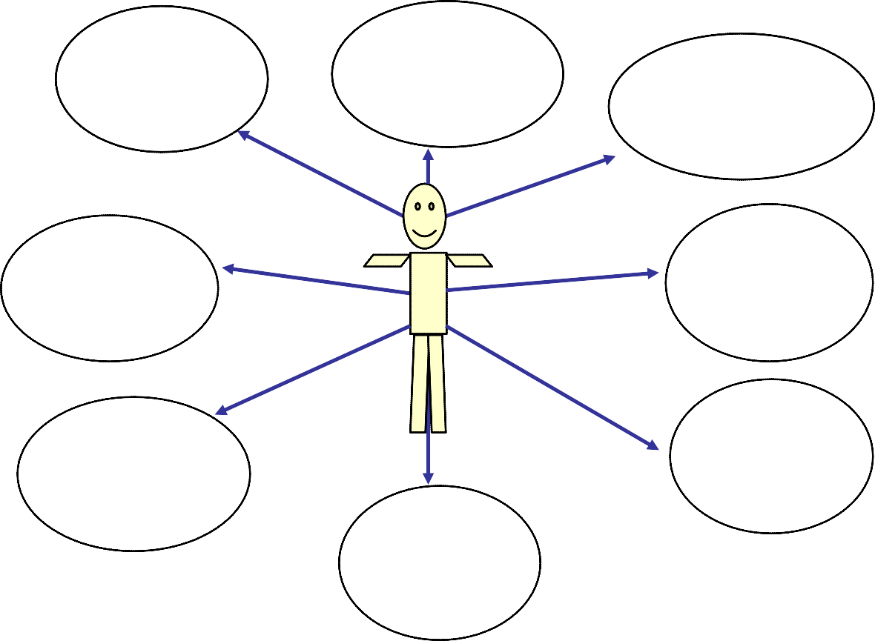
Consistent
management by all staff
Training and
support program
Sexuality and
self protection education
Record
information on
individual plan
Meaningful
consequences for behaviours
Liaise with
family, relevant staff and services
Monitoring
and supervision

Activity 11 – External referrals

In pairs, discuss at least one external person/organisation that you could access to support the child or young person from one of the scenarios.

Activity 12 – Looking after you

Working and caring for children and young people who have experienced abuse can be very challenging. It is essential for all carers to have strategies in place to support themselves in times of high stress, in order to be able to still help the children and young people who you support.

What strategies do you use to look after yourself?

