Positive and Protective
Sexuality and Autism Spectrum Disorder

Participant Workbook

Information for participants

How to use this workbook:

This workbook has been developed to support your learning while attending this training.

It is your opportunity to jot down ideas, points of interest and notes for when you want to transform what you have learnt into ACTION!

The workbook can also be used for your ongoing professional development.

Share your workbook with peers, colleagues or partner. We encourage you to discuss your day of training with others.

Most importantly, use the strategies in this workbook to promote a positive and proactive approach to supporting the healthy sexual development of the children and young people in care that you support.

All children and young people have the right to know about their bodies and to learn how to develop healthy relationships.

I didn’t know I could ask them about sex.
They (carers) talked about their family and stuff but never about contraception, or saying yes, or saying no.

Taken from a presentation given by Family Planning Queensland at the Child Safety Research Forum, Brisbane 2008. Meeting our obligations: Understanding and responding to the sexuality needs of children and young people in care.

© True Relationships and Reproductive Health 230 Lutwyche Road
Windsor 4030 Australia

Phone: +61 7 3250 0240
info@fpq.com.au www.true.org.au

This work is copyright. Except under the conditions of the Copyright Act 1968, written permission should be sought from the copyright owners to use any part of this work for reselling, distribution or use in resource development.
Permission to photocopy activities and worksheets is granted.

Every reasonable effort has been made to obtain permissions relating to information reproduced in this publication. Requests and enquiries concerning reproduction and rights should be email to publications@true.org.au
Disclaimer
True Relationships and Reproductive Health (True) has taken every care to ensure that the information contained in this publication is accurate and up to date at the time of being published. As information and knowledge is constantly changing, readers are strongly advised to confirm that the information complies with present research, legislation and policy guidelines. True accepts no responsibility for difficulties that may arise as a result of an individual acting on the advice and recommendations it contains.
Positive and Protective: Preparing for puberty v1-2016 2
Document uncontrolled when printed

Activity 1 What is sexuality?

When talking about sexual behaviours it is important to establish what sexuality is and what is normal, healthy sexual behaviour and development and to accurately and proactively respond to sexual behaviours that may be of concern. Promoting healthy sexuality requires us to think about sexuality as far more than just a physical activity.

Write down some key words or a sentence about what sexuality means.

Activity 2 Values and attitudes

It is essential to be aware of your own values, attitudes and beliefs about sexuality in order to manage responses to sexuality in positive and supportive ways.

How might your personal values and beliefs affect how you interpret sexuality issues?

Circle the responses that you believe may impact on your values and attitudes about sexuality.

- personal background
- health and wellbeing
- religious beliefs
- cultural background
- perception of societal norms, rules and laws
- use of media/popular culture
- experience of safety or abuse
- experience of relationships
- experience of being a young person
- experience of being a parent or carer
- experience of being male or female

- experience of sexual identity
- other

How do your organisational values and culture affect the support provided to children and young people in relation to sexuality?

Activity 3 – Autism Spectrum Disorder

Autism Spectrum Disorder (ASD) is a complex, lifelong disability. Whilst no two children and young people with ASD will be the same, they will all have difficulties in two main areas – social communication and interests and behavior.
What are some of the characteristics of ASD?

Activity 4 – Social learning and ASD

How might ASD impact on a child or young person’s experience of social learning about their sexuality?

Activity 5 – Rationale for self protection education

Children and young people with ASD may have complex support needs in the area of sexuality and self-protection education. It is important that all children have the opportunity for learning about self protection and staying safe.

What are some of the benefits of self protection education?

Activity 6 – Changes during puberty

Children and young people with ASD experience the same process of sexual development as other people. However, for those with ASD, a gap may occur between physical development and social development.

Most girls will notice their bodies starting to change around the age of 10 or 11 and most boys will notice changes around the age of 12 or 13. However, there is a great difference in age range and all young people will experience puberty differently.

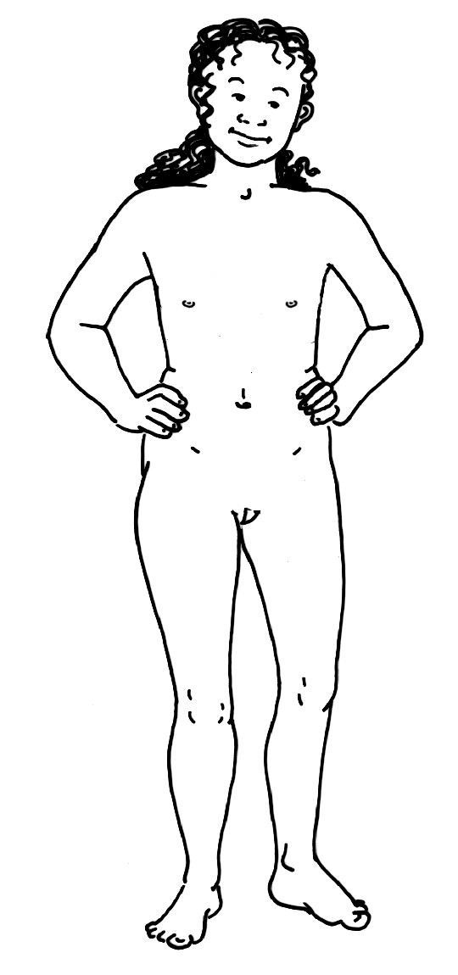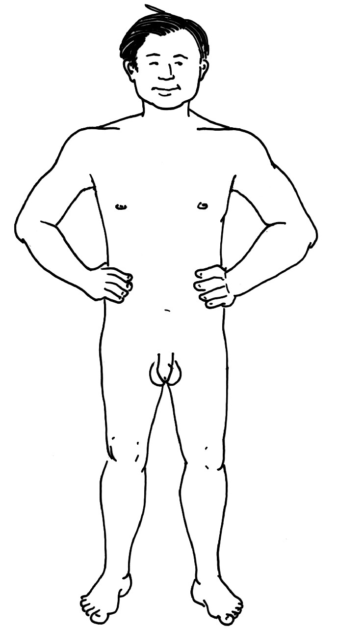Draw and write the physical, social and emotional puberty changes on the body diagrams.

This activity has been adapted from FPQ (2003) Every Body Needs to Know. Brisbane: Family Planning Queensland

Participant Workbook

Activity 7 – Relationships ladder
Fill the steps of the ladder with the names or pictures of the people that fit in each section. The relationships ladder can be used to discuss the qualities of the people in level and the types of activities and personal space that is ok. For example: In the Love section are people who are kind and trustworthy and who can hug and kiss us. 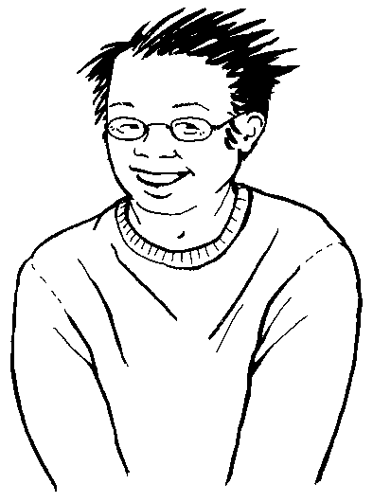

YOU

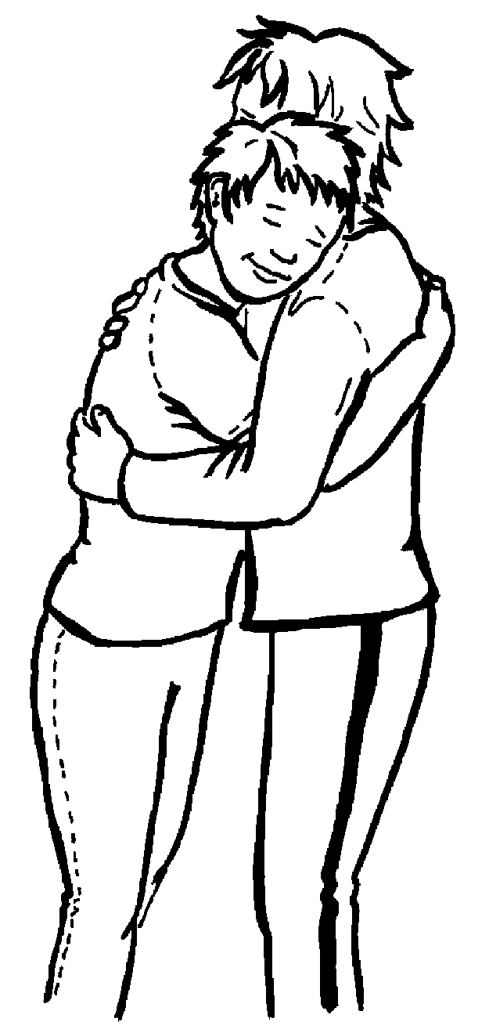

Love
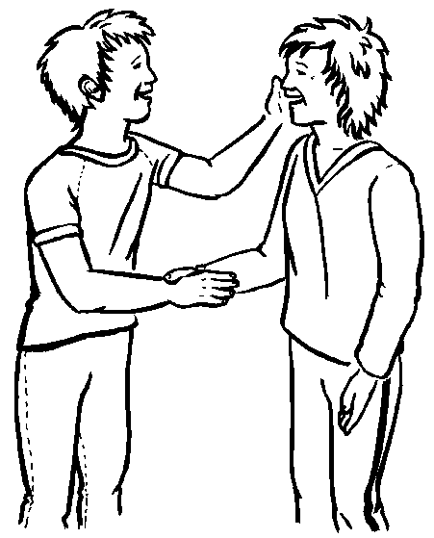

Like

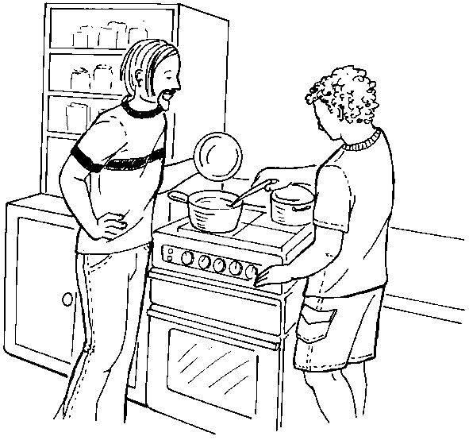

Staff

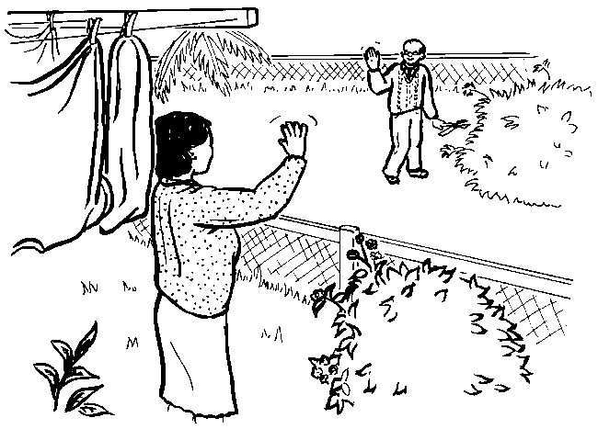

Know

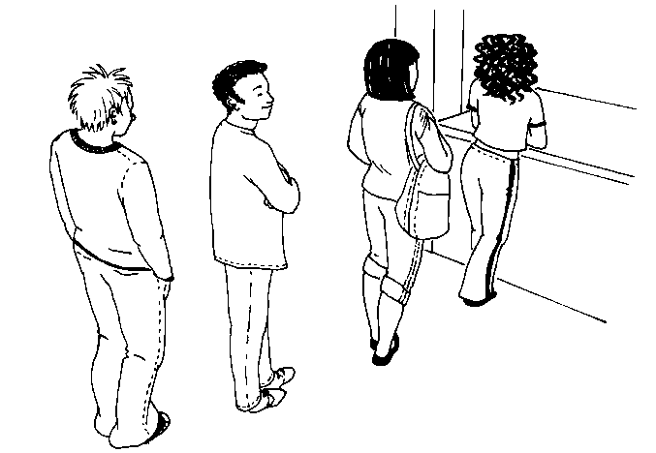Positive and Protective: Preparing for puberty v1-2016 7 Document uncontrolled when printed

Don’t Know

Activity 8 – Talking about relationships and touch

Children and young people with ASD in care have the same types of relationships as other young people. They may also have a lot more people in their lives that are involved as a result of care.

Why is it important talk about relationships and touch as part of a self protection program?

Rules about touch
It is an important part of self protection education for children in care to be able to recognise when touch is OK or if it is a NO touch.

The following cards below are examples of a concrete resource that participants can use with people with a disability to discuss the rules about sexy touch.

Cards below adapted from FPQ (2007) Everybody Needs to Know. Brisbane: Family Planning Queensland
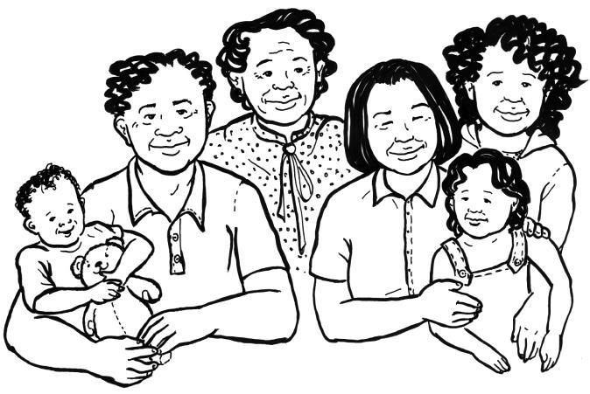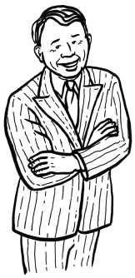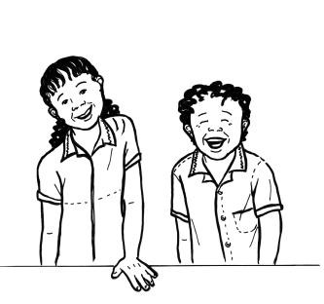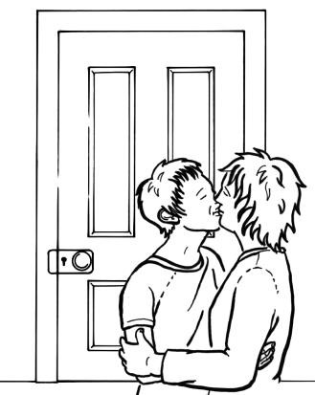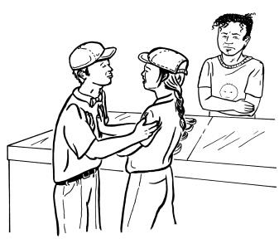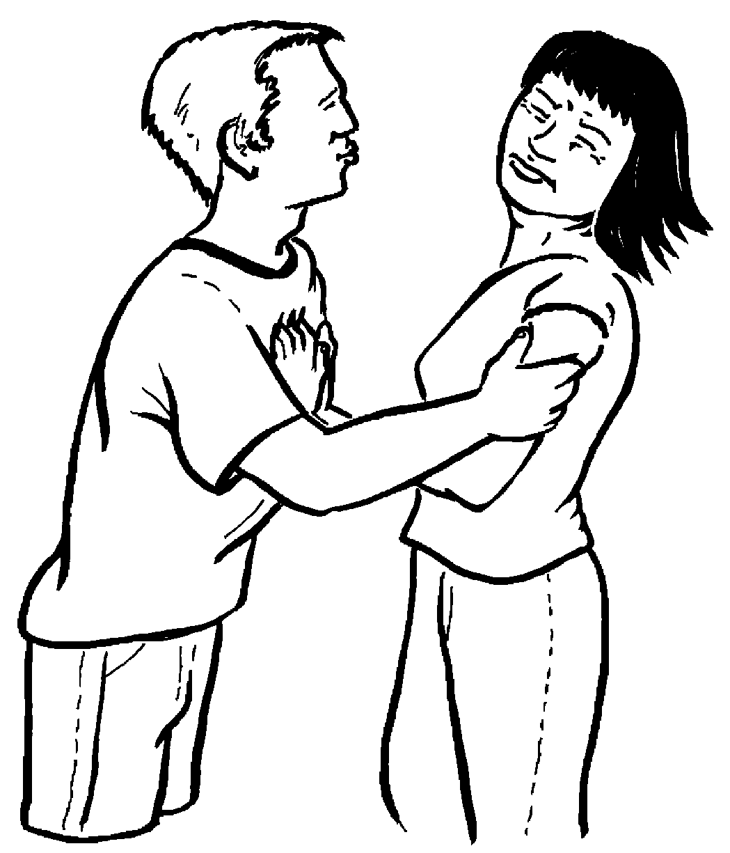

Both people want to be sexy

Sexy touch is private

Both people are old enough

Not in the same family

Positive and Protective: Preparing for puberty v1-2016 8
Document uncontrolled when printed

Activity 9 – Supporting and addressing sexuality issues

Children and young people with ASD who are in care may have complex and diverse needs in the area of sexuality education. Carers and support workers have a significant role to play in fostering the independence of the children and young people with ASD who they support.

Complete the questions for each scenario.

Scenario 1: Hannah
Hannah is 15 years old and has ASD. She has been trying to manage her own periods and has communicated to her foster carers that she wants to learn how to do it by herself so she can be like her big sister. She is finding it difficult to know when to change her pads and how to position the pads securely in her underwear.

- What are the issues in the scenario?

- What strengths or abilities does the young person in the scenario have?

- What could you say or do to support the young person?

- What services or support people could help you or the young person with the issue?

Scenario 2: Ahmed
After swimming class, Ahmed, aged ten, is found behind the girls change room, standing on the wheelie bins trying to look through the windows. Ahmed says he is looking for a wasp’s nest he saw there last week.

- What are the issues in the scenario?

- What strengths or abilities does the young person in the scenario have?

- What could you say or do to support the young person?

- What services or support people could help you or the young person with the issue?

Scenario 3: Harry
Harry is 12 and is interested in architecture and buildings. He would like to have a friend to spend time with on the weekends with but isn’t sure about how to find one who likes the same things he does.

- What are the issues in the scenario?

- What strengths or abilities does the young person in the scenario have?

- What could you say or do to support the young person?

- What services or support people could help you or the young person with the issue?

Activity 16 – Getting help and feeling safe

Teaching self protection skills is about giving children and young people the information and skills they need to feel safe and get help.

Why is it important to teach problem solving as part of a self protection program?

Activity 17 – Safety networks

Participants are asked to complete this activity as if they were a child.
Brainstorm the trusted adults that you know personally who you could talk to, to ask for help if you were ever in a situation where you felt scared or unsafe, or who you could tell if you had been in a situation where your private body parts had been looked at or touched.

Write the names of your five trusted adults on the fingers of one hand. Brainstorm a list of official people in the community you may not know personally but who could also help. Write these names in the fingers of the other hand.

Activity 18 – Looking after you

Working and caring for children and young people who have experienced abuse can be very challenging. It is essential for all carers to have strategies in place to support themselves in times of high stress, in order to be able to still help the children and young people who you support.

What strategies do you use to look after yourself?

