Handouts for participants
Module 6: Carer support, advocacy and self-care

Handout 1 FATIGUE:
Fatigue is described as the experience of physical and mental tiredness or exhaustion that can be triggered by stress, medication, overwork, or mental and physical illness or disease. Fatigue is different to general feelings of tiredness that we all experience from time to time. Physically, fatigue may be experienced as an intense lack of energy, feelings of muscle weakness, and slowed movements or central nervous system reactions. Fatigue can also trigger feelings of mental "fuzziness", difficulty thinking, concentrating and making decisions. When experiencing fatigue our body is signaling to us that something is wrong physically or emotionally (The Free Dictionary, 2014; Harvard Health Publications, 2011) .

How will I know if I am experiencing fatigue?

Conduct a body scan looking for: signs of tiredness, exhaustion, lack of energy

Check in with yourself: Am I having difficulty with sleeping, eating, engaging in daily tasks, social or leisure activities or do not feel like talking.

Ask a support person if they have noticed you appearing more tired than usual.

What should I do if I am experiencing fatigue?

Seek medical assistance

Ensure that safe care continues for children in my care Reach out to my supports
Seek to balance sleep, diet, exercise, relaxation, social or leisure activities, work/life balance and reduce stress

Handout 2

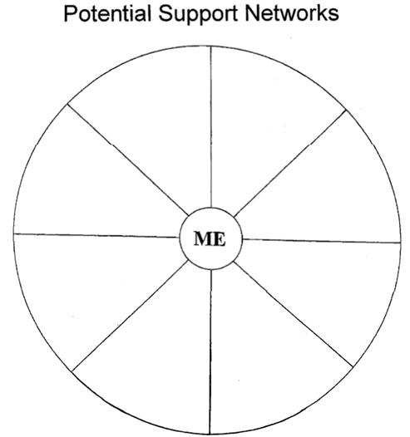

Formal and Informal

- Emotional support
- Physical and practical support
  - Financial support
- Professional development
- Task focused, problem-solving support
  - Respite care
- Community support
  - Social support

Handout 3

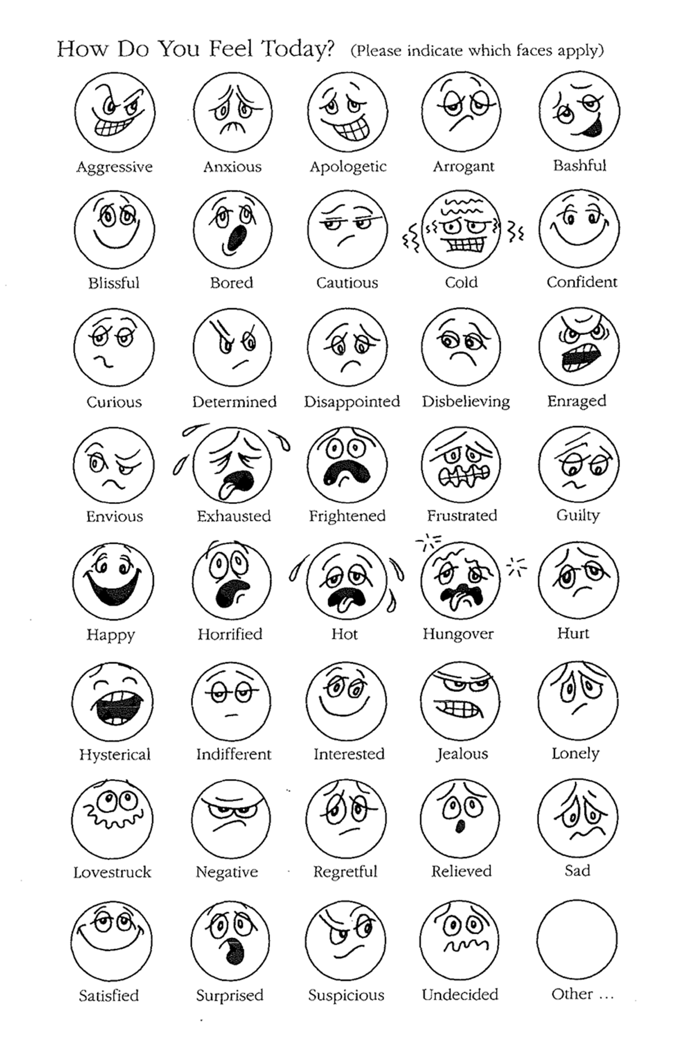

Handout 4
Self Awareness Body Scan Activity – what am I feeling now?

My Early Warning Signs of Stress or Fatigue:
(examples: yawning, forgetting things, feeling impatient)

When I am really stressed or fatigued I experience:

Emotional:
(examples: crying, withdrawn, yelling at the kids)

Physical
(examples: sore back, headaches, dry eyes)

Handout 5

Understanding Emotions

Emotional feelings are signals from the subconscious to the conscious mind about a person’s life. They may be expressed in behaviour or consciously understood as an internal message regarding one’s life.

Generally happiness tells us that our expectations and experiences are matching each other. Unhappiness tells us that our expectations are different to our experiences. The degree of difference is equal to the degree of unhappiness.

Other understandings of emotional feelings:

Hurt: What I was expecting of someone is different to my experience of them.

Solution: 1. Check expectations 2. Check experiences 3. Try to bring them closer

Disappointment: What I expected of a situation is different to what happened.

Solution: 1. Check expectations 2. Check experiences 3. Try to bring them closer

Frustration: The path I want to be on is blocked.

Solution: How can I use my energy in another way to get on with life?

Fear: Tells me that there are unknowns in my life.

Solution: I convert unknowns to knowns by gathering information

Anger: Is a secondary emotion – generates a lot of energy. Behind anger is a primary emotion – mostly hurt, disappointment, frustration or fear, sometimes sadness or guilt
Solution: Look at primary emotions and resolve them

Sadness: Tells me that an era has come to an end. The end of an era is the beginning of the next.
Solution: Value what I learnt from my experience of this era – wisdom

Guilt: Tells me that I am not following the way to which I was conditioned.

Solution: I need to consciously choose whether I will return to the old way or do a combination of both.

Depression: Tells me I am holding back my energy because I am not sure what to do with it.

Solution: Notice the use of even a small amount of energy and how this helps to get on with life.

If we only follow emotions, then they control our life. If we make sense of emotions, we consciously choose what to do with our energy. When we lose our energy we can easily become fatigued.

Handout 6

Signs of stress

PHYSICAL
Heart pounding Fidgeting
Diarrhea or constipation Sweating
Stomach distress Anorexia
Dizziness Back pain
Lingering cold Headaches
High blood pressure Insomnia
Dry mouth Muscle tension
Fatigue Shortness of breath
Weakness Generalized aches and pains

PSYCHOLOGICAL

Depressed Nightmares
Bored Helplessness
Urge to cry Irritable
Urge to hide Feelings of unreality
Suspicions Urge to run
Negative attitude/thoughts Worry
Loneliness Unable to concentrate
Lethargy Nervous

BEHAVIORAL
Cigarette smoking Antisocial
Use of medications Under eating
Impulsive behaviour Quickly angered
Inappropriate crying Lower sex drive
Aggressive Accident prone
Overeating Blaming
Initiative Nervous laughing
Isolation Overly argumentative
Using people Reclusive
Drug abuse Decline in work effectiveness
Alcohol abuse Inflexible
Cynical Nagging
Fault finding

Handout 7

Stress Management Strategies

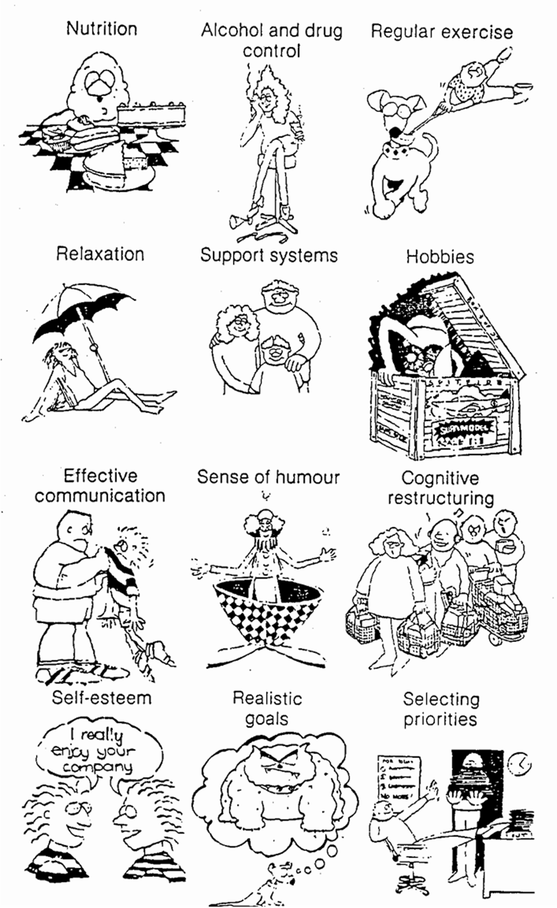

Handout 8

Self talk

What do you usually tell yourself when you…….

- Think about having your hair cut differently

- Are given a lotto ticket

- Try on some new clothes

- Forget to attend an appointment or meeting

- Think about asking for help from your support network

- Are told that the Manager is looking for you

- Are asked to do a 5 minute presentation to a group of 40 people

- Are invited to a school reunion

Handout 9

Problem solving

When problems come up in your life, recognise them then ask “what would it look like without the problem?” Tell yourself how you want it to be. If the problem is significant you may wish to go through the following process of clarification:

Write down exactly what you believe the main problem to be

- Write down all possible solutions, even the bad or outrageous ones

- Think about each solution in practical terms

- Choose the most practical solution

- Plan how you will carry that solution out

- DO IT!

Handout 10

Personal Reflections

What supports my feelings of worth as a foster carer?

What supports my feelings of worth generally in life?

What are my attitudes, values and beliefs towards asking for support?

How does my body signal it is feeling fatigued or stressed?

What are my barriers to seeking support if I am feeling fatigued or stressed?

Additional Handouts

The FAST brochure;

  - The FCQ brochure;

  - The Carer Information Sheet – Do you have a complaint about the Department of Child Safety?

Available at www.childsafety.qld.gov.au/fostercare/publications/carer.html

  - Information on Administrative Release and FOI;

  - The summary page on the complaints process from the Office of the Public Guardian;

  - Information on lodging an appeal from the Children Services Tribunal;

  - Information on the Ombudsman; and

  - Information on Judicial Review.

