All funded non-government organisations that are required to demonstrate compliance with the Human Services Quality Framework (HSQF) through certification have up to 18 months to complete an independent third-party audit and achieve HSQF certification. To help planning and preparation, the key milestones below need to be met by organisations:

12 Months
Continue planning and preparation for your audit.
Work with your certification body on audit planning and your organisation’s readiness for the audit.
Your certification body will complete a Stage 1 audit first. This involves reviewing your documentation to assess whether your organisation is ready for the onsite (or Stage 2) audit.
Commencement Date
This is the date your organisation’s legal obligations to achieve HSQF certification commence. Please refer to your service agreement or contact your contract officer to confirm your commencement date.

12-15 Months
Your onsite (Stage 2) audit will occur between 12 and 15 months. Your organisation should prepare in consultation with your certification body.
Activities will include:
- obtaining consents from customers/clients participating in the audit process
- gathering documentation for review by the auditor including staff and client files, organisation records, policies, procedures and registers
- liaising with your certification body to confirm the audit schedule including the sites to be visited and any other requirements.
At the completion of the audit, the auditors will outline findings and any corrective actions that need to be made before certification is granted. You will receive a copy of the audit report which will outline areas of good practice and areas for improvement. If any non-conformities are identified, the auditors will provide your organisation with a set timeframe for identifying the cause of the issues and developing and implementing corrective actions. The auditor will then assess the effectiveness of the corrective actions.
During this 6-9-month period, you should choose and contract a certification body. Refer to the HSQF website for tips on what to consider when contracting a certifying body.
6 Months
Undertake initial planning and preparation.
Activities will include:
- setting the scene (leadership endorsement and building engagement)
- setting the scope (understanding the quality requirements and allocating resources)
- planning for action (preparing for change and developing quality action plans) and customer/client and stakeholder engagement.

18 months
Certification Due Date
Ensure that all outstanding issues have been actioned in order to achieve certification.

9 Months
Conduct a self-assessment to check your organisation’s compliance with the standards and identify gaps to make improvements.
Familiarise and use the HSQF User Guide - Certification to assist in this process. You will need to allocate resources, schedule timeframes and activities and develop a plan to complete the self-assessment.

The Continuous Improvement Cycle
After the Stage 1 audit, continue planning for the onsite (Stage 2) audit and implement any improvement actions identified in the Stage 1 audit.

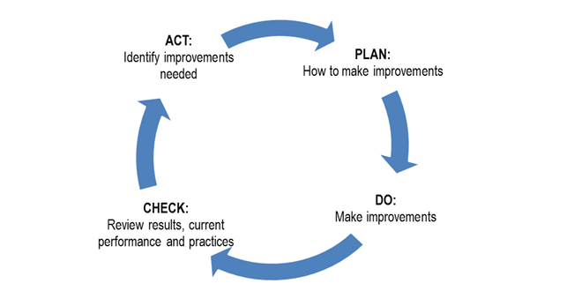

Need more assistance?
Queensland Council of Social Service (QCOSS) website: www.qcoss.org.au/sector-building/human-services-quality-framework-resources/

Resources
HSQF website: www.dcssds.qld.gov.au/our-work/human-services-quality-framework

Continuous Improvement

