What is the Aboriginal and Torres Strait Islander Family Participation Program (FPP)?
The Family Participation Program (FPP) is a free and confidential state-wide program which supports Aboriginal and Torres Strait Islander children and families to participate in any significant child protection decisions that affect their lives.
The program can:
- Create a Family Designed Plan through an Aboriginal and Torres Strait Islander Family Led Decision Making (ATSIFLDM) meeting
- Identify mob who can support the family to yarn with child safety about concerns
- Help the family identify an Independent Person (IP) or FPP staff can act as the IP, if they have capacity and no conflict of interest
- Refer to the Aboriginal and Torres Strait Islander Family Wellbeing Services for ongoing case management
FPP services are delivered by local independent Aboriginal and Torres Strait Islander community controlled organisations
How can the FPP help?
FPP services support ATSIFLDM, a process where you and your mob have the authority to come together and build a family designed plan in a culturally safe space that addresses Child Safety’s worries and keeps your children safe.
FPP services can link your family to other culturally appropriate support services for ongoing assistance
Ongoing support will help your family designed plan to be implemented in a holistic and coordinated way to your specific needs. It will identify the steps you need to take to address Child Safety’s worries and can include specialist services such as the Family Wellbeing Service to support you after the FPP process has been completed.
How is the FPP accessed?
The FPP should be engaged with your family as early as possible.
There are four referral points:
- Investigation and Assessment
- Reunification
- Six months prior to order expiry
- Self-Referral (this can be done at any point, speak to the FPP provider about your situation).
Child Placement Principle (CPP)
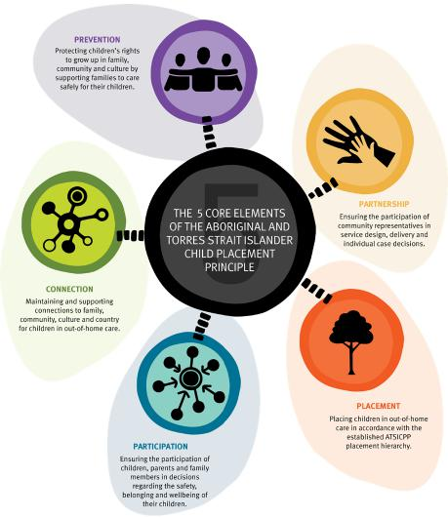
The Aboriginal and Torres Strait Islander Child Placement Principle has five core elements to ensure our children do not experience a sense of lost cultural identity or detachment from family and community.
It is designed to safeguard the rights of Aboriginal and Torres Strait Islander children within the child protection system and recognise the importance of connections to family, community, culture and country.

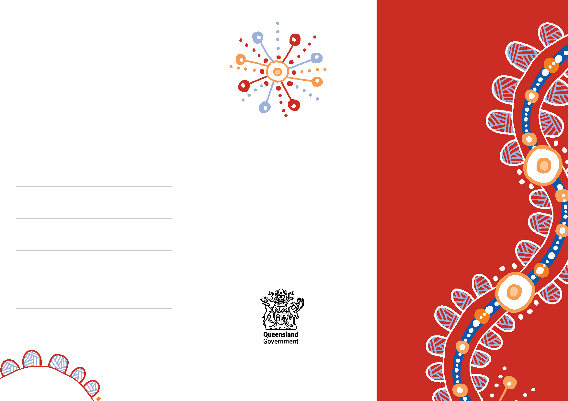
FPP: Supporting Aboriginal and Torres Strait
Islander families to have a clear and strong voice
in the child protection system
For further information send your email request to ATSIFamilies@cyjma.qld.gov.au
or checkout the Family Participation
Program website at
https://www.dcssds.qld.gov.au/fpp
Your local FPP service is:
Service name:
Address:
Contact phone/email:
Aboriginal and
Torres Strait
Islander Family
Participation
Program
Strengthening your
family’s voice during child protection decisions

