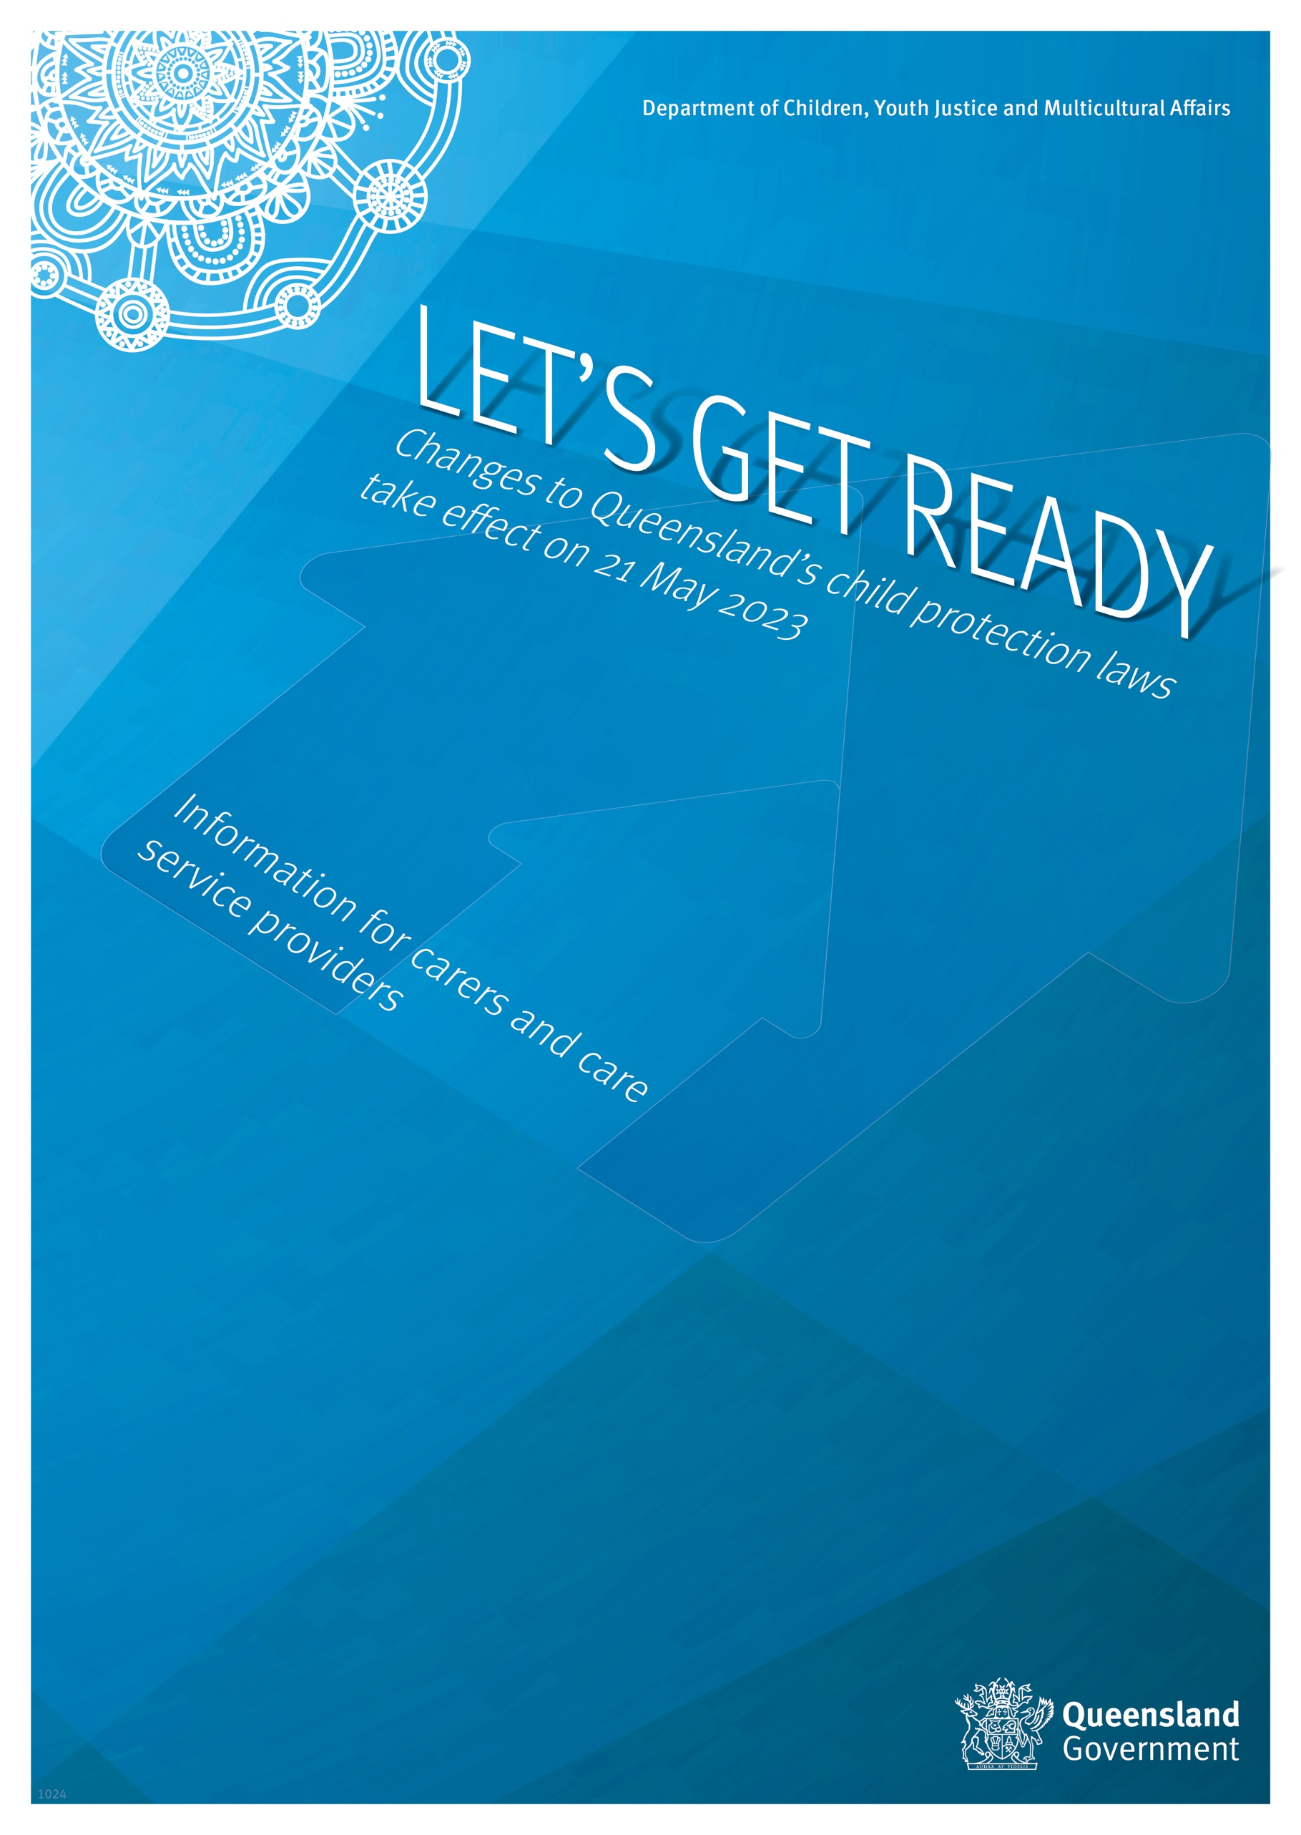
Contents
Background 2
Amendments that strengthen the regulation of care 3
Information to be provided to carers 3
Support to be provided to carers 3
Carer training 4
National carers’ register 4
Changes to amendments that may be made to a licence 4
Ensuring a person carrying out a risk assessed role is a suitable person 4
Change to who needs a blue card 5
Amendments that strengthen children’s rights and voices 6
Views about own best interests 6
Requirement to ensure children have the opportunity and supported to participate 6
Right to seek review of a decision not to review a case plan 7
Children’s participation in decisions about programs and services 7
Charter of rights for a child in care 7
Amendments that strengthen Aboriginal and Torres Strait Islander children and families’ rights 9
Making active efforts 9
Expanded partnership principle 10
Definition of kin 10
Existing care arrangements affected by the new definition of kin 10
Information resources developed to support implementation 12

Background
The second tranche of amendments to the Child Protection Act 1999 (the Act), resulting from the Child Protection Reform and Other Legislation Amendment Act 2022, will commence on 21 May 2023.
They address outstanding recommendations from the Queensland Child Protection Commission of Inquiry, the Royal Commission into Institutional Responses to Child Sexual Abuse, the Queensland Family and Child Commission Keeping Queensland’s children more than safe: Review of the foster care system report and significant issues arising from previous consultation and considerations related to obligations under the Human Rights Act 2019.
They also aim to help address the disproportionate representation of Aboriginal and Torres Strait Islander children and families in the child protection system and to support the Breaking cycles second implementation phase for 2023 – 25. The second phase focuses on changing the way that services are designed and delivered to Aboriginal and Torres Strait Islander children and families.
The amendments:
- strengthen the regulation of care
- reinforce children’s rights in the legislative framework and strengthen children’s voices in decisions that affect them
- strengthen the consideration that must be given to the Aboriginal and Torres Strait Islander Child Placement Principle when administering the Act
- make minor and technical amendments to improve the operation of the Act.
The commencement of tranche two completes the amendments required by the Child Protection Reform and Other Legislation Amendment Act 2022.

Amendments that strengthen the regulation of care

Information to be provided to carers
Currently, the Act requires Child Safety to give a carer, who is considering caring for a child, information about the child that the carer reasonably needs to make an informed decision about caring for the child.
The amendments provide examples to help clarify information a proposed carer may reasonably need. The examples include information about:
- why the child has come into care
- the child’s medical or disability needs
- the proposed length of time of the placement
- other matters the carer reasonably needs to know to ensure the safety of the child, themselves and other members of their household.
The amendments also clarify that:
- comprehensive information is to be given to the carer and
- information must be given to carers in a way that can be easily understood by the carer.
When a carer is caring for a child, the Act currently requires Child Safety to give the carer information about a child that they reasonably need to help them care for the child.
The amendments provide the following examples of information a carer may reasonably need to be given to enable them to (provide ongoing) care for a child:
- information that updates or corrects information previously given
- a copy of the child’s case plan
- information about the child’s goals, personality preferences and behaviours
- information about any special behaviour management needs of the child
- information about the child’s family, culture and background
- information about any arrangements for contact between the child and the child’s family group
- information about the child’s specific needs including cultural needs, educational needs and support needs, if applicable.

Support to be provided to carers
Child Safety has a long-standing commitment to providing carers with access to support and training to help them in their caring role and to be able to provide care consistent with the Statement of standards. However, there is no specific requirement in the Act to do this.
The amendments require Child Safety to provide approved carers, or ensure that carers have access to, support to assist them care for a child. The amendments require Child Safety to do this to the extent it is practical and appropriate.
The amendments provide the following examples of support carers may need to care for a child:
- information about financial assistance
- information and advice about providing care for children
- respite care and
- access to support persons.

Carer training
In addition to support, the amendments also require Child Safety to provide carers with, or access to training programs to maintain or develop their ability to care for children.
Access to training is also to be provided to the extent it is practicable and appropriate in the circumstances.
Embedding these requirements in the legislative framework recognises the key role carers play in protecting children and reinforces the need to give carers appropriate support and training to provide care.

National carers’ register
The Final Report of the Royal Commission into Institutional Responses to Child Sexual Abuse (the Royal Commission) made recommendations about state and territory child protection agencies:
- developing and maintaining nationally consistent carers’ registers.
- making legislative and administrative arrangements to enable states and territories to seek information about carer applicants and members of their household from another register, where relevant.
The amendments establish the legislative framework for Child Safety to maintain a register of information about people who have applied to be carers, are approved carers or former carers or are associated with an application for a licence for a licensed care service and people who perform certain roles for a licensed care service.
It is the first step in Queensland’s approach to implementing the Royal Commission’s recommendations.
Currently there is no agreement between jurisdictions for carers’ registers to be established or accessed.

Changes to amendments that may be made to a licence
When the amendments commence, Child Safety will be able to amend a licence at any time to remove, or temporarily remove, a licensed premise from the licence if:
- a licensed care service provided at the premises does not comply with the standards of care
- a person responsible for directly managing a licensed care service provided at the premises is not a suitable person or does not hold a blue card
- the methods for the selection, training and management of people engaged at the premises are not suitable
- if the premises is a residential service facility – the premises is not suitable for providing accommodation to children in need of protection.
The amendment enables appropriate action to be taken to address non-compliance at a specific facility included in the licence or within the organisation as a whole. This aligns with existing licensing practice and procedures.

Ensuring a person carrying out a risk assessed role is a suitable person
A licensee will be responsible for ensuring that each person performing a risk-assessed role for a licensed care service is a suitable person. The Department of Children, Youth Justice and Multicultural Affairs, Central Screening Unit supports licensees to meet this requirement by undertaking screening and providing advice about whether the person poses a risk to the safety of children.
The amendments also ensure licensees will receive updated information about the blue card status of people performing risk-assessed roles in a licensed care services to ensure services know if a person performing a risk-assessed role cannot continue to do so because they are no longer eligible to hold a blue card.

Change to who needs a blue card
Yes. The amendments make minor changes to the Working with Children (Risk Management and Screening) Act 2000 to require any person performing a risk-assessed role in a licensed care service to hold a blue card.
Currently a person requires a blue card if any of the usual functions of their employment is carried out, or is likely to be carried out, inside a licensed residential facility. A person also requires a blue card if they are employed by a licensed care service and any of the usual functions of the employment includes or is likely to include providing support to an approved carer. A person responsible for directly managing a licensed care service and a person who is engaged by a licensed care service, to provide care to a child, also require a blue card.
When the amendments commence, any person whose employment is carried out, or is likely to be carried out, inside a licensed residential facility, directly managing a licensed care service or performing a risk-assessed role for a licensed care service will require a blue card.
This includes a person directly engaged by a licensed care service to carry out a risk-assessed role or a person contracted from another entity to carry out a risk assessed role in the service.

Amendments that strengthen children’s rights and voices

Views about own best interests
An additional principle has been added to the Act that gives children the right to express their views about what is in their best interests when Child Safety is making decisions about their safety, wellbeing and best interests.

Requirement to ensure children have the opportunity and supported to participate
The amendments include a new Principles for the participation of children. The principles require Child Safety, when making a decision or exercising a power that affects or may affect a child, to make sure:
- the child is given meaningful and ongoing opportunities to participate
- the child is:
  - allowed to decide whether they participate in a decision
  - given information that is reasonably necessary to allow the child to participate
  - advised about what help is available to them
  - allowed to express views that are different to views they have previously expressed.
It also requires Child Safety to:
- understand and consider, or make a genuine attempt to understand and consider, the views expressed by the child
- listen to and engage with, or make a genuine attempt to listen to and engage with, the child
- ensure a record is made of the child’s views that, if appropriate, uses the child’s words
- ensure communication is carried out with the child in a way that is appropriate for them, having regard to their age, maturity, capacity, culture and circumstances
- ensure, if a child participates, they are allowed to decide how they will participate. This may include:
  - verbally or non-verbally
  - communicating directly with a particular person
  - communicating indirectly through a trusted person
  - communicating indirectly through someone independent such as their legal representative or health practitioner
  - communicating indirectly through a written statement or an audio or video recording
  - communicating indirectly through an expert report
  - participating separately from particular persons
  - giving the child the help they need to participate, if it is required.

Right to seek review of a decision not to review a case plan
Currently, only a child who has a long-term guardian or permanent guardian (or the long-term or permanent guardian of a child) can ask Child Safety to review their case plan and apply to the Queensland Civil and Administrative Tribunal (QCAT) for a review of the decision if Child Safety refuses the request.
This means the right to seek review does not apply if the chief executive is the child’s long-term guardian (ie child subject to LTG-CE).
When the amendments commence, if a child subject to LTG-CE requests a review of their case plan and Child Safety decides not to review the plan, Child Safety must give the child a reviewable decision letter.
The child may then make an application to QCAT for the decision to be reviewed.

Children’s participation in decisions about programs and services
The amendments require Child Safety to make sure children have meaningful and ongoing opportunities to participate in decisions about programs and services relating to the Act.
A range of strategies will be used to ensure children’s voices are heard and considered in decisions about programs and services, provided or funded by Child Safety.
The strategies will include consultation where appropriate and practical. They will also include listening to the issues raised and views expressed by children and young people in relevant local, state and national engagement processes, considering the findings of relevant research and feedback and complaints made by children and young people in contact with the child protection system.

Charter of rights for a child in care
The amendments expand the charter to respond to contemporary legal and social issues. The charter does this by providing children in care with additional rights, including the right to:
- be treated fairly and with respect
- develop, maintain and enjoy a connection to the child’s culture of origin
- for an Aboriginal child—to develop, maintain and enjoy a connection to Aboriginal tradition
- for a Torres Strait Islander child—to develop, maintain and enjoy a connection to Island custom
- develop, maintain and enjoy the child’s identity, including, for example, the child’s sexual orientation or gender identity
- choose and practise one or more languages
- choose and practise one or more religions
- keep, and have a safe space to store, personal belongings
- engage in play, and other recreational activities, appropriate for the child
- make a complaint to the chief executive if the child considers that the charter of rights is not being complied with in relation to the child.
The amendments add new requirements for Child Safety to ensure:
Children in care are:
- regularly told about the chief executive’s obligation to ensure the Charter is complied with
- regularly told about the child’s right to contact Child Safety if the child has any questions or concerns about the child’s protection and care needs.
Children subject to an order granting long-term guardianship to a suitable person or to a permanent care order are:
- regularly told about the charter and its effect, and
- regularly given written information about the Charter (having regard to the child’s age and ability to understand).
Information provided to children about the charter and their rights under the charter is:
- communicated in language that is easy and clear for a child to understand, and
- carried out in a way appropriate for the child.
Children subject to a child protection order granting long-term guardianship of the child to a suitable person will be regularly provided with information about their rights under the charter and Child Safety’s obligations by:
- providing the charter to them when the order granting long-term guardianship is made
- providing the charter to them each time Child Safety has contact with the child after the order is made (at least every 12 months, or more regularly if requested by the child or the guardian, or considered necessary by Child Safety)
- making the charter accessible on kicbox and the Department of Children, Youth Justice and Multicultural Affairs website https://www.cyjma.qld.gov.au/
Children subject to a permanent care order (PCO) will be regularly provided with information about their rights under the charter and Child Safety’s obligations by:
- providing the charter to them when the permanent care order is made
- providing the charter to them if the case plan is being reviewed at the request of the child or guardian or for another reason
- making it accessible on kicbox and the Department of Children, Youth Justice and Multicultural Affairs website https://www.cyjma.qld.gov.au/

Amendments that strengthen Aboriginal and Torres Strait Islander children and families’ rights

Making active efforts
The Act currently requires Child Safety to have regard to the child placement principles when making a significant decision about an Aboriginal or Torres Strait Islander child.
The amendments require Child Safety to not just ‘have regard’ but to ‘make active efforts to apply’ the Aboriginal and Torres Strait Islander Child Placement Principle, when making a significant decision about an Aboriginal and Torres Strait Islander child.
The term ‘active efforts’ is defined as purposeful, thorough and timely efforts.
Significant decisions are:
- where or with whom a child subject to a child protection care agreement or order granting custody or guardianship to the chief executive will live
- matters that have a significant impact on the child’s life including:
  - how to keep a child safe (immediate safety planning during investigation and assessment and ongoing intervention)
  - whether a child is in need of protection
  - case planning regarding the type of ongoing intervention that will be undertaken and how the child’s needs will be met
- whether to refer a matter regarding an application for a child protection order for the child to the Director of Child Protection Litigation
- support service planning prior to the birth of an Aboriginal or Torres Strait Islander child
- a matter the child and/or family consider significant or is significant in the child’s particular circumstances.
Active efforts are purposeful, thorough and timely steps taken, when making a significant decision, to uphold:
- a child’s right to be brought up within the child’s own family and community (the prevention principle)
- Aboriginal or Torres Strait Islander persons’ right to participate in significant decisions about Aboriginal or Torres Strait Islander children (the partnership principle)
- if a child is to be placed in care, the child’s right to be placed with a member of their family group (the placement principle)
- a child’s right and their parents’ and family members’ right to participate, and be enabled to participate, in an administrative or judicial process for making a significant decision about the child (the participation principle)
- a child’s right to be supported to develop and maintain a connection with their family, community, culture, traditions and language, particularly when the child is in the care of a person who is not an Aboriginal or Torres Strait Islander person (the connection principle).

Expanded partnership principle
The amendments require Child Safety to ensure Aboriginal and Torres Strait Islander persons have a meaningful opportunity to participate in decisions about the development and delivery of services for Aboriginal or Torres Strait Islander children and services that support their families.
This is in addition to the right to participate when decisions about Aboriginal and Torres Strait Islander children are being made.

Definition of kin
Currently, the Act defines kin in relation to a child as meaning:
- any of the child’s relatives who are persons of significance to the child; and
- anyone else who is a person of significance to the child.
The amendment changes the definition of kin, in relation to a child, as meaning persons who are:
- a member of the child’s family group who is a person of significance to the child
- if the child is an Aboriginal child, a person who, under Aboriginal tradition, is regarded as kin of the child
- if the child is a Torres Strait Islander child, a person who under Island custom, is regarded as kin of the child
- another person
  - who is recognised by the child, or the child’s family group as a person of significance to the child, and
  - if the child is an Aboriginal or Torres Strait Islander child, with whom the child has a cultural connection.
The amendment:
- ensures that persons who are kin to an Aboriginal and Torres Strait Islander child under Aboriginal tradition or Island custom are recognised as kin
- clarifies that a person is of significance to the child if the child or family consider the person to be of significance, and
- means that for an Aboriginal or Torres Strait Islander child, a person of significance to a child can only be approved as a kinship carer for the child if the person also has a cultural connection to the child
- helps ensure decisions about who is kin uphold Aboriginal and Torres Strait Islander peoples’ right under the Human Rights Act 2019 to enjoy, maintain, control, protect and develop their kinship ties.

Existing care arrangements affected by the new definition of kin
If a child does not have kin who can provide them with the safe care they need, being cared for by a person who is significant to them and has a close emotional bond with them, may be the best option for meeting their relational, physical and legal permanency needs and being supported to successfully transition to adulthood. The benefits resulting from the secure attachment that exists in such care relationship, regardless of whether approval is for foster or kinship care, are recognised and valued.
Kinship carers who have a current certificate of approval
If the care relationship does not meet the new definition of kin, the carer can apply for renewal of approval as a foster carer. The approval can be for a particular child only if this is the carer’s wish.
After 21 May 2023, if an approved kinship carer applies for approval as a foster carer before their current kinship approval expires, their kinship care approval will continue until the application for approval as a foster carer is finalised.
Prior to the expiry date, Child Safety will work with foster and kinship care service providers and kinship carers affected by the changed definition to provide information and support during their reapproval as foster carers.
A carer affected by the changed definition can continue to be supported by the same foster and kinship care service or kinship care service.
As it will be the first time the carer has been approved as a foster carer, the foster carer certificate of approval will expire after 1 year.
In recognition that the carer has previously been approved as a kinship carer for the child they are caring for, there will be a streamlined process for the first renewal assessment.
After the initial 1-year approval, the foster carer renewal assessment will consider:
- the assessment information that was gathered as part of the assessment for the current certificate of approval, if the certificate of approval was issued within 1 year of the application for renewal
- changes to the carer’s or carer’s personal circumstances.
The applicant will be required to complete a Changes in carer circumstances ‐ Form 39 if there are any changes to their personal circumstances.
Unless specifically indicated by the carer’s circumstances, there will be no requirement to complete an additional Carer health and wellbeing questionnaire.
The renewal assessment report together with the initial assessment report relating to the carer will be submitted to the CSSC Manager for consideration.
Any certificate of approval issued after the application for renewal of approval will expire after 3 years.
Kinship carers who have applied for renewal of approval as a kinship carer
If an approved kinship carer has applied for renewal of approval as a kinship carer before 21 May 2023, their approval will remain in place until the renewal application is finalised. The renewal application can be processed as though the previous definition of kin was still in place.
If the renewal application is approved after 21 May 2023, the kinship carer’s certificate of approval will expire after 3 years. Prior to the expiry date, Child Safety will work with care service providers and kinship carers affected by the changed definition to provide information and support during their reapproval as foster carers. The approval can be for a particular child only if this is their wish.
Training considerations
What training is appropriate and how and when training is provided or accessed, may vary depending on the circumstances of the relationship between people who apply to be approved as foster carers for a child who has a significant relationship with them (but who is not kin).
Where appropriate, assessment requirements can be varied so that pre-approval training does not need to be completed before an applicant, who has a significant relationship to a child (but is not kin to the child) can be approved (or have approval renewed) as a foster carer for the child.

Information resources developed to support implementation
Available online: www.cjyma.qld.gov.au
Brochures will be available in June 2023. Email requests for copies of brochures to ocp@cyjma.qld.gov.au

Strengthening children’s rights and voices
Children’s rights animated video
Charter of rights for children in care brochure
Information for children in care webpage

Aboriginal and Torres Strait Islander children and families
Active efforts video
Active efforts brochure for families
Active efforts brochure for children
What is an independent person brochure for families
Being and independent person brochure
Independent person brochure for children

If you require further information email: CPAReformImplementation@cyjma.qld.gov.au

