Providing supports to children and young people with high and complex needs who are in contact with the child safety system

Specialist Services

Need more information?

Email
SDSpecialistServices@csyw.qld.gov.au

Web
www.csyw.qld.gov.au

What is disability?
Disability can be defined as any impairment that limits a person’s participation in life activities. There are many different kinds of disability and they can result from accidents, illness or genetic disorders.
Having a disability may mean the child or young person experiences difficulties in:
- cognition or intellectual functioning
- mental health
- coping with sensory input
- physical movement
- general health.
They may have difficulties in one or more of these areas.
These difficulties may impact on the child or young person’s capacity to:
- communicate
- interact socially with others
- learn
- walk or move independently
- participate in activities such as eating and drinking, dressing and self-care
- engage in community activities
- make judgments and problem solve.

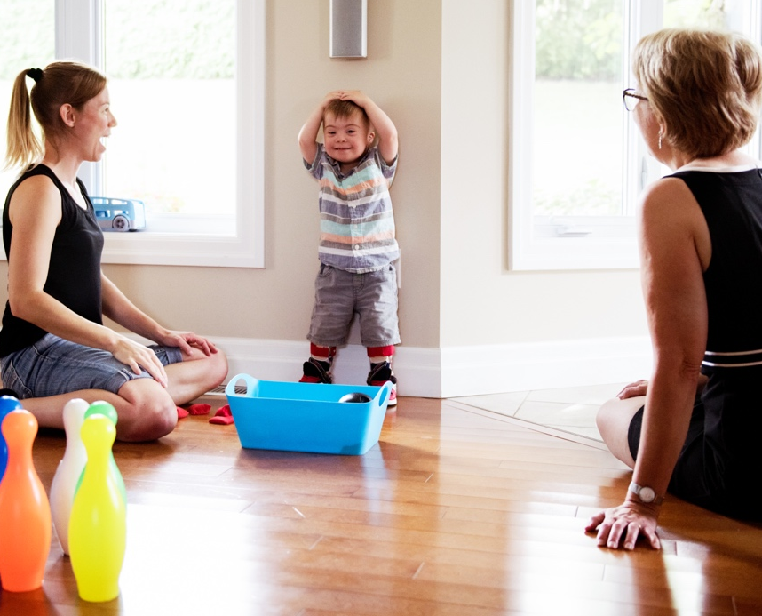

What we do
We provide support to children and young people in contact with the child safety system who have complex disability, mental health, and/or high risk behavioural needs. This includes children and young people from Aboriginal and Torres Strait Islander backgrounds and those on dual orders with Youth Justice.
Specialist Services values and practice are consistent with the frameworks of Strengthening Families – Protecting Children and The five core elements of the Aboriginal and Torres Strait Islander Child Placement Principle.

Who we are
Specialist Services provides support through two statewide service teams:
- Specialist Services team
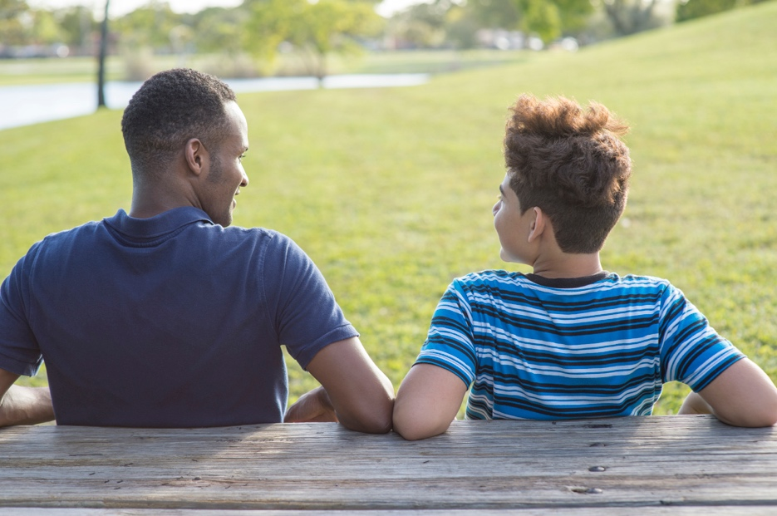
- Transition and Post Care Support team.

Specialist Services team
Specialist Services Clinicians work with children aged from 0 to 18 years who are in contact with Child Safety. The clinicians work with Child Safety Officers and other stakeholders to support the health, development and wellbeing of children with high and complex needs.
The Specialist Services clinicians can help with:
- identifying and understanding disability, health, mental health and behaviour support needs
- identifying health and disability supports and services to meet the child’s needs. These can be through mainstream services and the National Disability Insurance Scheme
- ensuring that NDIS plans meet the needs of the child or young person
- ensuring that clinical and disability support needs are met as young people transition to adulthood.

Transition and Post Care Support team
Transition Officers work with young people aged 15 to 21 years with complex needs to plan their transition to adulthood and provide post care support so they can:
- live in a safe and stable home
- feel supported in and connected to their community including services
- be involved in education, work or training
- build and maintain relationships.
This is achieved by
- establishing a trusting relationship with a young person when they start transition to adulthood planning at 15
- assisting the young person’s CSO to create and implement a transition to adulthood plan
- ensuring the young person is involved in preparing for and planning their own transition
- working directly with the young person to develop the skills they need for life post care
- establishing and maintaining links to appropriate services and supports.

